Software Requirements Specification (SRS)

Project: Smart Parking Management System (SPMS)
Version: 1.1
Authors: Team 06 – Raghav G Uddihal (PES1UG24AM215), Prithvish Adhikari (PES1UG24AM206), Rahul Prasanna (PES1UG24AM217), Rufus Thomas (PES1UG24AM232)
Date: 08-11-2026
Status: Final – as built after Sprint 2

Revision history
Version | Date | Author | Change summary | Approval
1.0 | 07-10-2026 | Team 06 | Initial SRS with use-case diagrams embedded | coordinator@pes.edu
1.1 | 08-11-2026 | Team 06 | As-built update after Sprint 2: RTM status filled from the test cycle; deviations listed in docs/Deviations.md and section 9

Approvals
Role | Name | Signature / Email | Date
Course Coordinator | Coordinator | coordinator@pes.edu | 11/10/2026

Table of Contents
1. Introduction
2. Overall description
3. External interfaces
4. System features (detailed)
5. Non-functional requirements (detailed)
6. Quality attributes & Acceptance tests
7. UML Use-Case Diagram
8. Requirements Traceability Matrix (RTM)

1. Introduction

1.1 Purpose
This document is a Software Requirements Specification (SRS) for the Smart Parking Management System (SPMS). It defines functional and non-functional requirements, interfaces, security requirements and verification criteria for the development team, testers and course evaluators.

1.2 Scope
Covers tracking of parking availability, vehicle entry and exit, advance slot reservations, automatic allocation of suitable parking spaces, fee calculation and payments (online in gateway test mode and cash), receipts, notifications and occupancy/revenue information for administrators. Excludes physical hardware such as boom barriers, ANPR cameras and slot sensors (their events are entered through the attendant console), real-money settlement and native mobile apps.

1.3 Audience
Developers (Team 06), QA/Test Engineers, Parking Administrators, Course Instructor and Assessment Evaluators.

1.4 Definitions
List of acronyms: SPMS, UI, API, REST, JWT, RBAC, QR, UPI, TLS, WSS, ORM, CSV, FR, NFR, RTM, RPO, RTO. Lot = parking facility; Level = floor; Slot = single parking space; Session = one stay from entry to exit; Grace period = free initial minutes; No-show = reservation not used within 15 min of its start.

2. Overall description

2.1 Product perspective
SPMS is a new web-based system used by drivers, parking attendants and administrators. It includes a React web front end (driver portal, attendant gate console, admin dashboard), a Python FastAPI backend, a PostgreSQL database, Redis for caching and live updates, and integrations with a payment gateway (test mode) and an email server.

2.2 Major product functions (detailed)
- User registration, login and role-based access
- Parking lot, level, slot and tariff management
- Real-time slot availability and occupancy display
- Advance slot reservation with double-booking prevention
- Automatic allocation of the most suitable slot
- Vehicle entry and exit recording (plate number / reservation QR)
- Fee calculation, online / cash payment and digital receipts
- Occupancy and revenue reports, CSV export and email notifications

2.3 User roles and characteristics (expanded)
- Driver: basic smartphone/internet skills; wants to find, reserve and pay for a slot quickly.
- Parking Attendant: works at the gate under time pressure; needs fast entry/exit screens and clear errors.
- Administrator: manages lots, slots and tariffs; needs dashboards, reports and audit trails.
2.4 Operating environment
Linux server (Docker) running Python 3.11/FastAPI, PostgreSQL 15 and Redis 7; clients use the latest Chrome, Edge, Firefox or Safari on desktop, tablet or mobile over HTTPS.

2.5 Constraints
Python backend and React frontend as agreed by the team, payment gateway in sandbox/test mode only, personal-data protection (DPDP Act 2023 principles), open-source tools only, completion within the semester by a team of four.

3. External interface requirements

3.1 User interfaces
Responsive web UI: driver portal (availability, reservation, payment, history), tablet-friendly attendant gate console (Entry/Exit, plate input, QR scan, fee due) and admin dashboard (CRUD screens and charts). Accessibility: keyboard navigation, screen-reader labels and WCAG 2.1 AA colour contrast.

3.2 Hardware interfaces
- Standard PC / tablet with a browser at the gate
- Optional USB/Bluetooth QR scanner (keyboard / HID mode)
- Boom barrier, ANPR camera and slot sensors: out of scope (simulated via Gate API)
3.3 Software interfaces
- PostgreSQL 15 database (via SQLAlchemy ORM) for all persistent data.
- Redis 7 for availability cache, locks, pub/sub and Celery task queue.
- Payment Gateway REST API (Razorpay test mode) for orders, refunds and signed webhooks; SMTP server for emails.

3.4 Communications
- HTTPS (TLS 1.2+) REST/JSON API (/api/v1) and WebSocket Secure (WSS) for live availability updates.
- Signed (HMAC-SHA256) webhooks from the payment gateway; SMTP over TLS for email; retry with backoff for external calls.

4. System features (detailed)
Each requirement below includes acceptance criteria and a reference test case. IDs follow SPMS-F-###.

4.1 User Registration & Authentication
Description: Allow drivers to create accounts and all users (Driver, Parking Attendant, Administrator) to sign in securely with role-based access.
Req ID | Requirement (shall...) | Type | Priority | Source/Stakeholder | Acceptance criteria / Test case ref | Comments / Dependencies
SPMS-F-001 | The system shall allow a driver to register with name, email, mobile number and password, rejecting duplicate email/mobile. | Functional | High | Driver | Valid form creates an account and returns 201; duplicate email returns 409 with a clear message. Test: TC-AUTH-01 | Email service for welcome mail
SPMS-F-002 | The system shall authenticate users with email and password and issue a signed JWT access token (30 min) and a refresh token. | Functional | High | Security | Valid credentials return tokens; invalid credentials return 401 with a generic message. Test: TC-AUTH-02 | Depends on SPMS-SR-002/003
SPMS-F-003 | The system shall enforce role-based access control (Driver, Attendant, Admin) on every API endpoint and UI screen. | Functional | High | Security / Admin | A Driver token calling an Admin endpoint receives 403; menu items hidden by role. Test: TC-AUTH-03 | Applies to all modules
SPMS-F-004 | The system shall lock an account for 15 minutes after 5 consecutive failed login attempts and record an audit event. | Functional | High | Security | 6th attempt within lock window is refused; audit entry exists. Test: TC-AUTH-04 | Audit Logger

4.2 Parking Lot & Slot Management
Description: Let the administrator model the physical parking facility (lots → levels → slots) and its pricing.
Req ID | Requirement (shall...) | Type | Priority | Source/Stakeholder | Acceptance criteria / Test case ref | Comments / Dependencies
SPMS-F-010 | The system shall allow the administrator to create, update and deactivate parking lots, levels and slots, each slot having a type (2-wheeler, 4-wheeler, EV-charging, accessible). | Functional | High | Parking owner | CRUD operations persist and appear in availability within 5 s. Test: TC-LOT-01 | —
SPMS-F-011 | The system shall allow the administrator to configure tariffs per lot and vehicle type (grace period, hourly rate, daily cap) with an effective date. | Functional | High | Parking owner | New tariff is applied only to sessions starting after its effective time. Test: TC-LOT-02 | Used by Billing
SPMS-F-012 | The system shall allow an administrator or attendant to mark a slot 'Under Maintenance', excluding it from allocation and availability counts. | Functional | Medium | Operations | Slot in maintenance is never allocated; free count decreases by one. Test: TC-LOT-03 | Allocation Engine

4.3 Real-time Availability
Description: Provide accurate, live occupancy information to drivers and staff.
Req ID | Requirement (shall...) | Type | Priority | Source/Stakeholder | Acceptance criteria / Test case ref | Comments / Dependencies
SPMS-F-020 | The system shall display the number of free slots per lot, level and slot type to all users, including unauthenticated visitors. | Functional | High | Driver | Displayed counts equal database state for a seeded lot. Test: TC-AVL-01 | —
SPMS-F-021 | The system shall push slot status changes to connected clients within 5 seconds of an entry, exit, reservation or maintenance event. | Functional | High | Driver / Operations | Change visible on a second browser within 5 s. Test: TC-AVL-02 | WebSocket + Redis pub/sub

4.4 Slot Reservation
Description: Let drivers book a slot in advance and manage their bookings.
Req ID | Requirement (shall...) | Type | Priority | Source/Stakeholder | Acceptance criteria / Test case ref | Comments / Dependencies
SPMS-F-030 | The system shall allow a driver to reserve a slot for a registered vehicle in a chosen lot for a future time window (30 min – 24 h long, up to 7 days ahead). | Functional | High | Driver | Valid request returns 201 with slot code and QR token after advance payment. Test: TC-RES-01 | Allocation Engine, Payment
SPMS-F-031 | The system shall prevent double booking: no two active reservations or sessions may overlap in time on the same slot. | Functional | High | Business | Of 50 concurrent requests for the last free slot exactly one succeeds. Test: TC-RES-02 | DB exclusion constraint
SPMS-F-032 | The system shall allow a driver to modify or cancel a reservation before its start time, refunding 100% of the advance if cancelled ≥ 1 h before start, otherwise 50%. | Functional | Medium | Driver / Business | Refund amount follows policy; slot released immediately. Test: TC-RES-03 | Payment gateway refund API
SPMS-F-033 | The system shall auto-cancel a reservation and release the slot if the vehicle has not entered within 15 minutes after the reservation start time (no-show). | Functional | Medium | Operations | Reservation status becomes NO_SHOW and slot is free at start + 15 min. Test: TC-RES-04 | Scheduled job (Celery beat)

4.5 Suitable Slot Allocation
Description: Automatically assign the best available slot for each vehicle.
Req ID | Requirement (shall...) | Type | Priority | Source/Stakeholder | Acceptance criteria / Test case ref | Comments / Dependencies
SPMS-F-040 | The system shall automatically allocate a free slot matching the vehicle type and accessibility need, preferring the slot with the least distance to the entrance. | Functional | High | Driver / Operations | For seeded data the allocated slot equals the expected nearest compatible slot. Test: TC-ALC-01 | —
SPMS-F-041 | The system shall allow an attendant to override the automatic allocation with another free compatible slot, recording a reason in the audit log. | Functional | Medium | Operations | Override succeeds only for free compatible slots; audit entry stored. Test: TC-ALC-02 | Audit Logger

4.6 Vehicle Entry & Exit
Description: Record vehicles entering and leaving the facility at the gate.
Req ID | Requirement (shall...) | Type | Priority | Source/Stakeholder | Acceptance criteria / Test case ref | Comments / Dependencies
SPMS-F-050 | The system shall allow an attendant to record vehicle entry by plate number (and optional reservation QR), storing the timestamp and issuing a ticket ID with the allocated slot code. | Functional | High | Operations | Entry creates an OPEN parking session and marks the slot OCCUPIED. Test: TC-GATE-01 | Allocation Engine
SPMS-F-051 | The system shall validate a reservation QR at entry: correct lot, within the reservation window (±15 min) and status CONFIRMED. | Functional | High | Business | Expired / wrong-lot / cancelled QR is rejected with reason. Test: TC-GATE-02 | Reservation Service
SPMS-F-052 | The system shall reject entry of a plate number that already has an open parking session. | Functional | High | Business | Second entry for same plate returns 409 DUPLICATE_ENTRY. Test: TC-GATE-03 | —
SPMS-F-053 | The system shall record vehicle exit, compute parking duration and fee, close the session and free the slot once payment is settled. | Functional | High | Operations | Exit closes session; slot becomes FREE; availability updated. Test: TC-GATE-04 | Billing & Payment

4.7 Billing & Payments
Description: Calculate parking charges and collect payment online or at the counter.
Req ID | Requirement (shall...) | Type | Priority | Source/Stakeholder | Acceptance criteria / Test case ref | Comments / Dependencies
SPMS-F-060 | The system shall compute the fee as 0 within the grace period, otherwise ceil(hours) × hourly rate, capped at the daily cap per 24 h, minus any advance already paid. | Functional | High | Business | Fee matches expected values for boundary cases (grace, 1 h + 1 min, > 24 h). Test: TC-PAY-01 | Tariff configuration
SPMS-F-061 | The system shall accept online payment (UPI / card via the payment gateway's hosted checkout) and cash payments recorded by the attendant. | Functional | High | Driver / Operations | Successful payment marks session/reservation PAID. Test: TC-PAY-02 | Payment gateway (test mode)
SPMS-F-062 | The system shall generate a digital receipt (receipt no., plate, entry/exit time, duration, amount, method) viewable in the app and downloadable as PDF. | Functional | Medium | Driver | Receipt fields match session and payment data. Test: TC-PAY-03 | —
SPMS-F-063 | The system shall not close a session with an unpaid fee unless an administrator records a waiver with a reason. | Functional | Medium | Business | Exit without payment is blocked (402); waiver is audited. Test: TC-PAY-04 | Audit Logger

4.8 Reports, History & Notifications
Description: Give administrators occupancy/revenue insight and keep drivers informed.
Req ID | Requirement (shall...) | Type | Priority | Source/Stakeholder | Acceptance criteria / Test case ref | Comments / Dependencies
SPMS-F-070 | The system shall show administrators a dashboard of occupancy %, revenue, average stay and peak hours per lot for a selected date range. | Functional | Medium | Parking owner | Dashboard figures match SQL computed from test data. Test: TC-RPT-01 | —
SPMS-F-071 | The system shall allow administrators to export occupancy and revenue reports as CSV. | Functional | Low | Parking owner | CSV opens in a spreadsheet and totals match the dashboard. Test: TC-RPT-02 | —
SPMS-F-072 | The system shall email the driver on reservation confirmation, cancellation/refund, and 15 minutes before the reservation starts. | Functional | Medium | Driver | Emails captured in test SMTP inbox with correct content. Test: TC-NOT-01 | SMTP server
SPMS-F-073 | The system shall allow a driver to view their past reservations, parking sessions and receipts. | Functional | Medium | Driver | History lists only the logged-in driver's records. Test: TC-HIS-01 | —

5. Non-functional requirements (detailed)
NFRs below are measurable and tied to test plans. IDs SPMS-NF-###.

Req ID | Requirement | Category | Priority | Acceptance criteria / Measurement
SPMS-NF-001 | 95% of API requests shall complete within 2 seconds with 200 concurrent users under normal load. | Performance | High | Locust load test: p95 ≤ 2 s. Test: TC-PERF-01
SPMS-NF-002 | A gate entry or exit transaction (request to ticket/receipt) shall complete within 3 seconds. | Performance | High | Measured over 100 gate operations: max ≤ 3 s. Test: TC-PERF-02
SPMS-NF-003 | The system shall be available 99% of operating hours (06:00–23:00); the database shall be backed up daily (RPO ≤ 24 h, RTO ≤ 2 h). | Reliability / Availability | High | Uptime monitor report; restore drill succeeds within 2 h. Test: TC-REL-01
SPMS-NF-004 | A first-time driver shall be able to complete a reservation in at most 4 screens / 2 minutes; UI shall be responsive from 360 px to 1920 px wide and meet WCAG 2.1 AA colour contrast. | Usability / Accessibility | Medium | Usability test with 5 users; Lighthouse accessibility ≥ 90. Test: TC-UX-01
SPMS-NF-005 | The system shall support at least 10 lots, 5,000 slots and 1,000 reservations per day without schema changes, with a stateless API that can be scaled horizontally. | Scalability | Medium | Load test with seeded volume meets NF-001. Test: TC-PERF-03
SPMS-NF-006 | Backend code shall follow PEP 8 (flake8 clean), have ≥ 70% unit-test line coverage and auto-generated OpenAPI documentation. | Maintainability | Medium | CI pipeline report shows coverage ≥ 70% and 0 lint errors. Test: TC-MNT-01

5.1. Security

5.1.1 Security Objectives
- SO-1 Confidentiality – Protect users' personal data (name, email, phone, vehicle plate numbers) and payment information from unauthorised disclosure.
- SO-2 Integrity – Ensure slot states, parking sessions, fees and payment confirmations cannot be tampered with (e.g., fee manipulation or forged payment success).
- SO-3 Accountability – Make every privileged action (allocation override, fee waiver, tariff change) traceable to an authenticated user.
- SO-4 Availability – Resist brute-force and request-flooding abuse so that gate operations continue during peak hours.

5.1.2 Security Requirements
Req ID | Requirement (shall...) | Type | Priority | Acceptance criteria / Test case ref
SPMS-SR-001 | All network traffic (browser ↔ API, API ↔ payment gateway/SMTP) shall use TLS 1.2 or higher, with HSTS enabled. | Security | High | SSL Labs / testssl scan shows no TLS < 1.2. Test: TC-SEC-01
SPMS-SR-002 | Passwords shall be stored only as bcrypt hashes (cost ≥ 12) and shall never be logged or returned by any API. | Security | High | DB inspection and log review show no plaintext. Test: TC-SEC-02
SPMS-SR-003 | Access tokens shall be signed JWTs expiring in 30 minutes; refresh tokens shall be rotated on use and revoked on logout. | Security | High | Expired / tampered / revoked token returns 401. Test: TC-SEC-03
SPMS-SR-004 | All inputs shall be validated server-side with Pydantic schemas and all database access shall use parameterised ORM queries; output shall be encoded to prevent XSS. | Security | High | OWASP ZAP scan: 0 high findings for SQLi/XSS. Test: TC-SEC-04
SPMS-SR-005 | Card data shall never be handled or stored by SPMS (gateway hosted checkout); a payment shall be marked successful only after HMAC-SHA256 webhook signature verification. | Security | High | Forged webhook is rejected (400) and payment stays PENDING. Test: TC-SEC-05
SPMS-SR-006 | Login, registration and payment endpoints shall be rate-limited (e.g., 10 requests/min per IP for login). | Security | Medium | 11th request in a minute returns 429. Test: TC-SEC-06
SPMS-SR-007 | Privileged actions shall be written to an append-only audit log containing user, role, timestamp, action and before/after values, retained for 1 year. | Security | Medium | Override/waiver/tariff change creates audit entry; log rows cannot be updated via API. Test: TC-SEC-07

6. Quality attributes & Acceptance tests
- Exit criteria for acceptance: All high-priority functional and security requirements implemented and verified, no critical NFR failures, and RTM shows all test cases passed.
- Acceptance test suites: Authentication, Lot & Slot Management, Availability, Reservation, Allocation, Gate Entry/Exit, Payments, Reports & Notifications, Performance, Reliability, Usability, Maintainability and Security tests.

7. System models and diagrams

7.1 UML Use-Case diagram
Two UML use case diagrams are provided: (1) Driver services and (2) Gate operations & administration.
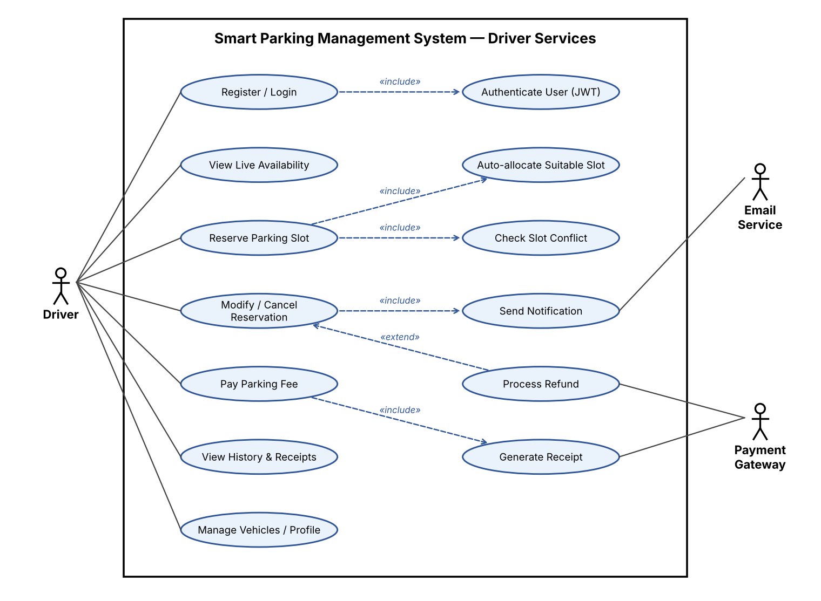
Figure 1: Use-case diagram – Driver services
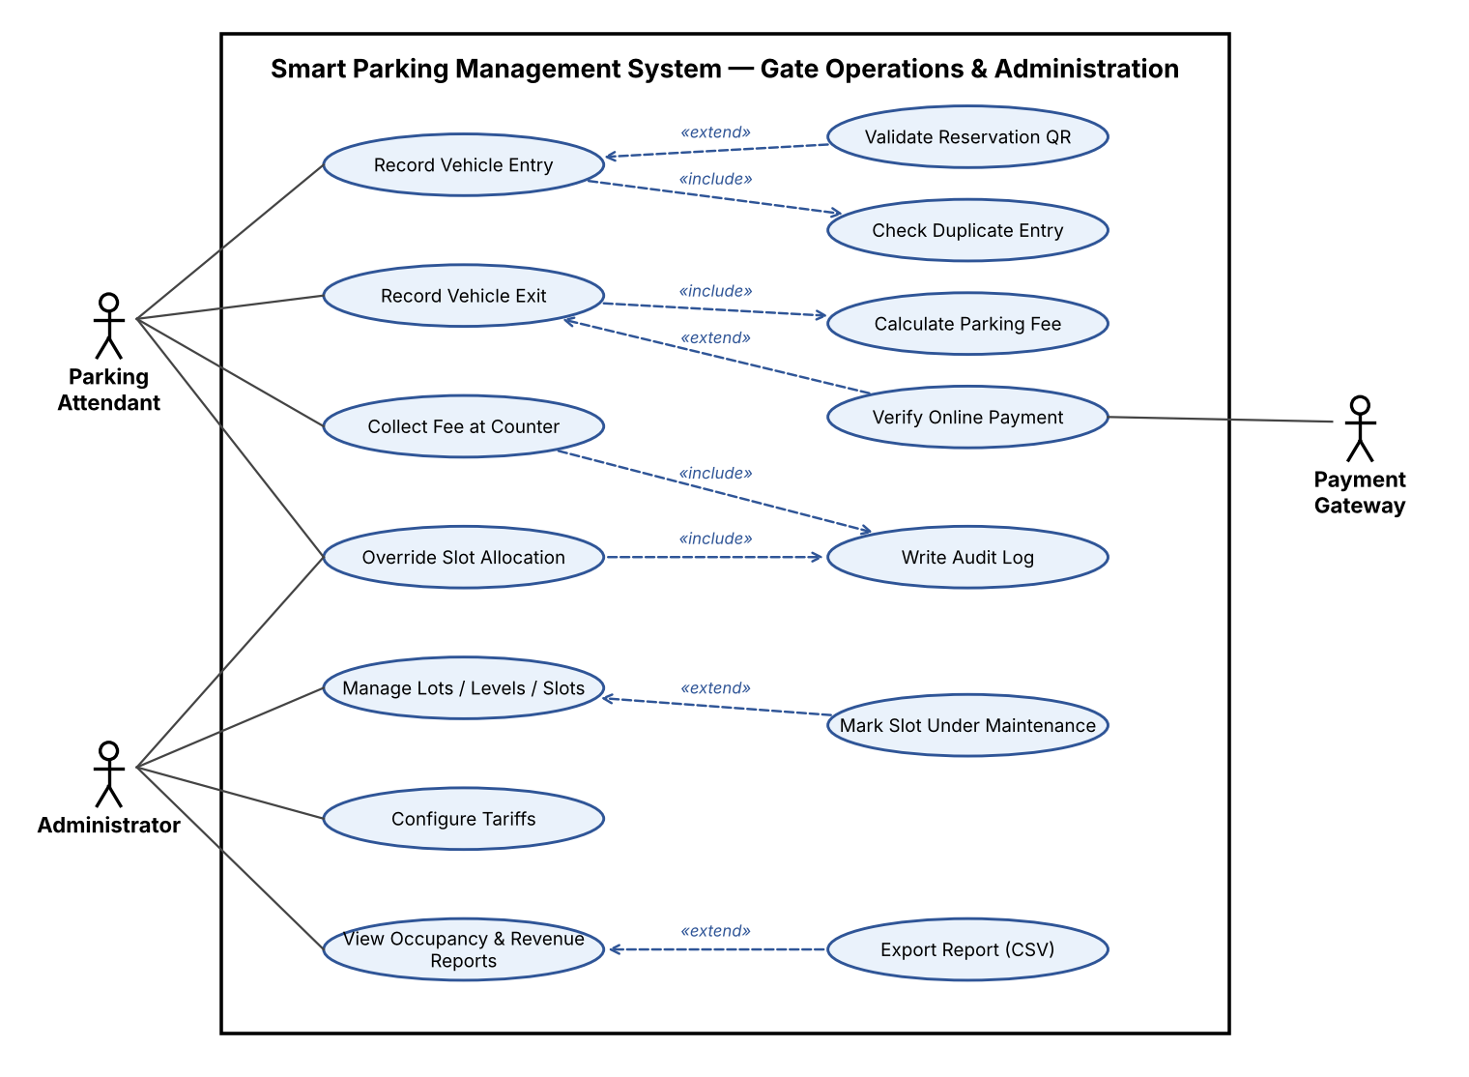
Figure 2: Use-case diagram – Gate operations & administration

8. Requirements Traceability Matrix (RTM)

Req ID | Requirement short | Section ref / Design Spec | Module | Test case(s) | Status (N/P/A) | Comments
SPMS-F-001 | Driver registration | 4.1 / DS-AUTH-01 | Auth & User Service | TC-AUTH-01 | P
SPMS-F-002 | Login & JWT issue | 4.1 / DS-AUTH-01 | Auth & User Service | TC-AUTH-02 | P
SPMS-F-003 | Role-based access control | 4.1 / DS-AUTH-02 | API Router / Auth MW | TC-AUTH-03 | P
SPMS-F-004 | Account lockout after 5 failures | 4.1 / DS-AUTH-01 | Auth & User Service | TC-AUTH-04 | P
SPMS-F-010 | Manage lots / levels / slots | 4.2 / DS-LOT-01 | Lot & Slot Management | TC-LOT-01 | P
SPMS-F-011 | Configure tariffs | 4.2 / DS-LOT-02 | Lot & Slot Management | TC-LOT-02 | P
SPMS-F-012 | Slot maintenance status | 4.2 / DS-LOT-01 | Lot & Slot Management | TC-LOT-03 | P
SPMS-F-020 | Display free-slot counts | 4.3 / DS-AVL-01 | Availability Service | TC-AVL-01 | P
SPMS-F-021 | Live status push ≤ 5 s | 4.3 / DS-AVL-01 | Availability Service | TC-AVL-02 | P
SPMS-F-030 | Reserve a slot | 4.4 / DS-RES-01 | Reservation Service | TC-RES-01 | P
SPMS-F-031 | Prevent double booking | 4.4 / DS-RES-02 | Reservation Service | TC-RES-02 | P
SPMS-F-032 | Modify / cancel with refund | 4.4 / DS-RES-01 | Reservation Service | TC-RES-03 | P
SPMS-F-033 | Auto-release no-shows | 4.4 / DS-RES-03 | Reservation Service | TC-RES-04 | P
SPMS-F-040 | Auto-allocate suitable slot | 4.5 / DS-ALC-01 | Slot Allocation Engine | TC-ALC-01 | P
SPMS-F-041 | Attendant allocation override | 4.5 / DS-ALC-01 | Slot Allocation Engine | TC-ALC-02 | P
SPMS-F-050 | Record vehicle entry | 4.6 / DS-GATE-01 | Entry/Exit Gate Service | TC-GATE-01 | P
SPMS-F-051 | Validate reservation QR | 4.6 / DS-GATE-01 | Entry/Exit Gate Service | TC-GATE-02 | P
SPMS-F-052 | Reject duplicate entry | 4.6 / DS-GATE-01 | Entry/Exit Gate Service | TC-GATE-03 | P
SPMS-F-053 | Record vehicle exit | 4.6 / DS-GATE-02 | Entry/Exit Gate Service | TC-GATE-04 | P
SPMS-F-060 | Fee calculation | 4.7 / DS-PAY-01 | Billing & Payment Service | TC-PAY-01 | P
SPMS-F-061 | Online & cash payment | 4.7 / DS-PAY-02 | Billing & Payment Service | TC-PAY-02 | P
SPMS-F-062 | Digital receipt | 4.7 / DS-PAY-01 | Billing & Payment Service | TC-PAY-03 | P
SPMS-F-063 | Block unpaid exit / waiver | 4.7 / DS-PAY-01 | Billing & Payment Service | TC-PAY-04 | P
SPMS-F-070 | Occupancy & revenue dashboard | 4.8 / DS-RPT-01 | Reporting & Analytics | TC-RPT-01 | P
SPMS-F-071 | CSV export | 4.8 / DS-RPT-01 | Reporting & Analytics | TC-RPT-02 | P
SPMS-F-072 | Email notifications | 4.8 / DS-NOT-01 | Notification Service | TC-NOT-01 | P
SPMS-F-073 | Driver history & receipts | 4.8 / DS-RPT-02 | Reporting & Analytics | TC-HIS-01 | P
SPMS-NF-001 | API response time | 5 / DS-PERF-01 | FastAPI / PostgreSQL | TC-PERF-01 | P
SPMS-NF-002 | Gate transaction time | 5 / DS-PERF-01 | Gate Service | TC-PERF-02 | P
SPMS-NF-003 | Availability & backup | 5 / DS-OPS-01 | Deployment, backups | TC-REL-01 | P
SPMS-NF-004 | Usability & accessibility | 5 / DS-UX-01 | React UI | TC-UX-01 | P
SPMS-NF-005 | Scalability | 5 / DS-PERF-01 | Architecture | TC-PERF-03 | P
SPMS-NF-006 | Maintainability | 5 / DS-OPS-02 | CI (GitHub Actions) | TC-MNT-01 | P
SPMS-SR-001 | TLS 1.2+ everywhere | 5.1.2 / DS-SEC-01 | Cross-cutting | TC-SEC-01 | A | SO-1, SO-2; TLS at the reverse proxy in deployment (deviation D-08)
SPMS-SR-002 | bcrypt password hashing | 5.1.2 / DS-SEC-01 | Cross-cutting | TC-SEC-02 | P | SO-1
SPMS-SR-003 | JWT expiry & revocation | 5.1.2 / DS-SEC-01 | Cross-cutting | TC-SEC-03 | P | SO-1, SO-3
SPMS-SR-004 | Input validation / no SQLi-XSS | 5.1.2 / DS-SEC-01 | Cross-cutting | TC-SEC-04 | P | SO-2
SPMS-SR-005 | No card data; signed webhooks | 5.1.2 / DS-SEC-01 | Cross-cutting | TC-SEC-05 | P | SO-1, SO-2
SPMS-SR-006 | Rate limiting | 5.1.2 / DS-SEC-01 | Cross-cutting | TC-SEC-06 | P | SO-4
SPMS-SR-007 | Append-only audit log | 5.1.2 / DS-SEC-01 | Cross-cutting | TC-SEC-07 | P | SO-3

9. Changes in version 1.1
No requirement was removed or weakened. RTM status legend: N = not yet tested, P = passed in the test cycle of 07-08 Nov 2026, A = accepted with a documented deviation. Implementation choices that differ from the SAD v1.0 (plain HTML/JS pages instead of React, SQLite instead of PostgreSQL, in-process jobs instead of Redis/Celery, mock payment gateway, email outbox) are listed in docs/Deviations.md. SPMS-SR-001 (TLS) is met at deployment; the local demo runs on http://localhost.

