Question 01 : Feature : Customer wants to Apply for Annual Plan membership

Test Case A: SignUp, Loan in and Get Started - Displays

Step 01: User Navigate to the “<https://www.shipt.com/>”

Step 02: Shipt Home page Should display : Expected

Step 03 : Shipt Home page is displayed : Actual

Step 04: User should see “Get Started” button in the middle of the page :Expected

Step 05: “Get Started” button is displayed : Actual

Step 04: User should see “LogIn” button on the top left of the page :Expected

Step 05: User should see “Sign up” button next to “Log in” button :Expected

Step 06: “Login button” and “Sign Up” is displayed :Actual

Step 07: Test Close

TestCase B: Validating Functionality of “Sign up” button

Step 01: User clicks “Sign Up” button

Step 02: “Let’s get started with your membership!” modal should display :Expected

Step 03: “Let’s get started with your membership!” modal is displayed : Actual

Step 04: “Let’s get started with your membership!” modal should have two required field : Expected

Step 05: “Email” and “Zip” field displayed :Actual

Step 06: field reads “ Email” and Zip Code” :Expected

Step 07: “Go” button should display on “Email” and “zip” modal :Expected

Step 08: “Go” button displayed with Green color :Actual

Step 09: User clicks “Go” button without answering “Email” and “Zip Code” field

Step 10: Error message “Please fill out this field” is displayed.

Step 11: User enters “[ABCD@bbbb.com](mailto:ABCD@bbbb.com)” in to the “Email filled”

Step 12: User enters “123456” in to the “Zip Code” field

Step 13: User clicks “Go” button

Step 14: User should see “Try Free for 2 Weeks!” modal

Step 15: “Try Free for 2 Weeks!” modal is displayed

Step 16: Test Close

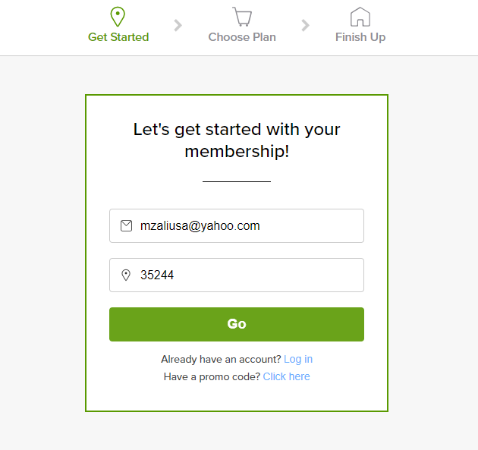

TestCase C: Validating Functionality of “Get started” button

Step 01: User clicks “Get Started” button

Step 02: “Let’s get started with your membership!” modal should display

Step 03: “Let’s get started with your membership!” modal is displayed

Step 04: “Let’s get started with your membership!” modal should have two required field

Step 05: Required field reads “ Email” and Zip Code”

Step 06: User clicks “Go” button without answering “Email” and “Zip Code” field

Step 07: Error message “Please fill out this field” is displayed.

Step 08: User enters “[ABCD@bbbb.com](mailto:ABCD@bbbb.com)” in to the “Email filled”

Step 09: User enters “123456” in to the “Zip Code” field

Step 10: User clicks “Go” button

Step 11: User should see “Try Free for 2 Weeks!” modal

Step 12: “Try Free for 2 Weeks!” modal is displayed

Step 13: Header Color for “Try Free for 2 Weeks!” should be Green

Step 14 Actually Header Color for “Try Free for 2 Weeks!” is Not Green (Step Failed)

Step 15: Test Close

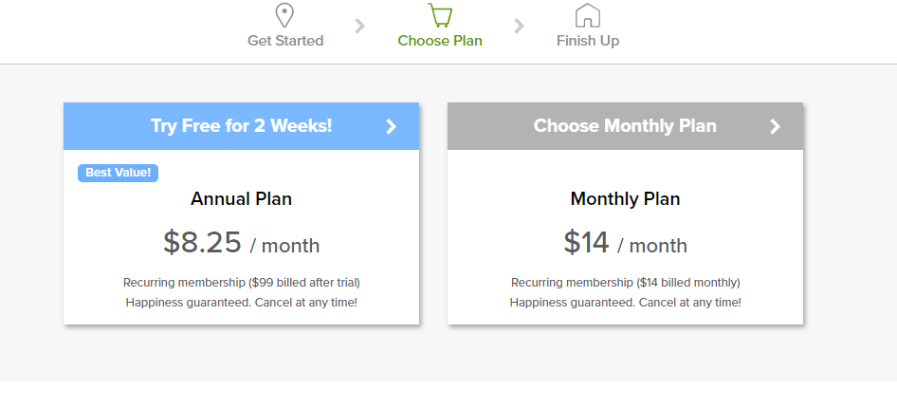

**Questions 2. Locate one bug or bad workflow within the app.**

a. Explain the behavior you are seeing

b. Include any useful errors or screenshots

c. Explain why and how it needs to be corrected

d. What are the steps you would take to report the issue?

e. What priority would you give this bug (Scale of 1-5, 1 being highest) and why?

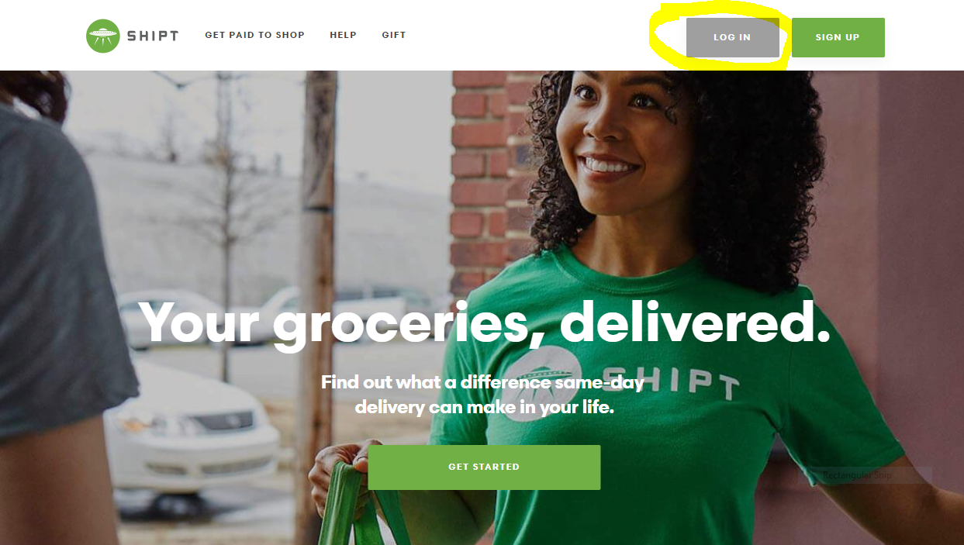

Figure 01

**Explanation:** I Should have a Requirement Document to Verify How those button should looks Like and correct Spelling Should be and also Color should be.

A. Details “Log IN” and “sign up” Both Spelling is wrong and both Buttons Color is not same

B. Screenshot Attached Figure 01 .

C. “Log IN” and “sign up” Both Spelling and Format is not correct Both Buttons Color should be Green or as required

D. Steps for defect creation

Step 01: Navigate to <https://www.shipt.com/>

Step 02: Shipt Home page Should display

Step 03: Look for Login button on the top right

Step 04: Verify the spelling of the “login” button

Step 05: Expected Spelling is “Login”

Step 06: Actual Spelling “LOG IN” is displayed (Step Failed)

Step 07: Expected Button’s Color should be Green

Step 08: Actual color “Gray” is displayed (Step Failed)

Step 09: Test Close

D. Expected Spelling is “Sign Up” and button’s Color should be Green.

Step 01: User Navigate to <https://www.shipt.com/>

Step 02: Shipt Home page Should display

Step 03: Shipt Home page is displayed

Step 04: “Sign Up” button should display on the top Right of the Home Page

Step 05: “Sign Up” button is display on the top Right of the Home Page

Step 06: Expected : “Sign Up” Should display

Step 07: Actually “SIGN UP” is displayed (Step Failed)

Step 08: “Sign Up” button’s color Green is displayed

Step 09: Test Close

**E. This is Hi visible Customer Facing Object , So Priority is 01 (High)**

Screenshot Attached as Shown on Figure 01.

Q 3.

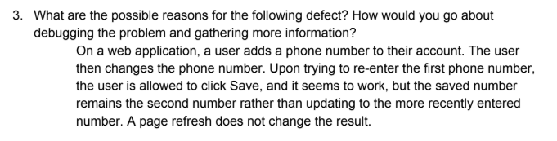

Requirement is not clear to me. What Application or the Phone Number Field Suppose to do

When User Entered or changed the Number.

Requirement is saying First Number, Second Number and most Recent Number.

I would Like to discuss with Product Owner or Business Analyst for more detail : How the the Phone Number field should behave or work.Then I will test or Log defect.

SQL ( I am a Tester and this Question looks like is for Developer)

1.. Store 01 that has allowed_Alcohol boolean

2..Store id 1 Expensive Items are Grape 3.59 , Banana 3.32

3..Product Not Sold in Store_id 2 is “Waysafe”

4.. No Answer

5..

UPDATE *Order_Line*

SET *line_total1* = 3, *line_total2* = *50*, *line_total3* = *1*,*line_total4* = *4*,

WHERE *Product_Id = 1,2,2,3*;

Automation: I have separate file for Automation