NavPulse
AI-ML Intelligent Dead Reckoning for GNSS-Denied Navigation
Proof of Concept Document
Smart India Hackathon 2026 · Problem Statement 26168 (ISRO)
Team Hattori

Contents
1. Executive Summary
2. Problem Statement
3. Solution Architecture
4. Technical Mechanism — Physics, Machine Learning, and Why Each Choice Was Made
5. Quantitative Results
6. Proof of Concept — the Working Android Application
7. User Guide — How to Use the App, Step by Step, with Screenshots
8. Honest Limitations
9. References

1. Executive Summary
NavPulse is a software-only, fully offline dead-reckoning engine that keeps a vehicle's position tracked through a GNSS blackout — a tunnel, an underpass, an urban canyon, a jammed corridor, or a multi-level car park — using only the sensors already present on a consumer smartphone: an accelerometer, a gyroscope, and an offline OpenStreetMap road network. No wheel odometry, no CAN bus access, no dedicated inertial hardware, and zero recurring connectivity cost.
The system is built as four layers, each one solving exactly the failure the layer before it could not: a motion classifier that freezes the position estimate correctly at a stop; a learned speed model that predicts the vehicle's speed second by second during a blackout, replacing the naive assumption that speed never changes; a road-constrained particle filter that carries hundreds of position hypotheses along the real road network, steered by the gyroscope and the learned speed; and a reporting layer that turns the filter's internal, sometimes-conflicting beliefs into one steady, physically plausible position on screen.
On drivers never used to tune any setting, the final engine holds a median path-average drift of 5.9% of distance travelled, with 80–82% of blackouts meeting the 10% industry-style benchmark — up from 73% for the engine's own predecessor stage. On the team's own recordings — a two-wheeler, phone hand-held, on real Tamil Nadu roads with no speed-limit tags in the map at all — 45 of 111 real blackouts meet the same 10% target, and the engine beats the simpler baseline on 85 of 111.
This document is the proof-of-concept record: what the problem is, how the solution works mechanically (with the physics and the machine learning explained, not just claimed), what was measured, and — as a working artifact — a screenshot-by-screenshot guide to using the actual built Android application.

2. Problem Statement
A vehicle's GNSS signal is lost — physically blocked by a tunnel or a dense urban canyon, denied by multi-level parking structures, or deliberately jammed. The phone still has its accelerometer and gyroscope, sampling continuously. The task is to estimate the vehicle's position for the duration of that blackout using only those two sensors plus a static offline road map, and to be back within roughly 10% of the distance actually travelled by the time GNSS returns.

2.1 Why this is hard
- The pitch wall: a smartphone accelerometer cannot separate gravity from real acceleration below a small tilt error. At 60 km/h, a 1 km budget of 100 m demands an accelerometer error under 0.028 m/s² — a tilt error as small as 0.16° already produces a phantom acceleration (g·sin(0.16°) ≈ 0.027 m/s²) at the edge of that budget, before any real vehicle motion is even measured. Confirmed by direct static test, not a datasheet estimate.
- Aliasing: sampling at 10 Hz sets a Nyquist limit of 5 Hz. Wheel and engine vibration cross that frequency above roughly 36 km/h, and above that speed the sensor does not just lose resolution — it misreads the true vibration frequency as a different, wrong one. No formula recovers information destroyed this way.
- No CAN bus or OBD access on a consumer smartphone, so there is no wheel-speed signal to fall back on — every estimate has to come from the IMU and the map alone.
Round 1 of this project established that a plain speed regressor on raw sensor data actually loses to the simplest possible baseline — holding the last known GNSS speed for the whole blackout — which is why every later layer exists to correct exactly the errors that baseline leaves behind, rather than to replace it outright.

3. Solution Architecture
The system branches on one condition at every sensor tick — is a GNSS fix available right now — and everything downstream depends on that branch.

3.1 Inputs
- Accelerometer + gyroscope, phone MEMS IMU — 10 Hz (benchmark dataset) or 248 Hz (native, own recordings)
- GNSS fix, when available, roughly 1 Hz
- Offline OSM road graph, pre-built as a binary adjacency structure with R-tree spatial indexing, under 85 MB for the full Tamil Nadu network (350,308 km) or the England IO-VNBD region

3.2 GNSS available
The raw fix is shown directly as the position. In the background, each phone's own gyroscope axis alignment, scale, and bias are fit by least-squares against this GNSS history, so the correction is ready the moment a blackout begins — this mattered directly: one test phone's gyroscope reported only about 54% of every real turn before this correction.

3.3 GNSS lost — the four-layer dead-reckoning pipeline
- Motion Classifier — a gradient-boosted decision tree (99.4% held-out accuracy) decides stationary vs. moving each tick. When stationary, a zero-velocity update (ZUPT) freezes the estimate so drift does not accumulate while parked or idling.
- Learned Speed Model — when moving, a second gradient-boosted model (HistGradientBoostingRegressor) predicts the current speed from four inputs: vibration spread and jerk from the raw IMU stream, the OSM road class under the current best-guess position, and the speed at the moment the GNSS fix was lost together with how long ago that was. Gated: on roads tagged 60 km/h or faster, held last-known speed is used instead, because it is already close to optimal there.
- Road-Constrained Particle Filter — 500 position hypotheses ('particles') are carried along the road graph, each weighted by how well its turning matches the gyroscope, its road class, and any speed-limit penalty, driven forward using the speed from layer 2, and resampled every tick.
- Reporting Layer — mode hysteresis selects which particle cluster to report, resisting rapid unjustified flips between competing road hypotheses; a speed-limited, direction-aware cursor caps how fast the displayed position can visibly 'catch up,' so a change of belief shows as motion rather than a teleport.

3.4 Output
A single (latitude, longitude, heading) estimate per tick, rendered on the Android app's map (Kotlin, Jetpack Compose, Osmdroid) as a moving cursor, with a live GNSS OK / GNSS LOST indicator and a re-centre control, in both a live sensor mode and an offline replay mode against recorded test drives.

3.5 Architecture diagram
GNSS-OK branch → raw fix shown directly, background gyro calibration.
GNSS-LOST branch → Layer 1 (Motion Classifier) → Layer 2 (Learned Speed Model) → Layer 3 (Particle Filter, 500 hypotheses on the OSM graph) → Layer 4 (Reporting: hysteresis + speed-limited cursor).
Both branches converge on the Android UI.

4. Technical Mechanism — Physics, Machine Learning, and Why Each Choice Was Made

4.1 Three physics formulas tried first, and why each failed
Before any learned component was built, three closed-form physics formulas were tried to estimate speed during a blackout, each a single fixed equation applied identically in every situation:
Approach | Formula | Measured result
Integrate accelerometer readings | v = ∫ a · dt | Worse than assuming speed never changes, at every time window tested (5 s to 30 s)
Turn-rate division | v = a_lateral ÷ ω | Accurate only on phones that could physically feel a corner — useless on 2 of 4 test phones
Map curvature | v = ω ÷ κ_road | Map curvature vs. real vehicle curvature: r = 0.22 — too weak a relationship to invert

All three share the same shape: one input, one smooth proportional relationship, trusted equally everywhere. The reason all three failed is physical, not a tuning shortfall — explained next.

4.2 The aliasing mechanism, with a real measured example
Sampling at 10 Hz sets the Nyquist limit at 5 Hz. Wheel rotation frequency is proportional to speed divided by wheel circumference, and it crosses 5 Hz at approximately 36 km/h. Above that speed, the true vibration frequency is not merely degraded — it is folded back (aliased) onto a different, incorrect frequency. This was measured directly on a real 69 km/h recording window, not assumed:
Quantity | True value (248 Hz) | 10 Hz-binned reading | Error
Frequency | 5.49 Hz | 3.68 Hz | 33% wrong
Magnitude (std) | 1.445 m/s² | 0.583 m/s² | 60% lost

The 10 Hz pipeline also mean-bins every 100 ms, which stacks an additional low-pass-filter attenuation on top of the aliasing itself — the two effects compound rather than being the same effect described twice.

4.3 The shift from a smooth formula to a step function
The insight that broke the deadlock: even though the aliased frequency reading is numerically wrong, the overall vibration magnitude still climbs in the correct direction as true speed increases — corrupted in exact value, but monotonic in ranking. A smooth formula trusts the exact numeric value everywhere and is therefore fooled by a single pothole jolt reading as 'very high speed.' A decision tree only asks whether a value is above or below a learned threshold, so it can exploit a monotonic-but-corrupted signal without being misled by its exact magnitude. This is why the adopted model is a gradient-boosted tree ensemble — a structure that is a step function by construction — and not a smooth regression.
This was measured directly by grouping real training rows into buckets per input feature and reading the model's actual predictions:

Vertical vibration spread → predicted speed
Vibration level | Raw sensor range | Model predicts
Very low (stationary/idling) | 0.02 – 0.25 | ~8 km/h
Low (just moving) | 0.25 – 0.38 | ~39 km/h
Medium | 0.38 – 0.49 | ~49 km/h
High | 0.49 – 0.65 | ~54 km/h
Very high | 0.65 – 17.80 | ~53 km/h (plateau)

Jerk (sudden acceleration change) → predicted speed
Jerk level | Model predicts
Very low | ~8 km/h
Low | ~42 km/h
Medium | ~50 km/h
High | ~51 km/h
Very high | ~50 km/h (plateau)

Map speed-limit tag → predicted speed
Tagged road limit (km/h) | Model predicts
2 – 13 (residential-ish) | ~30 km/h
13 – 18 | ~42 km/h
18 – 22 | ~60 km/h
22 – 31 (dual carriageway / motorway) | ~71 km/h

Last known GPS speed → predicted speed 30–90 s later
Speed at the fix | Model predicts later
0 – 14 km/h | ~25 km/h
14 – 32 | ~31 km/h
32 – 45 | ~37 km/h
45 – 59 | ~43 km/h
59+ | ~66 km/h

Reading across all four tables: the first two (raw sensor statistics) both show a steep-climb-then-plateau shape, the direct signature of sensor noise and aliasing damage — the model stops trusting the exact magnitude past a point. The third (a clean map tag) is closest to a straight line, because it never touched the accelerometer at all. The fourth shows the model's own discovered 'regression to the mean': v(60 s) ≈ 0.59 × v₀ + 5.6 — extreme starting speeds are predicted to move back toward a typical pace. This relationship was not hand-coded; it emerged from the training data's own structure.

4.4 Why gradient-boosted trees, and explicitly not a neural network
The model used throughout this project — both round 1's motion classifier and round 3's speed model — is a HistGradientBoosting model: several hundred shallow decision trees (depth 6), built sequentially, where each new tree is trained on the residual error left by every tree before it, so the ensemble progressively corrects its own mistakes. At each split, a tree asks a single yes/no threshold question on one input at a time, and splits are nested, so a feature's effect changes depending on what has already been asked (a given jerk value predicts a different speed on a motorway split than on a residential-road split).
There is no neural network anywhere in this pipeline — no layers, no neurons, no backpropagation. That architecture was deliberately not used, for two measured reasons: the true feature-to-speed relationships are step-shaped, not smooth (§4.3), so a model that is a step function by construction matches the actual shape of the data rather than fighting it; and the available training data (19–40 km of driving) is far too small to fit a neural network's typical parameter count without overfitting, whereas a shallow boosted-tree ensemble is well matched to a dataset this size.

4.5 How the four inputs combine
The four inputs are combined jointly by the tree structure, not averaged or summed as independent correction terms: v̂ = f(vibration_bucket, jerk_bucket, road_class, v_last_fix), where map and last-known-speed context change which vibration/jerk threshold actually gets applied, rather than being added on afterward as a separate correction. The trained model is evaluated purely as a forward pass — a fixed sequence of threshold checks — so no training happens on-device and inference cost is negligible next to the particle filter's own per-cycle cost.

4.6 How the speed model plugs into the particle filter
The learned speed prediction becomes a per-tick target that every particle's velocity state drifts toward, rather than replacing the filter's own weighting logic. Particles are still scored primarily by gyroscope-vs-road-bearing agreement; the speed model only supplies how far each particle should advance along its current road segment on a given tick. This keeps the map-matching mechanism (which decided round 2's success) fully intact while fixing only the along-track distance error that round 2 could not.

4.7 Why gating is necessary (mixture of experts)
The learned model is not universally better than simply holding the last known GNSS speed. On roads tagged 60 km/h or faster, held speed already performs close to optimally, and only around 6% of the training data covers that speed range — the model has too little evidence there to be trusted over the simpler baseline. The engine therefore gates explicitly: hold last-known speed on fast, tagged roads; use the learned model everywhere else. This is a measured mixture-of-experts decision, not an assumption — an oracle test of a perfect chooser between the two methods tops out at 78% of blackouts under 10%, only 8 points above simply always using the learned model (70%), and that remaining gap was shown to be fundamentally unpredictable in advance from any information available at the moment GNSS is lost.

4.8 Why individual test clips cannot be used to tune settings
Across the tuning set, small filter-setting changes move the overall (aggregate) result by roughly 0.3 percentage points, but flip approximately 5% of individual blackouts across the pass/fail line. One real blackout scored anywhere from 3.3% to 26.7% across four otherwise-reasonable configurations, because that specific moment sits on a genuine coin-flip between two roads the map cannot disambiguate. Every setting in this project was therefore chosen using the aggregate result across hundreds of blackouts on tuning drivers only (A and B), frozen, and then applied exactly once, unmodified, to drivers never used for tuning (D and E).

5. Quantitative Results
All numbers below are measured on drivers never used to choose any filter, gate, or model setting, scored by the error averaged along the entire blackout path — not only at the finish line, a metric switch made after finding the end-point score could hide a cursor that wandered badly off-route mid-blackout and happened to be close again by the end.
Metric | Predecessor engine | Final engine
Path drift, median | 7.0% | 5.9% (5.8% with the speed-model gate)
Blackouts meeting the 10% target | 73% | 80–82%
Worst moment in a blackout, median | 16.3% | 13.0–13.1%
Blackouts that leave the driven road | 45% | ~28–29%
Cursor jumping between roads | 71% of blackouts | 5%
Slow driving (under 40 km/h), path median | 10.6% | 8.2%
Speed MAE | 6.09 m/s | 3.15 m/s (−48%)

With the true speed substituted (an oracle test, not achievable in deployment), the same engine scores 2.5–3% — this is the theoretical floor, and the gap between it and 5.9% is almost entirely residual speed uncertainty, not a flaw in the map matching or the reporting layer.

5.1 Path-drift distribution, test drivers
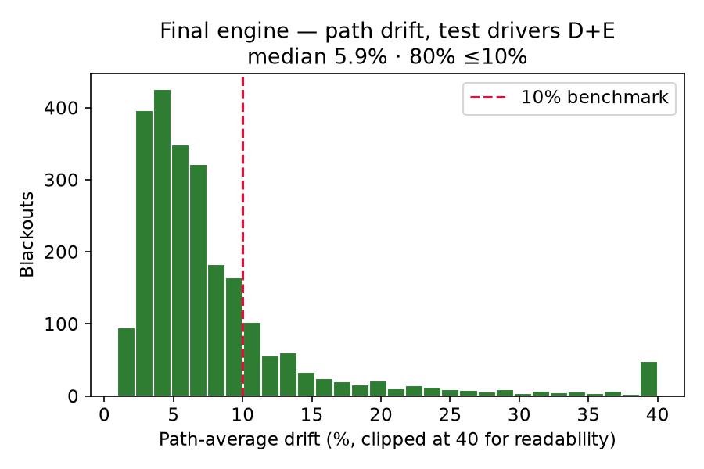
Path-average drift across 2,421 test blackouts (drivers D and E, never used for tuning). Median 5.9%, 80% of blackouts under the 10% benchmark line.

5.2 Learned speed model vs. held last-known speed, by riding condition
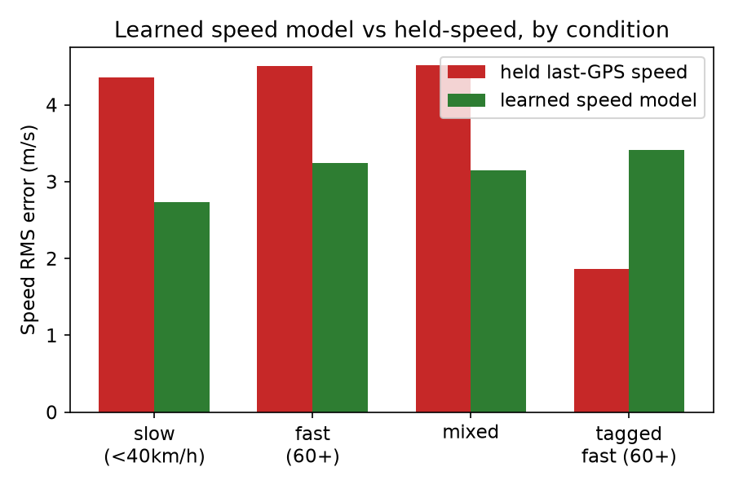
The learned model reduces speed RMS error in 3 of 4 conditions — most on slow, stop-start driving (4.35 → 2.73 m/s). On roads tagged 60 km/h or faster, held speed is already near-optimal (1.86 m/s) and the model is measurably worse there (3.41 m/s); this is exactly the evidence the engine's gating rule uses to decide when to trust the model and when not to — a mixture-of-experts decision made from measured data, not assumed.

5.3 Validation on the team's own India recordings (Tiruchirappalli)
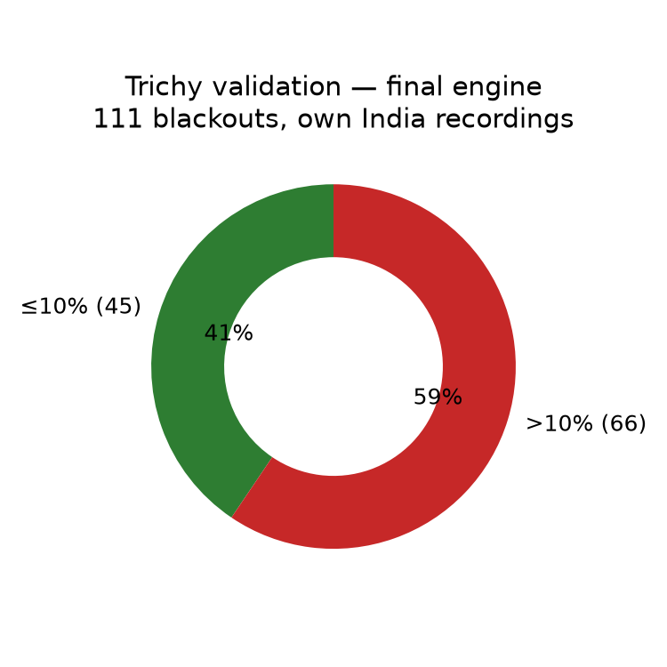
111 real blackouts recorded on a two-wheeler, phone hand-held, at 248 Hz, on Tamil Nadu roads carrying no speed-limit tags at all. 45 of 111 (41%) meet the 10% benchmark; the engine beats the simpler baseline on 85 of 111.
By riding condition, the gain concentrates exactly where Indian traffic conditions are hardest for a held-speed approach: under 40 km/h, median error improves from 27.5% to 14.7%. Eight consecutive, non-overlapping kilometres of one ride, scored by a model trained only on the return leg of a separate ride, average 6.5% with seven of eight legs under the benchmark.

6. Proof of Concept — the Working Android Application
The engine described above is not a notebook exercise — it is compiled into a working Android application (package com.sih2026.nav), built with Kotlin and Jetpack Compose, using Osmdroid for the map view. The app runs in two modes:
- Live ML Engine mode — reads the phone's live accelerometer, gyroscope, and GNSS, runs the full four-layer pipeline in real time, and shows the current position estimate together with a GNSS OK / GNSS LOST status badge.
- Replay Dataset Clips mode — replays pre-recorded test drives (IO-VNBD drivers A, B, D, E, and the team's own Tiruchirappalli recordings) through the same engine, so a blackout's true track, the engine's estimate, and a no-map baseline can all be compared on screen, with live drift percentages.
All screenshots in Section 7 below were captured directly from this build, running on a physical Android device, during this document's preparation — not mockups.

7. User Guide — How to Use the App, Step by Step, with Screenshots

Step 1 — Launch the app
On opening, the app defaults to Replay mode with a pre-selected dataset clip. The top bar shows which driver and clip is loaded, the current GNSS status (OK / LOST), and a settings icon (the sliders symbol, top right) that opens the engine and dataset configuration sheet. The bottom panel shows live drift-with-map, drift-without-map, and distance-driven readouts, plus Play, Restart, playback-speed, and No-Map-toggle controls.
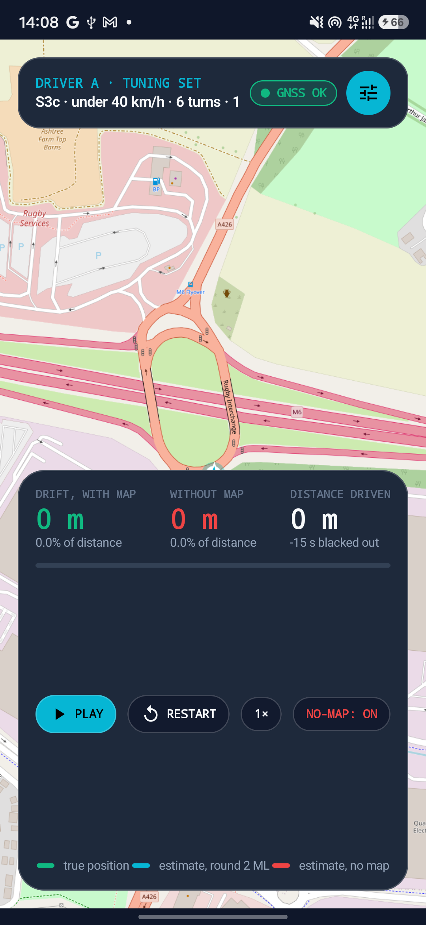
Screenshot 1 — app on launch, Replay mode, Driver A tuning clip loaded, ready to play.

Step 2 — Open the configuration sheet to choose a mode or a clip
Tapping the sliders icon opens the Engine and Dataset Configuration sheet. From here the user switches between 'Replay Dataset Clips' and 'Live ML Engine', and — in replay mode — picks which recorded driver to load (Driver A, B, D, E for IO-VNBD, plus the team's own Trichy recordings). Each available clip is listed with its average speed, number of turns, duration, and its measured drift percentage with and without the map, colour-coded green under the 10% benchmark.
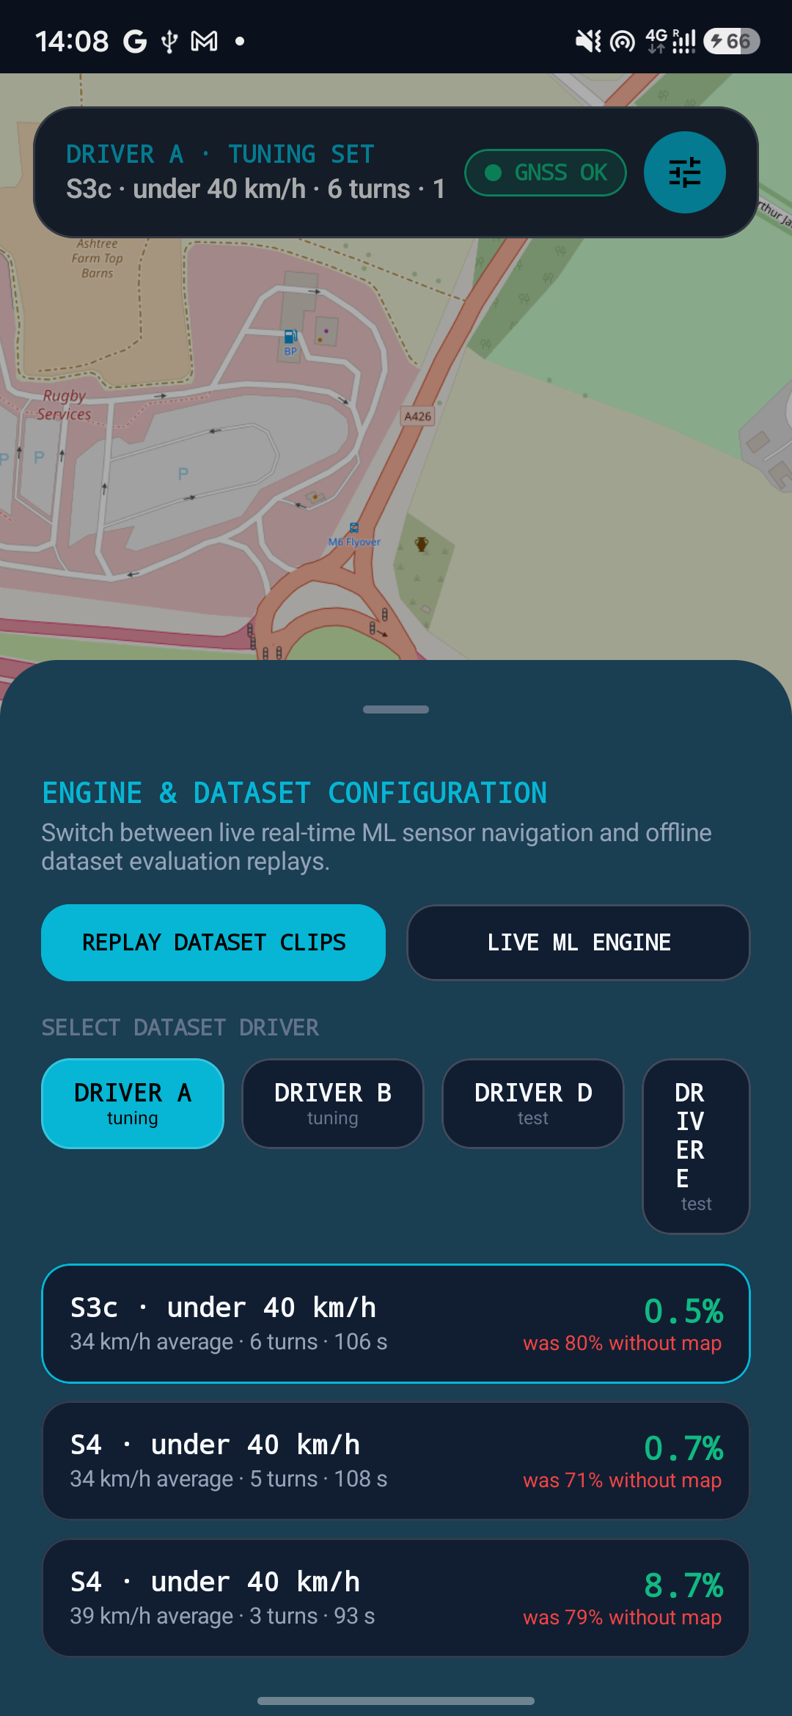
Screenshot 2 — the configuration sheet: mode toggle, driver selector, and the clip list with live scores.

Step 3 — Play a clip and watch the blackout begin
Selecting a clip and pressing Play starts the replay. The true recorded track draws in green as the vehicle moves; while GNSS is available, the engine's own estimate tracks it closely. The bottom panel's Pause button confirms playback is running, and the drift readouts update live.
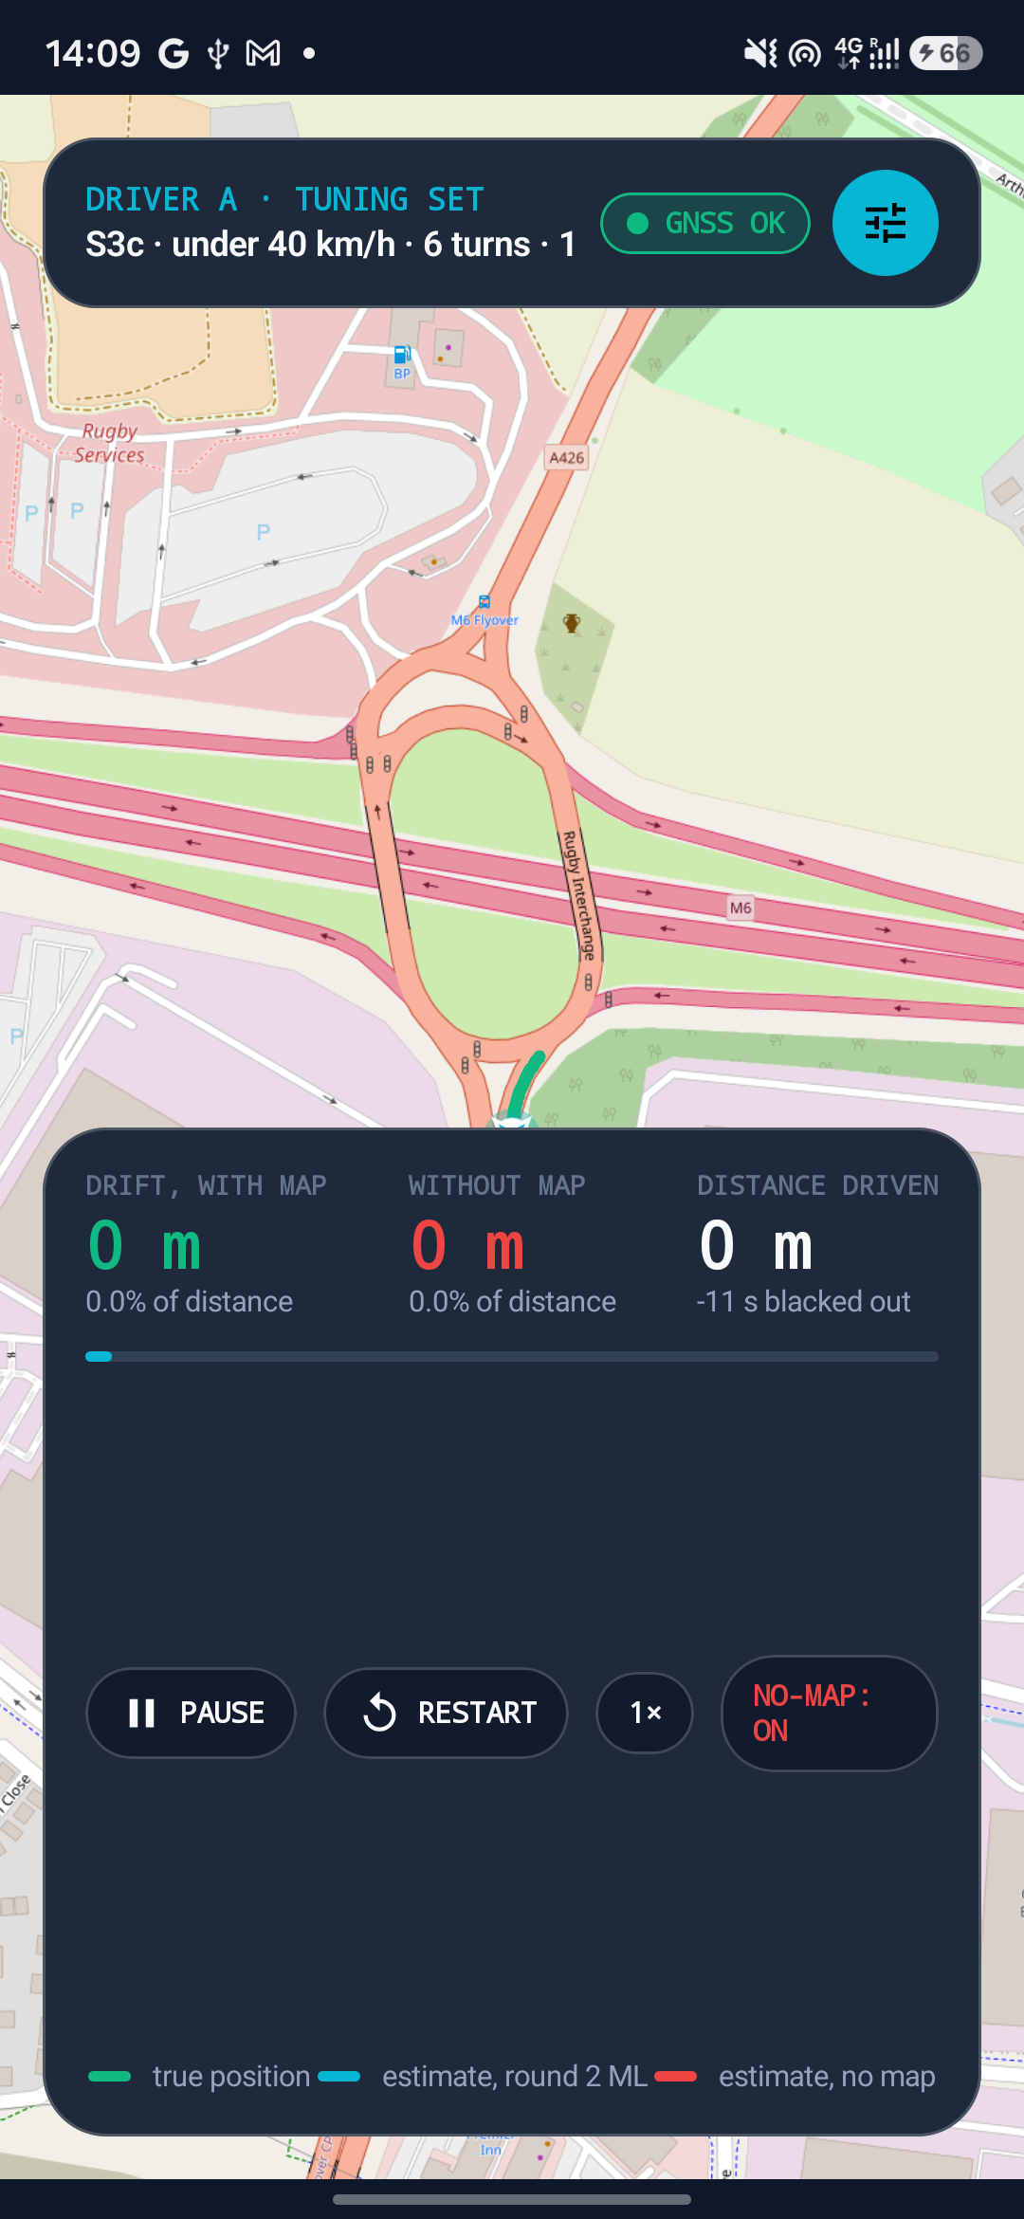
Screenshot 3 — a clip in progress, GNSS still available, true track building on the map.

Step 4 — Observe the engine during a GNSS blackout
When the recorded GNSS signal drops (simulating a tunnel or jammed corridor), the top badge switches to GNSS LOST in red, and the dead-reckoning pipeline takes over. The map shows the true position (green) against the engine's live estimate (blue), with the drift-with-map and drift-without-map percentages updating every tick, alongside the distance driven and seconds blacked out.
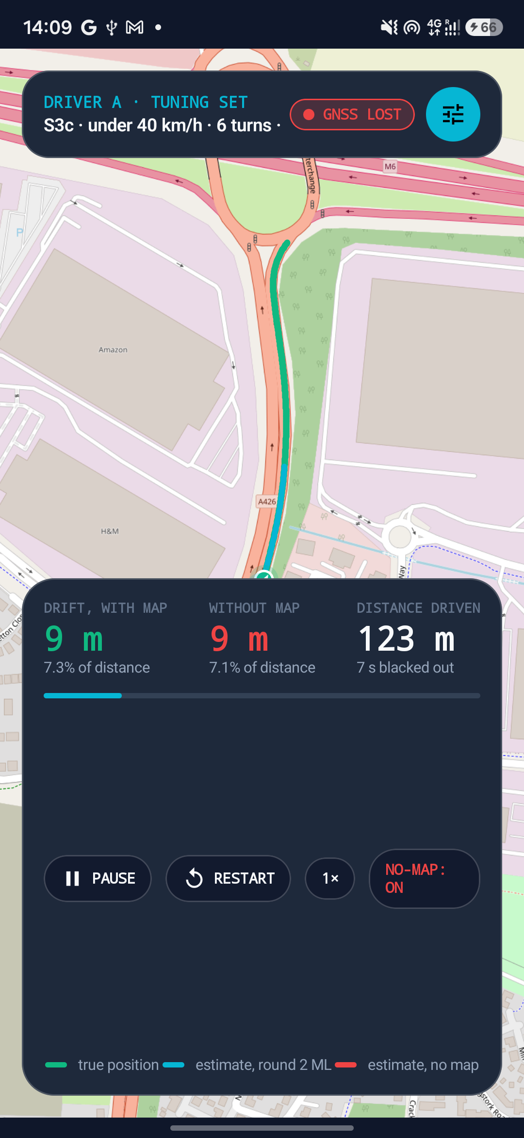
Screenshot 4 — mid-blackout: GNSS LOST shown live, the engine's estimate (blue) tracking closely behind the true path (green), drift at 7.3% of distance with 7 seconds into the blackout.

Step 5 — Switch to Live ML Engine mode for real-time navigation
Selecting 'Live ML Engine' in the configuration sheet switches the app to use the phone's own live sensors instead of a recorded clip. The top bar now shows the current classifier state (e.g. STATIONARY or MOVING) directly from the round-1 motion classifier, and the map centres on the phone's live position, ready to carry through an actual GNSS loss exactly as it would in the field.
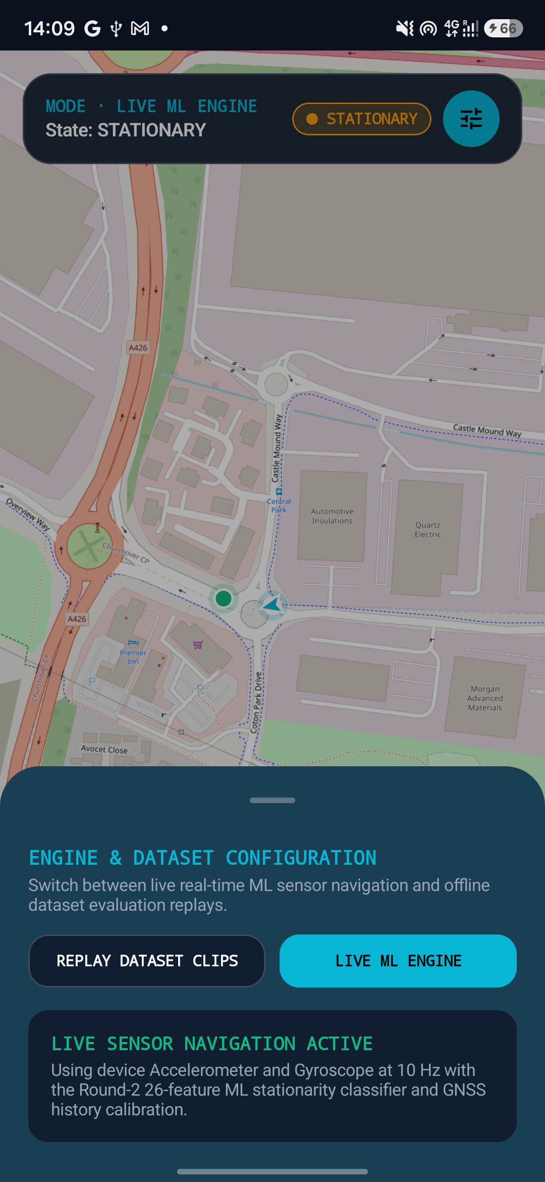
Screenshot 5 — Live ML Engine mode active: live GNSS position, classifier reporting STATIONARY, using the device's own accelerometer and gyroscope at 10 Hz with the round-2 26-feature stationarity classifier and GNSS-history gyro calibration.

Step 6 — Interpret the result
Once GNSS returns (in replay mode) or once the user reaches a location with signal again (in live mode), the drift readouts settle to their final value for that blackout — the number to compare against the 10% benchmark discussed throughout this document. The 'without map' baseline stays visible throughout so the value the road network and learned speed model are adding is visible directly on screen, not just in an offline report.

8. Honest Limitations
- The remaining error is a speed problem, not a mapping problem. With true speed substituted, the same engine scores 2.5–3%; the 5.9% actually achieved is almost entirely residual speed-prediction uncertainty.
- Two distinct failure modes remain: a vehicle accelerating hard immediately after GNSS is lost (the model, trained mostly on typical driving, under-predicts this until it sees the new vibration signature), and the filter occasionally locking onto the wrong parallel road at a sparse junction — a map-matching limitation that even a perfect speed input cannot fully correct on its own.
- The gap between the achieved result and a theoretical perfect chooser between the engine's own internal methods is about eight percentage points, and this gap was shown to be fundamentally unpredictable in advance from any information available at the moment GNSS is lost — not a limitation of modelling effort.
- Self-mapped, unofficial road landmarks (e.g. speed breakers detected from repeated passes rather than official map data) are a promising but unproven idea — a control test showed most apparent matches were coincidence, and this is flagged honestly as not a working feature.
- No working stop detector currently exists for a two-wheeler specifically — the motion classifier was trained on car data, and this is a known gap for the two-wheeler deployment case.
- Validation on Indian roads covers one corridor, recorded on one day, with a hand-held phone — a real, useful, out-of-dataset validation, but not yet a claim of generalisation across road types or vehicles beyond that corridor.

9. References

9.1 Literature
- Groves, P. D. (2013). Principles of GNSS, Inertial, and Multisensor Integrated Navigation Systems. Artech House.
- Newson, P., & Krumm, J. (2009). Hidden Markov Map Matching Through Noise and Sparseness. ACM SIGSPATIAL GIS.
- Skog, I., & Händel, P. (2010). Zero-Velocity Detection — An Algorithm Evaluation. IEEE Transactions on Biomedical Engineering.
- Gustafsson, F., et al. (2002). Particle Filters for Positioning, Navigation, and Tracking. IEEE Transactions on Signal Processing.

9.2 Datasets
- IO-VNBD — Inertial/Odometry Vehicle Navigation Benchmark Dataset, England, multiple drivers, car, 10 Hz IMU.
- Team's own recordings — Tiruchirappalli, Tamil Nadu, two-wheeler, hand-held phone, 248 Hz IMU, 1 Hz GNSS, 17 September 2026.
- OpenStreetMap contributors — road network data for Tamil Nadu and the England test region, via the Overpass API.

9.3 Project documentation
Topic | File
Full top-to-bottom project summary | FINAL_SOLUTION.md
Complete numbered history of every measured step | EXECUTION_LOG.md
Four-layer architecture in depth | ENGINE_LAYERS.md
Learned speed model, full technical mechanism | ROUND3_REPORT.md
Learned speed model explained in plain terms, worked examples | ROUND3_THEORY.md
Results on the team's own recordings | TRICHY_REPORT.md (local only)

