**Ansible**

* **What is Ansible?**

It is a configuration management tool... With automation

* **What is configuration management tool?**

It maintain number (100 and 1000's) of machines with automation

**What it maintain?**

* Maintain the system resources such as
* Install an application
* Configuration
* Updates
* Maintain and so a...
* **Why configuration management tool?**
* Reduce the management complexity.
* Save time.
* Infrastructure as a code:
* -with the code we can manage the infrastructure.
* -reusable
* **How Ansible work?**

Ansible work based on push mechanism, push based means here server (master) will push the code in to the nodes (slaves).

* **How the master communicate with the slaves?**
* With Ssh public key& private key they communicate.

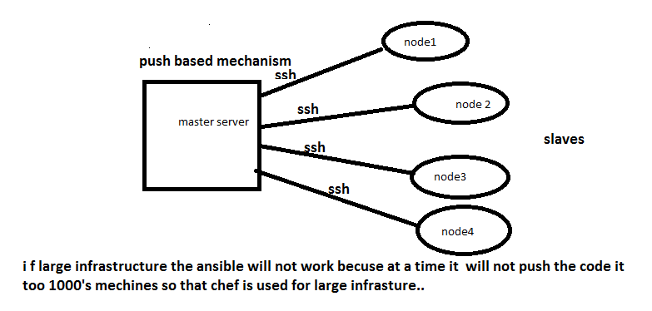

* **Configuration management tools**
* puppet--2005
* chef--2008
* Ansible—2011 (push operation)
* **How to install Ansible?**
* **2 ways to install**

1. Pip install Ansible --it is a python module

2. Yum install Ansible -- before that you can install epel-release and enable it

* Create the master user private and public key.
* Then please the master public key in "authorized-key" file.
* Cat id-rsa.pub>>authorized- keys
* Then copy key to nodes
* ssh-copy-id root@ (nodeip)
* Set nodes in master (vi/etc/ansible/hosts) file
* [Webserver]
* host1 web1 = nodeip
* host2 web2= nodeip2
* **We can work with ansible in two ways**

1. Playbooks --all tasks place in one .yml file and run it
2. Ad.hoc (on the command line we perform this

**Perform some commands:**

ansible -m ping (node)

ansible -m shell -a "yum -y install httpd" (node)

ansible --version

ssh-keygen -to generate public and private key to ssh

Ip a -to know ip

ssh-copy-id root@192.168.43.18 (nodeip)

Install web server

ansible -m shell -a "yum install httpd -y" webserver (node)

ansible -m shell -a "systemctl start httpd" webserver (node)

ansible -m service -a "name=httpd state=started" webserver

**Ansible adv.**

It has galaxy mans predefined playbooks

* **Ansible playbook:**

Playbook is a set of instructions file. To do a particular tasks on target (host) or group of target (hosts)...

* **How playbook works**

Play book works with a modules (yum, service, file, etc...), and inventory file (etc/ansible/hosts) over ssh communication.

* **What we need to run play book**

We need to specify target, tasks in play book with modules (yum, file, etc...)

* **How playbook starts**

**- Name:** simple playbook

**Hosts:** target host or hosts name specified in /etc/ansible/hosts

**Tasks:**

- **Name:**

Ansible role:

-place the group of playbooks in one file. It will help reduce the code complexity, and increase the code reusability.

Ansible-galaxy init lamp (Linux apache MySQL php)

tree /lamp