University of Málaga
Health Engineering

Assigment

Search and Logic

Author

Alejandro Domínguez Recio

Course

Intelligent Systems

Teachers

Enrique Domínguez Merino

Jesús de Benito Picazo

Content

- Part 1

Search (A*). Design a search problem to apply step by step the studied A* algorithm, the solution length should have at least three steps.

Description of the problem
We are going to find the minimum path that joins a series of points applying the A* algorithm.
The distance between the points is given in the following table.

 | A | B | C | D | E | F | G | H
A |  | 6 |  |  | 9
B |  |  | 5 | 10
C |  |  |  | 7 |  | 6
D |  |  |  |  | 2
E |  |  |  |  |  | 17 | 9
F |  |  |  |  |  |  | 10 | 5
G |  |  |  |  |  |  |  | 8
H

For this exercise we will calculate the distance between A and H.
Due to the characteristics of the algorithm A* we must calculate a heuristic of the cost of going from any point to H

 | A | B | C | D | E | F | G | H
Distance to H | 4 | 9 | 5 | 7 | 1 | 8 | 5 | 0

Solution

Resulting search tree

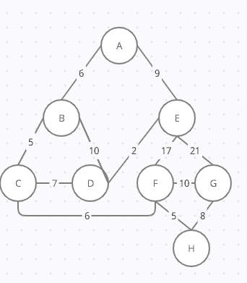

Solution table
f(n) = estimated cost of the cheapest solution through n
g(n) = real path cost from the initial state to the at node n
h(n) = estimated path cost from the state at node n to a goal state

Selected node | Successor g +h = f | Closing order
A | B = 6+9 = 15  E = 9+1 = 10 | (2)  (1)
E | F = (9+17)+8 = 34  G =(9+21)+9 = 39 | (Better for C)
B | C = (6+5)+6 = 17  D = (6+10)+7 = 23 | (3)
C | D = (6+5+7)+7 = 26  F = (6+5+6)+8 = 25 | (Better for B)  (4)
F | H = (6+5+6+5)+8 = 30  G = (6+5+6+10)+9 = 36 | (5)
H | Objetive | Cost 30

- Part 2

Propositional logic. Create a knowledge base with at least 4 sentences and a conclusion (inference), then apply the resolution algorithm step by step.

1.- You can only enter the club if you are over 18 years old or have an authorization from your parents. But since you are not 18 years old and you do not have authorization from your parents, you cannot enter.

2.- Today there is fish or seafood for dinner. But if we arrive after 10 we eat fish. It's after 10 o'clock. We eat fish.

3.- Climate change will not stop if we continue to use fossil fuels. Stop consuming fossil fuels has to be a decision of East and West. If one of the two does not agree, it is not possible to stop consuming fossil fuels. It has been possible to stop consuming fossil fuels. East and West have agreed.

4.- The dog has to be in the yard or on the street. If Juan is in the patio having a barbecue, the dog is in the patio. Juan is in the patio having a barbecue. The dog is in the yard.

- Part 3
First order logic. Translate at least 4 sentences from natural language to the first order logic. Every cuantifier and operator must be used at least once in the set of sentences.

1.- All university students start the course in October.
The students party when they start the course.
Pepe is a student.
Therefore Pepe goes out partying in October

2.- If a doctor suspects that you are infected, they do a COVID test.
Manuel is a doctor.
Pepe has not been tested.
Therefore, Manuel does not suspect that Manuel is infected.

3.- Any vehicle that does not have a driver is a self-driving car.
The Toyota or the Honda is a self-driving car.
Toyota is a car.
Honda is a car.
The Honda has no driver.
The Honda is a self-driving car.

4.- All good movies are rewarded.
A bad movie cannot be in Vialia and Plaza Mayor.
SpiderMan is a movie.
SpiderMan is in Plaza Mayor and in Vialia
SpiderMan is a good movie and awarded

