University of Málaga
Health Engineering

Laboratory Task

Decision Trees

Author

Alejandro Dominguez Recio

Course

Intelligent Systems

Teachers

Enrique Domínguez Merino

Jesús de Benito Picazo

Introduction

In this practice we going to evaluate three diferents dataset with the classifier J48. To evaluate which dataset is more optimal with this classifier we going to describe the performance measures see in class like confusion matrix, acurracy, precision, fallout, recall, F-measure and area under ROC curve. Also we going to detail the characteristics of the different datasets and structure of the generated trees.

How are we going to do it?

To do the different studies we will have the following structure in each of then.

- Dataset context
In this part we going to write a little introduction of the dataset context commenting on data type and prediction target.
- Number of classes
We going to describe the number of classes as if it is binary o multiclass. To do that we going to observe the atributtes weka panel and we going to select the class attribute and depending on the number of values that it takes, we will determine if it is binary or multiclass.
- Number of attributes
For the number of attributes we going to inspect the weka attributes panel or open the file in text mode and inspect the characteristics.
- Number of samples or instances
To know the number of samples we can proceed as in the previous section by inspecting the weka panels or opening the document in text mode and seeing its characteristics.

  - Values of permance measures

Accuracy
We can obtain the acurracy in two ways, one of them is directly from the classifier out and the another one is by calculating the number of correctly predicted examples divided by the number of examples.
Precision
This measurement shows the positive predictive value, higher is bettter. We are going to obtain the necessary values from the confusion matrix and perform the following calculation TP/(TP+FP).
Fallout
This measurement shows the false positive rate, lower is better. We are going to obtain the necessary values from the confusion matrix and perform the following calculation FP/(FP+TN).
Recall
This measurement shows the true positive rate, higher is better. We are going to obtain the necessary values from the confusion matrix and perform the following calculation TP/(TP+FN).
F-measure
This measurement provides a single score that balances both the concers of precision and recall in one number, higher is better. We are going to obtain the necessary values of the previous measurements, precision and recall, and perform the following calculation 2*(Precision*Recall)/(Precision+Recall).

Tree structure
We going to describe the number of leaves and size of the tree. We will obtain these measures from classifier output panel of Weka.

  - ROC curve and the area under the curve
We are going to obtain these measurements visualization the threshold curve in Weka. The area under the ROC curve is a number in the interval [0,1], a higher value is better. This measure show the trade-off between the ratios of false positives and false negatives.

  - Structure of the tree
We are going to show a image of the generated tree, get this from weka.

*The previous points will be repeated for each dataset

  - Evaluation of the results
In this section we are goint to compare the results of the different performance measures.
  - Differences between datasets
Here we are going to describe the main differences in the data of the different datasets.
  - Last conclusions
Finally, we are going explain possible reasons why some datasets perform better with the J48 classifier than others. We will support our conclusions on the performance measures taken and on the characteristics of the datasets

BREAST CANCER DATASET

- Introduction
The main idea of this classification problem is given a dataset about patients with a series of characteristics which determine if they have recurrence events or no recurrence events of breast cancer train a J48 classification model and evaluate its performance.

In this dataset we have 286 instances in total of which 201 of one class and 85 instances of another class. Each instance has ten attributes, one of them is the class attribute. Because of we have only two classes we are faced with a binary classification problem.

- Number of classes
In this case our class attribute can take only two values, recurrence events and no recurrence events. Because of that we are faced to a binary classification problem.

- Number of attributes
In this case we have ten attributes which are class, age, menopause, tumor-size, inv-nodes, node-caps, deg-malig, breast, breast-quad and irradiat.

- Number of samples
In this case in particular the number of samples or instances is 286.

  - Values of permance measures

Confusion Matrix

=== Confusion Matrix ===

a b ← classified as
192 9 | a = no-recurrence-events
62 23 | b = recurrence-events

Accuracy
Correctly Classified Instances 215
Incorrectly Classified Instances 71
Total instances 286
Acurracy = 215/286 = 0,7543
Precision
TP/(TP+FP) = 192/(192+62) = 0,7559%
Fallout
FP/(FP+TN) = 62/(62+23) = 0,7294%
Recall
TP/(TP+FN) = 192/(192+9) = 0,9552%
F-measure
2*(Precision*Recall)/(Precision+Recall) = 2*(0,7559*0,9552)/(0,7559+0,9552) = 0,8439 %
Tree structure
Number of Leaves : 4
Size of the tree : 6

  - ROC curve and the area under the curve

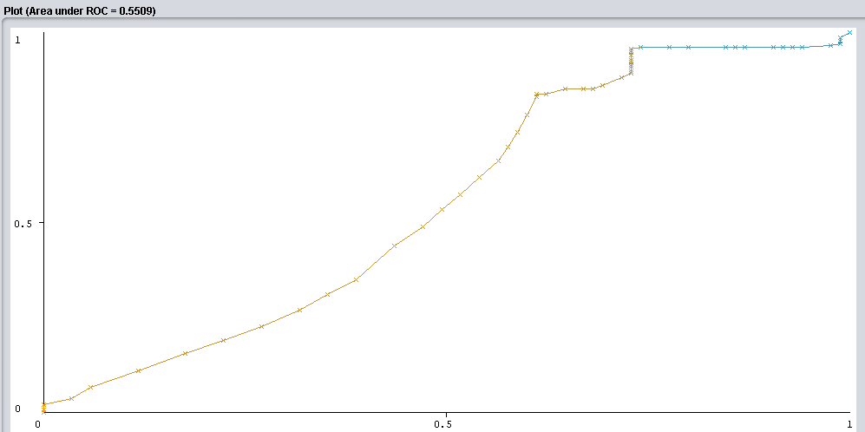Ilustración 1: Graphic ROC Breast Cancer

- Structure of the tree
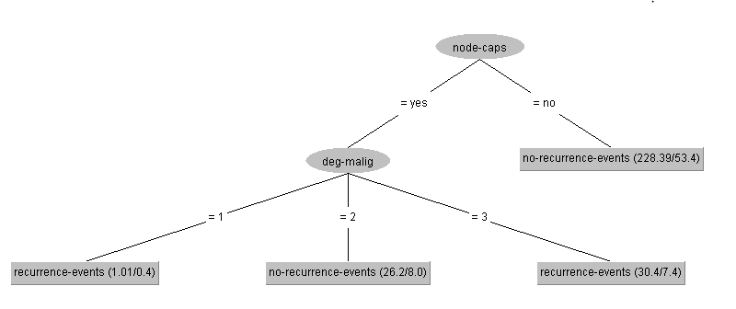Ilustración 2: BreastCancer Tree

HEPATITIS DATASET

- Introduction
The main idea of this classification problem is given a dataset about patients which suffer from hepatitis and they a series of characteristics which determine if they died or live because train a J48 classification model and evaluate its performance.

In this dataset we have 155 instances in total of which 129 of one class and 26 instances of another class. Each instance has 20 attributes, one of them is the class attribute. Because of we have only two classes we are faced with a binary classification problem.

- Number of classes
In this case our class attribute can take only two values, die and live. Because of that we are faced to a binary classification problem.

- Number of attributes
In this case we have twenty attributes which are age, sex, steroid, antivirals, fatigue, malaise, anorexia, liver big, liver firm, spleen palpable, spiders, ascites, varices, bilirubin, alk phosphate, sgot, albumin, protime, histology and class.

- Number of samples
In this case in particular the number of samples or instances is 155.

  - Values of permance measures

Confusion Matrix

=== Confusion Matrix ===

a b ← classified as
15 17| a = die
11 112 | b = live

Accuracy
Correctly Classified Instances 127
Incorrectly Classified Instances 28
Total instances 155
Acurracy = 127/155 = 0,8193%
Precision
TP/(TP+FP) = 15/(15+11) = 0,5769%
Fallout
FP/(FP+TN) = 11/(11+112) = 0,0894%
Recall
TP/(TP+FN) = 15/(15+17) = 0,4687%
F-measure
2*(Precision*Recall)/(Precision+Recall) = 2*(0,5769*0,4687)/(0,5769+0,4687) = 0,5172%

Tree structure
Number of Leaves : 11
Size of the tree : 21

  - ROC curve and the area under the curve

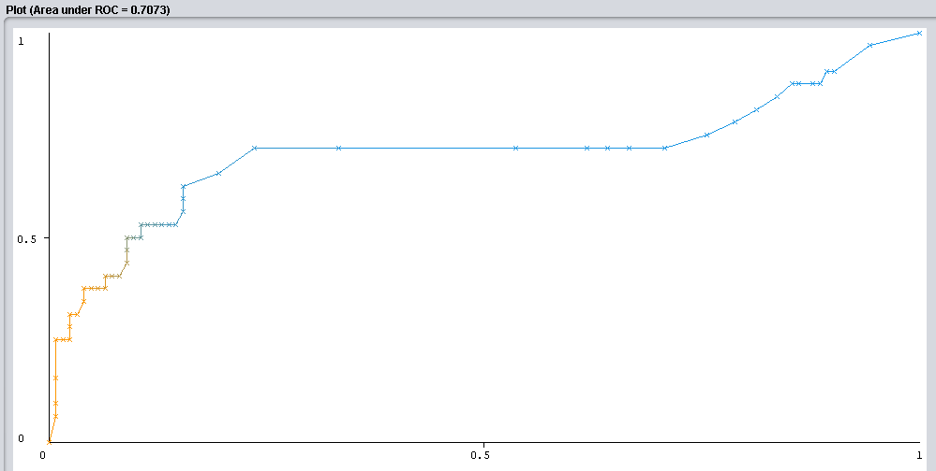Ilustración 3: Graphic ROC Hepatitis

- Tree structure

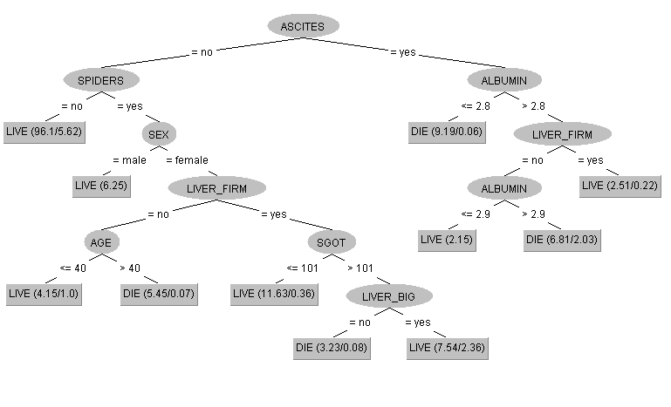

POST-OPERATIVE PATIENTS DATASET

- Introduction
The main idea of this classification problem is given a dataset about patients which have passed an operation and they are in a postoperative recovery area waiting to a decision of where they should be sent next. Depending on a number of temperature measurements we train a J48 classification model and evaluate its performance.

In this dataset we have 90 instances in total of which they are divided in three categories or classes, 2 of class I, 24 of class S and 64 of class A. Each instance has 9 attributes, one of them is the class attribute. Because of we have three possible classes we are faced with a multiclass classification problem.

- Number of classes
In this case our class attribute can take only three values, I, S and A. Because of that we are faced to a multiclass classification problem.

- Number of attributes
In this case we have nine attributes which l-core, l-surf, l-02, l-bp, surf-stbl, core-stbl, bp-stbl, comfort and class.

- Number of samples
In this case in particular the number of samples or instances is 90.

  - Values of permance measures

Confusion Matrix

=== Confusion Matrix ===

a b c ← classified as
63 0 1| a = A
2 0 0| b = I
24 0 0| c = S

Accuracy
Correctly Classified Instances 63
Incorrectly Classified Instances 27
Total instances 90
Acurracy = 63/90 = 70 %

Tree structure
Number of Leaves : 1
Size of the tree : 1

  - Evaluation of the results

Dataset | Acurracy | Precision | Fall  out | Recall | F-mesure | ROC | Tree  Size | Leaves
BreastCancer | 0,7543 | 0,7559 | 0,7294 | 0,9552 | 0,8439 | 0,5509 | 6 | 4
Hepatitis | 0,8193 | 0,5769 | 0,0894 | 0,4687 | 0,5172 | 0,7079 | 21 | 11
Post-Operative | 0,7000 |  |  |  |  |  | 1 | 1

  - Differences between datasets
Dataset | NumSamples | ClassType | ClassDistribution | Atributte  Characteristics
BreastCancer | 286 | Binary | 201/85 | Linear/Nominal
Hepatitis | 155 | Binary | 32/123 | Nominal/  Numerical
Post-Operative | 70 | Multiclass | 2/24/64 | Nominal/  Numerical

  - Last conclusions
Looking at the results of the performance measurements we can say that the most suitable dataset for the J48 classifier is Hepatitis due to better results in ROC, coinciding with the dataset chosen from the previous practice. However, if we analyze the data more in depth, we can say that J48 gives a worse result in the area under the curved ROC than Naive Bayes, but, in the rest of the measures, J48 has not notable differences. For the choice of which dataset is more suitable we rely on ROC for its reliability even with unbalanced data. Regarding the characteristics of the trees obtained, a larger tree has been created from the Hepatitis dataset than from the Breast Cancer dataset, although shorter trees are preferable over larger ones, in this case the Breast Cancer version is too simplified.

