University of Málaga
Health Engineering

Laboratory Task

Support Vector Machines

Author

Alejandro Domínguez Recio

Course

Intelligent Systems

Teachers

Enrique Domínguez Merino

Jesús de Benito Picazo

Introduction

In this practice we going to evaluate three diferents dataset with the SMO classifier. We will evaluate the dataset with different kernel functions as well as their parameters.To evaluate which dataset is more optimal with this classifier we going to describe the performance measures seen in class like confusion matrix, acurracy, precision, fallout, recall, F-measure and area under ROC curve. Also we going to detail the characteristics of the different datasets.

How are we going to do it?

To do the different studies we will have the following structure in each of then.

- Dataset context
In this part we going to write a little introduction of the dataset context commenting on data type and prediction target.
- Number of classes
We going to describe the number of classes as if it is binary o multiclass. To do that we going to observe the atributtes weka panel and we going to select the class attribute and depending on the number of values that it takes, we will determine if it is binary or multiclass.
- Number of attributes
For the number of attributes we going to inspect the weka attributes panel or open the file in text mode and inspect the characteristics.

- Number of samples or instances
To know the number of samples we can proceed as in the previous section by inspecting the weka panels or opening the document in text mode and seeing its characteristics.

  - Performance metric values by configuration

Accuracy
We can obtain the acurracy in two ways, one of them is directly from the classifier out and the another one is by calculating the number of correctly predicted examples divided by the total number of examples.
Precision
This measurement shows the positive predictive value, higher is bettter. We are going to obtain the necessary values from the confusion matrix and perform the following calculation TP/(TP+FP).
Fallout
This measurement shows the false positive rate, lower is better. We are going to obtain the necessary values from the confusion matrix and perform the following calculation FP/(FP+TN).
Recall
This measurement shows the true positive rate, higher is better. We are going to obtain the necessary values from the confusion matrix and perform the following calculation TP/(TP+FN).
F-measure
This measurement provides a single score that balances both the concers of precision and recall in one number, higher is better. We are going to obtain the necessary values of the previous measurements, precision and recall, and perform the following calculation 2*(Precision*Recall)/(Precision+Recall).

  - ROC curve and the area under the curve
We are going to obtain this measurement by visualizing the threshold curve in Weka. The area under the ROC curve is a number in the interval [0,1], a higher value is better. This measure show the trade-off between the ratios of false positives and false negatives. This measurement is very useful when we faced with unbalanced data.

*The previous points will be repeated for each dataset

  - Evaluation of the results
In this section we are goint to compare the results of the different performance measures.
  - Differences between datasets
Here we are going to describe the main differences in the data of the different datasets.
  - Last conclusions
Finally, we are going explain possible reasons why some datasets perform better with the SMO classifier than others. We will support our conclusions on the performance measures taken.

BREAST CANCER DATASET

- Introduction
The main idea of this classification problem is given a dataset about patients with a series of characteristics which determine if they have recurrence events or no recurrence events of breast cancer train a SMO classification model and evaluate its performance.

In this dataset we have 286 instances in total of which 201 of one class and 85 instances of another class. Each instance has ten attributes, one of them is the class attribute. Because of we have only two classes we are faced with a binary classification problem.

- Number of classes
In this case our class attribute can take only two values, recurrence events and no recurrence events. Because of that we are faced to a binary classification problem.

- Number of attributes
In this case we have ten attributes which are class, age, menopause, tumor-size, inv-nodes, node-caps, deg-malig, breast, breast-quad and irradiat.

- Number of samples
In this case in particular the number of samples or instances is 286.

  - Performance metric values by configuration

    - Configuration PolyKernel 1
Exponencial = 1

TP Rate FP Rate Precision Recall F-Measure MCC ROC
0,866 0,671 0,753 0,866 0,806 0,226 0,598

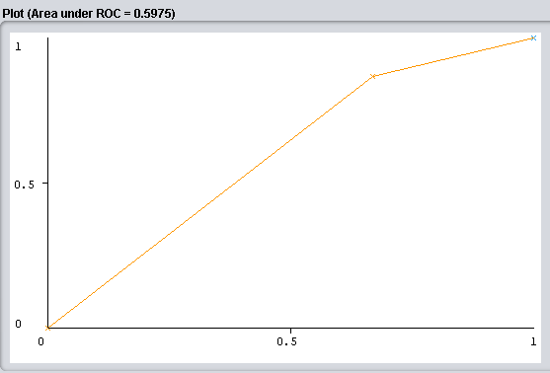Ilustración 1: Graphic ROC Breast Cancer

    - Configuration PolyKernel 2
Exponencial = 10

TP Rate FP Rate Precision Recall F-Measure MCC ROC
0,547 0,376 0,775 0,547 0,641 0,156 0,585

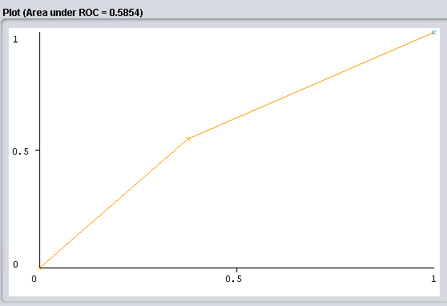Ilustración 2: ROC BreastCancer2

    - Configuration PolyKernel 3
Exponencial = 100

TP Rate FP Rate Precision Recall F-Measure MCC ROC
1,000 1,000 0,703 1,000 0,825 ? 0,500

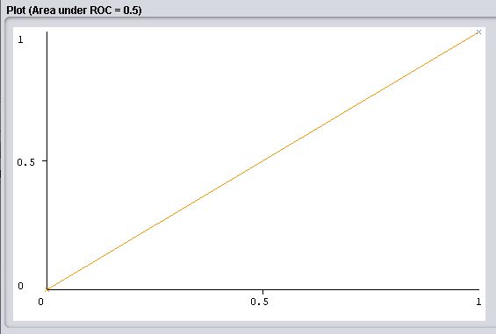Ilustración 3: ROC BreastCancer3

    - Configuration Normalized Poly Kernel 1
Exponencial = 1

TP Rate FP Rate Precision Recall F-Measure MCC ROC
0,896 0,729 0,744 0,896 0,813 0,210 0,583

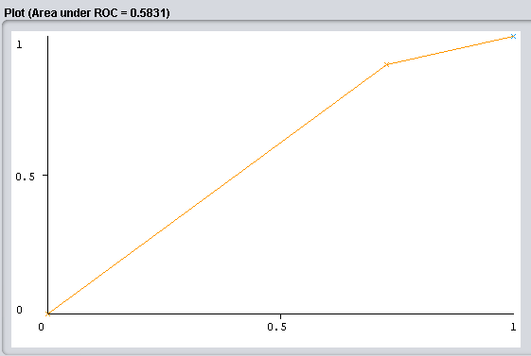Ilustración 4: ROC BreastCancer4

    - Configuration Normalized Poly Kernel 2
Exponencial = 10

TP Rate FP Rate Precision Recall F-Measure MCC ROC
0,970 0,953 0,707 0,970 0,818 0,043 0,509

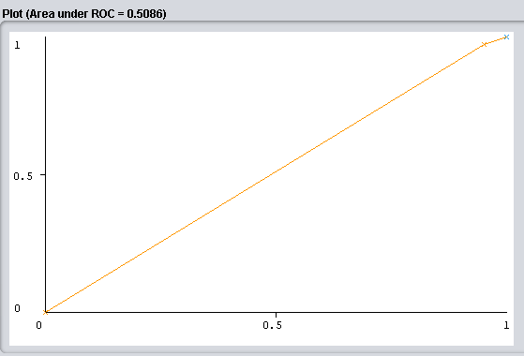Ilustración 5: ROC BreastCancer5

    - Configuration Normalized Poly Kernel 3
Exponencial = 100

TP Rate FP Rate Precision Recall F-Measure MCC ROC
0,970 0,953 0,707 0,970 0,818 0,043 0,509

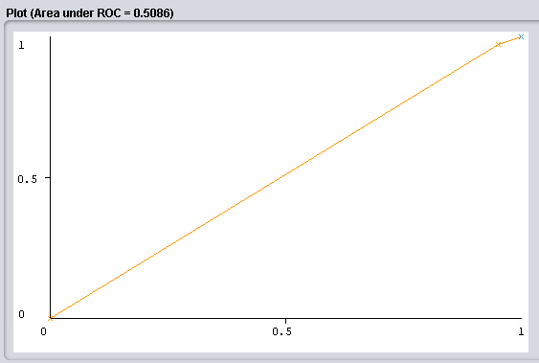Ilustración 6: ROC BreastCancer6

    - Configuration RBF Kernel 1
Gamma = 0.01

TP Rate FP Rate Precision Recall F-Measure MCC ROC
1,000 1,000 0,703 1,000 0,825 ? 0,500

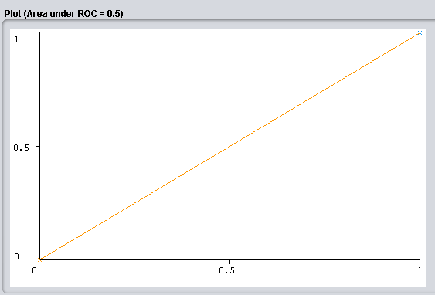Ilustración 7: ROC BreastCancer7

    - Configuration RBF Kernel 2
Gamma = 0.1

TP Rate FP Rate Precision Recall F-Measure MCC ROC
0,950 0,741 0,752 0,950 0,840 0,303 0,605

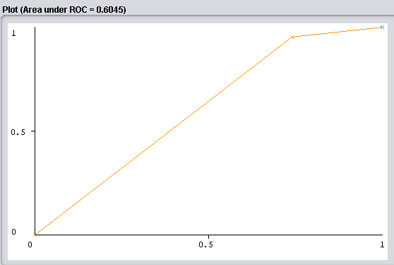Ilustración 8: ROC BreastCancer8

    - Configuration RBF Kernel 3
Gamma = 1

TP Rate FP Rate Precision Recall F-Measure MCC ROC
0,970 0,953 0,707 0,970 0,818 0,043 0,509

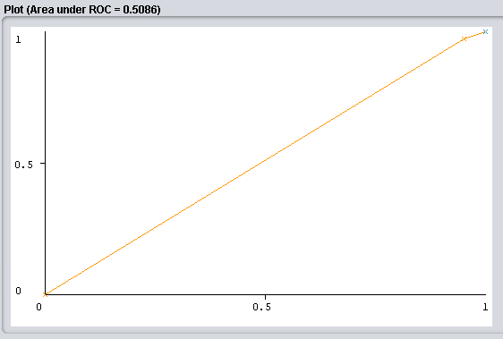Ilustración 9: ROC BreastCancer9

First of all we base our choices on the function type of our kernel. In the case of polynomial kernels we have tested with a polynomial of different degrees marked by the exponent parameter and in the case of the RBF kernel we modify gamma, which is a parameter that modifies its amplitude. We have been giving ascending values ​​in the three kernels to check their effect.
Regarding the results, we can verify that polynomials of a higher degree or with a greater kernel amplitude do not imply better performance, but in this case the configurations with lower exponent and gamma values ​​have given better results. However, in values ​​such as Precision, this relationship is not followed.
HEPATITIS DATASET

- Introduction
The main idea of this classification problem is given a dataset about patients which suffer from hepatitis and they a series of characteristics which determine if they died or live because train a SMO classification model and evaluate its performance.

In this dataset we have 155 instances in total of which 129 of one class and 26 instances of another class. Each instance has 20 attributes, one of them is the class attribute. Because of we have only two classes we are faced with a binary classification problem.

- Number of classes
In this case our class attribute can take only two values, die and live. Because of that we are faced to a binary classification problem.

- Number of attributes
In this case we have twenty attributes which are age, sex, steroid, antivirals, fatigue, malaise, anorexia, liver big, liver firm, spleen palpable, spiders, ascites, varices, bilirubin, alk phosphate, sgot, albumin, protime, histology and class.

- Number of samples
In this case in particular the number of samples or instances is 155.

  - Performance metrics values by configuration

    - Configuration PolyKernel 1
Exponencial = 1

TP Rate FP Rate Precision Recall F-Measure MCC ROC
0,625 0,081 0,667 0,625 0,645 0,557 0,772

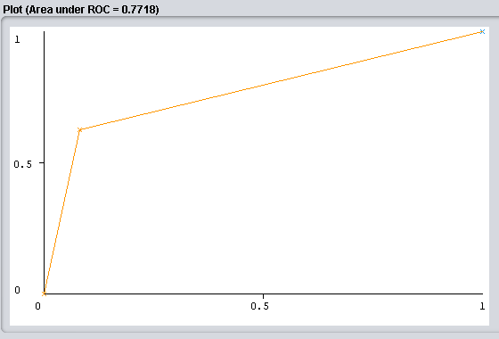Ilustración 10: ROC Hepatitis1

    - Configuration PolyKernel 2
Exponencial = 10

TP Rate FP Rate Precision Recall F-Measure MCC ROC
0,406 0,098 0,520 0,406 0,456 0,340 0,654

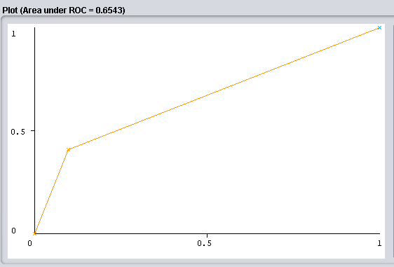

    - Configuration PolyKernel 3
Exponencial = 100

TP Rate FP Rate Precision Recall F-Measure MCC ROC
1,000 1,000 0,206 1,000 0,342 ? 0,500

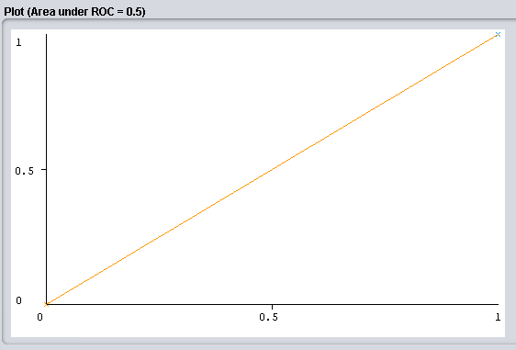Ilustración 11: ROC Hepatitis3

    - Configuration Normalized Poly Kernel 1
Exponencial = 1

TP Rate FP Rate Precision Recall F-Measure MCC ROC
0,344 0,057 0,611 0,344 0,440 0,362 0,643

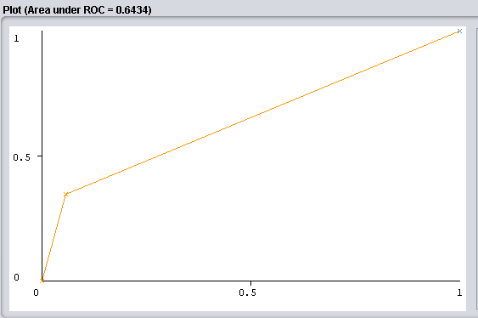Ilustración 12: ROC Hepatitis4

    - Configuration Normalized Poly Kernel 2
Exponencial = 10

TP Rate FP Rate Precision Recall F-Measure MCC ROC
0,406 0,057 0,650 0,406 0,500 0,422 0,675

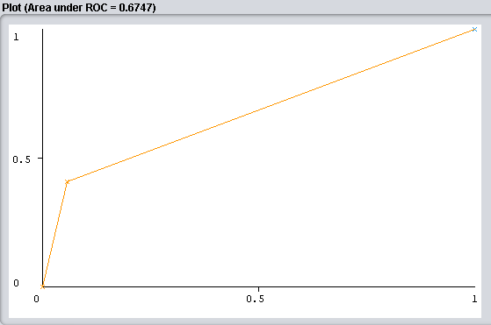

    - Configuration Normalized Poly Kernel 3
Exponencial = 100

TP Rate FP Rate Precision Recall F-Measure MCC ROC
0,000 0,000 ? 0,000 ? ? 0,500

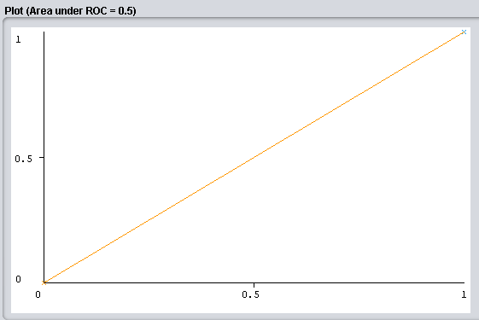

    - Configuration RBF Kernel 1
Gamma = 0,01

TP Rate FP Rate Precision Recall F-Measure MCC ROC
0,000 0,000 ? 0,000 ? ? 0,500

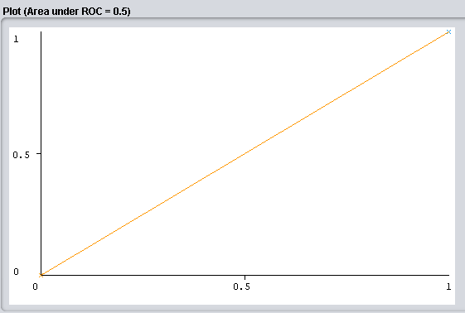

    - Configuration RBF Kernel 2
Gamma = 0,1

TP Rate FP Rate Precision Recall F-Measure MCC ROC
0,438 0,057 0,667 0,438 0,528 0,450 0,690

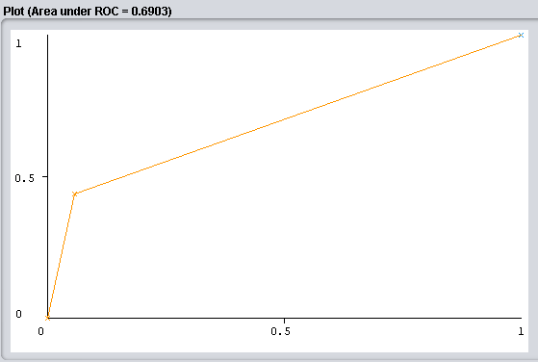

    - Configuration RBF Kernel 3
Gamma = 1

TP Rate FP Rate Precision Recall F-Measure MCC ROC
0,188 0,041 0,545 0,188 0,279 0,231 0,573

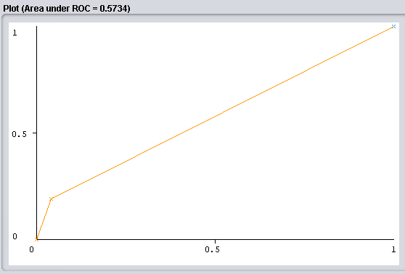

In this data set, something similar to the previous one occurs, small values ​​of exponent and gamma give better results compared to the larger ones except in RBF adding that in this case the intermediate values ​​of normalized poly kernel and RBF give better results than the small ones with a greater difference in the latter case.

POST-OPERATIVE PATIENTS DATASET

- Introduction
The main idea of this classification problem is given a dataset about patients which have passed an operation and they are in a postoperative recovery area waiting to a decision of where they should be sent next. Depending on a number of temperature measurements we train a SMO classification model and evaluate its performance.

In this dataset we have 90 instances in total of which they are divided in three categories or classes, 2 of class I, 24 of class S and 64 of class A. Each instance has 9 attributes, one of them is the class attribute. Because of we have three possible classes we are faced with a multiclass classification problem.

- Number of classes
In this case our class attribute can take only three values, I, S and A. Because of that we are faced to a multiclass classification problem.

- Number of attributes
In this case we have nine attributes which l-core, l-surf, l-02, l-bp, surf-stbl, core-stbl, bp-stbl, comfort and class.

- Number of samples
In this case in particular the number of samples or instances is 90.

  - Performance metrics values by configuration

    - Configuration PolyKernel 1
Exponencial = 1

TP Rate FP Rate Precision Recall F-Measure MCC ROC 0,678 0,723 ? 0,678 ? ? 0,4777

    - Configuration PolyKernel 2
Exponencial = 10

TP Rate FP Rate Precision Recall F-Measure MCC ROC
0,600 0,682 ? 0,600 ? ? 0,459

    - Configuration PolyKernel 3
Exponencial = 100

TP Rate FP Rate Precision Recall F-Measure MCC ROC
0,711 0,711 ? 0,711 ? ? 0,500

    - Configuration Normalized Poly Kernel 1
Exponencial = 1

TP Rate FP Rate Precision Recall F-Measure MCC ROC
0,711 0,711 ? 0,711 ? ? 0,50

    - Configuration Normalized Poly Kernel 2
Exponencial = 10

TP Rate FP Rate Precision Recall F-Measure MCC ROC
0,678 0,723 ? 0,678 ? ? 0,477

    - Configuration Normalized Poly Kernel 3
Exponencial = 100

TP Rate FP Rate Precision Recall F-Measure MCC ROC
0,667 0,727 ? 0,667 ? ? 0,470

    - Configuration RBF Kernel 1
Gamma = 0,01

TP Rate FP Rate Precision Recall F-Measure MCC ROC
0,667 0,727 ? 0,667 ? ? 0,470

    - Configuration RBF Kernel 2
Gamma = 0,1

TP Rate FP Rate Precision Recall F-Measure MCC ROC
0,711 0,711 ? 0,711 ? ? 0,500

    - Configuration RBF Kernel 3
Gamma = 1

TP Rate FP Rate Precision Recall F-Measure MCC ROC
0,678 0,723 ? 0,678 ? ? 0,477
In this last dataset there is not a uniform order between the different kernels since with a polynomial kernel the highest value of the best result but the lowest is better than the intermediate and in the case of normalized polynomials the intermediate value gives the best result followed by the highest and finally the minor. In the case of RBF, the intermediate is the one that gives the best result followed by the highest. As we can see, none of the three configurations follows an order in relation to the modified values, making it difficult to choose.

  - Evaluation of the results
DatasetBreastCancer | TP rate | FP rate | Precision | Recall | F-mesure | ROC
PolyKernel1 | 0,866 | 0,671 | 0,753 | 0,866 | 0,806 | 0,598
PolyKernel10 | 0,547 | 0,376 | 0,775 | 0,547 | 0,641 | 0,585
PolyKernel100 | 1,00 | 1,00 | 0,703 | 1,00 | 0,825 | 0,500
Normalized1 | 0,896 | 0,729 | 0,744 | 0,896 | 0,813 | 0,583
Normalized10 | 0,970 | 0,953 | 0,707 | 0,970 | 0,818 | 0,509
Normalized100 | 0,970 | 0,953 | 0,707 | 0,970 | 0,818 | 0,509
RBF0.01 | 1,00 | 1,00 | 0,703 | 1,00 | 0,825 | 0,500
RBF0.1 | 0,950 | 0,741 | 0,752 | 0,950 | 0,840 | 0,605
RBF1 | 0,970 | 0,953 | 0,707 | 0,970 | 0,818 | 0,509

Dataset  Hepatitis | TP rate | FP rate | Precision | Recall | Fmeasure | ROC
PolyKernel1 | 0,625 | 0,081 | 0,667 | 0,625 | 0,645 | 0,772
PolyKernel10 | 0,406 | 0,098 | 0,520 | 0,406 | 0,456 | 0,654
PolyKernel100 | 1,00 | 1,00 | 0,206 | 1,00 | 0,342 | 0,500
Normalized1 | 0,344 | 0,057 | 0,611 | 0,344 | 0,440 | 0,643
Normalized10 | 0,406 | 0,057 | 0,650 | 0,406 | 0,500 | 0,675
Normalized100 | 0,00 | 0,00 | ? | ? | ? | 0,500
RBF0.01 | 0,00 | 0,00 | ? | ? | ? | 0,500
RBF0.1 | 0,438 | 0,057 | 0,667 | 0,438 | 0,528 | 0,690
RBF1 | 0,188 | 0,041 | 0,545 | 0,188 | 0,279 | 0,573

Dataset  PostOperative | TP rate | FP rate | Precision | Recall | Fmeasure | ROC
PolyKernel1 | 0,678 | 0,723 | ? | 0,678 | ? | 0,477
PolyKernel10 | 0,600 | 0,682 | ? | 0,600 | ? | 0,459
PolyKernel100 | 0,711 | 0,711 | ? | 0,711 | ? | 0,500
Normalized1 | 0,711 | 0,711 | ? | 0,711 | ? | 0,500
Normalized10 | 0,678 | 0,723 | ? | 0,678 | ? | 0,477
Normalized100 | 0,667 | 0,727 | ? | 0,667 | ? | 0,470
RBF0.01 | 0,667 | 0,727 | ? | 0,667 | ? | 0,470
RBF0.1 | 0,711 | 0,711 | ? | 0,711 | ? | 0,500
RBF1 | 0,678 | 0,723 | ? | 0,678 | ? | 0,477

  - Differences between datasets

Dataset | NumSamples | ClassType | ClassDistribution | Atributte  Characteristics
BreastCancer | 286 | Binary | 201/85 | Linear/Nominal
Hepatitis | 155 | Binary | 32/123 | Nominal/  Numerical
Post-Operative | 70 | Multiclass | 2/24/64 | Nominal/  Numerical

  - Last conclusions
As a conclusion we are going to compare the results obtained in the different datasets. Looking at the performance measures we can say that Hepatitis is the dataset that best fits with an area ROC result of 0.772 in a first degree polynomial configuration, that is, a linear kernel, followed by BreastCancer with an area ROC result of 0.605 with a kernel radial and gamma 0.1 finally we have PostOperative with a better ROC result of 0.5 obtained from various configurations.
With the experience obtained we can conclude that the choice and study of the type of kernel transformation as the modifiable parameters in these determine the result and that depending on the type of data evaluated it will be more convenient to use some combinations or others without following an exact relationship.

