University of Málaga
Health Engineering

Laboratory Task

Nonparametric Models

Author

Alejandro Dominguez Recio

Course

Intelligent Systems

Teachers

Enrique Domínguez Merino

Jesús de Benito Picazo

Introduction

In this practice we going to evaluate three diferents dataset with the Ibk classifier which is an implementation of the k-nearest neighbours classifier. To evaluate which dataset is more optimal with this classifier we going to describe the performance measures seen in class like confusion matrix, acurracy, precision, fallout, recall, F-measure and area under ROC curve. In order to improve its performance, we will modify the parameters such as the number of closest neighbors and the distance function. Also we going to detail the characteristics of the different datasets.

How are we going to do it?

To do the different studies we will have the following structure in each of then.

- Dataset context
In this part we going to write a little introduction of the dataset context commenting on data type and prediction target.
- Number of classes
We going to describe the number of classes as if it is binary o multiclass. To do that we going to observe the atributtes weka panel and we going to select the class attribute and depending on the number of values that it takes, we will determine if it is binary or multiclass.
- Number of attributes
For the number of attributes we going to inspect the weka attributes panel or open the file in text mode and inspect the characteristics.

- Number of samples or instances
To know the number of samples we can proceed as in the previous section by inspecting the weka panels or opening the document in text mode and seeing its characteristics.
  - Performance metric values by configuration

Accuracy
We can obtain the acurracy in two ways, one of them is directly from the classifier out and the another one is by calculating the number of correctly predicted examples divided by the total number of examples.
Precision
This measurement shows the positive predictive value, higher is bettter. We are going to obtain the necessary values from the confusion matrix and perform the following calculation TP/(TP+FP).
Fallout
This measurement shows the false positive rate, lower is better. We are going to obtain the necessary values from the confusion matrix and perform the following calculation FP/(FP+TN).
Recall
This measurement shows the true positive rate, higher is better. We are going to obtain the necessary values from the confusion matrix and perform the following calculation TP/(TP+FN).
F-measure
This measurement provides a single score that balances both the concers of precision and recall in one number, higher is better. We are going to obtain the necessary values of the previous measurements, precision and recall, and perform the following calculation 2*(Precision*Recall)/(Precision+Recall).

  - ROC curve and the area under the curve
We are going to obtain this measurement by visualizing the threshold curve in Weka. The area under the ROC curve is a number in the interval [0,1], a higher value is better. This measure show the trade-off between the ratios of false positives and false negatives. This measurement is very useful when we faced with unbalanced data.

*The previous points will be repeated for each dataset

  - Evaluation of the results
In this section we are goint to compare the results of the different performance measures.
  - Differences between datasets
Here we are going to describe the main differences in the data of the different datasets.
  - Last conclusions
Finally, we are going explain possible reasons why some datasets perform better with the Naive Bayes classifier than others. We will support our conclusions on the performance measures taken and on the characteristics of the datasets

BREAST CANCER DATASET

- Introduction
The main idea of this classification problem is given a dataset about patients with a series of characteristics which determine if they have recurrence events or no recurrence events of breast cancer train a Naive Bayes classification model and evaluate its performance.

In this dataset we have 286 instances in total of which 201 of one class and 85 instances of another class. Each instance has ten attributes, one of them is the class attribute. Because of we have only two classes we are faced with a binary classification problem.

- Number of classes
In this case our class attribute can take only two values, recurrence events and no recurrence events. Because of that we are faced to a binary classification problem.

- Number of attributes
In this case we have ten attributes which are class, age, menopause, tumor-size, inv-nodes, node-caps, deg-malig, breast, breast-quad and irradiat.

- Number of samples
In this case in particular the number of samples or instances is 286.

  - Performance metric values by configuration

Configurations
Configuration | KNN | Distance  Function
C1 | 1 | Euclidean
C2 | 1 | Manhattan
C3 | 1 | Minkowski
C4 | 4 | Euclidean
C5 | 4 | Manhattan
C6 | 4 | Minkowski
C7 | 9 | Euclidean
C8 | 9 | Manhattan
C9 | 9 | Minkowski
C10 | 6 | Minkowski
C11 | 12 | Minkowski
C12 | 15 | Minkowski

Results

Dataset | Correctly  Classified% | TP rate | FP rate | Precision | Recall | Fmeasure | ROC
C1 | 72,7273 | 0,896 | 0,671 | 0,759 | 0,896 | 0,822 | 0,641
C2 | 74,8252 | 0,975 | 0,788 | 0,745 | 0,975 | 0,845 | 0,670
C3 | 74,1259 | 0,970 | 0,800 | 0,741 | 0,970 | 0,841 | 0,676
C4 | 72,7273 | 0,896 | 0,671 | 0,759 | 0,896 | 0,822 | 0,641
C5 | 74,8252 | 0,975 | 0,788 | 0,745 | 0,975 | 0,845 | 0,670
C6 | 74,1259 | 0,970 | 0,800 | 0,741 | 0,970 | 0,841 | 0,676
C7 | 72,7273 | 0,896 | 0,671 | 0,759 | 0,896 | 0,822 | 0,641
C8 | 74,8252 | 0,975 | 0,788 | 0,745 | 0,975 | 0,845 | 0,670
C9 | 74,1259 | 0,970 | 0,800 | 0,741 | 0,970 | 0,841 | 0,676
C10 | 73,776 | 0,970 | 0,812 | 0,739 | 0,970 | 0,839 | 0,670
C11 | 73,0769 | 0,965 | 0,824 | 0,735 | 0,965 | 0,834 | 0,685
C12 | 73,7762 | 0,985 | 0,847 | 0,733 | 0,985 | 0,841 | 0,676

Section conclusions
In the first place, the selection of the values of k has the objective of seeing how the model behaves according to its size and its effect on noise as in even and odd values and its effect on class ties. We also change the distance function.
As we can, configuration 1 is the one that gives us the worst result, stating that a value of k = 1 creates a lot of noise in the classification. The best results in correctly classified instances can be found with k = 4 although the value of K = 12 gives us the best ROC area. By way of conclusion, we can say that this dataset behaves in a similar way in the tested configurations, perhaps because its instances are clearly differences and contribute little noise to the classification.

  - ROC curve C1
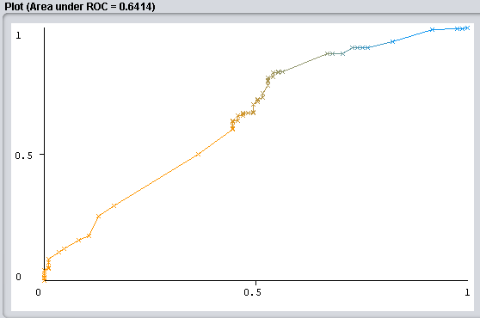

  - ROC curve C2
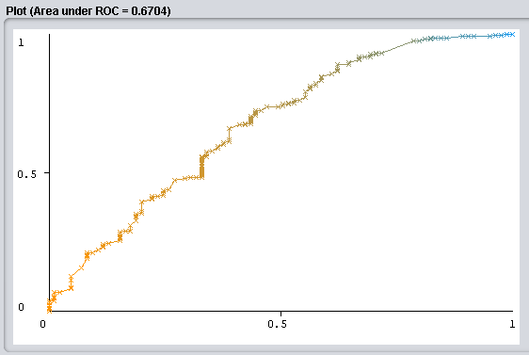

  - ROC curve C3
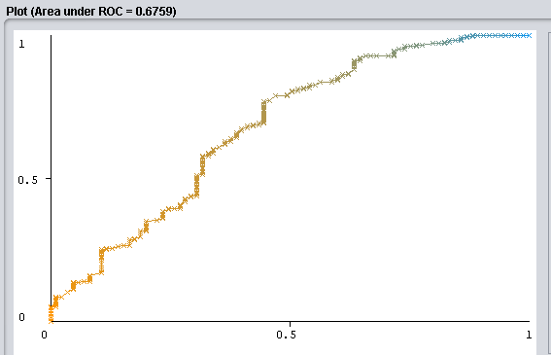

  - ROC curve C4
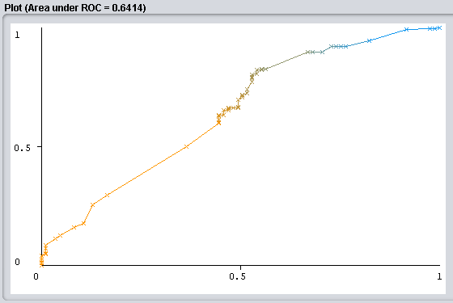

  - ROC curve C5
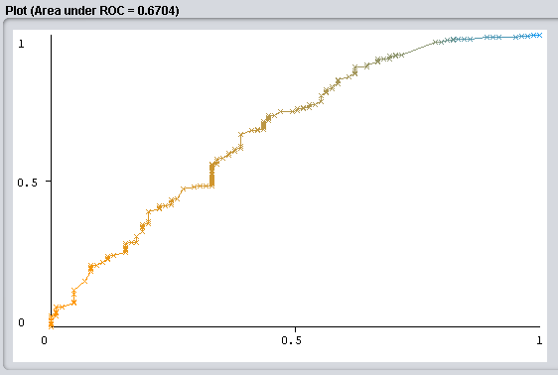

  - ROC curve C6
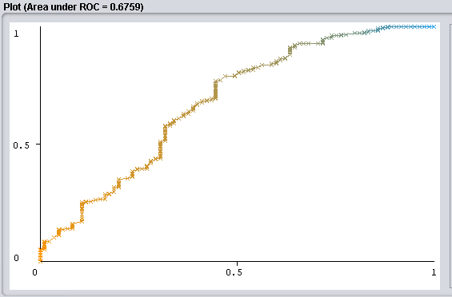

  - ROC curve C7
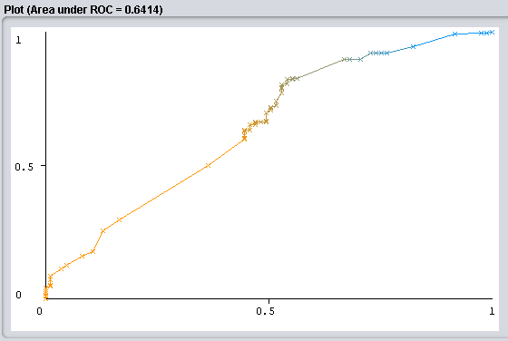

  - ROC curve C8
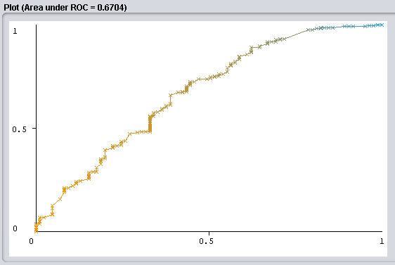

  - ROC curve C9
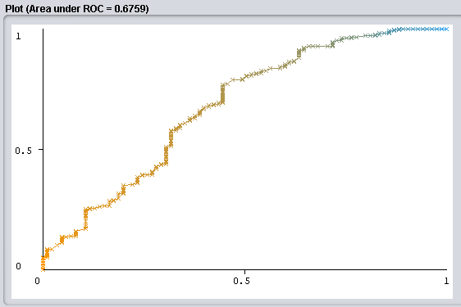

  - ROC curve C10
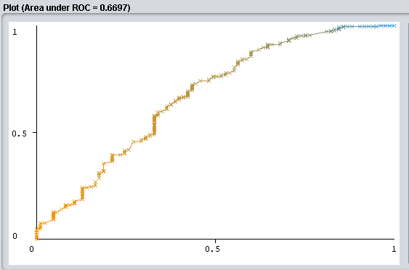

  - ROC curve C11
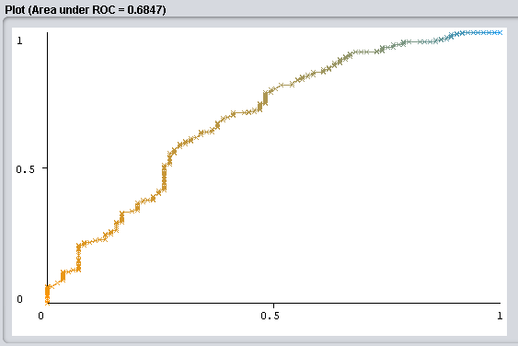

  - ROC curve C12
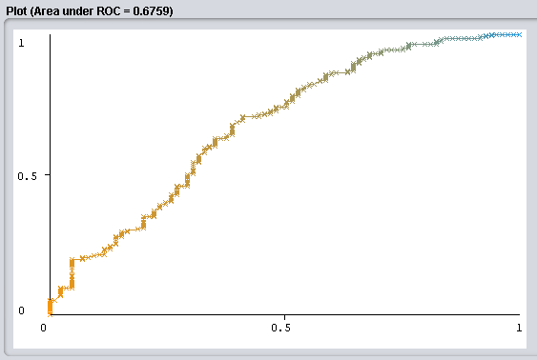

HEPATITIS DATASET

- Introduction
The main idea of this classification problem is given a dataset about patients which suffer from hepatitis and they a series of characteristics which determine if they died or live because train a IBk classification model and evaluate its performance.

In this dataset we have 155 instances in total of which 129 of one class and 26 instances of another class. Each instance has 20 attributes, one of them is the class attribute. Because of we have only two classes we are faced with a binary classification problem.

- Number of classes
In this case our class attribute can take only two values, die and live. Because of that we are faced to a binary classification problem.

- Number of attributes
In this case we have twenty attributes which are age, sex, steroid, antivirals, fatigue, malaise, anorexia, liver big, liver firm, spleen palpable, spiders, ascites, varices, bilirubin, alk phosphate, sgot, albumin, protime, histology and class.

- Number of samples
In this case in particular the number of samples or instances is 155.

  - Performance metric values by configuration

Configurations

Configuration | KNN | Distance  Function
C1 | 1 | Euclidean
C2 | 4 | Euclidean
C3 | 9 | Euclidean
C4 | 1 | Manhattan
C5 | 4 | Manhattan
C6 | 9 | Manhattan
C7 | 1 | Minkowski
C8 | 4 | Minkowski
C9 | 9 | Minkowski
C10 | 6 | Minkowski
C11 | 12 | Minkowski
C12 | 15 | Minkowski

Results

Configuration | Correctly  Classified% | TP rate | FP rate | Precision | Recall | Fmeasure | ROC
C1 | 80,6452 | 0,438 | 0,098 | 0,538 | 0,438 | 0,483 | 0,703
C2 | 82,5806 | 0,563 | 0,106 | 0,581 | 0,563 | 0,571 | 0,789
C3 | 85,1613 | 0,500 | 0,057 | 0,689 | 0,500 | 0,582 | 0,829
C4 | 81,2903 | 0,469 | 0,098 | 0,556 | 0,469 | 0,508 | 0,719
C5 | 82,5806 | 0,594 | 0,114 | 0,576 | 0,594 | 0,585 | 0,801
C6 | 85,1613 | 0,500 | 0,057 | 0,696 | 0,500 | 0,582 | 0,819
C7 | 80,6452 | 0,438 | 0,098 | 0,538 | 0,438 | 0,483 | 0,703
C8 | 82,5806 | 0,563 | 0,106 | 0,581 | 0,563 | 0,571 | 0,789
C9 | 85,1613 | 0,500 | 0,057 | 0,696 | 0,500 | 0,582 | 0,829
C10 | 85,1613 | 0,594 | 0,081 | 0,655 | 0,594 | 0,623 | 0,804
C11 | 82,5806 | 0,469 | 0,081 | 0,600 | 0,469 | 0,526 | 0,816
C12 | 81,2903 | 0,250 | 0,041 | 0,615 | 0,250 | 0,356 | 0,825

Section conclusions
As we can see again, configuration 1 is the one that gives the worst result, stating that a value of k = 1 creates a lot of noise in the classification. The best results in correctly classified instances can be found with k = 9 and without difference between distance functions, which give the same results at the same values of K. By way of conclusion we can say that this dataset behaves in a similarly in the tested configurations although with a notable improvement between the worst and the best result in ROC curve, which means that some instances create a small noise that can be eliminated by configuring the model.

  - ROC curve C1
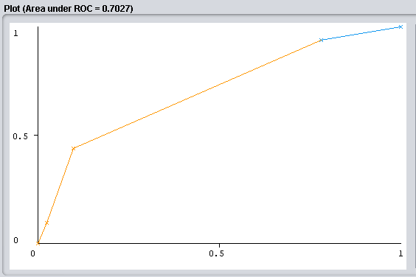

  - ROC curve C2
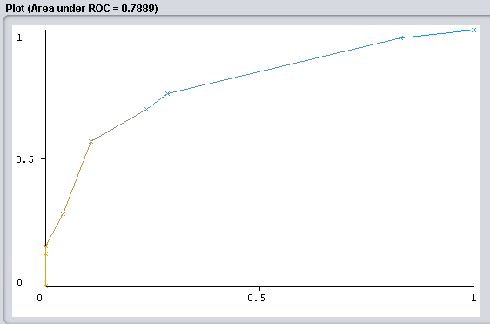

  - ROC curve C3
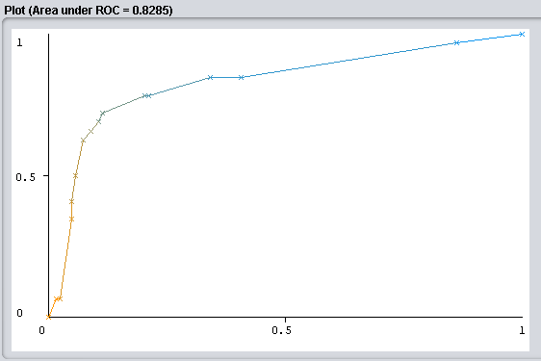

  - ROC curve C4
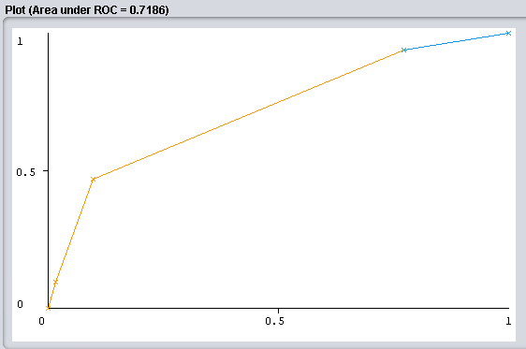

  - ROC curve C5
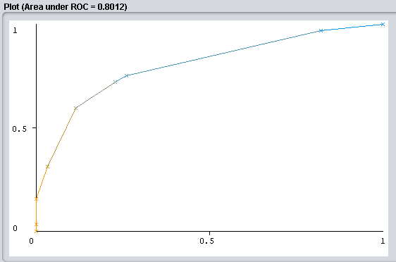

  - ROC curve C6
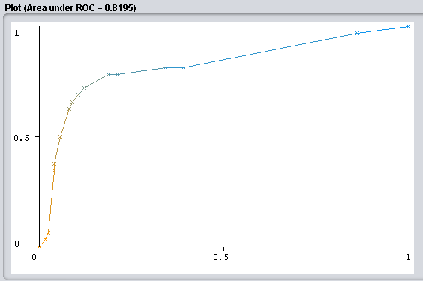

  - ROC curve C7
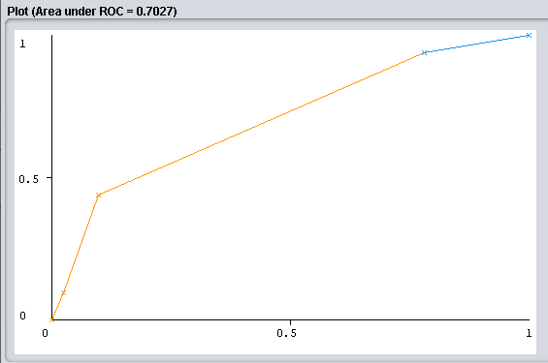

  - ROC curve C8
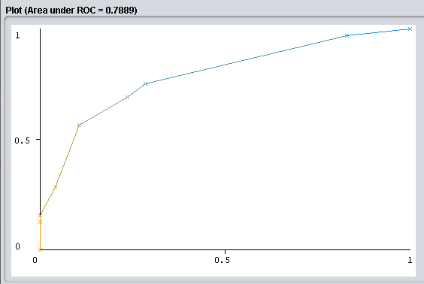

  - ROC curve C9
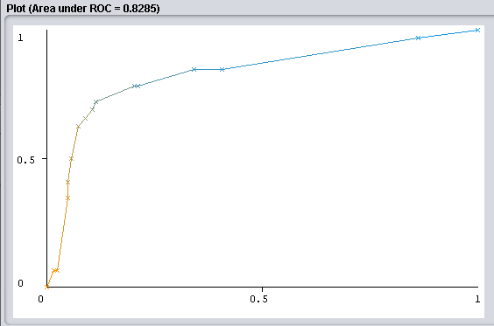

  - ROC curve C10
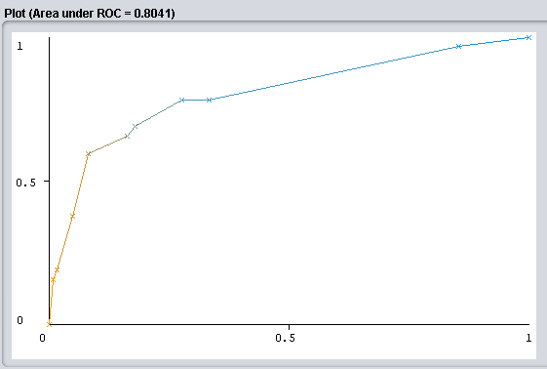

  - ROC curve C11
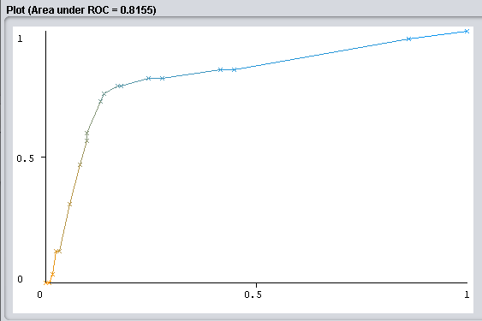

  - ROC curve C12
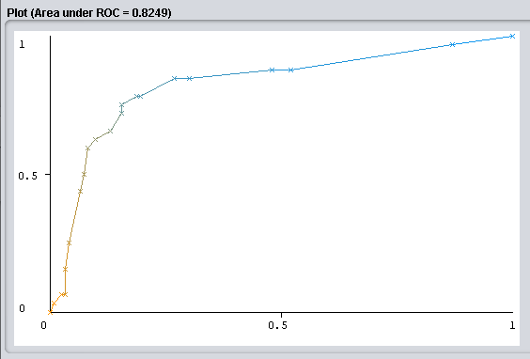
POST-OPERATIVE PATIENTS DATASET

- Introduction
The main idea of this classification problem is given a dataset about patients which have passed an operation and they are in a postoperative recovery area waiting to a decision of where they should be sent next. Depending on a number of temperature measurements we train a IBk classification model and evaluate its performance.

In this dataset we have 90 instances in total of which they are divided in three categories or classes, 2 of class I, 24 of class S and 64 of class A. Each instance has 9 attributes, one of them is the class attribute. Because of we have three possible classes we are faced with a multiclass classification problem.

- Number of classes
In this case our class attribute can take only three values, I, S and A. Because of that we are faced to a multiclass classification problem.

- Number of attributes
In this case we have nine attributes which l-core, l-surf, l-02, l-bp, surf-stbl, core-stbl, bp-stbl, comfort and class.

- Number of samples
In this case in particular the number of samples or instances is 90.

  - Performance metric values by configuration

Configurations
Configuration | KNN | Distance  Function
C1 | 1 | Euclidean
C2 | 4 | Euclidean
C3 | 9 | Euclidean
C4 | 1 | Manhattan
C5 | 4 | Manhattan
C6 | 9 | Manhattan
C7 | 1 | Minkowski
C8 | 4 | Minkowski
C9 | 9 | Minkowski
C10 | 6 | Minkowski
C11 | 12 | Minkowski
C12 | 15 | Minkowski

Results

Configuration | Correctly  Classified% | TP rate | FP rate | Precision | Recall | Fmeasure | ROC
C1 | 66,666 | 0,667 | 0,704 | ? | 0,667 | ? | 0,414
C2 | 71,111 | 0,711 | 0,711 | ? | 0,711 | ? | 0,242
C3 | 71,111 | 0,711 | 0,711 | ? | 0,711 | ? | 0,385
C4 | 66,666 | 0,667 | 0,704 | ? | 0,667 | ? | 0,414
C5 | 71,111 | 0,711 | 0,711 | ? | 0,711 | ? | 0,242
C6 | 71,111 | 0,711 | 0,711 | ? | 0,711 | ? | 0,385
C7 | 66,666 | 0,667 | 0,704 | ? | 0,667 | ? | 0,414
C8 | 71,111 | 0,711 | 0,711 | ? | 0,711 | ? | 0,242
C9 | 71,111 | 0,711 | 0,711 | ? | 0,711 | ? | 0,385
C10 | 71,111 | 0,711 | 0,711 | ? | 0,711 | ? | 0,322
C11 | 71,111 | 0,711 | 0,711 | ? | 0,711 | ? | 0,378
C12 | 71,111 | 0,711 | 0,711 | ? | 0,711 | ? | 0,410

Section conclusions
In this dataset we have that the instances with the best results in correctly classified instances do not correspond to the best results in the ROC area. In relation to the configurations with a higher percentage of correctly classified instances we have a tie in all of which are greater than K = 1 and in ROC area we have that the Mankowski configurations with K = 1 and K = 15 are the most optimal.

  - Evaluation of the results

Dataset | Best  Result  CorrectlyClassified | Best  Result  ROC | Best  Result  Precision
BreastCancer | C2,C5,C8, | C11 | C12
Hepatitis | C3,C6,C9,C10 | C3,C9 | C3,C6,C9
Post-Operative | Tie K>1 | C1,C4,C7 | ?

  - Differences between datasets

Dataset | NumSamples | ClassType | ClassDistribution | Atributte  Characteristics
BreastCancer | 286 | Binary | 201/85 | Linear/Nominal
Hepatitis | 155 | Binary | 32/123 | Nominal/  Numerical
Post-Operative | 70 | Multiclass | 2/24/64 | Nominal/  Numerical

  - Last conclusions
By way of conclusion we can say that the choice of the number of closest neighbors is a fundamental parameter in the results. Introducing ourselves more in this aspect we have verified that k = 1 has been one of the worst results that we have obtained, verifying that for a correct classification we must normally take into account more than one point, on the other hand an excessively high number does not correspond to a better result causing overfiting and being able to classify based only on the proportions of classes in our dataset. Analyzing the global results of the three datasets we have that the best results in correctly classified instances have been given in configurations with k = 4 for BreastCancer or K = 9 for Hepatitis, in the case of PostOperative it provides us with the same results with values ​​of K> 1. In the ROC curve results we have that the values ​​of K = 12 and K = 9 give us the best results in BreastCancer and Hepatitis respectively, in PostOperative curiously the best value is K = 1. Finally we can say that KNN has been an easy algorithm to understand and configure, K being the only hyperparameter to modify, in turn it would also highlight the limitations it has due to its complexity in time and space for datasets with high dimensionality. Changes in the distance function, normalizing the data or reducing the dimensionality are ways to reduce the inconveniences that this presents.

