KARNIVAL GAMES
Little Spy – Extended Edition
Final Project
Version 2

All work Copyright © 2015 by EPICARNIVAL.
All rights reserved.

KEVIN LUU
ALEXANDER MAN


December 4th 2015

Table of Contents
- Game Overview

- Game Settings

- Moving Items

- Sound and Art Direction
Version History
- Little Spy – initial release
- Little Spy – Extended Edition – project started
- Little Spy – Extended Edition – New maps
- Little Spy – Extended Edition – new objectives
- Little Spy – Extended Edition – beta test
- Little Spy – Extended Edition – Initial Release

- Game Overview
The goal of the game is to reach the end of the level while collecting coins along the way. You will be facing off against simple enemies that will walk back and forth.

- Game Play Mechanics
The character will have the ability to double jump. The player can maneuver in mid-air by pressing the buttons that makes the character face left or right. The player can also climb walls by pressing the direction key towards the terrain. If the player looks the other direction while pressing jump, the character will move upwards. When jumping, if you land on an enemy, you will destroy it. There will be a separate scene that will inform the player of their remaining lives. When their lives are depleted, the player will then see a game over scene and that will end the game.

- Camera
The camera will be isometric, looking at the player on a 2 dimensional plane.

- Controls
The player will be using their default horizontal movement keys (A,D, Left Arrow Key, Right Arrow Key) to move side to side. The player will also have the space bar, which is capable of starting the level, and allow the player to jump and double jump.

- Interface Sketch
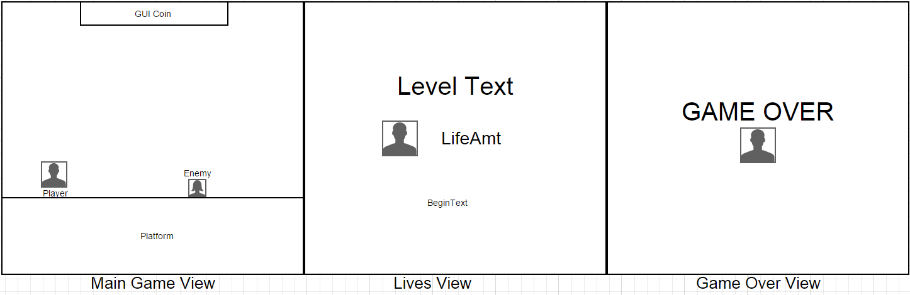

- Game World
There will be 3 normal levels and a final stage level where the character meets the final boss character.

- Levels
So far, there is only 3 level. However, more are planned to be added.

- Characters
The player’s character is a spy avatar, who wears a tuxedo. He is a bald character and is capable of jumping twice. His goal is to beat all the levels by reaching the end of the levels.

- Non-player Characters
The enemies are animated block monsters that do not actively look for you. However, when they do touch you, you will die and lose a life. There is no boss monster yet in the game.

- Enemies
The enemies are animated block monsters that do not actively look for you. However, when they do touch you, you will die and lose a life. There is no boss monster yet in the game. The final Boss Character is a bigger version of the block monster. The character must jump on all the other enemies, then the boss character will shrink and the main character then can jump on it. When the boss character dies, then the player beats the game.

- Script
- CameraController
- DestroyByContact
- GameOverAndReset
- LifeController
- PlatformFall
- PlayerController
- SimpleEnemyController

- Scoring
Every time you come in contact with a coin, a sound will appear and you will receive 1 coin in your UI text.

- Sound Index
- Darude Sandstorm 8 bit remix
- Ding
- The Price Is right losing horn
- Warhammer 40K - Chaos Gate Soundtrack

- Art / Multimedia Index
- Gentleman Spy (Animated)
- Jellybot Enemies
- Platformer Assets Pack – Cam Tatz

- Design Notes
- Animated characters
- Lives Scene
- Game over Scene
- Enemy Death animation
- Levels 1, 2 ,3 updated

- Future Features
- Life recovery items
- Increased level count
- Boss Battle
- Enemy Variety
- Cheat Codes

