|  |  |
| --- | --- |
| download | COMSATS University Islamabad, Vehari Campus Department ofComputer Science |

**Class: BCS-SP22-4B Submission Deadline: 10 Sep 2023**

**Subject: Data Structures and Algorithms-Lab Instructor: Yasmeen Jana Max Marks: 10 Reg. No: SP22-BCS-016**

**Email:** [**yasmeenjana@cuivehari.edu.pk**](mailto:yasmeenjana@cuivehari.edu.pk)

**You can ask queries related to Lab Activities on the above email.**

**Activity 1:**

Create a GitHub Account. Make a repository with the name “**DSA_Lab”. Mention the link here after the account creation.**

**Solution:**

<https://github.com/GitHubEsha/DSA-LAB>

**Activity 2:**

Write any 15 programs that will explain the concepts of pointers.

In this file, you should place the code and its output screenshot.

After completing the activities, Upload the final pdf and code to the “**DSA_Lab”**repository.

**Program 1: Basic point declaration and usage:**

#include <iostream>

using namespace std;

int main(){

int num;

int *ptr;

cout<<"Enter any number: ";

cin>>num;

ptr=&num;

cout<<"The value stored in pointer is: "<< *ptr <<endl;

cout<<"The address of the pointer is: "<< &ptr <<endl;

cout<<"The adress of the variable is: "<< &num <<endl;

return 0;

}

**Output:**

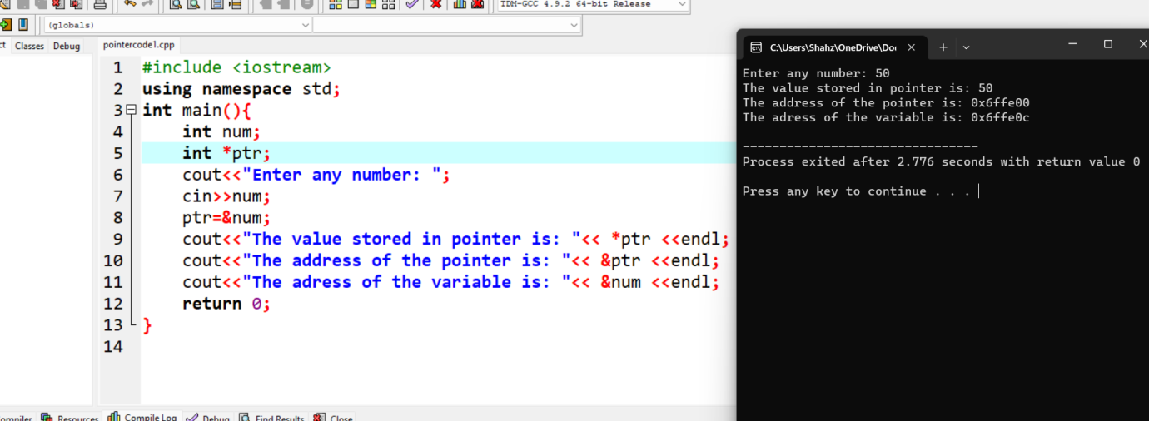

**Program 2: Number swapping using pointers:**

#include <iostream>

using namespace std;

int main() {

int num1= 20;

int num2= 40;

cout<<"Number before swapping: num1 = "<< num1<<", num2 = "<< num2<<endl;

int *ptr1 = &num1;

int *ptr2 = &num2;

int num = *ptr1;

*ptr1 = *ptr2;

*ptr2 = *ptr1;

cout<<"Numbers after swapping: num1 = "<< num1 <<", num2 = "<< num2<<endl;

return 0;

}

**Output:**

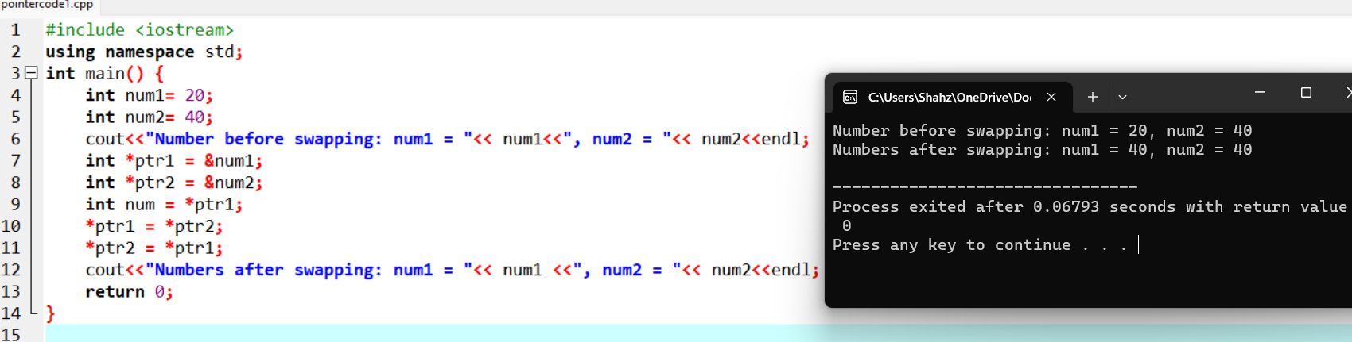

**Program 3: Incrementing and decrementing array index:**

#include <iostream>

using namespace std;

int main() {

int arr[6]={5,10,15,20,25,30};

cout<<"Elements of the array: "<<endl;

for(int i=0; i<6; i++){

cout<<" "<<arr[i]<<endl;

}

int *ptr=arr;

cout<<"The pointer points towards: "<<*ptr<<endl;

ptr++;

cout<<"After incrementing: "<<*ptr<<endl;

ptr--;

cout<<"After decrementing: "<<*ptr<<endl;

ptr+=5;

cout<<"Pointing towards specific value stored in index 5: "<<*ptr<<endl;

return 0;

}

**Output:**

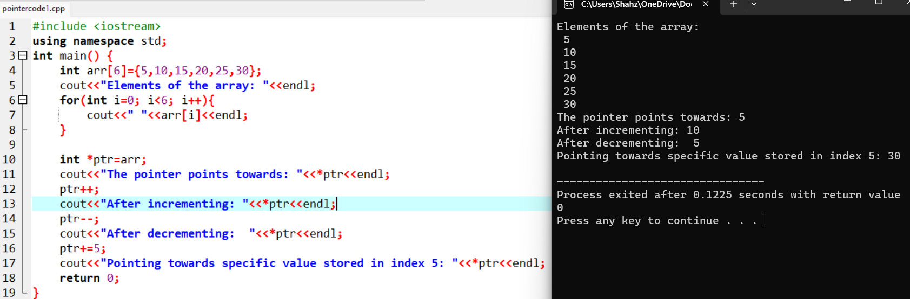

**Program 4: Printing array elements using pointer:**

#include<iostream>

using namespace std;

int main(){

int arr[6]={5,10,15,20,25,30};

int *ptr= arr;

cout<<"Elements of array using pointer: "<<endl;

for(int i=0; i<6; i++){

cout<<" "<<*ptr<<endl;

ptr++;

}

cout<<endl;

return 0;

}

**Output:**

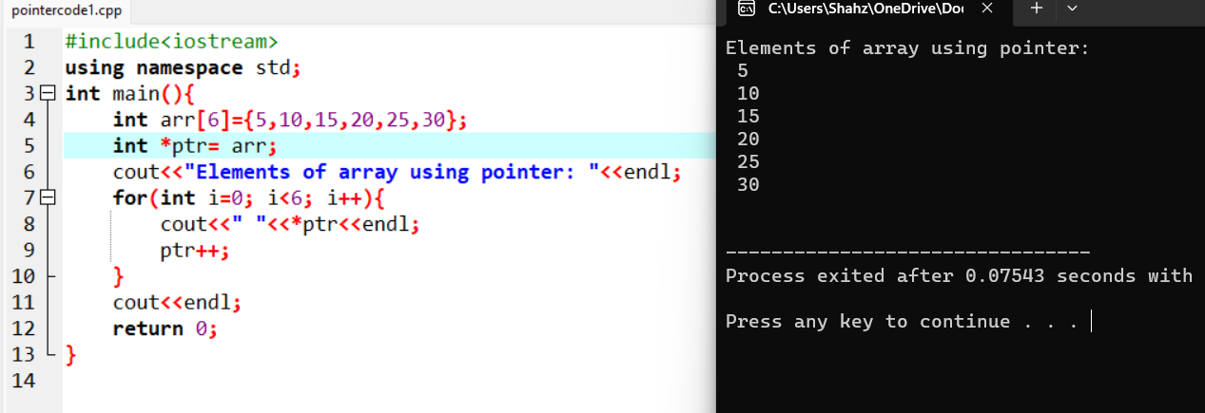

**Program 5: Sum and average of array using pointer:**

#include<iostream>

using namespace std;

int main(){

int arr[6];

cout<<"Enter 6 integars: ";

for(int i=0; i<6; i++){

cin>>arr[i];

}

double sum=0;

int *ptr = arr;

for(int i=0; i<6; i++){

sum+=*ptr;

ptr++;

}

double average= sum/6;

cout<<"Average is: "<< average<<endl;

cout<<"Sum is: " <<sum<<endl;

return 0;

}

**Output:**

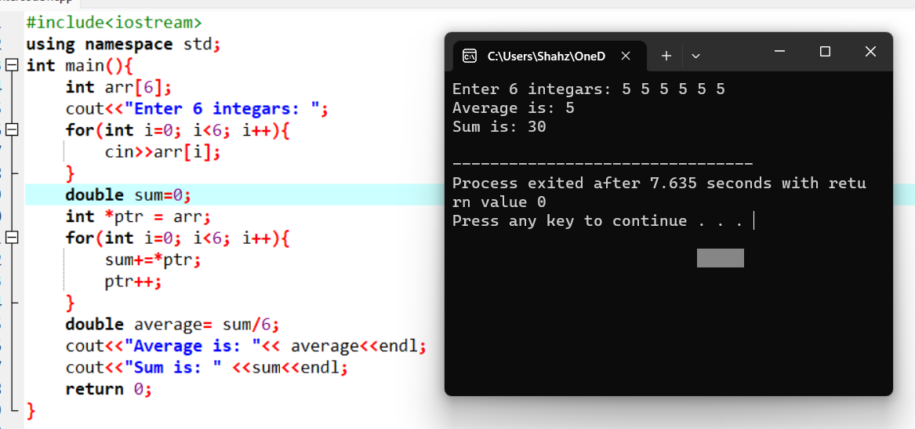

**Program 6: Finding maximum value in an array using pointer:**

#include<iostream>

using namespace std;

int main(){

int arr[6];

cout<<"Enter 6 integars as array elements: ";

for( int i=0; i<6; i++){

cin>>arr[i];

}

int *ptr=arr;

int max = *ptr;

for(int i=0; i<6; i++){

if (*ptr>max){

max=*ptr;

}

ptr++;

}

cout<<"The maximum value is: "<<max<<endl;

return 0;

}

**Output:**

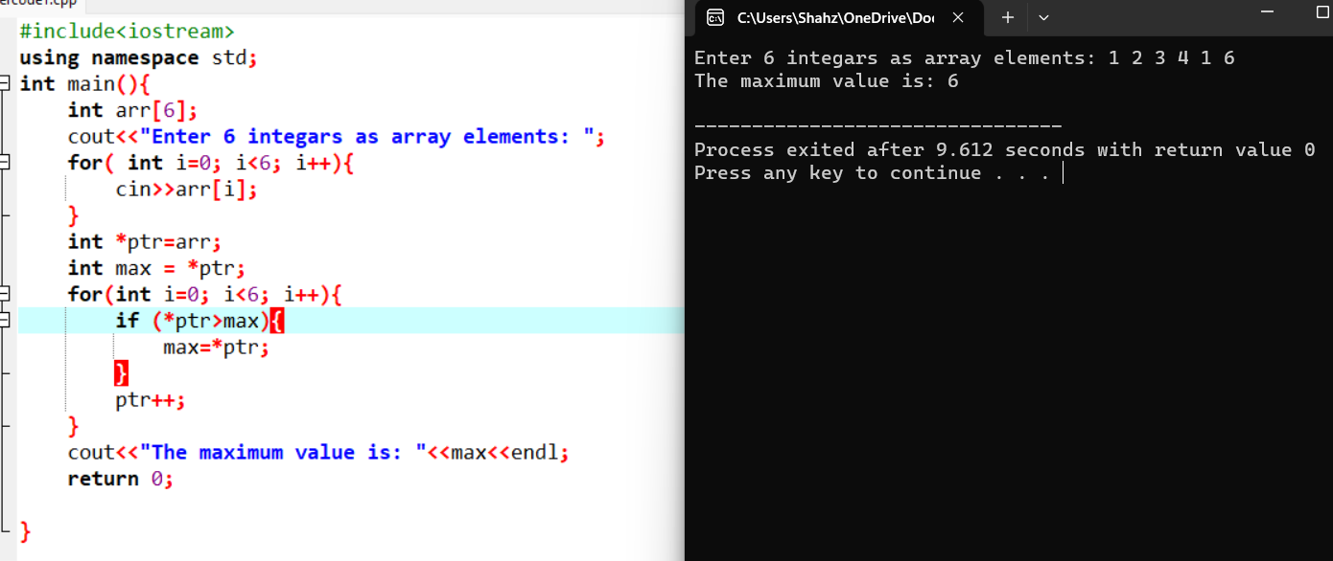

**Program 7: Minimum value in an array using pointer:**

#include<iostream>

using namespace std;

int main(){

int arr[6];

cout<<"Enter 6 integars as array elements: ";

for( int i=0; i<6; i++){

cin>>arr[i];

}

int *ptr=arr;

int min = *ptr;

for(int i=0; i<6; i++){

if (*ptr<min){

min=*ptr;

}

ptr++;

}

cout<<"The minimum value is: "<<min<<endl;

return 0;

}

**Output:**

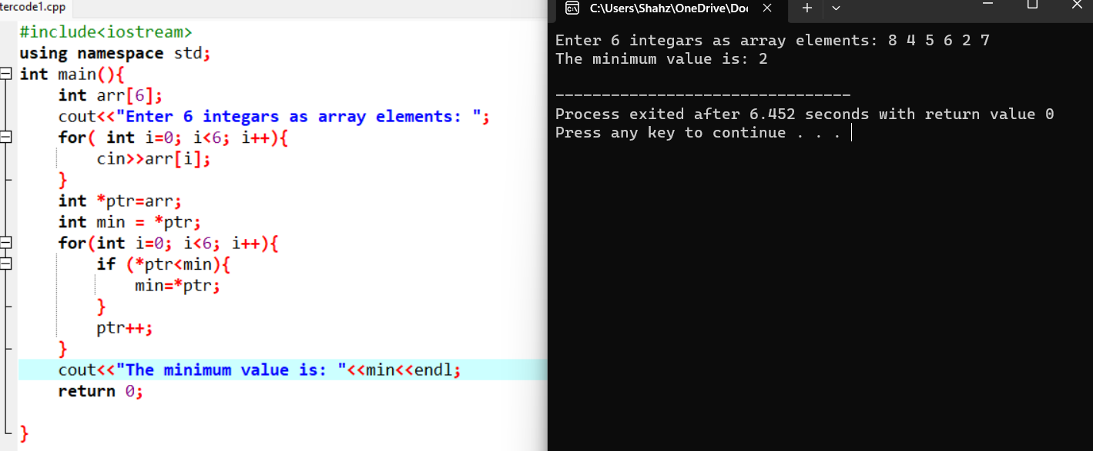

**Program 8:Pointer to reverse a character string:**

#include<iostream>

#include<cstring>

using namespace std;

int main(){

int maxlen=10;

char str[maxlen+1];

cout<<"Enter a string upto 10 charachters: ";

cin.get(str,maxlen+1);

int length= strlen(str);

char *start= str;

char *end= str+length-1;

while(start<end){

char temp = *start;

*start = *end;

*end = temp;

start++;

end--;

}

cout<<"Reversed string is: "<<str<<endl;

return 0;

}

**Output:**

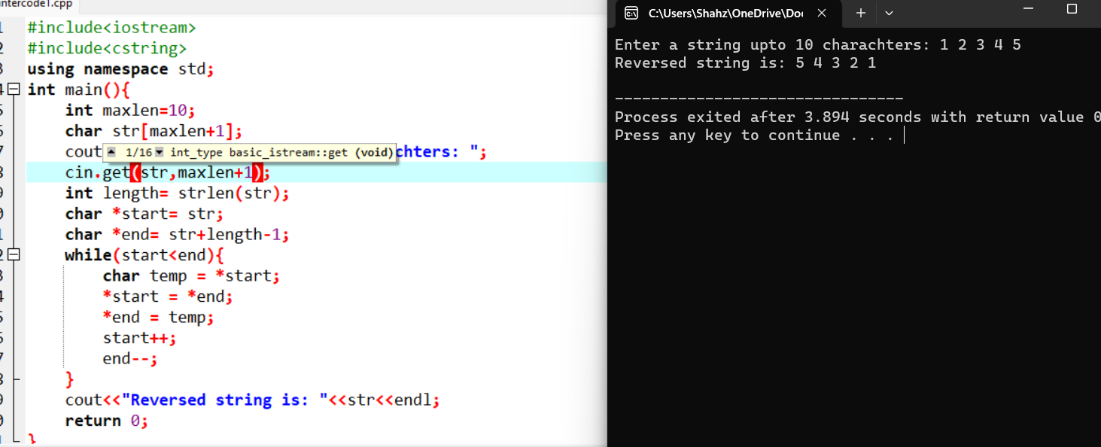

**Program 9: Pointer to object:**

#include<iostream>

#include<cstring>

using namespace std;

class Rectangle{

public:

int width;

int height;

};

int main(){

Rectangle rect;

rect.width=5;

rect.height=10;

Rectangle *ptr =&rect;

cout<<"Length: "<<ptr->height<<endl;

cout<<"Width:"<<ptr->width<<endl;

return 0;

}

**Output:**

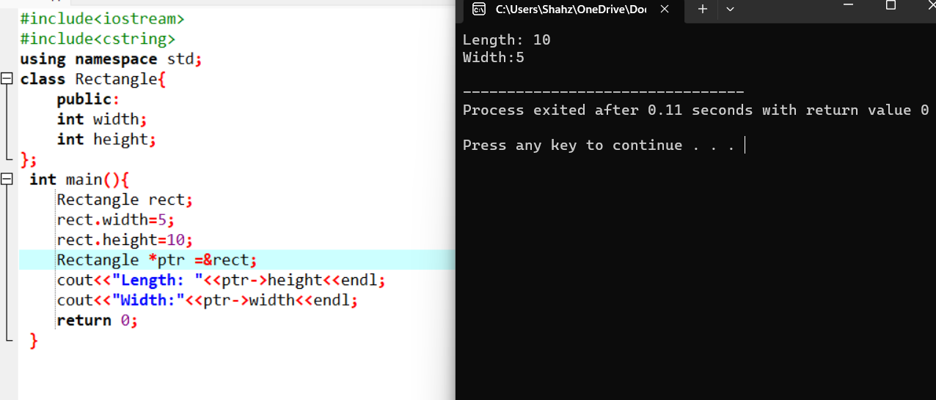

**Program 10: pointer to object and sum with pointer:**

#include<iostream>

#include<cstring>

using namespace std;

class Rectangle{

public:

int width;

int height;

};

int main(){

Rectangle rect;

cout<<"Enter the with: "<<endl;

cin>>rect.width;

cout<<"Enter the height: "<<endl;

cin>>rect.height;

Rectangle *ptr= &rect;

int *Widthpointer= &(ptr->width);

int *Heightpointer=&(ptr->height);

int sum= *Widthpointer+*Heightpointer;

cout<<"Width: "<<rect.width<<endl;

cout<<"Height: "<<rect.height<<endl;

cout<<"Sum: "<< sum<<endl;

return 0;

}

**Output:**

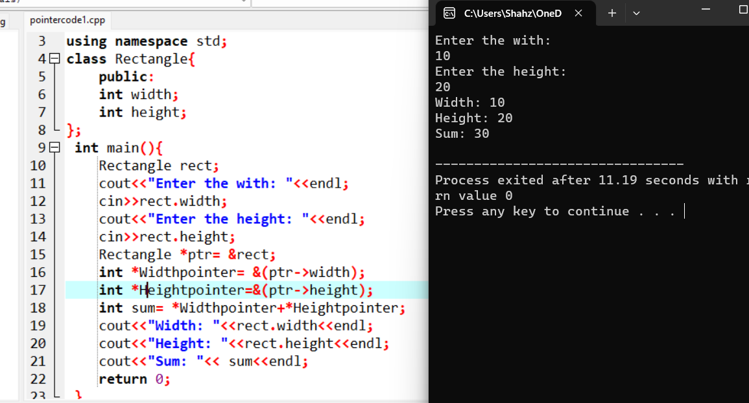

**Program 11:Pointer to Structure for Employee Information:**

#include<iostream>

#include<cstring>

using namespace std;

struct Employee{

string name;

int salary;

};

int main(){

int numEmployee = 3;

Employee employee[numEmployee];

for(int i=0; i<numEmployee; i++){

cout<<"Enter Employee name for: "<<i+1<<endl;

cin>>employee[i].name;

cout<<"Enter Employee salary for: "<<i+1<<endl;

cin>>employee[i].salary;

}

for(int i=0; i<numEmployee; i++){

Employee *emptr=&employee[i];

cout<<"Employee "<<i+1<<" information"<<endl;

cout<<"Name: "<<emptr->name<<endl;

cout<<"Salary: "<<emptr->salary<<endl;

}

return 0;

}

**Output:**

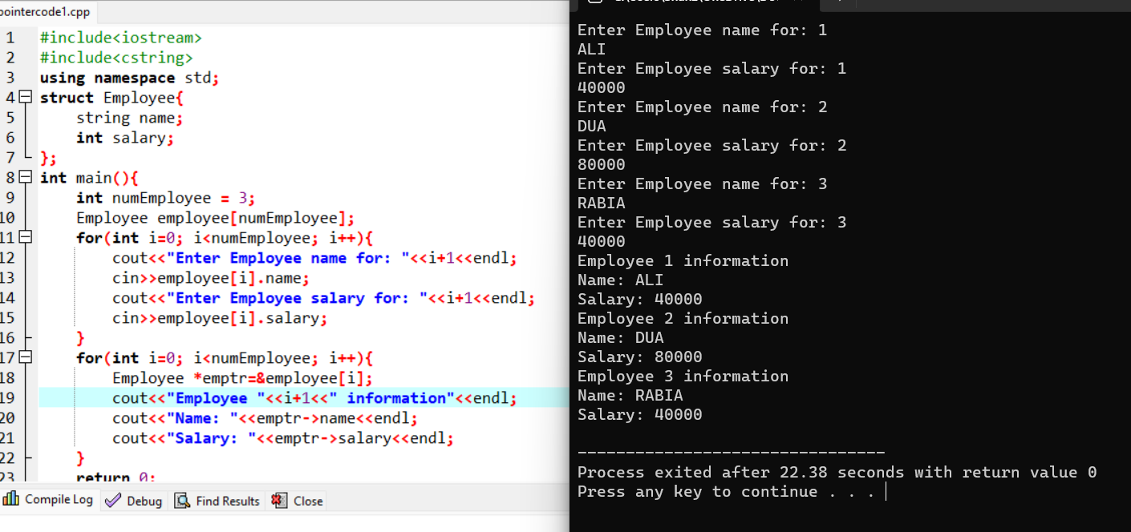

**Program 12: Array manipulation using pointers:**

#include<iostream>

using namespace std;

int main(){

int numbers[] ={1, 2, 3, 4, 5};

int *ptr=numbers;

for(int i=0;i<6;i++){

cout<< "Element " <<i<<": " <<*ptr <<endl;

ptr++;

}

ptr = numbers + 2;

*ptr = 10;

ptr = numbers;

for (int i = 0; i < 5; i++){

cout<< "Element " <<i<< ": "<<*ptr<<endl;

ptr++;

}

return 0;

}

**Output:**

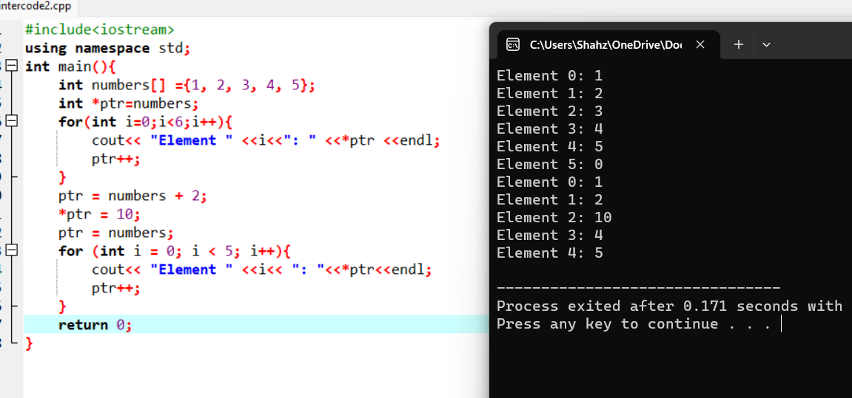

**Program 13:Counting Vowels:**

#include<iostream>

using namespace std;

bool isVowel(char ch) {

return (ch=='a' || ch=='e' || ch=='i' || ch=='o' || ch=='u' ||

ch=='A' || ch=='E' || ch=='I' || ch=='O' || ch=='U');

}

int countVowels(const char* str) {

int count =0;

while (*str){

if (isVowel(*str)) {

count++;

}

str++;

}

return count;

}

int main() {

const char *text = "Hello, World!";

int vowelCount = countVowels(text);

cout <<"The number of vowels in the text is: "<<vowelCount <<endl;

return 0;

}

**Output:**

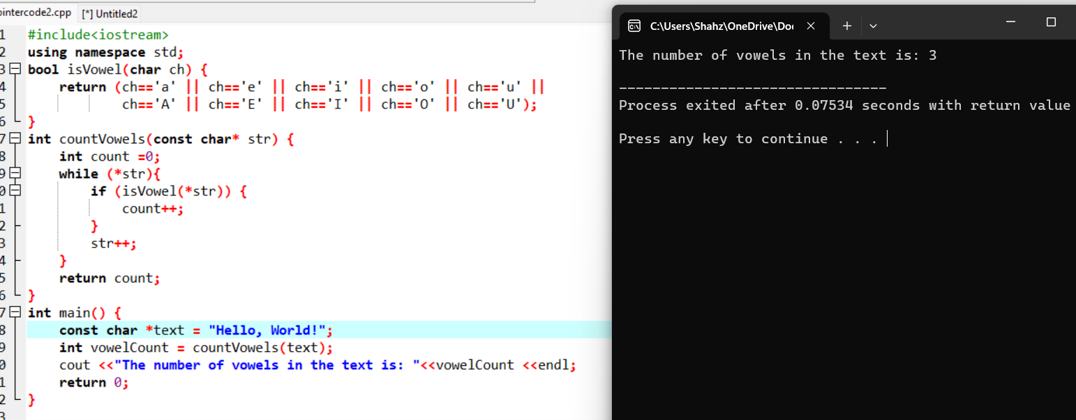

**Program 14:Finding Factorial:**

#include<iostream>

using namespace std;

int main() {

int number;

cout<<"Enter positive integer: ";

cin>>number;

if (number < 0) {

cout<< "Factorial not defined for negative numbers." <<endl;

} else {

int factorial = 1;

int *factorialPtr = &factorial;

for (int i = 1; i <= number; i++) {

*factorialPtr *= i;

}

cout<< "Factorial of " <<number << " is: " <<*factorialPtr<<endl;

}

return 0;

}

**Output:**

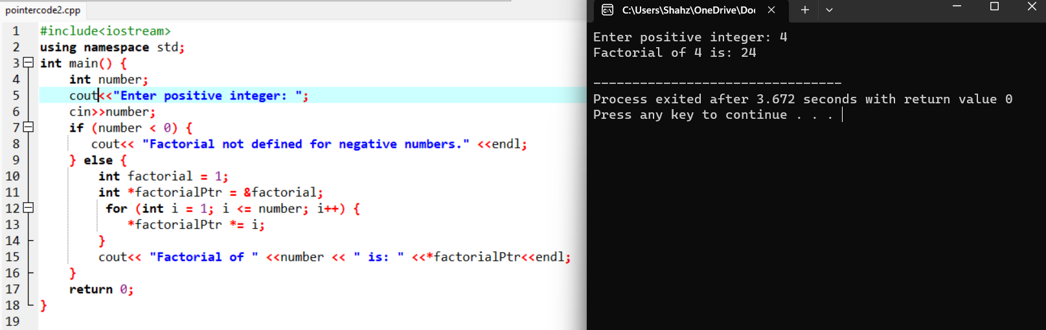

**Program 15:Person Introduction:**

#include <iostream>

using namespace std;

class Person{

public:

string name;

int age;

Person(string n, int a) :name(n), age(a) {}

void introduce(){

cout<< "Hi, my name is " <<name<< " and I am " <<age<< " years old." <<endl;

}

};

int main(){

Person person("Rabia", 20);

Person *personPtr = &person;

personPtr->introduce();

return 0;

}

**Output:**

