Microgrid to Grid-connected:
Two-Stage Capacity Expansion and DC Optimal Power Flow for Data Center Behind-the-Meter Generation

Introduction
Research question: When does it pay for a data center to sell its surplus on-site power back to the grid? And would energy prices will increase or decrease when data centers connect to the grid to sell their surplus capacity?
Global data center electricity consumption is projected to double to about 945 TWh by 2030, growing around 15% per year, more than four times faster than electricity demand from all other sectors. In the United States alone, data center consumption is expected to rise by about 240 TWh (+130%) over 2024 levels. However, grid connections are not keeping pace: as much as 20% of planned data center capacity could be delayed by grid constraints. To avoid these delays, hyperscalers are increasingly building behind-the-meter (BTM) power plants on site. For example, xAI received a permit for 41 natural gas turbines to power its Colossus data centers near Memphis. Once the grid connection arrives, however, these on-site plants risk sitting idle as backup, even though they could help supply a congested grid.
This project models the life cycle of such a facility in three regimes:
- off-grid “bridge” period in which BTM gas, solar and batteries supply all the data center’s demand (as a baseline with fixed capacity)
- grid-connected baseline in which the data center can import power but not export
- grid-connected regime in which it can also sell surplus BTM generation back to the grid.
The goal is to identify the export upgrade costs, fuel prices and levels of transmission congestion under which paying for export capacity lowers total system cost and relieves high prices in congested parts of the grid

- Motivation and What is Already Known

Stakeholder Context and Decision Problem
The rapid proliferation of artificial intelligence (AI), cloud computing, heat pumps, electric vehicles triggered unprecedented load growth across the United States bulk power system, creating acute tensions among four primary stakeholder groups:
- Hyperscale Data Center Developers: Facing potential revenue losses if compute deployment is delayed, developers increasingly construct behind-the-meter (BTM) microgrids of natural gas, liquefied natural gas (LNG), solar, and battery storage while waiting in utility interconnection queues. Once the grid substation is energized, developers must decide whether to retire these BTM assets, hold them strictly for emergency backup, or monetize them via grid export and demand-response contracts.

- Independent System Operators (ISOs) and Regional Transmission Organizations (RTOs): Operators such as PJM and ERCOT face mounting resource adequacy deficits and severe transmission congestion in concentrated “data center alleys” such as Loudoun County, Virginia, while managing interconnection backlogs exceeding 2,000 GW at the end of 2025.
- Load-Serving Entities (Utilities): Utilities must plan and finance a historic build-out. Investor-owned utilities plan at least $1.4 trillion in capital spending through 2030, driven largely by data center load growth. They must do so without stranding assets or shifting costs onto other customers if data center demand fails to materialize.
- Regulators (FERC and State PUCs): Policymakers are actively debating tariff structures, cost allocation, and reliability rules for co-located large loads and behind-the-meter generation (e.g., Federal Energy Regulatory Commission--FERC Docket AD24-11-000, Docket No. EL25-20-000).

Literature Review
Recent empirical and optimization literature establishes three foundational pillars for this study:
- Data Center Energy Growth and Operational Profiles: Shehabi et al. (2024) in the Lawrence Berkeley National Laboratory (LBNL) United States Data Center Energy Usage Report document that U.S. data center electricity demand tripled over the past decade and is projected to double or triple again by 2028, driven by high-utilization AI training clusters (85%–95% load factors) and temperature-sensitive cooling Power Usage Effectiveness ($\text{PUE}$).
- Interconnection Backlogs and Network Upgrade Costs: LBNL’s Queued Up series (Rand et al., 2026) finds that more than 2,000 GW of generation and storage (power plants, no data centers) was waiting to connect at the end of 2025, with typical waits exceeding five years. with network thermal upgrade costs acting as the primary barrier separating “Energy-Only / Zero-Export” interconnections from full capacity deliverability.
- Co-Optimization of Generation Sizing and DC Optimal Power Flow (DC-OPF): Classic transmission and capacity expansion literature formulates nodal pricing and congestion management using linear DC-OPF (e.g., Conejo et al., 2016; Brown et al., 2018). Recent studies have begun adding data centers to these models, either as large loads whose location is co-optimized with grid investment (Valencia Zuluaga et al., 2025) or as loads that can defer or shift workloads to reduce grid costs (Chen & Zheng, 2026). Related work on carbon-aware computing shifts flexible compute in time to cleaner hours (Radovanovic et al., 2022), and microgrid studies size on-site solar and storage for data centers (Irion et al., 2025).
However, these studies treat data centers as consumers only; none models data center microgrids injecting power back into a congested transmission network.

The Research Gap
While existing studies analyze either islanded microgrid sizing for data centers or demand-side compute curtailment in grid-connected facilities, a critical gap remains in quantifying the transition of a fixed-capacity behind-the-meter (BTM) "bridge" plant into a grid-interactive export resource.
Rather than optimizing the initial BTM generation mix, we use a fixed baseline capacity reflecting the facility's bridge-power deployment: 150 MW of natural gas turbines and 50 MW of solar. This 200 MW combined BTM plant is deliberately oversized relative to the data center's ~118 MW peak electrical demand (100 MW IT load plus PUE cooling overhead) to satisfy N+1 redundancy requirements, alongside [Y] MWh of battery storage.
Specifically, we address the following: once interconnected to a congested transmission node, under what network upgrade cost and locational marginal price (LMP) thresholds should the facility export surplus BTM generation back to the grid versus relying on grid imports with on-demand peak-shaving.

2. Problem Statement
We study when a hyperscale data center should purchase grid export capacity and sell surplus behind-the-meter (BTM) generation to the grid. Because a single facility is small relative to the regional market, we treat it as a price-taker and model the problem as a centralized cost minimization over the data center and the regional transmission network; under this assumption, the least-cost solution coincides with the data center’s profit-maximizing decisions when it is paid the locational marginal price (LMP) at its bus. The analysis covers a representative 168-hour summer week in three regimes.
Regime A (Islanded bridge): The data center has no connection to the transmission grid. Its BTM plant is fixed at a baseline capacity of 150 MW of natural gas turbines (fueled by pipeline gas or LNG) and 50 MW of solar. This 200 MW combined capacity is deliberately oversized to about 1.7× the ~118 MW peak data center load (100 MW IT load plus PUE cooling overhead) to reflect N+1 redundancy, alongside [Y] MWh of battery storage. The model dispatches these resources hourly to serve 100% of the data center’s server and cooling demand, subject to generator capacity limits, battery state-of-charge dynamics, and an optional carbon emissions cap.
Regimes B and C (Post-interconnection): The data center connects to a specific bus in a capacity-constrained transmission network, keeping the same BTM plant. In Regime B (zero-export baseline), it may import power up to the fixed substation limit but may not export. In Regime C (export-enabled), the model also decides how much export capacity to purchase at an amortized network upgrade cost. In both regimes, the model schedules hourly utility generation, BTM generation, battery charging and discharging, and grid imports and exports to meet 100% of data center and regional demand, s${\overline{K}}_{d}^{gas}$ubject to generator capacity limits, battery dynamics, linearized (DC) power flow equations and transmission line thermal limits.
The objective is to minimize total system investment and operating costs over the planning horizon. Comparing Regimes B and C shows under which export upgrade costs, fuel prices and congestion levels export capacity is worth its cost.

3. Optimization Model
Following the course guidelines, we formulate a multi-period DC Optimal Power Flow (DC-OPF) model with a fixed behind-the-meter (BTM) plant. The data center’s gas, solar, and battery capacities are fixed parameters (Section 3.2), so their capital cost is sunk and excluded from the objective; the only investment decision is how much grid export capacity to purchase.

3.1 Sets and Indices
- $N$: Set of transmission network buses, indexed by $i,j∈N$ (with reference/slack bus $\text{ref}∈N$).
- $L⊂N×N$: Set of directed transmission branches (lines and transformers), indexed by $\left(i,j\right)∈L$.
- $G$: Set of utility-scale generators, indexed by $g∈G$, with subset $G_{i}⊆G$ located at bus $i$.
- $D⊆N$: Set of buses hosting a hyperscale data center, indexed by $d∈D$.
- $T=\{1,…,T\}$: Set of discrete hourly time periods in the planning horizon, indexed by $t∈T$.

3.2 Parameters
- $D_{i,t}$: Non-data-center regional electricity demand at bus $i∈N$ in period $t∈T$ $\left[\text{MW}\right]$.
- $L_{d,t}^{\text{DC}}$: Total data center electricity load (IT compute plus cooling $\text{PUE}$) at node $d∈D$ in period $t∈T$ $\left[\text{MW}\right]$.
- ${\text{CF}}_{d,t}^{\text{sol}}∈\left[0,1\right]$: Hourly solar photovoltaic capacity factor at data center node $d$ in period $t$ $\left[\text{dimensionless}\right]$.
- $c_{g}^{\text{util}}$: Variable marginal generation cost (fuel plus variable O&M) of utility generator $g∈G$ $\left[\$/\text{MWh}\right]$.
- $c_{d}^{\text{gas}}$:Variable marginal generation cost of behind-the-meter natural gas/LNG at data center $d∈D$ $\left[\$/\text{MWh}\right]$.
- ${\overset{‾}{P}}_{g}^{\text{util}}$: Maximum nameplate capacity of utility generator $g∈G$ $\left[\text{MW}\right]$.
- $κ_{d}^{\text{exp}}$: Amortized network upgrade and interconnection cost per MW of export capacity at node $d$ $\left[\$/\text{MW}\right]$.
- ${\overset{‾}{K}}_{d}^{\text{imp}}$: Maximum physical substation import capacity at data center $d$ $\left[\text{MW}\right]$ ($0$ in Islanded Regime).
- $B_{ij}$: Series electrical susceptance of transmission branch $\left(i,j\right)∈L$ $\left[\text{MW/rad}\right]$.
- $F_{ij}^{max}$: Continuous thermal flow limit (rateA) of transmission branch $\left(i,j\right)∈L$ $\left[\text{MW}\right]$.
- $η_{\text{ch}},η_{\text{dis}}∈(0,1]$: Battery charging and discharging efficiency $\left[\text{dimensionless}\right]$, and $γ∈(0,1]$: battery power-to-energy ratio $\left[\text{MW/MWh}\right]$.
- $e_{d}^{\text{gas}}$: Carbon emission rate of BTM gas $\left[{\text{tCO}}_{2}/\text{MWh}\right]$, and ${\overset{‾}{E}}_{{\text{CO}}_{2}}$: maximum permissible carbon emissions cap $\left[{\text{tCO}}_{2}\right]$.
- ${\overline{K}}_{d}^{\text{gas}}$: Fixed installed BTM natural gas/LNG generation capacity at data center d [MW] (e.g., 150 MW).
- ${\overline{K}}_{d}^{\text{sol}}$: Fixed installed BTM solar PV capacity at data center d [MW] (e.g., 50 MW).
- ${\overline{K}}_{d}^{\text{bess}}$: Fixed installed BTM battery storage energy capacity at data center d [MWh]

3.3 Decision Variables
All decision variables below are continuous unless otherwise noted for discrete upgrade tiers:
- $K_{d}^{\text{exp}}≥0$: Purchased grid export interconnection capacity at data center $d∈D$ $\left[\text{MW}\right]$ (Continuous).
- $p_{g,t}^{\text{util}}≥0$: Power output of utility generator $g∈G$ in period $t∈T$ $\left[\text{MW}\right]$ (Continuous).
- $g_{d,t}^{\text{gas}},g_{d,t}^{\text{sol}}≥0$: BTM gas and solar power generated at data center $d∈D$ in period $t∈T$ $\left[\text{MW}\right]$ (Continuous).
- $p_{d,t}^{\text{ch}},p_{d,t}^{\text{dis}}≥0$: BTM battery charging and discharging power at data center $d∈D$ in period $t∈T$ $\left[\text{MW}\right]$ (Continuous).
- $s_{d,t}≥0$: Battery state of charge (stored energy) at data center $d∈D$ at the end of period $t∈T$ $\left[\text{MWh}\right]$ (Continuous).
- $p_{d,t}^{\text{imp}},p_{d,t}^{\text{exp}}≥0$: Power imported from and exported to the transmission grid at data center $d∈D$ in period $t∈T$ $\left[\text{MW}\right]$ (Continuous).
- $f_{ij,t}∈R$: Active power flow on branch $\left(i,j\right)∈L$ in period $t∈T$ $\left[\text{MW}\right]$ (Continuous, unrestricted in sign).
- $θ_{i,t}∈R$: Voltage phase angle at bus $i∈N$ in period $t∈T$ $\left[\text{radians}\right]$ (Continuous, unrestricted in sign).

3.4 Objective Function
We minimize the total system cost (the sum of amortized export interconnection capital costs plus hourly utility and BTM operational dispatch costs across all periods $t∈T$):
$\min{\sum_{d∈D}{κ_{d}^{\text{exp}}}}K_{d}^{\text{exp}}+\sum_{t∈T}{\left(\sum_{g∈G}{c_{g}^{\text{util}}}p_{g,t}^{\text{util}}+\sum_{d∈D}{c_{d}^{\text{gas}}}g_{d,t}^{\text{gas}}\right)}$

3.5 Constraints
Nodal Power Balance (Dual variable $λ_{i,t}$ yields the Nodal LMP):

Enforces Kirchhoff’s Current Law at every transmission bus so that net power outflows plus local grid load and net data center imports exactly equal local utility generation.
Data Center Internal Microgrid Power Balance:
$$g_{d,t}^{\text{gas}}+g_{d,t}^{\text{sol}}+p_{d,t}^{\text{dis}}-p_{d,t}^{\text{ch}}+p_{d,t}^{\text{imp}}-p_{d,t}^{\text{exp}}=L_{d,t}^{\text{DC}} ∀d∈D, ∀t∈T$$
Ensures the data center’s hourly compute and cooling load is satisfied 100% of the time by on-site generation, net battery discharge, and net grid imports.
DC-OPF Linearized Branch Power Flow:
$$f_{ij,t}=B_{ij}\left(θ_{i,t}-θ_{j,t}\right) ∀\left(i,j\right)∈L, ∀t∈T$$
Defines active power flow along each transmission line as proportional to the line susceptance and the phase angle difference between connected buses.
Transmission Line Thermal Limits:
$$-F_{ij}^{max}≤f_{ij,t}≤F_{ij}^{max} ∀\left(i,j\right)∈L, ∀t∈T$$
Restricts bidirectional power flow on every transmission branch to remain within its continuous thermal rating (rateA).
Rotor Angle Stability and Linear Approximation Bounds:
$$-\frac{π}{6}≤θ_{i,t}-θ_{j,t}≤\frac{π}{6} ∀\left(i,j\right)∈L, ∀t∈T, θ_{\text{ref},t}=0 ∀t∈T$$
Bounds phase angle differences within $±{30}^{∘}$ to ensure rotor stability and preserve the accuracy of the small-angle sine approximation, while fixing the slack bus angle to zero.
Utility and BTM Generator Capacity Bounds:
$$\begin{matrix}0≤p_{g,t}^{\text{util}}≤{\overset{‾}{P}}_{g}^{\text{util}} ∀g∈G, ∀t∈T \\ 0≤g_{d,t}^{\text{gas}}≤{\overset{‾}{K}}_{d}^{\text{gas}}, 0≤g_{d,t}^{\text{sol}}≤{\text{CF}}_{d,t}^{\text{sol}}{\overset{‾}{K}}_{d}^{\text{sol}} ∀d∈D, ∀t∈T\end{matrix}$$
Limits utility generators to their nameplate rating and restricts BTM gas and solar output to their fixed installed capacities scaled by hourly solar irradiance availability.
Interconnection Import and Export Limits:
$$0≤p_{d,t}^{\text{imp}}≤{\overset{‾}{K}}_{d}^{\text{imp}}, 0≤p_{d,t}^{\text{exp}}≤K_{d}^{\text{exp}} ∀d∈D, ∀t∈T$$
Enforces that hourly grid imports cannot exceed physical substation capacity and hourly grid exports cannot exceed the purchased export interconnection capacity.
Battery Storage State-of-Charge Dynamics and Power Limits:
$$s_{d,t}=s_{d,t-1}+η_{\text{ch}} p_{d,t}^{\text{ch}}-\frac{1}{η_{\text{dis}}} p_{d,t}^{\text{dis}} ∀d∈D, ∀t∈T$$
$$s_{d,0}=s_{d,T}=0.5 {\overset{‾}{K}}_{d}^{\text{bess}} ∀d∈D$$
$$0≤s_{d,t}≤{\overset{‾}{K}}_{d}^{\text{bess}}, 0≤p_{d,t}^{\text{ch}}, p_{d,t}^{\text{dis}}≤γ {\overset{‾}{K}}_{d}^{\text{bess}} ∀d∈D, ∀t∈T$$
Tracks stored energy from hour to hour, accounting for charging and discharging losses. The battery starts and ends the horizon half full, so the model cannot drain stored energy for free, and both stored energy and charge/discharge power are limited by the installed battery size.
Optional Carbon Emissions Cap:
t∈T​d∈D​edgas gd,tgas≤ECO2
Caps total behind-the-meter fossil emissions. Because the BTM plant is fixed, the cap does not change what is built; it limits how many hours the gas turbines can run, shifting the data center toward solar, the battery, and grid imports and reducing the gas available for export. We test three settings: no cap, a partial cap that allows some gas, and a zero-gas cap. The zero-gas case is feasible only in Regimes B and C, because 50 MW of solar plus storage cannot meet the data center’s load on its own in Regime A.

3.6 Problem Class and Solver Selection
This baseline formulation is a continuous Linear Program (LP). LP is the ideal problem class because linear convexity guarantees global optimality, scales efficiently across multi-period networks, and provides well-defined shadow prices ($λ_{\left\{i,t\right\}}$) on the nodal balance constraints to directly measure Locational Marginal Prices.
(In our full study, this extends to a Mixed-Integer Linear Program [MILP] when introducing binary unit commitment or discrete network upgrade $z_{d }∈ \left\{0,1\right\}$. To extract LMPs in the MILP formulation, we employ standard practice: solving the MILP to global optimality via branch-and-bound, fixing the binary variables at their optimal values, and re-solving the resulting continuous LP to obtain the shadow prices.)
We solve the model in Julia using the Gurobi Optimizer.

3.7 What the Model Deliberately Leaves Out
- AC Reactive Power ($Q$), Voltage Magnitudes ($\left|V\right|$), and Off-Nominal Transformer Tap Ratios ($τ_{ij}$): We employ the lossless linear DC-OPF approximation (assuming $\left|V_{i}\right|=1.0\text{ p.u.}$, $r_{ij}≈0$, and $τ_{ij}=1.0$) rather than non-convex AC-OPF. This is acceptable and standard in techno-economic capacity expansion studies because wholesale congestion rents and thermal interconnection upgrades at the sub-transmission/transmission interface are primarily driven by real power ($P$) thermal limits.
- Non-Convex Bilevel Strategic Bidding (MPEC): We formulate a single-level centralized social-welfare cost minimization rather than a bilevel equilibrium model where the data center strategically withholds export capacity to manipulate nodal LMPs. Because a single 100–150 MW data center represents a small fraction of a regional ISO pool, treating the facility as a competitive participant in a centralized dispatch is economically realistic and avoids intractable complementarity constraints.

4. Data and Experimental Design

4.1 Data Sources and Sample Verification
All required datasets have been downloaded, parsed, and committed to our project directory:
- Transmission Network Topology: PGLib-OPF / MATPOWER IEEE 14-Bus and 200-Bus benchmark networks (pglib_opf_case14_ieee.m), providing branch reactances ($x_{ij}$), thermal limits (rateA), and bus loads: https://raw.githubusercontent.com/power-grid-lib/pglib-opf/master/pglib_opf_case14_ieee.m.
- Generator & Storage CAPEX/OPEX: National Renewable Energy Laboratory (NREL) Annual Technology Baseline (NREL_ATB_Electricity_Workbook.xlsx), providing capital costs, heat rates, and O&M for natural gas turbines, solar PV, and Li-ion BESS: https://data.openei.org/files/6006/2024_v4_Workbook_7-22-2026.xlsx.
- Empirical Hourly Weather & Solar Irradiance (Ashburn, VA): Open-Meteo Historical Archive API (ashburn_weather_raw.json), providing measured hourly 2-meter ambient temperature ($T_{t}^{\text{amb}}$) and shortwave solar radiation (${\text{W/m}}^{2}$) in Loudoun County, VA (“Data Center Alley”) for peak summer conditions (July 15–21, 2025): https://archive-api.open-meteo.com/v1/archive?latitude=39.0438&longitude=-77.4874&start_date=2025-07-15&end_date=2025-07-21&hourly=temperature_2m,shortwave_radiation&timezone=America%2FNew_York.
- Empirical Data Center Sizing & Queue Costs: LBNL 2024 US Data Center Energy Usage Report (https://eta-publications.lbl.gov/publications/2024-lbnl-data-center-energy-usage-report) and LBNL Interconnection Costs (https://emp.lbl.gov/interconnection_costs).

4.2 Defense of Synthetic Data Construction
Because commercial hyperscalers restrict building-level smart-meter traces as proprietary trade secrets, we construct our 168-hour single-facility demand profile (single_dc_profile.csv) using a deterministic engineering physics model rather than random number generation:
$$L_{t}^{\text{DC}}=P_{\text{rated}}^{\text{IT}}⋅u_{t}⋅\text{PUE}\left(T_{t}^{\text{amb}}\right), \text{PUE}\left(T_{t}^{\text{amb}}\right)=1.10+0.008⋅max\left(0, T_{t}^{\text{amb}}-{15}^{∘}\text{C}\right)$$
With the following assumptions/estimates:
- where $P_{\text{rated}}^{\text{IT}}=100\text{ MW}$ represents a standard hyperscale campus
- Utilization $u_{t}∈\left[0.88,0.94\right]$ is a modeling assumption representing a high-utilization AI campus
- $\text{PUE}\left(T_{t}^{\text{amb}}\right)$ scales chiller cooling load linearly with real measured Ashburn, VA hourly temperatures. We set the baseline PUE to 1.10, consistent with reported hyperscale fleet averages (Google reports 1.09 for 2025) and assume cooling overhead rises linearly by 0.008 per °C above 15°C, reflecting the higher PUE observed in hot seasons and climates.

4.3 Baseline, Experimental Variations, Null Result, and Fallback Plan
Baseline vs. Experiment: We compare three operational regimes:
- Regime A (Islanded BTM Bridge): ${\overset{‾}{K}}^{\text{imp}}=0$, $K^{\text{exp}}=0$ (pre-interconnection baseline: the fixed bridge plant of 150 MW gas, 50 MW solar, and [Y] MWh of battery storage serves 100% of the data center’s load with no grid connection. Regimes B and C keep this same plant, so any cost difference comes from the grid connection and the export option, not from new investment).
- Regime B (Grid-Connected Zero-Export Baseline): ${\overset{‾}{K}}^{\text{imp}}>0$, but $K^{\text{exp}}=0$ (current industry default where BTM assets sit idle or self-supply only during price spikes).
- Regime C (Grid-Connected Export-Enabled / On-Demand Contract): Co-optimizes $K^{\text{exp}}≥0$ and bidirectional dispatch.
What We Will Vary:
- Amortized export interconnection upgrade cost (Cost for gird operator to connect Data Center to grid) $κ^{exp}$ ($10–$100/MW),
- LNG/gas fuel price ($c^{\text{gas}}∈\left[\$35,\$75\right]/\text{MWh}$),
- transmission thermal congestion severity ($F_{ij}^{max}$), and
- carbon cap stringency (${\overset{‾}{E}}_{{\text{CO}}_{2}}$).
Becoming a Peaker vs Only running in DataC microgrid: An interesting result identifies a non-linear regime boundary where moderate congestion spreads justify paying network upgrade fees to turn data center BTM gas/solar into a “virtual peaker”. A null result occurs if network upgrade costs ($κ^{\text{exp}}$) exceed congestion rents across all realistic scarcity scenarios, yielding $K^{\text{exp}*}=0$ (meaning data centers should strictly peak-shave imports via $p_{t}^{\text{imp}}=0$ rather than export).
Fallback Plan: If scaling to a 200-bus synthetic ISO grid across 8,760 hours introduces MILP memory bottlenecks, our fallback is the downloaded IEEE 14-Bus system (pglib_opf_case14_ieee.m) solved over 168 hourly periods (single_dc_profile.csv), which solves to optimality in under 2 seconds in Gurobi.

5. Results:

3-Bus, 2-Period Toy Example
To verify our formulation prior to scaling to the 14-bus network, we solve a 3-bus, 2-period triangle network ($B_{12}=B_{13}=B_{23}=1000\text{ MW/rad}$) using two empirical hours from single_dc_profile.csv:
Period 1 (Hour 4, 3:00 AM Off-Peak: $T={23.2}^{∘}\text{C}$, $L_{1}^{\text{DC}}=101.94\text{ MW}$, ${\text{CF}}_{1}^{\text{sol}}=0$) and
Period 2 (Hour 15, 2:00 PM Peak: $T={33.2}^{∘}\text{C}$, $L_{2}^{\text{DC}}=114.72\text{ MW}$, ${\text{CF}}_{2}^{\text{sol}}=0.785$).
- Bus 1 hosts cheap utility baseload ($c_{1}=\$25/\text{MWh}$),
- Bus 2 hosts the Data Center ($c_{\text{gas}}=\$45/\text{MWh}$, $K^{\text{gas}}=150\text{ MW}$ | $K^{\text{sol}}=50\text{ MW}$), and
- Bus 3 is a congested load pocket ($D_{3,1}=100\text{ MW}$, $D_{3,2}=220\text{ MW}$) served by an expensive utility peaker ($c_{3}=\$120/\text{MWh}$) behind thermally constrained Line $1→3$ ($F_{13}^{max}=120\text{ MW}$).

Regime | Period | DC Load (MW) | BTM Gas (MW) | BTM Solar (MW) | Grid Import (MW) | Grid Export (MW) | Bus 3 Peaker (MW) | Bus 2 LMP ($/MWh) | Bus 3 LMP ($/MWh) | Total System Cost ($)
Baseline (Zero-Export) | 1 (Off-Peak) | 101.94 | 0 | 0 | 101.9 | 0 | 0 | $ 25.0 | $ 25.0 | $ 5,049
Baseline (Zero-Export) | 2 (Peak) | 114.72 | 73.2 | 41.6 | 0 | 0 | 40 | $ 72.5 | $ 120.0 | $ 5,049
Experiment (Export-Enabled) | 1 (Off-Peak) | 101.94 | 0 | 0 | 101.9 | 0 | 0 | $ 25.0 | $ 25.0 | $ 12,593
Experiment (Export-Enabled) | 2 (Peak) | 114.72 | 150 | 41.6 | 0 | 76.8 | 1.6 | $ 72.5 | $ 120.0 | $ 10,480 + $768 (export)
Baseline (Zero-Export) |  |  |  |  |  |  |  |  | TOTAL | $17,641
Experiment (Export-Enabled) |  |  |  |  |  |  |  |  | TOTAL | $16,297
 |  |  |  |  |  |  |  |  | savings | $1,345
Note: Table reflects the verified output in toy_3bus_cost_comparison_1.xlsx.
Refer to Appendix 8 & 9. 3-bus example results under Regime B & C

Cost comparison:
Cost doesn’t change between no-export vs. export options due to no congestion in period 1
Period | Cost component | Regime B production (MW) | Regime B cost ($) | Regime C production (MW) | Regime C cost ($) | Savings B − C ($)
Period 1 (3:00 AM) | Bus 1 baseload ($25/MWh) | 201.94 | $5,049 | 201.94 | $5,049 | -
Period 1 (3:00 AM) | Bus 3 peaker ($120/MWh) | - | - | - | - | -
Period 1 (3:00 AM) | Data center BTM gas ($45/MWh) | - | - | - | - | -
Period 1 (3:00 AM) | Data center solar ($0/MWh) | - | - | - | - | -
Period 1 (3:00 AM) | Subtotal (total generation / operating cost) | 201.94 | $5,049 | 201.94 | $5,049 | -
Cost savings due to reduction of peaker and instead gas is used to it’s maximum allowing data center to sell it’s surplus, getting paid at $72.5 bus 2 marginal price while gas cost $45.
Period | Cost component | Regime B production (MW) | Regime B cost ($) | Regime C production (MW) | Regime C cost ($) | Savings B − C ($)
Period 2 (2:00 PM) | Bus 1 baseload ($25/MWh) | 180.00 | $4,500 | 141.59 | $3,540 | $960
Period 2 (2:00 PM) | Bus 3 peaker ($120/MWh) | 40.00 | $4,800 | 1.59 | $190 | $4,610
Period 2 (2:00 PM) | Data center BTM gas ($45/MWh) | 73.17 | $3,293 | 150.00 | $6,750 | ($3,457)
Period 2 (2:00 PM) | Data center solar ($0/MWh) | 41.55 | - | 41.55 | - | -
Period 2 (2:00 PM) | Subtotal (total generation / operating cost) | 334.72 | $12,593 | 334.72 | $10,480 | $2,113
Both periods | Total operating cost | 536.66 | $17,641 | 536.66 | $15,528 | $2,113
Both periods | Export capacity (K_exp × κ_exp) $10* | - | - | 76.83 | $768 | ($768)
Both periods | Total system cost |  | $17,641 |  | $16,297 | $1,345
* Assumed value. Exporting stays worthwhile while κ < $27.50/MW (LMP at Bus 2 $72.50 − gas cost $45).

7. Division of Labor

Scope | John | Diana
Problem statement | Defined problem and scope | Defined problem and scope
Literature review | Gathered and reviewed sources | Gathered and reviewed sources
Optimization model | Defined initial model | Reviewed proposed model-made updates
Toy example | Gathered data for toy example: synthetic data construction | Reviewed proposed data: synthetic data construction
Model run | Run model with Gurobi | --
Results | Results recorded from model | 3 bus graphs to represent results and draw conclusions

AI use
Claude Opus 5.5 & Gemini 3.1 Pro was used during the literature review to confirm available papers related to the topic, and to confirm and validate data assumptions (AI boom in numbers, connection queues and data center sources of energy – if many are using BTM as assumed)
It was also used to generate a graph of the toy example in a 3-node visual representation, building based on assumptions on toy example, and the results from the model. It was verified step by step to confirm optimization model was correct (flow conservation demand=supply, and limit constraints)
It was also used to generate Business as Usual vs Grid connection graphic.

References

- International Energy Agency, Energy and AI, 2025. https://www.iea.org/reports/energy-and-ai/executive-summary
- Southern Environmental Law Center, press release, March 10, 2026. https://www.selc.org/press-releases/mississippi-regulators-rubber-stamp-air-permit-for-xai-power-plant-ignoring-overwhelming-public-pushback/
- Through the first quarter of 2026, CERA has tracked 130 North American data center projects that plan to build on-site generation. S&PGlobal. https://www.spglobal.com/energy/en/news-research/latest-news/natural-gas/052726-pipeline-operators-strike-deals-as-data-centers-turn-to-colocated-generation
- E&E News, “US utilities planning record-breaking capital spending,” April 15, 2026. https://www.eenews.net/articles/us-utilities-planning-record-breaking-capital-spending/
- A. Shehabi et al., 2024 United States Data Center Energy Usage Report, Lawrence Berkeley National Laboratory, LBNL-2001637, December 2024. https://eta-publications.lbl.gov/publications/2024-lbnl-data-center-energy-usage-report
- J. Rand et al., Queued Up: 2026 Edition, Characteristics of Power Plants Seeking Transmission Interconnection as of the End of 2025, Lawrence Berkeley National Laboratory, 2026. Available: https://emp.lbl.gov/queues
- preprint, not peer-reviewed:
  - T. Valencia Zuluaga, J.-P. Watson and S. Pang, “Nodal Capacity Expansion Planning with Flexible Large-Scale Load Siting,” arXiv preprint arXiv:2510.19781, 2025 (v2, April 15, 2026).
  - Y. Chen and X. Zheng, “To Defer or To Shift? The Role of AI Data Center Flexibility on Grid Interconnection,” arXiv preprint arXiv:2604.05376, April 2026.
- B. Gibbons, “Power grab for Musk AI data center in Memphis sparks environmental justice fight,” Oil & Gas Watch, Environmental Integrity Project, Mar. 5, 2026. https://news.oilandgaswatch.org/post/natural-gas-power-grab-for-musk-ai-data-center-in-memphis-sparks-environmental-justice-fight
- WREG News Channel 3, “TVA OKs additional 150 MW of electricity for xAI Memphis data center,” April 2026. https://wreg.com/news/local/tva-oks-additional-150-mw-of-electricity-for-xai-memphis-data-center/

Appendix

Appendix 1: Global data center electricity consumption, by equipment, Base Case, 2020-2030

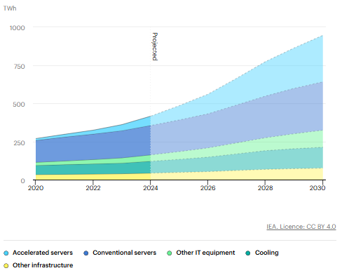
Appendix 2. Global data center capacity additions in the Base Case and capacity at risk of connection delay due to grid constraints, 2025-2030

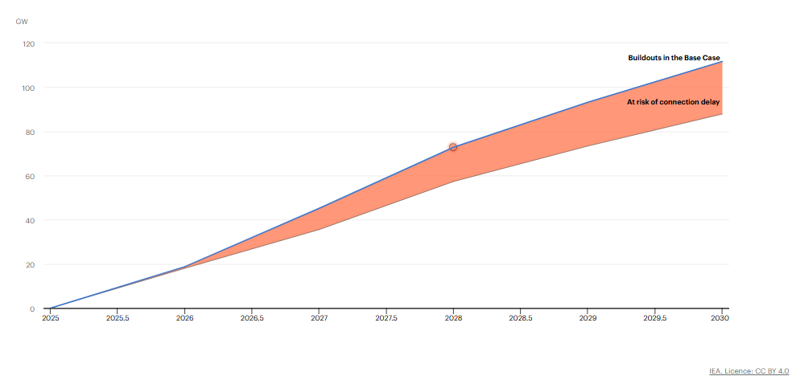
Appendix 3. Nodal power balance:
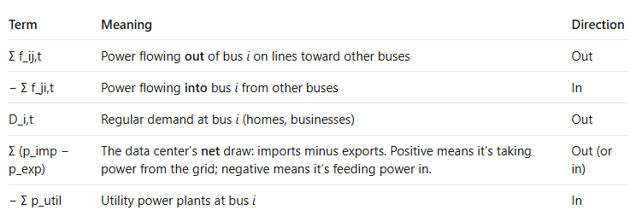

Appendix 4. Data center internal Microgrid Power balance:
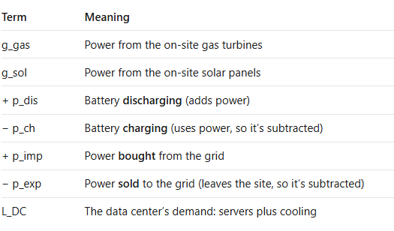
Appendix 5. Interconnection Import and Export Limits:

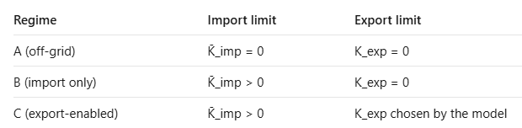

Appendix 6. Gas turbines for the xAI facility
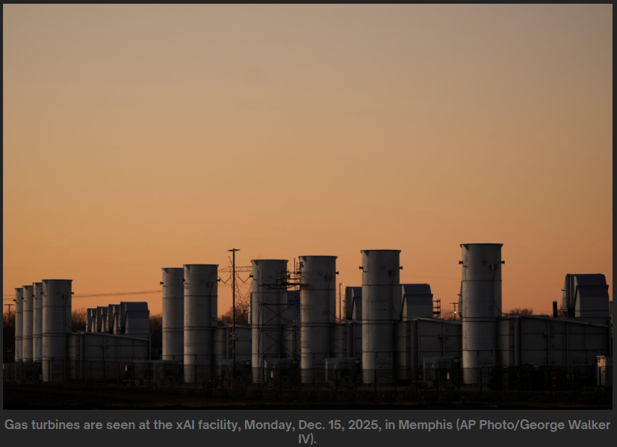
Appendix 7. Data center Colossus in Memphis
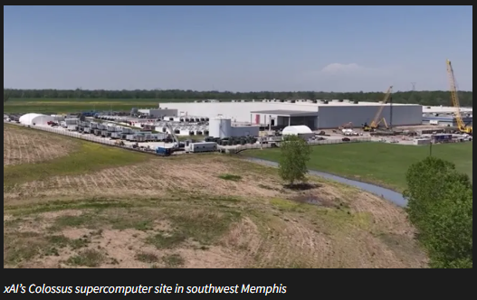

Appendix 8. 3-bus example results under Regime B

Regime B: on-grid but no export:

- In Period 1, Line $1→3$ is uncongested ($100\text{ MW}<120\text{ MW}$), nodal LMPs are uniform at $25/MWh, and the data center imports 100% of its power.
- Total demand = data center 101.94 + Bus 3’s 100 = 201.94 MW, all supplied by Bus 1. So P_G1 = 201.9 MW.
- Bus 1 baseload ($25) is cheaper than the data center’s gas ($45), so the data center (in bus2) buys from the grid instead of running gas. That gives BTM gas = 0.0 MW and Import = 101.9 MW.

Figure 1. Period 1 Off-Peak time (no export)
$$L_{1}^{\text{DC}}=101.94\text{ MW| }D_{3,1}=100\text{ MW}$$
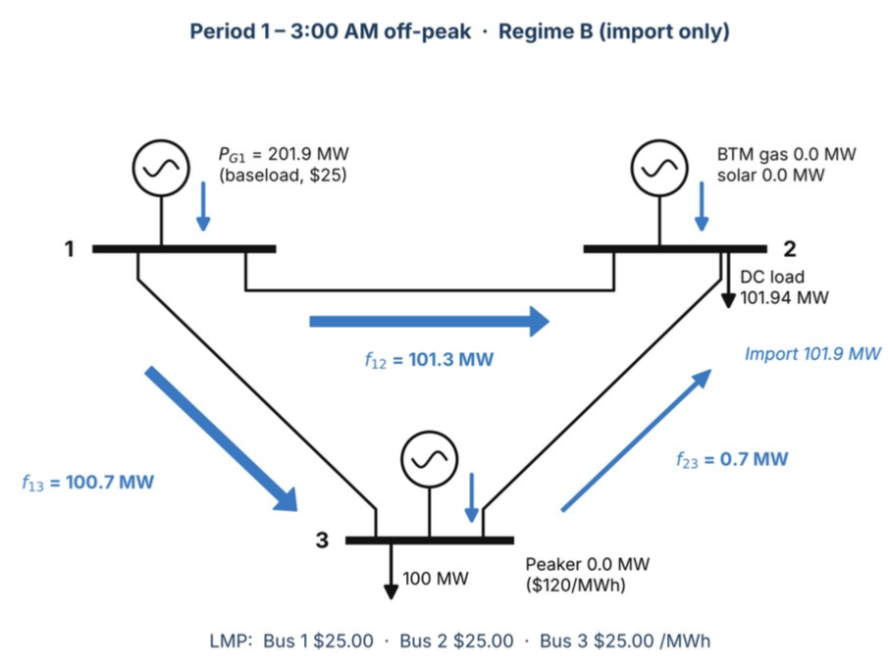

- In Period 2, Line $1→3$ binds at $120\text{ MW}$, splitting nodal LMPs to $72.50/MWh at Bus 2 and $120/MWh at Bus 3.
- Bus 3 needs 220 MW, and the cheapest power ($25) is at Bus 1. But the direct line from Bus 1 to Bus 3 can carry only 120 MW, so it maxes out: f₁₃ = 120.0 MW (limit).
- Bus 2: The data center isn’t importing or exporting, so Bus 2 is a pass-through. Whatever enters Bus 2 must leave it, which means f₁₂ = f₂₃.
- Data center: solar is free, so all 41.5 MW is used. Gas covers the rest: 114.72 − 41.55 = 73.2 MW. Net grid exchange = 0, so it’s self-supplied.
- Peaker at Bus 3 = 220 − (120 + 60) = 40.0 MW. It fills the gap the lines can’t deliver.
- NOTE: the data center has spare gas capacity (150 − 73.2 = 76.8 MW) costing $45, while Bus 3 is paying $120 for the peaker, allowing BTM to cover for the peaker will reduce total cost for the system.

Figure 2. Period 2 Peak (no export)
$L_{2}^{\text{DC}}=114.72\text{MW }{\text{CF}}_{2}^{\text{sol}}=0.785$ |$D_{3,2}=220\text{ MW}$
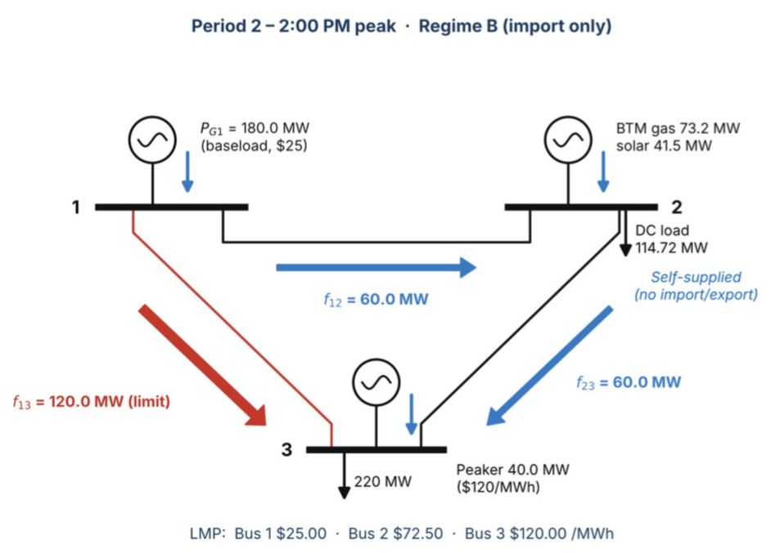

Appendix 9. 3-bus example results under Regime C
Regime C: grid-connected with export option:
- In Period 1, Line $1→3$ is uncongested ($100\text{ MW}<120\text{ MW}$), nodal LMPs are uniform at $25/MWh, and the data center imports 100% of its power.
- Grid power ($25) is cheaper than gas ($45), so gas = 0.0 MW and Import = 101.9 MW, Export = 0.
- Bus 1 supplies everything: 101.94 + 100 = 201.9 MW.
- Peaker = 0.0 MW (not needed).
- NOTE: being allowed to export only matters when there’s congestion

Figure 3. Period 1 Off-Peak time (with export)
$$L_{1}^{\text{DC}}=101.94\text{ MW| }D_{3,1}=100\text{ MW}$$
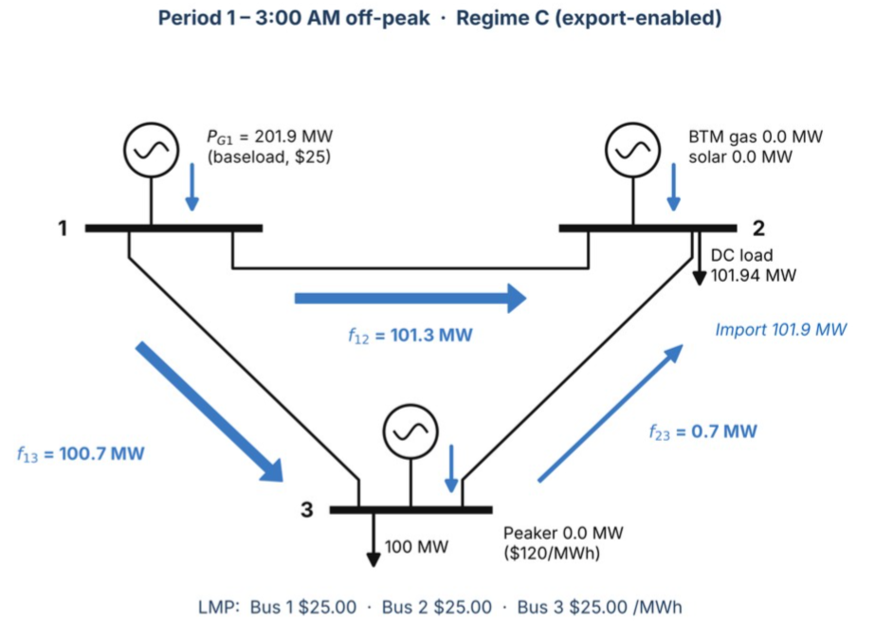

Figure 2. Period 2 Peak (with export)
$L_{2}^{\text{DC}}=114.72\text{MW }{\text{CF}}_{2}^{\text{sol}}=0.785$ |$D_{3,2}=220\text{ MW}$
- In Period 2, Line $1→3$ binds at $120\text{ MW}$, splitting nodal LMPs to $72.50/MWh at Bus 2 and $120/MWh at Bus 3.
- Marginal price at Bus 2 is worth $72.50/MWh (due to congestion).
- Gas costs $45/MWh, so every MW sold earns $27.50.
- The model therefore runs gas at its maximum: BTM gas = 150.0 MW.
- Export = gas + solar − DC load = 150 + 41.55 − 114.72 = 76.8 MW (K_exp = 76.83 MW export capacity which is the surplus)
- Bus 1 baseload = f₁₂ + f₁₃ = 21.6 + 120 = 141.6 MW
- Peaker at Bus 3 = 220 − (120 + 98.4) = 1.6 MW
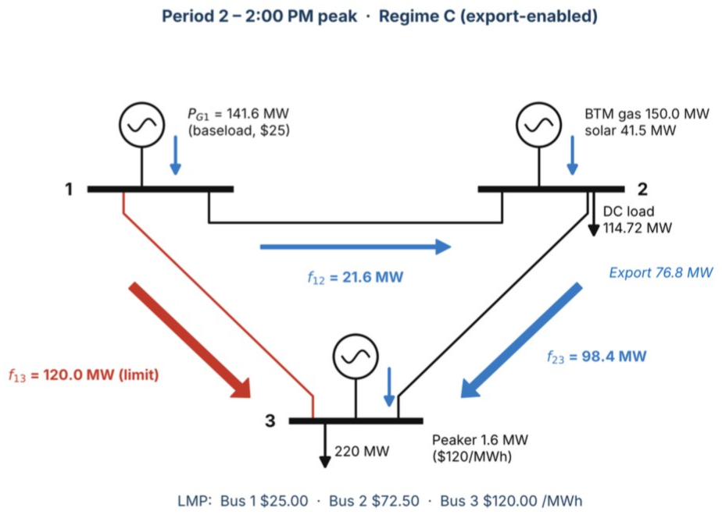

Appendix 10. Visual representation of Grid-Interactive architecture (regime C) Vs. usual setup (regime A)
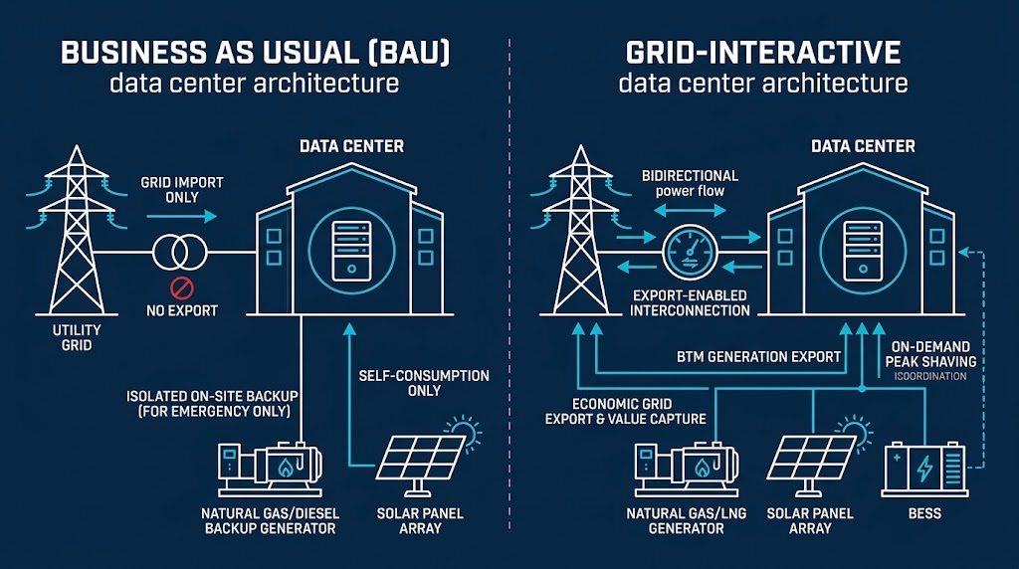

International Energy Agency, Energy and AI, 2025. https://www.iea.org/reports/energy-and-ai/executive-summary
Ibid
Southern Environmental Law Center, press release, March 10, 2026. https://www.selc.org/press-releases/mississippi-regulators-rubber-stamp-air-permit-for-xai-power-plant-ignoring-overwhelming-public-pushback/
Through the first quarter of 2026, CERA has tracked 130 North American data center projects that plan to build on-site generation. S&PGlobal. https://www.spglobal.com/energy/en/news-research/latest-news/natural-gas/052726-pipeline-operators-strike-deals-as-data-centers-turn-to-colocated-generation
J. Rand et al., Queued Up: 2026 Edition, Characteristics of Power Plants Seeking Transmission Interconnection as of the End of 2025, Lawrence Berkeley National Laboratory, 2026.
E&E News, “US utilities planning record-breaking capital spending,” April 15, 2026. https://www.eenews.net/articles/us-utilities-planning-record-breaking-capital-spending/
A. Shehabi et al., 2024 United States Data Center Energy Usage Report, Lawrence Berkeley National Laboratory, LBNL-2001637, December 2024. https://eta-publications.lbl.gov/publications/2024-lbnl-data-center-energy-usage-report
J. Rand et al., Queued Up: 2026 Edition, Characteristics of Power Plants Seeking Transmission Interconnection as of the End of 2025, Lawrence Berkeley National Laboratory, 2026.
T. Valencia Zuluaga, J.-P. Watson and S. Pang, “Nodal Capacity Expansion Planning with Flexible Large-Scale Load Siting,” arXiv preprint arXiv:2510.19781, 2025 (v2, April 15, 2026).
Y. Chen and X. Zheng, “To Defer or To Shift? The Role of AI Data Center Flexibility on Grid Interconnection,” arXiv preprint arXiv:2604.05376, April 2026.
hourly solar capacity factor: the fraction of the solar panels’ full rated output that they actually produce in a given hour.
https://www.datacenters.google/efficiency/
IEA (2025), Global data centre electricity consumption, by equipment, Base Case, 2020-2030, IEA, Paris https://www.iea.org/data-and-statistics/charts/global-data-centre-electricity-consumption-by-equipment-base-case-2020-2030, Licence: CC BY 4.0
IEA (2025), Global data centre capacity additions in the Base Case and capacity at risk of connection delay due to grid constraints, 2025-2030, IEA, Paris https://www.iea.org/data-and-statistics/charts/global-data-centre-capacity-additions-in-the-base-case-and-capacity-at-risk-of-connection-delay-due-to-grid-constraints-2025-2030, Licence: CC BY 4.0
B. Gibbons, “Power grab for Musk AI data center in Memphis sparks environmental justice fight,” Oil & Gas Watch, Environmental Integrity Project, Mar. 5, 2026. https://news.oilandgaswatch.org/post/natural-gas-power-grab-for-musk-ai-data-center-in-memphis-sparks-environmental-justice-fight
WREG News Channel 3, “TVA OKs additional 150 MW of electricity for xAI Memphis data center,” [date]. https://wreg.com/news/local/tva-oks-additional-150-mw-of-electricity-for-xai-memphis-data-center/

