Microgrid to Grid-connected:
Two-Stage Capacity Expansion and DC Optimal Power Flow for Data Center Behind-the-Meter Generation

Introduction
Research question: Can on-site generation make a data center curtailable without losing compute? When does a flexible connection, in which the grid may curtail the data center’s imports during stressed hours, cost the system less than a firm connection, and how much does it reduce network upgrades and local electricity prices?
Global data center electricity consumption is projected to double to about 945 TWh by 2030, growing around 15% per year, more than four times faster than electricity demand from all other sectors. In the United States alone, data center consumption is expected to rise by about 240 TWh (+130%) over 2024 levels. However, grid connections are not keeping pace: as much as 20% of planned data center capacity could be delayed by grid constraints. To avoid these delays, hyperscalers are increasingly building behind-the-meter (BTM) power plants on site. For example, xAI received a permit for 41 natural gas turbines to power its Colossus data centers near Memphis. Once the grid connection arrives, these on-site plants typically sit idle as backup. They could instead let the data center step back from the grid during its most stressed hours while computing continues at full output.
This project models the life cycle of such a facility in three regimes:
- off-grid “bridge” period in which BTM gas, solar and batteries supply all the data center’s demand (as a baseline with fixed capacity)
- firm connection, in which the grid must deliver the data center’s full demand in every hour, likely requiring network upgrades, and the on-site plant is only backup
- flexible connection, in which the grid may curtail the data center’s imports in stressed hours, the on-site plant covers the gap, and fewer upgrades are needed.
The goal is to identify the network upgrade costs, fuel prices and levels of transmission congestion under which a flexible connection lowers total system cost compared with a firm one, and how much it relieves congestion and high prices in the surrounding grid.

- Motivation and What is Already Known

Stakeholder Context and Decision Problem
The rapid proliferation of artificial intelligence (AI), cloud computing, heat pumps, electric vehicles triggered unprecedented load growth across the United States bulk power system, creating acute tensions among four primary stakeholder groups:
- Hyperscale Data Center Developers: Facing potential revenue losses if compute deployment is delayed, developers increasingly construct behind-the-meter (BTM) microgrids of natural gas, liquefied natural gas (LNG), solar, and battery storage while waiting in utility interconnection queues. Once the grid substation is energized, developers must decide whether to retire these BTM assets, hold them strictly for emergency backup, or use them to qualify for a faster, flexible grid connection in which the grid may curtail the facility’s imports during stressed hours.

- Independent System Operators (ISOs) and Regional Transmission Organizations (RTOs): Operators such as PJM and ERCOT face mounting resource adequacy deficits and severe transmission congestion in concentrated “data center alleys” such as Loudoun County, Virginia, while managing interconnection backlogs exceeding 2,000 GW at the end of 2025.
- Load-Serving Entities (Utilities): Utilities must plan and finance a historic build-out. Investor-owned utilities plan at least $1.4 trillion in capital spending through 2030, driven largely by data center load growth. They must do so without stranding assets or shifting costs onto other customers if data center demand fails to materialize.
- Regulators (FERC and State PUCs): Policymakers are actively debating tariff structures, cost allocation, and reliability rules for co-located large loads and behind-the-meter generation (e.g., Federal Energy Regulatory Commission--FERC Docket AD24-11-000, Docket No. EL25-20-000). In June 2026, FERC ordered each regional grid operator, including PJM, to justify or revise its rules for interconnecting large loads, and asked them to consider new firm and non-firm transmission services for large loads that can limit their grid withdrawals during stress, as well as processes for studying generation that serves nearby large loads (Appendix 9). In Texas, Senate Bill 6 (2025) requires large loads of 75 MW or more that interconnect after 2025 to install equipment that lets ERCOT curtail them during emergencies, and lets ERCOT direct loads with on-site backup generation to run it or reduce their grid draw.

Literature Review
Recent empirical and optimization literature establishes three foundational pillars for this study:
- Data Center Energy Growth and Operational Profiles: Shehabi et al. (2024) in the Lawrence Berkeley National Laboratory (LBNL) United States Data Center Energy Usage Report document that U.S. data center electricity demand tripled over the past decade and is projected to double or triple again by 2028, driven by high-utilization AI training clusters (85%–95% load factors) and temperature-sensitive cooling Power Usage Effectiveness ($\text{PUE}$).
- Interconnection Backlogs and Network Upgrade Costs: LBNL’s Queued Up series (Rand et al., 2026) finds that more than 2,000 GW of generation and storage (power plants, no data centers) was waiting to connect at the end of 2025, with typical waits exceeding five years. with network thermal upgrade costs acting as the primary barrier separating “Energy-Only / Zero-Export” interconnections from full capacity deliverability.
- Co-Optimization of Generation Sizing and DC Optimal Power Flow (DC-OPF): Classic transmission and capacity expansion literature formulates nodal pricing and congestion management using linear DC-OPF (e.g., Conejo et al., 2016; Brown et al., 2018). Recent studies have begun adding data centers to these models, either as large loads whose location is co-optimized with grid investment (Valencia Zuluaga et al., 2025) or as loads that can defer or shift workloads to reduce grid costs (Chen & Zheng, 2026). Related work on carbon-aware computing shifts flexible compute in time to cleaner hours (Radovanovic et al., 2022), and microgrid studies size on-site solar and storage for data centers (Irion et al., 2025).
Norris et al. (2025) estimate that U.S. power systems could absorb about 76 GW of new large load if those loads accept curtailment for 0.25% of their maximum uptime, and about 126 GW at 1%. They point to on-site power and energy storage as one way for loads to curtail, but their analysis estimates system-level headroom rather than modeling how an individual facility keeps operating while curtailed. The data center flexibility studies above obtain flexibility through siting, deferring, or shifting computing. None models on-site generation as the resource that lets a data center be curtailed while its computing load stays fully served, within a congested transmission network.

The Research Gap
While existing studies analyze islanded microgrid sizing for data centers, flexibility that relocates, defers, or shifts computing, or how much curtailable load a grid can absorb, a gap remains in quantifying how a fixed-capacity behind-the-meter (BTM) "bridge" plant can make a data center curtailable without losing compute, and what that flexibility is worth to the transmission system.
Rather than optimizing the initial BTM generation mix, we use a fixed baseline capacity reflecting the facility's bridge-power deployment: 150 MW of natural gas turbines and 50 MW of solar. This 200 MW combined BTM plant is deliberately oversized relative to the data center's ~118 MW peak electrical demand (100 MW IT load plus PUE cooling overhead) to satisfy N+1 redundancy requirements, alongside [Y] MWh of battery storage.
Specifically, we ask: once the data center connects to a congested transmission node, under what network upgrade costs, fuel prices and congestion levels does a flexible connection, in which the grid may curtail the facility’s imports and the BTM plant fills the gap, cost less than a firm connection that must serve the full load at all times? And how much upgrade investment and local price relief does that flexibility provide?

2. Problem Statement
We study a hyperscale data center and its behind-the-meter (BTM) generation as a single co-located unit connected to a congested transmission node. Rather than exporting power, the unit may accept curtailment of its grid withdrawals during stressed hours while its BTM natural gas, solar and battery resources keep the computing load fully served. Because a single facility is small relative to the regional market, we model the problem as a centralized cost minimization over the unit and the regional transmission network, using a representative 168-hour summer week.
Regime A (Islanded bridge): The data center has no connection to the transmission grid. Its BTM plant is fixed at a baseline capacity of 150 MW of natural gas turbines (fueled by pipeline gas or LNG) and 50 MW of solar. This 200 MW combined capacity is deliberately oversized to about 1.7× the ~118 MW peak data center load (100 MW IT load plus PUE cooling overhead) to reflect N+1 redundancy, alongside [Y] MWh of battery storage. The model dispatches these resources hourly to serve 100% of the data center’s server and cooling demand, subject to generator capacity limits, battery state-of-charge dynamics, and an optional carbon emissions cap.
Regime B (Firm connection): The data center connects to a specific bus in a capacity-constrained transmission network and keeps the same BTM plant. The grid must deliver the data center’s full demand in every hour. Doing so is likely to require network upgrades, and the on-site plant serves only as backup.
Regime C (Flexible connection): Same bus and plant, but the grid may curtail the data center’s imports during stressed hours. The on-site plant covers the gap so computing continues at full output, and fewer network upgrades are needed.
In Regimes B and C, the model schedules hourly utility generation, BTM generation, battery charging and discharging, and grid imports to meet 100% of data center and regional demand, subject to generator capacity limits, battery dynamics, linearized (DC) power flow equations and transmission line thermal limits.
The objective is to minimize total system investment and operating costs over the planning horizon. Comparing Regimes B and C shows under which upgrade costs, fuel prices and congestion levels a flexible connection is worth more than a firm one.

3. Optimization Model
Following the course guidelines, we formulate a multi-period DC Optimal Power Flow (DC-OPF) model with a fixed behind-the-meter (BTM) plant. The data center’s gas, solar, and battery capacities are fixed parameters (Section 3.2), so their capital cost is sunk and excluded from the objective; the only investment decision is how much network upgrade capacity to build.

3.1 Sets and Indices
- $N$: Set of transmission network buses, indexed by $i,j∈N$ (with reference/slack bus $\text{ref}∈N$).
- $L⊂N×N$: Set of directed transmission branches (lines and transformers), indexed by $\left(i,j\right)∈L$.
- $G$: Set of utility-scale generators, indexed by $g∈G$, with subset $G_{i}⊆G$ located at bus $i$.
- $D⊆N$: Set of buses hosting a hyperscale data center, indexed by $d∈D$.
- $D_{i}⊆D$: Data center located at bus $i$ (empty if bus $i$ hosts no data center).
- $T=\{1,…,T\}$: Set of discrete hourly time periods in the planning horizon, indexed by $t∈T$.

3.2 Parameters
- $D_{i,t}$: Non-data-center regional electricity demand at bus $i∈N$ in period $t∈T$ $\left[\text{MW}\right]$.
- $L_{d,t}^{\text{DC}}$: Total data center electricity load (IT compute plus cooling $\text{PUE}$) at node $d∈D$ in period $t∈T$ $\left[\text{MW}\right]$.
- ${\text{CF}}_{d,t}^{\text{sol}}∈\left[0,1\right]$: Hourly solar photovoltaic capacity factor at data center node $d$ in period $t$ $\left[\text{dimensionless}\right]$.
- $c_{g}^{\text{util}}$: Variable marginal generation cost (fuel plus variable O&M) of utility generator $g∈G$ $\left[\$/\text{MWh}\right]$.
- $c_{d}^{\text{gas}}$:Variable marginal generation cost of behind-the-meter natural gas/LNG at data center $d∈D$ $\left[\$/\text{MWh}\right]$.
- ${\overset{‾}{P}}_{g}^{\text{util}}$: Maximum nameplate capacity of utility generator $g∈G$ $\left[\text{MW}\right]$.
- $κ_{ij}^{\text{up}}$: Amortized network upgrade cost per MW of thermal capacity added to branch $\left(i,j\right)∈L$, scaled to the modeled horizon $\left[\$/\text{MW}\right]$.
- $α∈\left[0,1\right]$: Curtailment budget, the maximum share of the data center’s energy the grid may curtail over the horizon (Regime C) [dimensionless].
- ${\overset{‾}{K}}_{d}^{\text{imp}}$: Maximum physical substation import capacity at data center $d$ $\left[\text{MW}\right]$ ($0$ in Islanded Regime).
- $B_{ij}$: Series electrical susceptance of transmission branch $\left(i,j\right)∈L$ $\left[\text{MW/rad}\right]$.
- $F_{ij}^{max}$: Continuous thermal flow limit (rateA) of transmission branch $\left(i,j\right)∈L$ $\left[\text{MW}\right]$.
- $η_{\text{ch}},η_{\text{dis}}∈(0,1]$: Battery charging and discharging efficiency $\left[\text{dimensionless}\right]$, and $γ∈(0,1]$: battery power-to-energy ratio $\left[\text{MW/MWh}\right]$.
- $e_{d}^{\text{gas}}$: Carbon emission rate of BTM gas $\left[{\text{tCO}}_{2}/\text{MWh}\right]$, and ${\overset{‾}{E}}_{{\text{CO}}_{2}}$: maximum permissible carbon emissions cap $\left[{\text{tCO}}_{2}\right]$.
- ${\overline{K}}_{d}^{\text{gas}}$: Fixed installed BTM natural gas/LNG generation capacity at data center d [MW] (e.g., 150 MW).
- ${\overline{K}}_{d}^{\text{sol}}$: Fixed installed BTM solar PV capacity at data center d [MW] (e.g., 50 MW).
- ${\overline{K}}_{d}^{\text{bess}}$: Fixed installed BTM battery storage energy capacity at data center d [MWh]

3.3 Decision Variables
All decision variables below are continuous unless otherwise noted for discrete upgrade tiers:
- $ΔF_{ij}≥0$: Thermal capacity added to branch $\left(i,j\right)∈L$ by network upgrades $\left[\text{MW}\right]$ (Continuous).
- $p_{g,t}^{\text{util}}≥0$: Power output of utility generator $g∈G$ in period $t∈T$ $\left[\text{MW}\right]$ (Continuous).
- $g_{d,t}^{\text{gas}},g_{d,t}^{\text{sol}}≥0$: BTM gas and solar power generated at data center $d∈D$ in period $t∈T$ $\left[\text{MW}\right]$ (Continuous).
- $p_{d,t}^{\text{ch}},p_{d,t}^{\text{dis}}≥0$: BTM battery charging and discharging power at data center $d∈D$ in period $t∈T$ $\left[\text{MW}\right]$ (Continuous).
- $s_{d,t}≥0$: Battery state of charge (stored energy) at data center $d∈D$ at the end of period $t∈T$ $\left[\text{MWh}\right]$ (Continuous).
- $p_{d,t}^{\text{imp}}≥0$: Power imported from the transmission grid by data center $d∈D$ in period $t∈T$ $\left[\text{MW}\right]$ (Continuous).
- $c_{d,t}≥0$: Grid import curtailed at data center $d∈D$ in period $t∈T$ and covered by the BTM plant (Regime C) $\left[\text{MW}\right]$ (Continuous).
- $f_{ij,t}∈R$: Active power flow on branch $\left(i,j\right)∈L$ in period $t∈T$ $\left[\text{MW}\right]$ (Continuous, unrestricted in sign).
- $θ_{i,t}∈R$: Voltage phase angle at bus $i∈N$ in period $t∈T$ $\left[\text{radians}\right]$ (Continuous, unrestricted in sign).

3.4 Objective Function
We minimize the total system cost (the sum of amortized network upgrade costs plus hourly utility and BTM operating costs across all periods $t∈T$):
mini,j∈L​κijup ΔFij+t∈T​g∈G​cgutil pg,tutil+d∈D​cdgas gd,tgas

3.5 Constraints
Nodal Power Balance (Dual variable $λ_{i,t}$ yields the Nodal LMP):
i,j∈L​fij,t−j,i∈L​fji,t+Di,t+d∈Di​pd,timp−g∈Gi​pg,tutil=0 ∀i∈N, ∀t∈T λi,t

Enforces Kirchhoff’s Current Law at every transmission bus so that net power outflows plus local grid load and net data center imports exactly equal local utility generation.
Data Center Internal Microgrid Power Balance:
$$g_{d,t}^{\text{gas}}+g_{d,t}^{\text{sol}}+p_{d,t}^{\text{dis}}−p_{d,t}^{\text{ch}}+p_{d,t}^{\text{imp}}=L_{d,t}^{\text{DC}} ∀d∈D, ∀t∈T$$
Ensures the data center’s hourly compute and cooling load is satisfied 100% of the time by on-site generation, net battery discharge, and net grid imports.
DC-OPF Linearized Branch Power Flow:
$$f_{ij,t}=B_{ij}\left(θ_{i,t}-θ_{j,t}\right) ∀\left(i,j\right)∈L, ∀t∈T$$
Defines active power flow along each transmission line as proportional to the line susceptance and the phase angle difference between connected buses.
Transmission Line Thermal Limits:
$$−\left(F_{ij}^{max}+ΔF_{ij}\right)≤f_{ij,t}≤F_{ij}^{max}+ΔF_{ij} ∀\left(i,j\right)∈L, ∀t∈T$$
Restricts bidirectional power flow on every transmission branch to remain within its continuous thermal rating (rateA) plus any capacity added by network upgrades.
Rotor Angle Stability and Linear Approximation Bounds:
$$-\frac{π}{6}≤θ_{i,t}-θ_{j,t}≤\frac{π}{6} ∀\left(i,j\right)∈L, ∀t∈T, θ_{\text{ref},t}=0 ∀t∈T$$
Bounds phase angle differences within $±{30}^{∘}$ to ensure rotor stability and preserve the accuracy of the small-angle sine approximation, while fixing the slack bus angle to zero.
Utility and BTM Generator Capacity Bounds:
$$\begin{matrix}0≤p_{g,t}^{\text{util}}≤{\overset{‾}{P}}_{g}^{\text{util}} ∀g∈G, ∀t∈T \\ 0≤g_{d,t}^{\text{gas}}≤{\overset{‾}{K}}_{d}^{\text{gas}}, 0≤g_{d,t}^{\text{sol}}≤{\text{CF}}_{d,t}^{\text{sol}}{\overset{‾}{K}}_{d}^{\text{sol}} ∀d∈D, ∀t∈T\end{matrix}$$
Limits utility generators to their nameplate rating and restricts BTM gas and solar output to their fixed installed capacities scaled by hourly solar irradiance availability.
Interconnection Import Limit:
$$0≤p_{d,t}^{\text{imp}}≤{\overset{‾}{K}}_{d}^{\text{imp}} ∀d∈D, ∀t∈T$$
Enforces that hourly grid imports cannot exceed the physical substation capacity.
Regime-Specific Constraints:
$$\text{Regime A:} p_{d,t}^{\text{imp}}=0 ∀d∈D, ∀t∈T$$
$$\text{Regime B:} p_{d,t}^{\text{imp}}=L_{d,t}^{\text{DC}}, g_{d,t}^{\text{gas}}=g_{d,t}^{\text{sol}}=p_{d,t}^{\text{ch}}=p_{d,t}^{\text{dis}}=0 ∀d∈D, ∀t∈T$$
Regime C: cd,t≥Ld,tDC−pd,timp ∀d∈D, ∀t∈T, t∈T​cd,t≤αt∈T​Ld,tDC ∀d∈D
In Regime A the data center has no grid connection. In Regime B the grid must deliver the full data center load in every hour and the BTM plant stays off as backup, so any congestion must be relieved by network upgrades. In Regime C the grid may deliver less than the full load; the shortfall c is covered by the BTM plant, and the curtailment budget α limits how much of the data center’s energy can be curtailed. Because Regime B fixes imports at the full load, it requires a substation import capacity at least equal to the peak load.
Battery Storage State-of-Charge Dynamics and Power Limits:
$$s_{d,t}=s_{d,t-1}+η_{\text{ch}} p_{d,t}^{\text{ch}}-\frac{1}{η_{\text{dis}}} p_{d,t}^{\text{dis}} ∀d∈D, ∀t∈T$$
$$s_{d,0}=s_{d,T}=0.5 {\overset{‾}{K}}_{d}^{\text{bess}} ∀d∈D$$
$$0≤s_{d,t}≤{\overset{‾}{K}}_{d}^{\text{bess}}, 0≤p_{d,t}^{\text{ch}}, p_{d,t}^{\text{dis}}≤γ {\overset{‾}{K}}_{d}^{\text{bess}} ∀d∈D, ∀t∈T$$
Tracks stored energy from hour to hour, accounting for charging and discharging losses. The battery starts and ends the horizon half full, so the model cannot drain stored energy for free, and both stored energy and charge/discharge power are limited by the installed battery size.
Optional Carbon Emissions Cap:
t∈T​d∈D​edgas gd,tgas≤ECO2
Caps total behind-the-meter fossil emissions. Because the BTM plant is fixed, the cap does not change what is built; it limits how many hours the gas turbines can run, shifting the data center toward solar, the battery, and grid imports and reducing the gas available to cover curtailment. We test three settings: no cap, a partial cap that allows some gas, and a zero-gas cap. The zero-gas case is feasible only in Regimes B and C, because 50 MW of solar plus storage cannot meet the data center’s load on its own in Regime A.

3.6 Problem Class and Solver Selection
This baseline formulation is a continuous Linear Program (LP). LP is the ideal problem class because linear convexity guarantees global optimality, scales efficiently across multi-period networks, and provides well-defined shadow prices ($λ_{\left\{i,t\right\}}$) on the nodal balance constraints to directly measure Locational Marginal Prices.
(In our full study, this extends to a Mixed-Integer Linear Program [MILP] when introducing binary unit commitment or discrete network upgrade $z_{d }∈ \left\{0,1\right\}$. To extract LMPs in the MILP formulation, we employ standard practice: solving the MILP to global optimality via branch-and-bound, fixing the binary variables at their optimal values, and re-solving the resulting continuous LP to obtain the shadow prices.)
We solve the model in Julia using the Gurobi Optimizer.

3.7 What the Model Deliberately Leaves Out
- AC Reactive Power ($Q$), Voltage Magnitudes ($\left|V\right|$), and Off-Nominal Transformer Tap Ratios ($τ_{ij}$): We employ the lossless linear DC-OPF approximation (assuming $\left|V_{i}\right|=1.0\text{ p.u.}$, $r_{ij}≈0$, and $τ_{ij}=1.0$) rather than non-convex AC-OPF. This is acceptable and standard in techno-economic capacity expansion studies because wholesale congestion rents and thermal interconnection upgrades at the sub-transmission/transmission interface are primarily driven by real power ($P$) thermal limits.
- Non-Convex Bilevel Strategic Bidding (MPEC): We formulate a single-level centralized social-welfare cost minimization rather than a bilevel equilibrium model where the data center strategically times its grid withdrawals or curtailment to influence nodal LMPs. Because a single 100–150 MW data center represents a small fraction of a regional ISO pool, treating the facility as a competitive participant in a centralized dispatch is economically realistic and avoids intractable complementarity constraints.

4. Data and Experimental Design

4.1 Data Sources and Sample Verification
All required datasets have been downloaded, parsed, and committed to our project directory:
- Transmission Network Topology: PGLib-OPF / MATPOWER IEEE 14-Bus and 200-Bus benchmark networks (pglib_opf_case14_ieee.m), providing branch reactances ($x_{ij}$), thermal limits (rateA), and bus loads: https://raw.githubusercontent.com/power-grid-lib/pglib-opf/master/pglib_opf_case14_ieee.m.
- Generator & Storage CAPEX/OPEX: National Renewable Energy Laboratory (NREL) Annual Technology Baseline (NREL_ATB_Electricity_Workbook.xlsx), providing capital costs, heat rates, and O&M for natural gas turbines, solar PV, and Li-ion BESS: https://data.openei.org/files/6006/2024_v4_Workbook_7-22-2026.xlsx.
- Empirical Hourly Weather & Solar Irradiance (Ashburn, VA): Open-Meteo Historical Archive API (ashburn_weather_raw.json), providing measured hourly 2-meter ambient temperature ($T_{t}^{\text{amb}}$) and shortwave solar radiation (${\text{W/m}}^{2}$) in Loudoun County, VA (“Data Center Alley”) for peak summer conditions (July 15–21, 2025): https://archive-api.open-meteo.com/v1/archive?latitude=39.0438&longitude=-77.4874&start_date=2025-07-15&end_date=2025-07-21&hourly=temperature_2m,shortwave_radiation&timezone=America%2FNew_York.
- Real-Time Hourly LMPs (Ashburn, VA): PJM Data Miner 2 real-time hourly LMP feed (rt_hrl_lmps) for the ASHBURN 35 kV load node (pnode 34886139, Dominion zone), giving the total LMP and its system energy, congestion, and marginal loss components. LMP_ashburn_July14-23-2025.csv covers July 14–23, 2025 and includes all 168 hours of July 15–21, the same week as the weather data; LMP_Ashburn_Year Long Data.csv covers November 1, 2025 to November 1, 2026 (8,761 hours); LMP_ashburn_Nov_01.csv covers November 1, 2026: https://dataminer2.pjm.com/feed/rt_hrl_lmps.
- Regional Hourly Load (Dominion zone): PJM Data Miner 2 metered hourly load feed (hrl_load_metered) for the DOM zone (DOM_hrl_load_metered_July14-22-2025.csv). All 168 hours of July 15–21, 2025 are present and verified, ranging from 14,201 to 23,461 MW with the peak on July 17 at 5 PM. Each bus load in the 14-bus case is scaled by the hourly DOM load divided by its weekly peak, so the case’s bus loads (259 MW in total) are reached in the peak hour.
- Transmission Upgrade and Service Costs: MISO Transmission Cost Estimation Guide and Workbook for MTEP26 (June 2026, in 2026 dollars), which give reconductoring costs per mile and conductor ratings by voltage, transformer costs per MVA, and the annual cost factors used to build $κ^{\text{up}}$ (Section 4.3); and the Dominion zone network integration transmission service (NITS) rate of $75,876.81/MW-year from the Consumer Advocates of the PJM States’ Transmission Handbook, used as the price of firm transmission service.
- Empirical Data Center Sizing & Queue Costs: LBNL 2024 US Data Center Energy Usage Report (https://eta-publications.lbl.gov/publications/2024-lbnl-data-center-energy-usage-report) and LBNL Interconnection Costs (https://emp.lbl.gov/interconnection_costs).

4.2 Defense of Synthetic Data Construction
Because commercial hyperscalers restrict building-level smart-meter traces as proprietary trade secrets, we construct our 168-hour single-facility demand profile (single_dc_profile.csv) using a deterministic engineering physics model rather than random number generation:
$$L_{t}^{\text{DC}}=P_{\text{rated}}^{\text{IT}}⋅u_{t}⋅\text{PUE}\left(T_{t}^{\text{amb}}\right), \text{PUE}\left(T_{t}^{\text{amb}}\right)=1.10+0.008⋅max\left(0, T_{t}^{\text{amb}}-{15}^{∘}\text{C}\right)$$
With the following assumptions/estimates:
- where $P_{\text{rated}}^{\text{IT}}=100\text{ MW}$ represents a standard hyperscale campus
- Utilization $u_{t}∈\left[0.88,0.94\right]$ is a modeling assumption representing a high-utilization AI campus
- $\text{PUE}\left(T_{t}^{\text{amb}}\right)$ scales chiller cooling load linearly with real measured Ashburn, VA hourly temperatures. We set the baseline PUE to 1.10, consistent with reported hyperscale fleet averages (Google reports 1.09 for 2025) and assume cooling overhead rises linearly by 0.008 per °C above 15°C, reflecting the higher PUE observed in hot seasons and climates.

4.3 Baseline, Experimental Variations, Null Result, and Fallback Plan
Baseline vs. Experiment: We compare three operational regimes:
- Regime A (Islanded BTM Bridge): ${\overset{‾}{K}}^{\text{imp}}=0$ (pre-interconnection baseline: the fixed bridge plant of 150 MW gas, 50 MW solar, and [Y] MWh of battery storage serves 100% of the data center’s load with no grid connection. Regimes B and C keep this same plant, so any cost difference between them comes from the type of grid connection (firm or flexible) and the network upgrades it requires, not from new BTM investment).
- Regime B (Firm Connection): the grid must be able to deliver the data center’s full load in every hour, with network upgrades where needed; the BTM plant is backup only (today’s standard firm service).
- Regime C (Flexible Connection): the grid may curtail the data center’s imports during stressed hours, and the BTM plant covers the gap so computing continues; network upgrades are sized only for the import the grid commits to deliver.
What We Will Vary:
- Network upgrade cost (cost for the grid operator to add transmission capacity) $κ_{ij}^{\text{up}}$, built for each branch from the MISO MTEP26 Cost Estimation Workbook: reconductoring costs $0.42 million per mile at 69 kV and $0.50 million per mile at 138 kV (Table 4.1-3), divided by the rating after reconductoring (140 and 394 MVA, Table 3.1-5) and multiplied by a line length estimated from each branch’s reactance; transformers cost $6,000 per MVA (138/69 kV, Table 2.3-7). Capital costs are converted to an annual cost of 13.65% per year (2.5% depreciation, 8.07% return and 3.08% expenses; MISO guide Table 5.2, Kentucky as the nearest MISO state to Virginia) and scaled to the 168-hour horizon (×168/8,760), giving $16–$176 per MW of added capacity per week. Because Northern Virginia costs are likely higher than MISO’s, we vary this cost from 0.5× to 50× and compare it with the Dominion zone firm transmission service (NITS) rate, about $1,455 per MW per week,
- LNG/gas fuel price ($c^{\text{gas}}∈\left[\$35,\$75\right]/\text{MWh}$),
- transmission thermal congestion severity ($F_{ij}^{max}$),
- carbon cap stringency (${\overset{‾}{E}}_{{\text{CO}}_{2}}$), and
- Curtailment budget $α$ (0.25%–1% of the data center’s energy, following Norris et al., 2025).
Flexible vs. Firm Connection: An interesting result identifies a boundary in (κ^up, congestion) space beyond which a flexible connection avoids enough network upgrades and expensive peaking generation to outweigh the extra BTM fuel cost, so that Regime C costs less than Regime B. A null result occurs if upgrade costs are low or congestion is mild, so that Regimes B and C build the same upgrades and have the same total cost; flexibility then adds no value and a firm connection is just as good.
Fallback Plan: If scaling to a 200-bus synthetic ISO grid across 8,760 hours introduces MILP memory bottlenecks, our fallback is the downloaded IEEE 14-Bus system (pglib_opf_case14_ieee.m) solved over 168 hourly periods (single_dc_profile.csv), which solves to optimality in under 2 seconds in Gurobi.

5. Results:
Results for the flexible-connection framing are in progress. The earlier export-based analysis, including the 3-bus toy example and the real-price check at Ashburn, is kept in Appendix 8 for reference.

7. Division of Labor

Scope | John | Diana
Problem statement | Defined problem and scope | Defined problem and scope
Literature review | Gathered and reviewed sources | Gathered and reviewed sources
Optimization model | Defined initial model | Reviewed proposed model-made updates
Toy example | Gathered data for toy example: synthetic data construction | Reviewed proposed data: synthetic data construction
Model run | Run model with Gurobi | --
Results | Results recorded from model | 3 bus graphs to represent results and draw conclusions

AI use
Claude Opus 5.5 & Gemini 3.1 Pro was used during the literature review to confirm available papers related to the topic, and to confirm and validate data assumptions (AI boom in numbers, connection queues and data center sources of energy – if many are using BTM as assumed)
It was also used to generate a graph of the toy example in a 3-node visual representation, building based on assumptions on toy example, and the results from the model. It was verified step by step to confirm optimization model was correct (flow conservation demand=supply, and limit constraints)
It was also used to generate Business as Usual vs Grid connection graphic.

References

- International Energy Agency, Energy and AI, 2025. https://www.iea.org/reports/energy-and-ai/executive-summary
- Southern Environmental Law Center, press release, March 10, 2026. https://www.selc.org/press-releases/mississippi-regulators-rubber-stamp-air-permit-for-xai-power-plant-ignoring-overwhelming-public-pushback/
- Through the first quarter of 2026, CERA has tracked 130 North American data center projects that plan to build on-site generation. S&PGlobal. https://www.spglobal.com/energy/en/news-research/latest-news/natural-gas/052726-pipeline-operators-strike-deals-as-data-centers-turn-to-colocated-generation
- E&E News, “US utilities planning record-breaking capital spending,” April 15, 2026. https://www.eenews.net/articles/us-utilities-planning-record-breaking-capital-spending/
- A. Shehabi et al., 2024 United States Data Center Energy Usage Report, Lawrence Berkeley National Laboratory, LBNL-2001637, December 2024. https://eta-publications.lbl.gov/publications/2024-lbnl-data-center-energy-usage-report
- J. Rand et al., Queued Up: 2026 Edition, Characteristics of Power Plants Seeking Transmission Interconnection as of the End of 2025, Lawrence Berkeley National Laboratory, 2026. Available: https://emp.lbl.gov/queues
- preprint, not peer-reviewed:
  - T. Valencia Zuluaga, J.-P. Watson and S. Pang, “Nodal Capacity Expansion Planning with Flexible Large-Scale Load Siting,” arXiv preprint arXiv:2510.19781, 2025 (v2, April 15, 2026).
  - Y. Chen and X. Zheng, “To Defer or To Shift? The Role of AI Data Center Flexibility on Grid Interconnection,” arXiv preprint arXiv:2604.05376, April 2026.
  - J. Irion, P. Wiesner, J. Bader and O. Kao, “Optimizing Microgrid Composition for Sustainable Data Centers,” arXiv preprint arXiv:2508.04284, 2025. https://arxiv.org/abs/2508.04284
- B. Gibbons, “Power grab for Musk AI data center in Memphis sparks environmental justice fight,” Oil & Gas Watch, Environmental Integrity Project, Mar. 5, 2026. https://news.oilandgaswatch.org/post/natural-gas-power-grab-for-musk-ai-data-center-in-memphis-sparks-environmental-justice-fight
- WREG News Channel 3, “TVA OKs additional 150 MW of electricity for xAI Memphis data center,” April 2026. https://wreg.com/news/local/tva-oks-additional-150-mw-of-electricity-for-xai-memphis-data-center/
- A. J. Conejo, L. Baringo, S. J. Kazempour and A. S. Siddiqui, Investment in Electricity Generation and Transmission: Decision Making under Uncertainty, Springer, 2016. https://doi.org/10.1007/978-3-319-29501-5
- T. Brown, J. Hörsch and D. Schlachtberger, “PyPSA: Python for Power System Analysis,” Journal of Open Research Software, vol. 6, no. 1, 2018. https://doi.org/10.5334/jors.188
- A. Radovanovic et al., “Carbon-Aware Computing for Datacenters,” IEEE Transactions on Power Systems, vol. 38, no. 2, 2023 (preprint arXiv:2106.11750). https://arxiv.org/abs/2106.11750
- Federal Energy Regulatory Commission, Commissioner-led Technical Conference Regarding Large Loads Co-Located at Generating Facilities, Docket No. AD24-11-000, November 1, 2024. https://ferc.gov/news-events/events/commissioner-led-technical-conference-regarding-large-loads-co-located
- Constellation Energy Generation, LLC v. PJM Interconnection, L.L.C., Complaint, FERC Docket No. EL25-20-000 (consolidated into FERC’s co-located load show-cause proceeding, February 20, 2025).
- Google, “Power usage effectiveness,” Google Data Centers (fleet trailing twelve-month PUE of 1.09 in 2025). https://www.datacenters.google/efficiency
- PJM Interconnection, “Real-Time Hourly LMPs (rt_hrl_lmps),” Data Miner 2, ASHBURN 35 kV node (pnode 34886139), accessed November 2026. https://dataminer2.pjm.com/feed/rt_hrl_lmps
- T. Norris, T. Profeta, D. Patiño-Echeverri and A. Cowie-Haskell, Rethinking Load Growth: Assessing the Potential for Integration of Large Flexible Loads in US Power Systems, Nicholas Institute for Energy, Environment & Sustainability, Duke University, February 2025. https://nicholasinstitute.duke.edu/sites/default/files/publications/rethinking-load-growth.pdf
- Federal Energy Regulatory Commission, show cause orders on large load interconnection issued to PJM, MISO, SPP, CAISO, ISO-NE and NYISO, June 18, 2026 (following the Department of Energy’s October 23, 2025 proposal in Docket No. RM26-4-000). https://www.ferc.gov/rm26-4
- Texas Senate Bill 6, 89th Legislature, Regular Session (2025), signed June 20, 2025; summary: Bracewell, “Texas Senate Bill 6 Ushers in Major Overhaul of Large Load Interconnection and Grid Access Rules,” July 2025. https://www.bracewell.com/resources/texas-senate-bill-6-ushers-in-major-overhaul-of-large-load-interconnection-and-grid-access-rules/
- D. Rosner, Commissioner, Federal Energy Regulatory Commission, “Commissioner Rosner’s Remarks on the Large Load Show Cause Orders, E-7 to E-12,” June 18, 2026. https://www.ferc.gov/news-events/news/commissioner-rosners-remarks-large-load-show-cause-orders-e-7-e-12-june-18-2026
- Midcontinent Independent System Operator (MISO), Transmission Cost Estimation Guide for MTEP26, June 10, 2026 (costs in 2026 dollars). http://www.misoenergy.org/planning/transmissionplanning
- Midcontinent Independent System Operator (MISO), Transmission Cost Estimation Workbook for MTEP26 (supplemental tables to the Cost Estimation Guide), 2026.
- Consumer Advocates of the PJM States (CAPS), Transmission Handbook, Volume VI: Transmission Project Costs and Charges, Version 2, updated July 2025 (Dominion zone NITS rate, $75,876.81/MW-year).
- PJM Interconnection, “Hourly Load: Metered (hrl_load_metered),” Data Miner 2, Dominion (DOM) zone, accessed November 2026. https://dataminer2.pjm.com/feed/hrl_load_metered

Appendix

Appendix 1: Global data center electricity consumption, by equipment, Base Case, 2020-2030

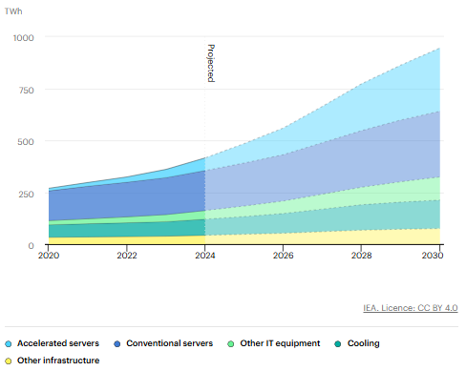
Appendix 2. Global data center capacity additions in the Base Case and capacity at risk of connection delay due to grid constraints, 2025-2030

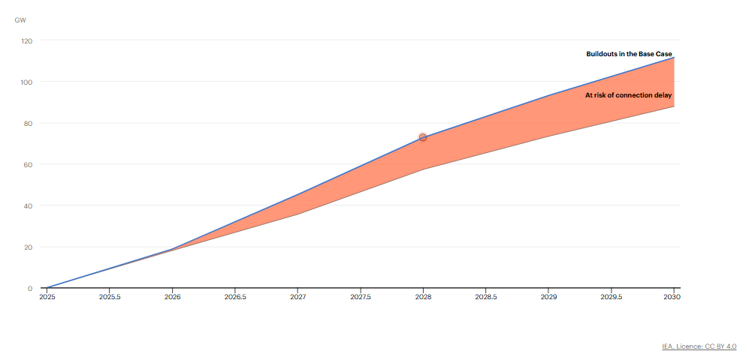
Appendix 3. Gas turbines for the xAI facility
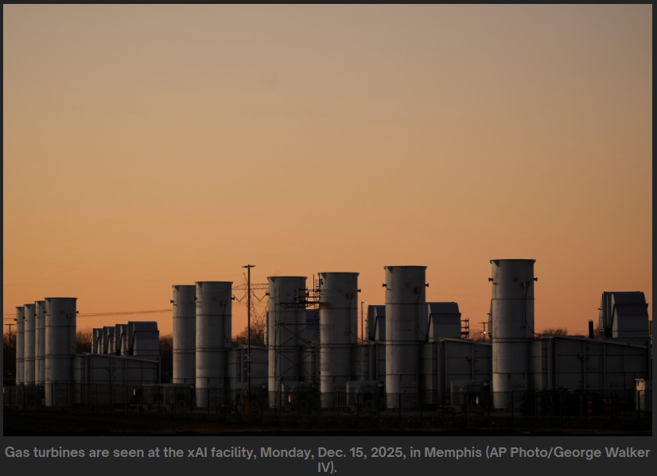
Appendix 4. Data center Colossus in Memphis
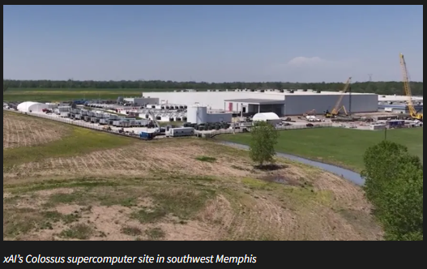

Appendix 5. 3-bus example results under Regime B (earlier export framing)

Regime B: on-grid but no export:

- In Period 1, Line $1→3$ is uncongested ($100\text{ MW}<120\text{ MW}$), nodal LMPs are uniform at $25/MWh, and the data center imports 100% of its power.
- Total demand = data center 101.94 + Bus 3’s 100 = 201.94 MW, all supplied by Bus 1. So P_G1 = 201.9 MW.
- Bus 1 baseload ($25) is cheaper than the data center’s gas ($45), so the data center (in bus2) buys from the grid instead of running gas. That gives BTM gas = 0.0 MW and Import = 101.9 MW.

Figure 1. Period 1 Off-Peak time (no export)
$$L_{1}^{\text{DC}}=101.94\text{ MW| }D_{3,1}=100\text{ MW}$$
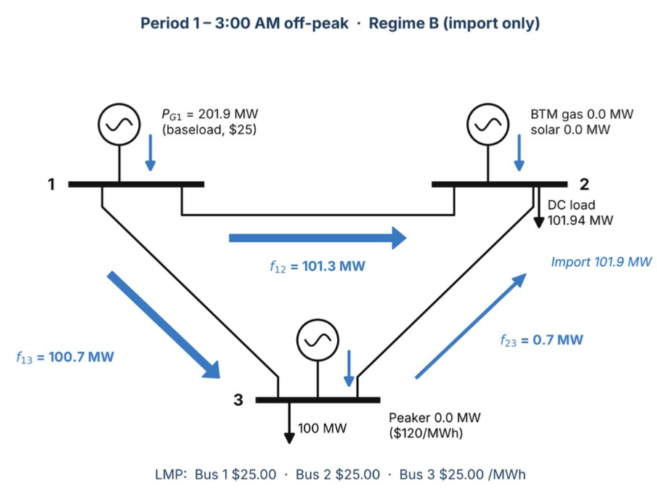

- In Period 2, Line $1→3$ binds at $120\text{ MW}$, splitting nodal LMPs to $72.50/MWh at Bus 2 and $120/MWh at Bus 3.
- Bus 3 needs 220 MW, and the cheapest power ($25) is at Bus 1. But the direct line from Bus 1 to Bus 3 can carry only 120 MW, so it maxes out: f₁₃ = 120.0 MW (limit).
- Bus 2: The data center isn’t importing or exporting, so Bus 2 is a pass-through. Whatever enters Bus 2 must leave it, which means f₁₂ = f₂₃.
- Data center: solar is free, so all 41.5 MW is used. Gas covers the rest: 114.72 − 41.55 = 73.2 MW. Net grid exchange = 0, so it’s self-supplied.
- Peaker at Bus 3 = 220 − (120 + 60) = 40.0 MW. It fills the gap the lines can’t deliver.
- NOTE: the data center has spare gas capacity (150 − 73.2 = 76.8 MW) costing $45, while Bus 3 is paying $120 for the peaker, allowing BTM to cover for the peaker will reduce total cost for the system.

Figure 2. Period 2 Peak (no export)
$L_{2}^{\text{DC}}=114.72\text{MW }{\text{CF}}_{2}^{\text{sol}}=0.831$ |$D_{3,2}=220\text{ MW}$
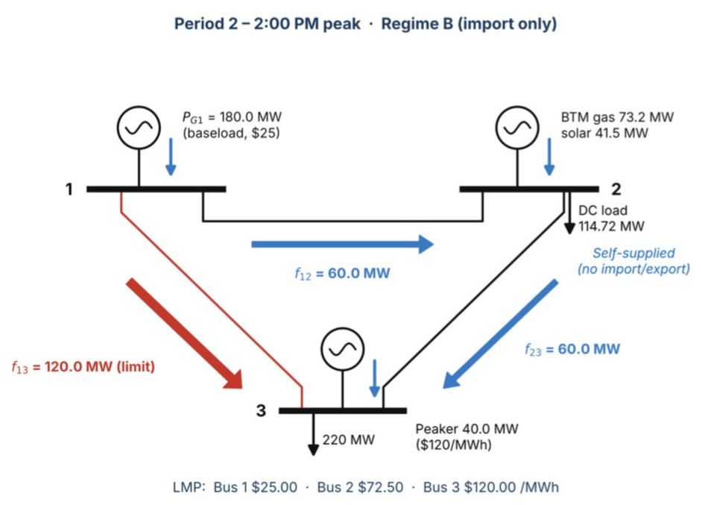

Appendix 6. 3-bus example results under Regime C (earlier export framing)
Regime C: grid-connected with export option:
- In Period 1, Line $1→3$ is uncongested ($100\text{ MW}<120\text{ MW}$), nodal LMPs are uniform at $25/MWh, and the data center imports 100% of its power.
- Grid power ($25) is cheaper than gas ($45), so gas = 0.0 MW and Import = 101.9 MW, Export = 0.
- Bus 1 supplies everything: 101.94 + 100 = 201.9 MW.
- Peaker = 0.0 MW (not needed).
- NOTE: being allowed to export only matters when there’s congestion

Figure 3. Period 1 Off-Peak time (with export)
$$L_{1}^{\text{DC}}=101.94\text{ MW| }D_{3,1}=100\text{ MW}$$
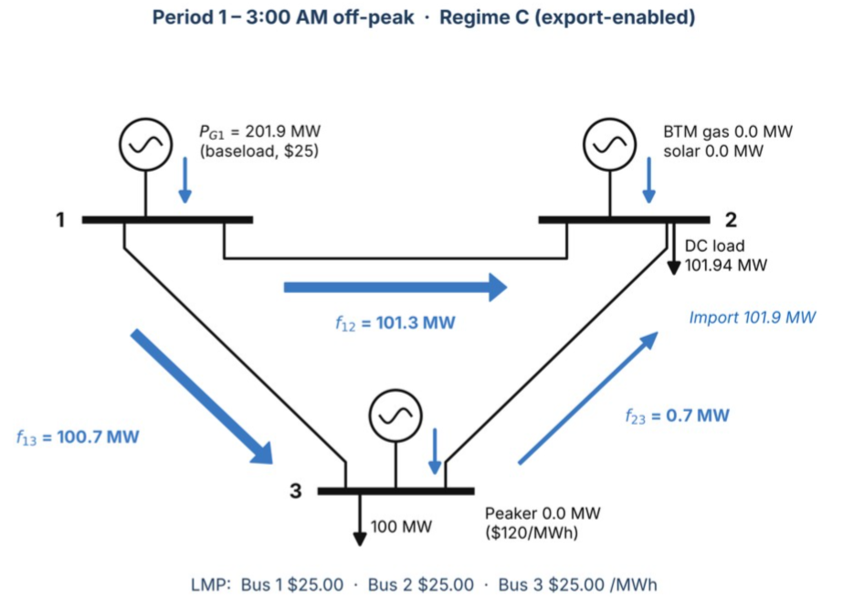

Figure 4. Period 2 Peak (with export)
$L_{2}^{\text{DC}}=114.72\text{MW }{\text{CF}}_{2}^{\text{sol}}=0.831$ |$D_{3,2}=220\text{ MW}$
- In Period 2, Line $1→3$ binds at $120\text{ MW}$, splitting nodal LMPs to $72.50/MWh at Bus 2 and $120/MWh at Bus 3.
- Marginal price at Bus 2 is worth $72.50/MWh (due to congestion).
- Gas costs $45/MWh, so every MW sold earns $27.50.
- The model therefore runs gas at its maximum: BTM gas = 150.0 MW.
- Export = gas + solar − DC load = 150 + 41.55 − 114.72 = 76.8 MW (K_exp = 76.83 MW export capacity which is the surplus)
- Bus 1 baseload = f₁₂ + f₁₃ = 21.6 + 120 = 141.6 MW
- Peaker at Bus 3 = 220 − (120 + 98.4) = 1.6 MW
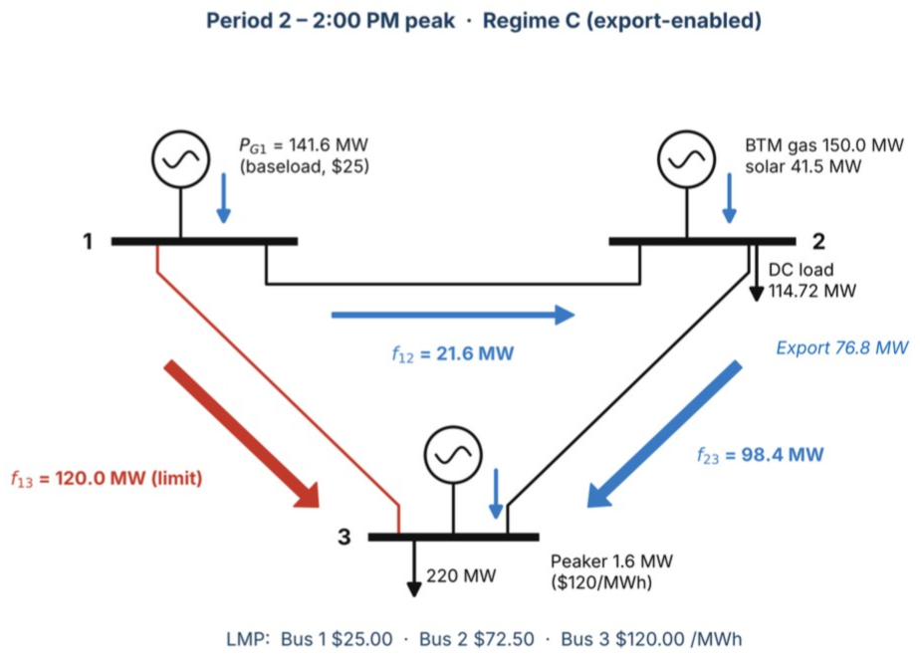

Appendix 7. Earlier export framing: grid-interactive (export-enabled) architecture vs. business as usual
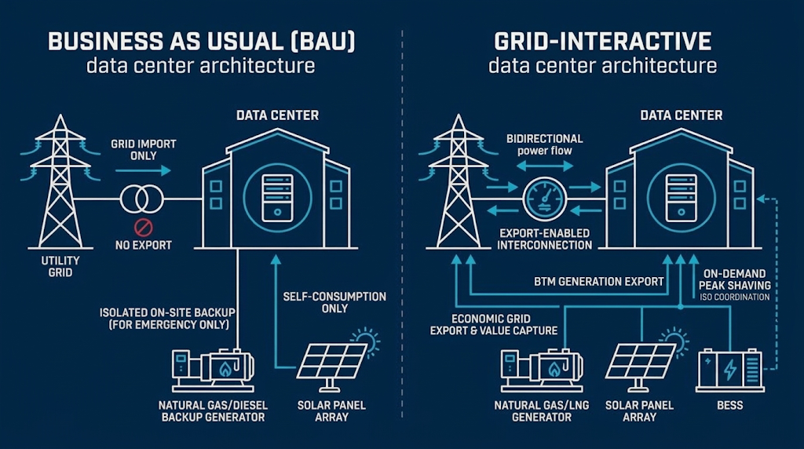

Appendix 8. Earlier analysis: exporting surplus BTM power
This appendix keeps the analysis from the project’s earlier framing, in which the data center exported surplus BTM generation. It documents the model verification and the price data, but is not part of the current flexible-connection study.

3-Bus, 2-Period Toy Example
To verify our formulation prior to scaling to the 14-bus network, we solve a 3-bus, 2-period triangle network ($B_{12}=B_{13}=B_{23}=1000\text{ MW/rad}$) using two empirical hours from single_dc_profile.csv:
Period 1 (Hour 4, 3:00 AM Off-Peak: $T={22.3}^{∘}\text{C}$, $L_{1}^{\text{DC}}=101.94\text{ MW}$, ${\text{CF}}_{1}^{\text{sol}}=0$) and
Period 2 (Hour 15, 2:00 PM Peak: $T={30.3}^{∘}\text{C}$, $L_{2}^{\text{DC}}=114.72\text{ MW}$, ${\text{CF}}_{2}^{\text{sol}}=0.831$).
- Bus 1 hosts cheap utility baseload ($c_{1}=\$25/\text{MWh}$),
- Bus 2 hosts the Data Center ($c_{\text{gas}}=\$45/\text{MWh}$, $K^{\text{gas}}=150\text{ MW}$ | $K^{\text{sol}}=50\text{ MW}$), and
- Bus 3 is a congested load pocket ($D_{3,1}=100\text{ MW}$, $D_{3,2}=220\text{ MW}$) served by an expensive utility peaker ($c_{3}=\$120/\text{MWh}$) behind thermally constrained Line $1→3$ ($F_{13}^{max}=120\text{ MW}$).

Regime | Period | DC Load (MW) | BTM Gas (MW) | BTM Solar (MW) | Grid Import (MW) | Grid Export (MW) | Bus 3 Peaker (MW) | Bus 2 LMP ($/MWh) | Bus 3 LMP ($/MWh) | Total System Cost ($)
Baseline (Zero-Export) | 1 (Off-Peak) | 101.94 | 0 | 0 | 101.9 | 0 | 0 | $ 25.0 | $ 25.0 | $ 5,049
Baseline (Zero-Export) | 2 (Peak) | 114.72 | 73.2 | 41.6 | 0 | 0 | 40 | $ 72.5 | $ 120.0 | $ 5,049
Experiment (Export-Enabled) | 1 (Off-Peak) | 101.94 | 0 | 0 | 101.9 | 0 | 0 | $ 25.0 | $ 25.0 | $ 12,593
Experiment (Export-Enabled) | 2 (Peak) | 114.72 | 150 | 41.6 | 0 | 76.8 | 1.6 | $ 72.5 | $ 120.0 | $ 10,480 + $768 (export)
Baseline (Zero-Export) |  |  |  |  |  |  |  |  | TOTAL | $17,641
Experiment (Export-Enabled) |  |  |  |  |  |  |  |  | TOTAL | $16,297
 |  |  |  |  |  |  |  |  | savings | $1,345
Note: Table reflects the verified output in toy_3bus_cost_comparison_1.xlsx.
Refer to Appendix 5 & 6. 3-bus example results under Regime B & C
Regime A (islanded bridge): with no grid connection, the data center runs its own plant in both periods (101.9 MW of gas at 3:00 AM; 73.2 MW of gas plus 41.6 MW of solar at 2:00 PM), while Bus 3 is served by the grid alone, with the peaker at 40 MW in Period 2. Total system cost is $19,679.95, which is $2,038.80 more than Regime B and $3,383.33 more than Regime C. The entire gap with Regime B comes from the off-peak hour, when the data center burns $45/MWh gas instead of importing $25/MWh grid power: 101.94 MW × ($45 − $25) = $2,038.80 (source: toy_example_results.csv).

Cost comparison:
Cost doesn’t change between no-export vs. export options due to no congestion in period 1
Period | Cost component | Regime B production (MW) | Regime B cost ($) | Regime C production (MW) | Regime C cost ($) | Savings B − C ($)
Period 1 (3:00 AM) | Bus 1 baseload ($25/MWh) | 201.94 | $5,049 | 201.94 | $5,049 | -
Period 1 (3:00 AM) | Bus 3 peaker ($120/MWh) | - | - | - | - | -
Period 1 (3:00 AM) | Data center BTM gas ($45/MWh) | - | - | - | - | -
Period 1 (3:00 AM) | Data center solar ($0/MWh) | - | - | - | - | -
Period 1 (3:00 AM) | Subtotal (total generation / operating cost) | 201.94 | $5,049 | 201.94 | $5,049 | -
Cost savings due to reduction of peaker and instead gas is used to it’s maximum allowing data center to sell it’s surplus, getting paid at $72.5 bus 2 marginal price while gas cost $45.
Period | Cost component | Regime B production (MW) | Regime B cost ($) | Regime C production (MW) | Regime C cost ($) | Savings B − C ($)
Period 2 (2:00 PM) | Bus 1 baseload ($25/MWh) | 180.00 | $4,500 | 141.59 | $3,540 | $960
Period 2 (2:00 PM) | Bus 3 peaker ($120/MWh) | 40.00 | $4,800 | 1.59 | $190 | $4,610
Period 2 (2:00 PM) | Data center BTM gas ($45/MWh) | 73.17 | $3,293 | 150.00 | $6,750 | ($3,457)
Period 2 (2:00 PM) | Data center solar ($0/MWh) | 41.55 | - | 41.55 | - | -
Period 2 (2:00 PM) | Subtotal (total generation / operating cost) | 334.72 | $12,593 | 334.72 | $10,480 | $2,113
Both periods | Total operating cost | 536.66 | $17,641 | 536.66 | $15,528 | $2,113
Both periods | Export capacity (K_exp × κ_exp) $10* | - | - | 76.83 | $768 | ($768)
Both periods | Total system cost |  | $17,641 |  | $16,297 | $1,345
* Assumed value. Exporting stays worthwhile while κ < $27.50/MW (LMP at Bus 2 $72.50 − gas cost $45).

Real-Price Check: Ashburn LMPs
The toy example uses assumed prices. To test the research question with actual prices, code/lmp_export_value.jl treats the data center as a price-taker at the ASHBURN 35 kV node (Section 4.1) and asks how much one MW of export capacity would have earned from November 1, 2025 to November 1, 2026: the sum over all hours of max(LMP − c^gas, 0). This is the most the facility could pay per MW of export capacity (the break-even κ^exp, per year) and still come out ahead.
Annual export margin per MW of export capacity, ASHBURN 35 kV node (Nov 1, 2025 – Nov 1, 2026)
Gas cost c^gas ($/MWh) | Profitable hours | Export margin ($/MW-yr) | Margin without congestion ($/MW-yr) | Share from congestion
$35 | 5,714 | 674,738 | 296,789 | 56%
$45 | 4,065 | 626,669 | 255,688 | 59%
$75 | 2,163 | 539,433 | 186,802 | 65%
At $45/MWh gas, one MW of export capacity would have earned about $627,000 over the year, and about 59% of that came from the congestion component of the LMP; with congestion removed, the margin falls to about $256,000. The value is concentrated in a few hours: the top 100 hours (about 1% of the year) provide 28% of the annual margin, and average prices are highest between 5 and 7 PM, when solar output is falling.
For July 15–19, 2025, the same days as our load profile, we match the hourly LMPs to the data center’s surplus (150 MW of gas plus 50 MW × solar CF, minus load), which ranged from 45.1 to 76.8 MW. At $45/MWh gas, each of the first 45 MW of export capacity would have earned $14,935 over these five days, because that much surplus is available in every hour. Above 45 MW the value of each additional MW falls ($11,848 at 50 MW, $9,954 at 60 MW, $3,979 at 70 MW) and reaches zero near 77 MW, where no surplus is left. The optimal export capacity is where this marginal value equals κ^exp for the same period. July 20–21 will be added once those LMPs are downloaded.
Full year with the actual surplus. We repeat the July calculation for the whole year, matching all 8,761 LMP hours to a year-long load profile built from Ashburn weather for November 1, 2025 to November 1, 2026 with the same load model as Section 4.2 (data/single_dc_profile_year.csv). Over the year, the surplus available for export ranges from 40.8 MW (hot evenings and nights, when cooling load is high and there is no solar) to 92.9 MW (a cool, sunny spring afternoon). It is at least 50 MW in 7,224 hours but at least 55 MW in only 2,942 hours.
Full-year value of export capacity at $45/MWh gas, ASHBURN 35 kV node (Nov 1, 2025 – Nov 1, 2026)
Export capacity K^exp (MW) | Value of one more MW ($/MW-yr) | Total annual export margin ($M/yr)
0 – 40 | 626,669 | up to 25.1
45 | 620,309 | 28.2
50 | 526,059 | 31.1
55 | 269,225 | 33.1
60 | 214,450 | 34.3
70 | 125,611 | 36.0
75 | 79,259 | 36.5
80 | 33,959 | 36.8
90 | 2,031 | 37.0
Because the surplus never falls below about 41 MW, each of the first 40 MW of export capacity earns the full $626,669 per year, the same as the annual break-even in the table above. Beyond 50 MW the value of each additional MW falls quickly, because that much surplus is available in only about a third of the year, mostly in cool or sunny hours. The optimal export capacity is where this value equals the annualized export cost κ^exp. As an illustration, at κ^exp = $500,000/MW-yr the optimum would be about 50 MW, at $250,000/MW-yr about 55–60 MW, and at $100,000/MW-yr about 70–75 MW. Exporting all of the surplus (about 93 MW) would earn roughly $37 million per year, but the last 15–20 MW add little.
These figures are upper bounds. They assume the data center does not move the LMP, hold the gas price constant even in hours when gas and power prices spike together, and ignore that injections of this size would shrink the local congestion spread, an effect the DC-OPF model captures. Even so, they are far above the toy example’s assumed export cost ($10/MW for two hours, about $44,000/MW-yr if scaled to a full year). At Ashburn, the binding limits on export are therefore more likely to be physical, such as gas supply, air-permit run-hours, and local network capacity, than the cost of the upgrade (source: results/lmp_breakeven_summary.csv, results/lmp_july2025_export_value.csv, results/lmp_year_export_value.csv).
Appendix 9. FERC large load interconnection service options
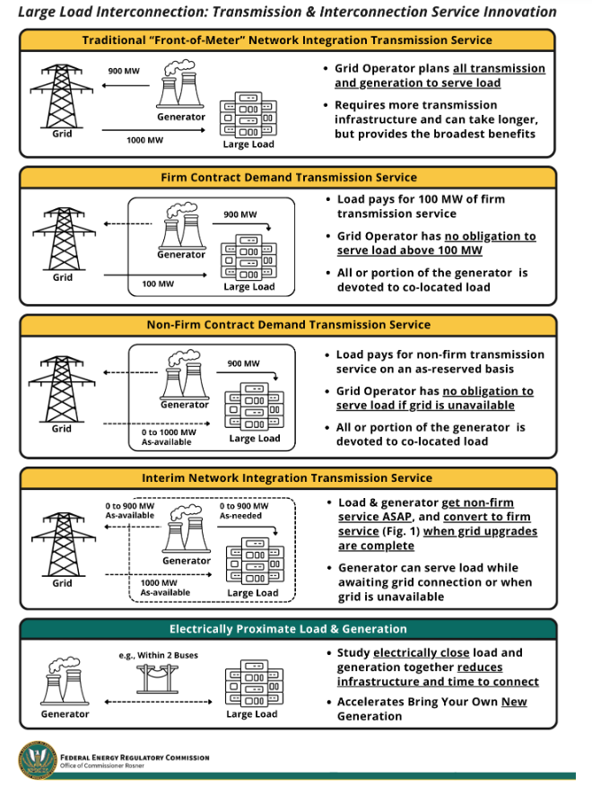
Source: FERC, Office of Commissioner Rosner, “Large Load Interconnection: Transmission & Interconnection Service Innovation,” graphic accompanying Commissioner Rosner’s remarks on the large load show cause orders (E-7 to E-12), June 18, 2026. https://www.ferc.gov/news-events/news/commissioner-rosners-remarks-large-load-show-cause-orders-e-7-e-12-june-18-2026
The figure summarizes the transmission service options discussed with FERC’s June 18, 2026 show cause orders, which directed each RTO to assess or justify its rules for large loads rather than mandating specific services. In this project, Regime B corresponds to traditional network integration transmission service, in which the grid operator plans transmission and generation to serve the full load. Regime C corresponds to non-firm contract demand service, in which the grid operator has no obligation to serve the load when the grid is unavailable and the co-located generator covers the gap. Firm contract demand service at a level below peak load, and interim network integration service while upgrades are built, lie between the two.

International Energy Agency, Energy and AI, 2025. https://www.iea.org/reports/energy-and-ai/executive-summary
Ibid
Southern Environmental Law Center, press release, March 10, 2026. https://www.selc.org/press-releases/mississippi-regulators-rubber-stamp-air-permit-for-xai-power-plant-ignoring-overwhelming-public-pushback/
Through the first quarter of 2026, CERA has tracked 130 North American data center projects that plan to build on-site generation. S&PGlobal. https://www.spglobal.com/energy/en/news-research/latest-news/natural-gas/052726-pipeline-operators-strike-deals-as-data-centers-turn-to-colocated-generation
J. Rand et al., Queued Up: 2026 Edition, Characteristics of Power Plants Seeking Transmission Interconnection as of the End of 2025, Lawrence Berkeley National Laboratory, 2026.
E&E News, “US utilities planning record-breaking capital spending,” April 15, 2026. https://www.eenews.net/articles/us-utilities-planning-record-breaking-capital-spending/
A. Shehabi et al., 2024 United States Data Center Energy Usage Report, Lawrence Berkeley National Laboratory, LBNL-2001637, December 2024. https://eta-publications.lbl.gov/publications/2024-lbnl-data-center-energy-usage-report
J. Rand et al., Queued Up: 2026 Edition, Characteristics of Power Plants Seeking Transmission Interconnection as of the End of 2025, Lawrence Berkeley National Laboratory, 2026.
T. Valencia Zuluaga, J.-P. Watson and S. Pang, “Nodal Capacity Expansion Planning with Flexible Large-Scale Load Siting,” arXiv preprint arXiv:2510.19781, 2025 (v2, April 15, 2026).
Y. Chen and X. Zheng, “To Defer or To Shift? The Role of AI Data Center Flexibility on Grid Interconnection,” arXiv preprint arXiv:2604.05376, April 2026.
hourly solar capacity factor: the fraction of the solar panels’ full rated output that they actually produce in a given hour.
https://www.datacenters.google/efficiency/
IEA (2025), Global data centre electricity consumption, by equipment, Base Case, 2020-2030, IEA, Paris https://www.iea.org/data-and-statistics/charts/global-data-centre-electricity-consumption-by-equipment-base-case-2020-2030, Licence: CC BY 4.0
IEA (2025), Global data centre capacity additions in the Base Case and capacity at risk of connection delay due to grid constraints, 2025-2030, IEA, Paris https://www.iea.org/data-and-statistics/charts/global-data-centre-capacity-additions-in-the-base-case-and-capacity-at-risk-of-connection-delay-due-to-grid-constraints-2025-2030, Licence: CC BY 4.0
B. Gibbons, “Power grab for Musk AI data center in Memphis sparks environmental justice fight,” Oil & Gas Watch, Environmental Integrity Project, Mar. 5, 2026. https://news.oilandgaswatch.org/post/natural-gas-power-grab-for-musk-ai-data-center-in-memphis-sparks-environmental-justice-fight
WREG News Channel 3, “TVA OKs additional 150 MW of electricity for xAI Memphis data center,” [date]. https://wreg.com/news/local/tva-oks-additional-150-mw-of-electricity-for-xai-memphis-data-center/

