Health Inequality Across U.S. Counties
A Visual Analytics Dashboard for Exploring Socioeconomic Drivers of Health Disparities
Mahim Mohtadi & Naseer Ahmed • CSE 564 – Information Visualization • April 2026

Note: AI tools were used to help in completing this proposal. Claude code was used to brainstorm the architecture of the project and start with a basic template. Cursor code editor was used to make necessary UI changes and make it more visually appealing. For the report, a draft with notes and bullet points were given to cursor and Claude to format it properly and display it in a nice professional way.

1. Background
Health disparities across the United States are deeply rooted in socioeconomic inequalities. Counties with higher poverty rates, lower educational attainment, and limited access to healthcare consistently report shorter life expectancies, higher rates of premature death, and greater burdens of preventable disease. These disparities are not random: they reflect structural inequities in income distribution, employment opportunity, educational access, and healthcare infrastructure that have accumulated over decades. Despite substantial public health research, the disparities persist and, in many regions, have widened — a trend sharpened by the differential impact of the COVID-19 pandemic on low-income and underinsured communities.
County-level data provides a uniquely actionable lens for studying these dynamics. Counties are the primary unit of local governance in the United States, making them directly relevant to policy intervention and resource allocation decisions. Analyzing health outcomes at the county level allows researchers to capture the enormous within-state variation that is masked by state-level aggregates, and to identify specific communities where targeted public health investment could have the greatest impact.
Despite the availability of rich county-level data, most existing tools for exploring it are either static (non-interactive maps or reports) or require specialized statistical knowledge to operate. There is a clear and pressing need for visual analytics tools that allow non-expert stakeholders — including local officials, community advocates, and the general public — to explore multi-dimensional health data intuitively and draw actionable insights.

Dataset Overview
This project uses a merged county-level dataset derived from the Robert Wood Johnson Foundation’s County Health Rankings and Roadmaps program, one of the most comprehensive publicly available county-level health datasets in the United States. The dataset covers 542 counties and contains 23 variables spanning five thematic categories:
- Health Outcomes: Life Expectancy, Years of Potential Life Lost Rate, % Fair or Poor Health, Average Physically and Mentally Unhealthy Days, Drug Overdose Mortality Rate, Firearm Fatalities Rate, Homicide Rate, Injury Death Rate
- Socioeconomic: Median Household Income, Income Ratio (80th/20th percentile), % Children in Poverty, % Uninsured, % Unemployed
- Healthcare Access: Primary Care Physicians Rate (per 100,000 population)
- Education & Lifestyle: High School Graduation Rate, % Adults with Obesity, % Adults Currently Smoking
- Demographics: % Rural, Total Population
This breadth of variables — combining outcome measures with upstream social determinants, behavioral risk factors, and healthcare access metrics — makes the dataset uniquely well-suited for multivariate visual exploration. Patterns that are invisible in any single variable become apparent when explored interactively across multiple linked views.

2. Problem Statement
The central challenge this project addresses is the difficulty of making sense of complex, multi-dimensional county-level health data without specialized statistical expertise. Existing tools for exploring county health data typically fall into two categories: static reports and maps that display one variable at a time and offer no interactivity, or advanced statistical dashboards that require familiarity with tools like R or Python to operate. Neither approach is accessible to the policymakers, community advocates, and local officials who most need to act on this information.
A well-designed interactive visual analytics dashboard can bridge this gap by enabling users to explore all 23 variables simultaneously, discover patterns through direct manipulation, and tell data-driven stories without writing a single line of code. The linked-brushing paradigm — where selecting counties in one view immediately highlights them in all others — is particularly powerful for multi-dimensional health data: it allows a user to, for example, identify the counties with the lowest life expectancy on a map, then instantly see those same counties' income levels on a scatter plot and their full variable profiles on a parallel coordinates chart.

Core Research Questions
This project is motivated by three primary research questions:
- How do socioeconomic factors — including income, poverty rate, insurance coverage, and educational attainment — correlate with health outcomes such as life expectancy, premature mortality, and self-reported poor health across U.S. counties?
- Which geographic regions exhibit the greatest health disparities, and are these disparities spatially clustered or primarily explained by specific combinations of socioeconomic variables?
- Can a linked, single-screen interactive dashboard enable users without statistical training to identify high-risk county profiles, compare regions, and generate data-driven hypotheses about the drivers of health inequality?

Target Users & Use Cases
The dashboard is designed for four primary user groups: (1) public health researchers investigating the social determinants of health at the county level; (2) state and local policymakers seeking to identify counties with the greatest need for targeted intervention; (3) non-profit organizations and advocacy groups working on health equity and social justice; and (4) graduate students in public health, data science, and information visualization courses. The dashboard prioritizes accessibility and interpretability while still supporting in-depth exploratory analysis.

Relevance & Motivation
This project ties directly to issues of health equity, access to care, and economic justice — concerns that are central to public discourse in the 2020s. The intersection of poverty, lack of insurance, and poor health outcomes documented in this dataset represents a systemic failure that demands data-driven attention. By making these patterns visible and explorable to a broad audience, the dashboard can directly support evidence-based advocacy and policy design.

3. Approach

Dashboard Architecture & Technology Stack
The dashboard will be built as a single-screen interactive web application served by a Python (Flask) backend. The frontend will use D3.js (v7) for all visualizations. Files will be organized into separate HTML, CSS, and JavaScript modules for maintainability and clarity. The Python server will handle data loading and preprocessing, serve static frontend assets, and expose a JSON API that the frontend queries for filtered datasets and GeoJSON county boundary files. All views must fit on a single screen without scrolling, consistent with the course’s linked single-screen dashboard requirement.
Backend | Python 3 / Flask — serves static files, preprocesses data, exposes JSON API endpoints
Visualizations | D3.js v7 — all chart and map rendering; linked brushing implemented via shared JS state object
Geodata | U.S. County TopoJSON boundaries from U.S. Census TIGER files, joined to dataset by FIPS code
Data Processing | Pandas (Python) — CSV cleaning, normalization, summary statistics computation
Styling | Custom CSS — clean minimal dashboard layout, responsive column grid, no external UI frameworks

Planned Visualizations
The dashboard will include a mix of standard and non-standard visualizations, all linked via a shared selection state:
View | Data Encoded | Key Interaction
Choropleth Geo-Map | U.S. counties colored by selected outcome variable (e.g., Life Expectancy or Drug Overdose Rate) | Click or brush counties; dropdown to change encoded variable
Scatter Plot | Any two variables (default: Median Income vs. Life Expectancy); county as dot, color by state or region | Axis dropdowns; brush lasso to select county subset
Parallel Coordinates | All 23 variables shown as parallel axes; each polyline = one county | Axis range brush to filter counties; reorder axes by drag
Bar / Ranked Chart | State-level aggregates or top/bottom N counties for selected variable | Click bar to highlight counties in map and scatter
Correlation Heatmap | Pairwise Pearson correlations between all 23 variables | Hover for exact value; click cell to auto-set scatter axes

Linked Brushing & Interaction Design
All five views will share a single JavaScript selection state object. When a user brushes counties in any view — drawing a lasso on the scatter plot, selecting an axis range in parallel coordinates, or clicking a region on the map — all other views immediately update to highlight only the selected subset. This design enables interactive storytelling: a user can identify counties with both high poverty and low life expectancy on the scatter plot, verify that those counties cluster geographically on the map, and inspect their full variable profiles simultaneously on the parallel coordinates chart. Dropdown menus allow changing which variable is encoded on the map and which variables are mapped to scatter axes without reloading the page. A global reset button clears all selections.

Project Timeline
April 10 | Project proposal submission (this document)
April 24 | Prelim report: first working implementation with choropleth map and scatter plot linked via brushing
May 5–10 | Full dashboard complete: all five views linked, UI polished, cross-browser tested
May 12 | Final submission: code + data zip, YouTube demo video (linked in Brightspace), Zoom presentation

Initial Project Draft
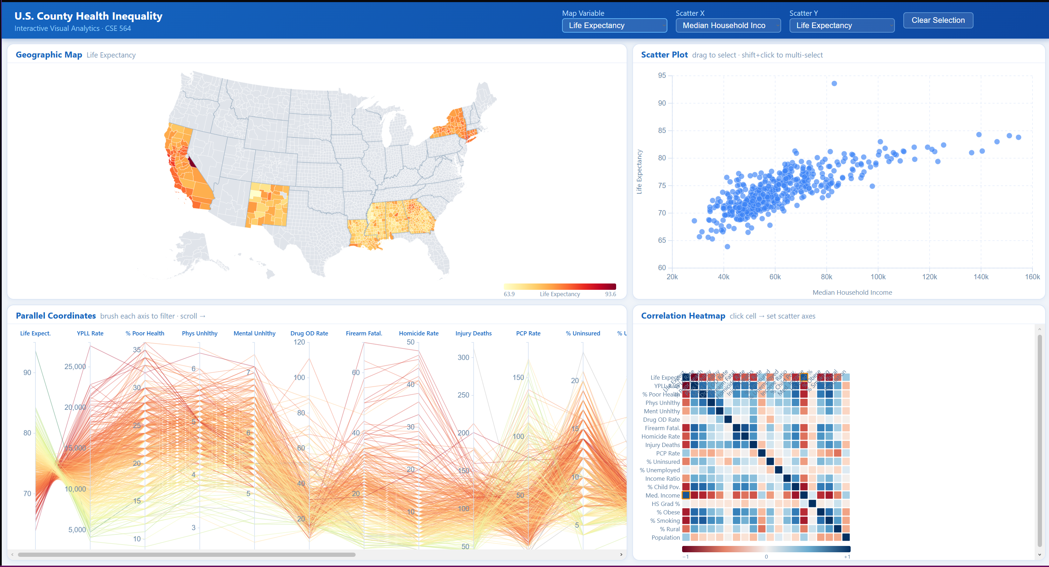

References
County Health Rankings & Roadmaps Program. Robert Wood Johnson Foundation & University of Wisconsin Population Health Institute. countyhealthrankings.org
U.S. Census Bureau. TIGER/Line Shapefiles — Counties and County Equivalents. census.gov/geographies/mapping-files
Shneiderman, B. (1996). The eyes have it: A task by data type taxonomy for information visualizations. IEEE Symposium on Visual Languages.

