RAID
https://www.prepressure.com/library/technology/raid
http://www.acnc.com/raid
https://en.wikipedia.org/wiki/Standard_RAID_levels
http://www.thegeekstuff.com/2010/08/raid-levels-tutorial

RAID is a technology that is used to increase the performance and/or reliability of data storage. The abbreviation stands for Redundant Array of Inexpensive Disks. A RAID system consists of two or more drives working in parallel. These disks can be hard discs, but there is a trend to also use the technology for SSD (solid state drives). There are different RAID levels, each optimized for a specific situation. These are not standardized by an industry group or standardization committee. This explains why companies sometimes come up with their own unique numbers and implementations. This article covers the following RAID levels:
- RAID 0 – striping
- RAID 1 – mirroring
- RAID 5 – striping with parity
- RAID 6 – striping with double parity
- RAID 10 – combining mirroring and striping

RAID 0, RAID 1, RAID 5, RAID 10 Explained with Diagrams
by RAMESH NATARAJAN on AUGUST 10, 2010
RAID stands for Redundant Array of Inexpensive (Independent) Disks.
On most situations you will be using one of the following four levels of RAIDs.
- RAID 0
- RAID 1
- RAID 5
- RAID 10 (also known as RAID 1+0)
This article explains the main difference between these raid levels along with an easy to understand diagram.
In all the diagrams mentioned below:
- A, B, C, D, E and F – represents blocks
- p1, p2, and p3 – represents parity

RAID LEVEL 0
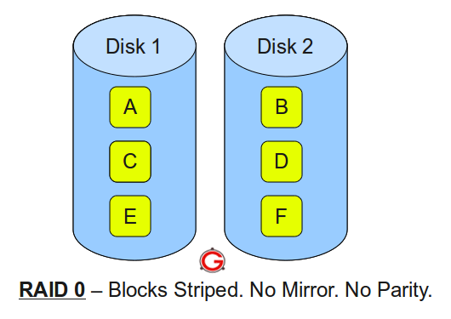
Following are the key points to remember for RAID level 0.
- Minimum 2 disks.
- Excellent performance ( as blocks are striped ).
- No redundancy ( no mirror, no parity ).
- Don’t use this for any critical system.

RAID LEVEL 1
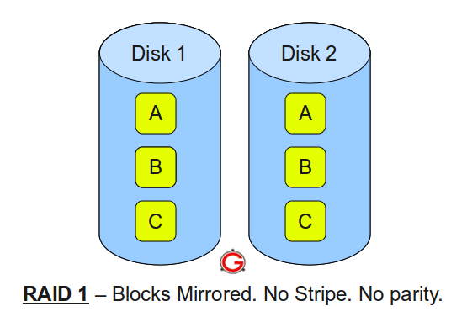Following are the key points to remember for RAID level 1.
- Minimum 2 disks.
- Good performance ( no striping. no parity ).
- Excellent redundancy ( as blocks are mirrored ).

RAID LEVEL 5
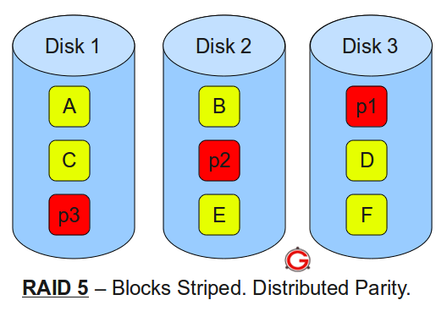
Following are the key points to remember for RAID level 5.
- Minimum 3 disks.
- Good performance ( as blocks are striped ).
- Good redundancy ( distributed parity ).
- Best cost effective option providing both performance and redundancy. Use this for DB that is heavily read oriented. Write operations will be slow.

RAID LEVEL 10
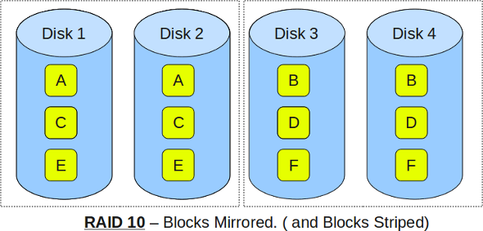Following are the key points to remember for RAID level 10.
- Minimum 4 disks.
- This is also called as “stripe of mirrors”
- Excellent redundancy ( as blocks are mirrored )
- Excellent performance ( as blocks are striped )
- If you can afford the dollar, this is the BEST option for any mission critical applications (especially databases).

