**ParallelGC**

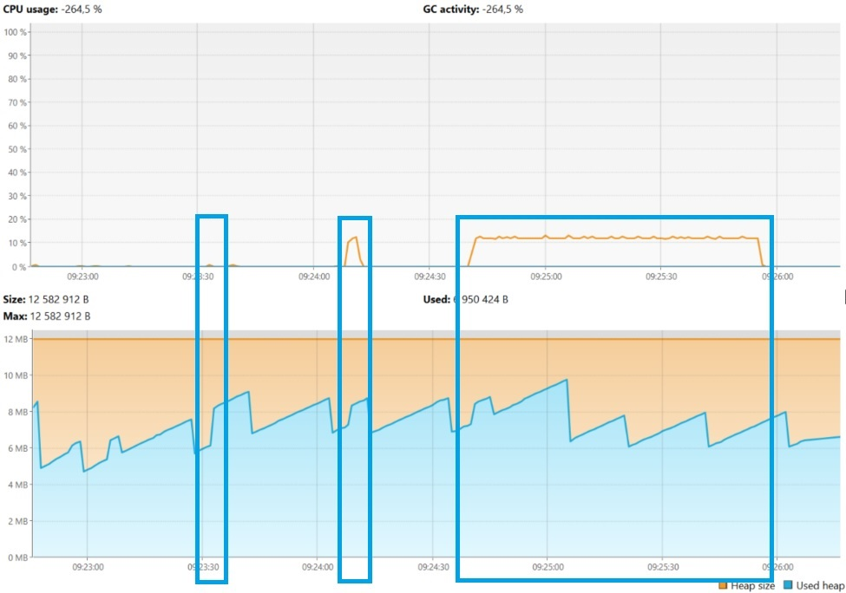

MergeSort Начало сортировки - 09:23:32.441308300

MergeSort Конец сортировки — 09:23:32.499804100

Время выполнения 0,0584958

InsertSort Начало сортировки - 09:24:08.256057800

InsertSort Конец сортировки — 09:24:11.349306700

Время выполнения 3,0932489

BubbleSort Начало сортировки - 09:24:40.520061500

BubbleSort Конец сортировки — 09:25:55.188977500

Время выполнения 74,668916

[2024-04-18T09:22:42.554+0400][info][gc] Using Parallel

[2024-04-18T09:22:43.577+0400][info][gc] GC(0) Pause Young (Allocation Failure) 2M->1M(11M) 12.281ms

[2024-04-18T09:22:45.123+0400][info][gc] GC(1) Pause Young (Allocation Failure) 4M->2M(11M) 2.253ms

[2024-04-18T09:22:45.166+0400][info][gc] GC(2) Pause Young (Allocation Failure) 5M->3M(11M) 1.464ms

[2024-04-18T09:22:45.201+0400][info][gc] GC(3) Pause Young (Allocation Failure) 6M->3M(11M) 2.100ms

[2024-04-18T09:22:45.224+0400][info][gc] GC(4) Pause Young (Allocation Failure) 6M->4M(11M) 2.074ms

[2024-04-18T09:22:45.737+0400][info][gc] GC(5) Pause Young (Allocation Failure) 7M->6M(10M) 2.349ms

[2024-04-18T09:22:45.765+0400][info][gc] GC(6) Pause Young (Allocation Failure) 8M->6M(11M) 1.846ms

[2024-04-18T09:22:45.834+0400][info][gc] GC(7) Pause Young (Allocation Failure) 8M->6M(11M) 1.056ms

[2024-04-18T09:22:45.965+0400][info][gc] GC(8) Pause Young (Allocation Failure) 8M->6M(11M) 1.613ms

[2024-04-18T09:22:47.095+0400][info][gc] GC(9) Pause Young (Allocation Failure) 8M->7M(11M) 1.627ms

[2024-04-18T09:22:47.106+0400][info][gc] GC(10) Pause Full (Ergonomics) 7M->4M(11M) 11.257ms

[2024-04-18T09:22:59.076+0400][info][gc] GC(11) Pause Young (Allocation Failure) 6M->4M(11M) 0.541ms

[2024-04-18T09:23:08.093+0400][info][gc] GC(12) Pause Young (Allocation Failure) 6M->5M(11M) 0.584ms

[2024-04-18T09:23:28.084+0400][info][gc] GC(13) Pause Young (Allocation Failure) 7M->5M(11M) 0.460ms

MergeSort Начало сортировки - 09:23:32.441308300

[2024-04-18T09:23:32.443+0400][info][gc] GC(14) Pause Young (Allocation Failure) 7M->6M(11M) 0.558ms

[2024-04-18T09:23:32.459+0400][info][gc] GC(15) Pause Full (Ergonomics) 6M->5M(11M) 16.716ms

[2024-04-18T09:23:32.462+0400][info][gc] GC(16) Pause Young (Allocation Failure) 7M->5M(11M) 0.395ms

[2024-04-18T09:23:32.464+0400][info][gc] GC(17) Pause Young (Allocation Failure) 7M->6M(11M) 0.313ms

[2024-04-18T09:23:32.466+0400][info][gc] GC(18) Pause Young (Allocation Failure) 8M->6M(11M) 0.353ms

[2024-04-18T09:23:32.468+0400][info][gc] GC(19) Pause Young (Allocation Failure) 8M->6M(11M) 0.349ms

[2024-04-18T09:23:32.471+0400][info][gc] GC(20) Pause Young (Allocation Failure) 8M->6M(11M) 0.368ms

[2024-04-18T09:23:32.473+0400][info][gc] GC(21) Pause Young (Allocation Failure) 8M->6M(11M) 0.318ms

[2024-04-18T09:23:32.476+0400][info][gc] GC(22) Pause Young (Allocation Failure) 8M->6M(11M) 0.443ms

[2024-04-18T09:23:32.478+0400][info][gc] GC(23) Pause Young (Allocation Failure) 8M->6M(11M) 0.457ms

[2024-04-18T09:23:32.481+0400][info][gc] GC(24) Pause Young (Allocation Failure) 8M->6M(11M) 0.386ms

[2024-04-18T09:23:32.490+0400][info][gc] GC(25) Pause Full (Ergonomics) 6M->6M(11M) 9.085ms

[2024-04-18T09:23:32.492+0400][info][gc] GC(26) Pause Young (Allocation Failure) 8M->6M(11M) 0.376ms

[2024-04-18T09:23:32.493+0400][info][gc] GC(27) Pause Young (Allocation Failure) 8M->6M(11M) 0.304ms

[2024-04-18T09:23:32.496+0400][info][gc] GC(28) Pause Young (Allocation Failure) 8M->6M(11M) 0.322ms

[2024-04-18T09:23:32.498+0400][info][gc] GC(29) Pause Young (Allocation Failure) 8M->7M(11M) 0.357ms

MergeSort Конец сортировки — 09:23:32.499804100

[2024-04-18T09:23:43.086+0400][info][gc] GC(30) Pause Young (Allocation Failure) 9M->6M(11M) 0.480ms

[2024-04-18T09:24:03.124+0400][info][gc] GC(31) Pause Young (Allocation Failure) 8M->6M(11M) 0.454ms

InsertSort Начало сортировки - 09:24:08.256057800

InsertSort Конец сортировки — 09:24:11.349306700

[2024-04-18T09:24:14.099+0400][info][gc] GC(32) Pause Young (Allocation Failure) 8M->6M(11M) 0.475ms

[2024-04-18T09:24:34.143+0400][info][gc] GC(33) Pause Young (Allocation Failure) 8M->6M(11M) 0.452ms

BubbleSort Начало сортировки - 09:24:40.520061500

[2024-04-18T09:24:45.151+0400][info][gc] GC(34) Pause Young (Allocation Failure) 8M->7M(11M) 0.549ms

[2024-04-18T09:25:05.169+0400][info][gc] GC(35) Pause Young (Allocation Failure) 9M->7M(11M) 0.759ms

[2024-04-18T09:25:05.179+0400][info][gc] GC(36) Pause Full (Ergonomics) 7M->5M(11M) 10.123ms

[2024-04-18T09:25:20.181+0400][info][gc] GC(37) Pause Young (Allocation Failure) 7M->6M(11M) 0.658ms

[2024-04-18T09:25:41.195+0400][info][gc] GC(38) Pause Young (Allocation Failure) 8M->6M(11M) 0.536ms

BubbleSort Конец сортировки — 09:25:55.188977500

[2024-04-18T09:26:02.208+0400][info][gc] GC(39) Pause Young (Allocation Failure) 8M->6M(11M) 0.684ms

**G1GC**

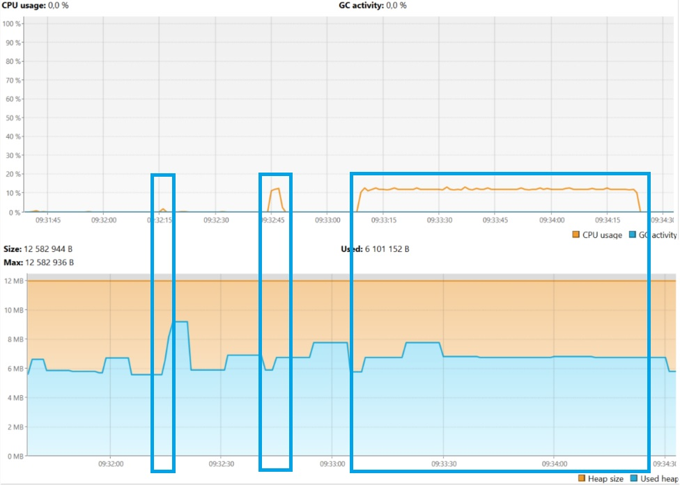

MergeSort Начало сортировки - 09:32:15.167866

MergeSort Конец сортировки — 09:32:15.227987200

Время выполнения 0,0601212

InsertSort Начало сортировки - 09:32:44.103872800

InsertSort Конец сортировки — 09:32:47.247594800

Время выполнения 3,143722

BubbleSort Начало сортировки - 09:33:08.143768500

BubbleSort Конец сортировки — 09:34:22.885278100

Время выполнения 74,7415096

[2024-04-18T09:31:32.743+0400][info][gc] Using G1

[2024-04-18T09:31:37.431+0400][info][gc] GC(0) Pause Young (Normal) (G1 Evacuation Pause) 4M->2M(12M) 2.968ms

[2024-04-18T09:31:37.473+0400][info][gc] GC(1) Pause Young (Normal) (G1 Evacuation Pause) 3M->2M(12M) 2.354ms

[2024-04-18T09:31:37.488+0400][info][gc] GC(2) Pause Young (Normal) (G1 Evacuation Pause) 3M->3M(12M) 1.468ms

[2024-04-18T09:31:37.501+0400][info][gc] GC(3) Pause Young (Normal) (G1 Evacuation Pause) 4M->2M(12M) 0.897ms

[2024-04-18T09:31:37.536+0400][info][gc] GC(4) Pause Young (Normal) (G1 Evacuation Pause) 4M->3M(12M) 0.851ms

[2024-04-18T09:31:37.566+0400][info][gc] GC(5) Pause Young (Normal) (G1 Evacuation Pause) 5M->3M(12M) 1.464ms

[2024-04-18T09:31:37.589+0400][info][gc] GC(6) Pause Young (Normal) (G1 Evacuation Pause) 6M->3M(12M) 1.155ms

[2024-04-18T09:31:37.610+0400][info][gc] GC(7) Pause Young (Normal) (G1 Evacuation Pause) 5M->4M(12M) 1.172ms

[2024-04-18T09:31:37.783+0400][info][gc] GC(8) Pause Young (Normal) (G1 Evacuation Pause) 6M->4M(12M) 1.524ms

[2024-04-18T09:31:37.805+0400][info][gc] GC(9) Pause Young (Normal) (G1 Evacuation Pause) 5M->5M(12M) 1.281ms

[2024-04-18T09:31:37.815+0400][info][gc] GC(10) Pause Young (Normal) (G1 Evacuation Pause) 6M->5M(12M) 0.518ms

[2024-04-18T09:31:37.829+0400][info][gc] GC(11) Pause Young (Normal) (G1 Evacuation Pause) 6M->4M(12M) 0.685ms

[2024-04-18T09:31:37.906+0400][info][gc] GC(12) Pause Young (Normal) (G1 Evacuation Pause) 6M->5M(12M) 0.957ms

[2024-04-18T09:31:37.951+0400][info][gc] GC(13) Pause Young (Normal) (G1 Evacuation Pause) 7M->5M(12M) 1.634ms

[2024-04-18T09:31:42.985+0400][info][gc] GC(14) Pause Young (Normal) (G1 Evacuation Pause) 7M->5M(12M) 2.225ms

[2024-04-18T09:31:48.989+0400][info][gc] GC(15) Pause Young (Concurrent Start) (G1 Evacuation Pause) 6M->5M(12M) 1.564ms

[2024-04-18T09:31:48.989+0400][info][gc] GC(16) Concurrent Mark Cycle

[2024-04-18T09:31:48.996+0400][info][gc] GC(16) Pause Remark 5M->5M(12M) 2.956ms

[2024-04-18T09:31:48.999+0400][info][gc] GC(16) Pause Cleanup 5M->5M(12M) 0.058ms

[2024-04-18T09:31:48.999+0400][info][gc] GC(16) Concurrent Mark Cycle 9.498ms

[2024-04-18T09:31:56.001+0400][info][gc] GC(17) Pause Young (Prepare Mixed) (G1 Evacuation Pause) 6M->5M(12M) 1.938ms

[2024-04-18T09:32:05.002+0400][info][gc] GC(18) Pause Young (Mixed) (G1 Evacuation Pause) 7M->5M(12M) 2.315ms

MergeSort Начало сортировки - 09:32:15.167866

[2024-04-18T09:32:15.169+0400][info][gc] GC(19) Pause Young (Concurrent Start) (G1 Humongous Allocation) 6M->5M(12M) 1.502ms

[2024-04-18T09:32:15.169+0400][info][gc] GC(20) Concurrent Mark Cycle

[2024-04-18T09:32:15.178+0400][info][gc] GC(20) Pause Remark 8M->8M(12M) 4.816ms

[2024-04-18T09:32:15.180+0400][info][gc] GC(21) Pause Young (Normal) (G1 Evacuation Pause) 8M->6M(12M) 1.344ms

[2024-04-18T09:32:15.184+0400][info][gc] GC(22) Pause Young (Normal) (G1 Evacuation Pause) 7M->6M(12M) 1.494ms

[2024-04-18T09:32:15.184+0400][info][gc] GC(20) Pause Cleanup 6M->6M(12M) 0.105ms

[2024-04-18T09:32:15.184+0400][info][gc] GC(20) Concurrent Mark Cycle 14.302ms

[2024-04-18T09:32:15.186+0400][info][gc] GC(23) Pause Young (Prepare Mixed) (G1 Evacuation Pause) 7M->6M(12M) 0.628ms

[2024-04-18T09:32:15.188+0400][info][gc] GC(24) Pause Young (Mixed) (G1 Evacuation Pause) 7M->6M(12M) 1.400ms

[2024-04-18T09:32:15.190+0400][info][gc] GC(25) Pause Young (Concurrent Start) (G1 Evacuation Pause) 7M->6M(12M) 0.506ms

[2024-04-18T09:32:15.190+0400][info][gc] GC(26) Concurrent Mark Cycle

[2024-04-18T09:32:15.191+0400][info][gc] GC(27) Pause Young (Normal) (G1 Evacuation Pause) 7M->6M(12M) 0.438ms

[2024-04-18T09:32:15.193+0400][info][gc] GC(28) Pause Young (Normal) (G1 Evacuation Pause) 7M->6M(12M) 0.420ms

[2024-04-18T09:32:15.194+0400][info][gc] GC(29) Pause Young (Normal) (G1 Evacuation Pause) 7M->6M(12M) 0.419ms

[2024-04-18T09:32:15.197+0400][info][gc] GC(26) Pause Remark 6M->6M(12M) 2.385ms

[2024-04-18T09:32:15.199+0400][info][gc] GC(30) Pause Young (Normal) (G1 Evacuation Pause) 7M->6M(12M) 0.881ms

[2024-04-18T09:32:15.199+0400][info][gc] GC(26) Pause Cleanup 7M->7M(12M) 0.013ms

[2024-04-18T09:32:15.199+0400][info][gc] GC(26) Concurrent Mark Cycle 9.768ms

[2024-04-18T09:32:15.200+0400][info][gc] GC(31) Pause Young (Prepare Mixed) (G1 Evacuation Pause) 7M->6M(12M) 0.661ms

[2024-04-18T09:32:15.203+0400][info][gc] GC(32) Pause Young (Mixed) (G1 Evacuation Pause) 7M->6M(12M) 1.383ms

[2024-04-18T09:32:15.205+0400][info][gc] GC(33) Pause Young (Concurrent Start) (G1 Evacuation Pause) 8M->6M(12M) 0.442ms

[2024-04-18T09:32:15.205+0400][info][gc] GC(34) Concurrent Mark Cycle

[2024-04-18T09:32:15.206+0400][info][gc] GC(35) Pause Young (Normal) (G1 Evacuation Pause) 7M->6M(12M) 0.327ms

[2024-04-18T09:32:15.209+0400][info][gc] GC(36) Pause Young (Normal) (G1 Evacuation Pause) 8M->6M(12M) 0.345ms

[2024-04-18T09:32:15.211+0400][info][gc] GC(34) Pause Remark 6M->6M(12M) 2.600ms

[2024-04-18T09:32:15.213+0400][info][gc] GC(37) Pause Young (Normal) (G1 Evacuation Pause) 7M->6M(12M) 0.232ms

[2024-04-18T09:32:15.213+0400][info][gc] GC(34) Pause Cleanup 7M->7M(12M) 0.013ms

[2024-04-18T09:32:15.213+0400][info][gc] GC(34) Concurrent Mark Cycle 8.641ms

[2024-04-18T09:32:15.214+0400][info][gc] GC(38) Pause Young (Normal) (G1 Evacuation Pause) 7M->6M(12M) 0.209ms

[2024-04-18T09:32:15.215+0400][info][gc] GC(39) Pause Young (Concurrent Start) (G1 Evacuation Pause) 7M->6M(12M) 0.377ms

[2024-04-18T09:32:15.215+0400][info][gc] GC(40) Concurrent Mark Cycle

[2024-04-18T09:32:15.216+0400][info][gc] GC(41) Pause Young (Normal) (G1 Evacuation Pause) 7M->7M(12M) 0.168ms

[2024-04-18T09:32:15.221+0400][info][gc] GC(40) Pause Remark 9M->9M(12M) 2.394ms

[2024-04-18T09:32:15.222+0400][info][gc] GC(42) Pause Young (Normal) (G1 Evacuation Pause) 9M->7M(12M) 0.276ms

[2024-04-18T09:32:15.223+0400][info][gc] GC(40) Pause Cleanup 8M->8M(12M) 0.014ms

[2024-04-18T09:32:15.223+0400][info][gc] GC(40) Concurrent Mark Cycle 7.928ms

[2024-04-18T09:32:15.224+0400][info][gc] GC(43) Pause Young (Normal) (G1 Evacuation Pause) 9M->7M(12M) 0.167ms

[2024-04-18T09:32:15.225+0400][info][gc] GC(44) Pause Young (Concurrent Start) (G1 Evacuation Pause) 8M->7M(12M) 0.333ms

[2024-04-18T09:32:15.225+0400][info][gc] GC(45) Concurrent Mark Cycle

MergeSort Конец сортировки — 09:32:15.227987200

[2024-04-18T09:32:15.230+0400][info][gc] GC(45) Pause Remark 8M->8M(12M) 1.917ms

[2024-04-18T09:32:15.231+0400][info][gc] GC(45) Pause Cleanup 8M->8M(12M) 0.018ms

[2024-04-18T09:32:15.231+0400][info][gc] GC(45) Concurrent Mark Cycle 6.116ms

[2024-04-18T09:32:21.011+0400][info][gc] GC(46) Pause Young (Normal) (G1 Preventive Collection) 10M->5M(12M) 1.334ms

[2024-04-18T09:32:41.027+0400][info][gc] GC(47) Pause Young (Concurrent Start) (G1 Evacuation Pause) 7M->5M(12M) 1.557ms

[2024-04-18T09:32:41.027+0400][info][gc] GC(48) Concurrent Mark Cycle

[2024-04-18T09:32:41.032+0400][info][gc] GC(48) Pause Remark 5M->5M(12M) 2.001ms

[2024-04-18T09:32:41.034+0400][info][gc] GC(48) Pause Cleanup 5M->5M(12M) 0.104ms

[2024-04-18T09:32:41.035+0400][info][gc] GC(48) Concurrent Mark Cycle 7.071ms

InsertSort Начало сортировки - 09:32:44.103872800

[2024-04-18T09:32:44.105+0400][info][gc] GC(49) Pause Young (Concurrent Start) (G1 Humongous Allocation) 6M->5M(12M) 1.501ms

[2024-04-18T09:32:44.105+0400][info][gc] GC(50) Concurrent Mark Cycle

[2024-04-18T09:32:44.111+0400][info][gc] GC(50) Pause Remark 6M->6M(12M) 2.214ms

[2024-04-18T09:32:44.113+0400][info][gc] GC(50) Pause Cleanup 6M->6M(12M) 0.069ms

[2024-04-18T09:32:44.113+0400][info][gc] GC(50) Concurrent Mark Cycle 8.502ms

InsertSort Конец сортировки — 09:32:47.247594800

[2024-04-18T09:33:05.007+0400][info][gc] GC(51) Pause Young (Normal) (G1 Evacuation Pause) 8M->5M(12M) 1.188ms

BubbleSort Начало сортировки - 09:33:08.143768500

[2024-04-18T09:33:08.145+0400][info][gc] GC(52) Pause Young (Concurrent Start) (G1 Humongous Allocation) 6M->5M(12M) 1.589ms

[2024-04-18T09:33:08.145+0400][info][gc] GC(53) Concurrent Mark Cycle

[2024-04-18T09:33:08.151+0400][info][gc] GC(53) Pause Remark 6M->6M(12M) 2.134ms

[2024-04-18T09:33:08.154+0400][info][gc] GC(53) Pause Cleanup 6M->6M(12M) 0.065ms

[2024-04-18T09:33:08.154+0400][info][gc] GC(53) Concurrent Mark Cycle 8.214ms

[2024-04-18T09:33:29.056+0400][info][gc] GC(54) Pause Young (Normal) (G1 Evacuation Pause) 8M->6M(12M) 1.269ms

[2024-04-18T09:33:40.017+0400][info][gc] GC(55) Pause Young (Concurrent Start) (G1 Evacuation Pause) 7M->6M(12M) 1.497ms

[2024-04-18T09:33:40.017+0400][info][gc] GC(56) Concurrent Mark Cycle

[2024-04-18T09:33:40.023+0400][info][gc] GC(56) Pause Remark 6M->6M(12M) 2.560ms

[2024-04-18T09:33:40.026+0400][info][gc] GC(56) Pause Cleanup 6M->6M(12M) 0.127ms

[2024-04-18T09:33:40.026+0400][info][gc] GC(56) Concurrent Mark Cycle 9.129ms

[2024-04-18T09:33:49.070+0400][info][gc] GC(57) Pause Young (Normal) (G1 Evacuation Pause) 7M->6M(12M) 1.265ms

[2024-04-18T09:33:59.080+0400][info][gc] GC(58) Pause Young (Concurrent Start) (G1 Evacuation Pause) 7M->6M(12M) 1.594ms

[2024-04-18T09:33:59.080+0400][info][gc] GC(59) Concurrent Mark Cycle

[2024-04-18T09:33:59.086+0400][info][gc] GC(59) Pause Remark 6M->6M(12M) 2.239ms

[2024-04-18T09:33:59.088+0400][info][gc] GC(59) Pause Cleanup 6M->6M(12M) 0.180ms

[2024-04-18T09:33:59.088+0400][info][gc] GC(59) Concurrent Mark Cycle 8.071ms

[2024-04-18T09:34:10.085+0400][info][gc] GC(60) Pause Young (Normal) (G1 Evacuation Pause) 7M->6M(12M) 1.253ms

[2024-04-18T09:34:20.093+0400][info][gc] GC(61) Pause Young (Concurrent Start) (G1 Evacuation Pause) 7M->6M(12M) 1.402ms

[2024-04-18T09:34:20.093+0400][info][gc] GC(62) Concurrent Mark Cycle

[2024-04-18T09:34:20.099+0400][info][gc] GC(62) Pause Remark 6M->6M(12M) 2.123ms

[2024-04-18T09:34:20.101+0400][info][gc] GC(62) Pause Cleanup 6M->6M(12M) 0.116ms

[2024-04-18T09:34:20.101+0400][info][gc] GC(62) Concurrent Mark Cycle 7.639ms

BubbleSort Конец сортировки — 09:34:22.885278100

[2024-04-18T09:34:30.101+0400][info][gc] GC(63) Pause Young (Normal) (G1 Evacuation Pause) 7M->5M(12M) 1.875ms

**ZGC**

Heap 20m

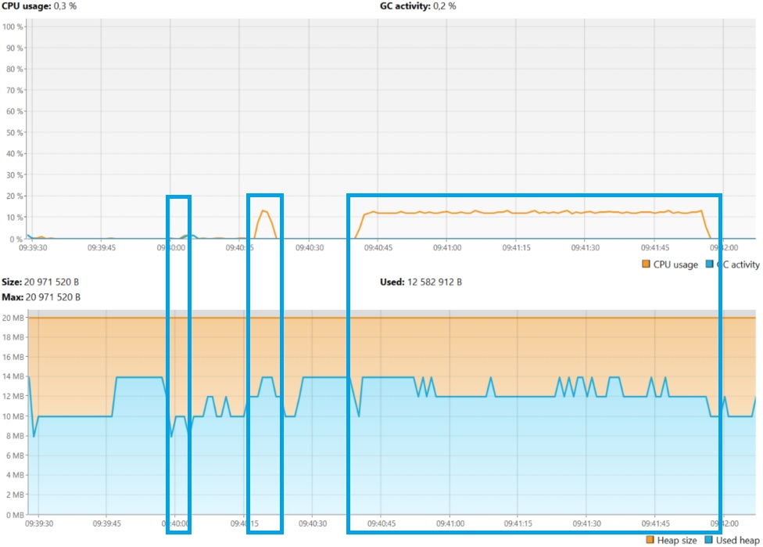

MergeSort Начало сортировки - 09:40:02.816083400

MergeSort Конец сортировки – 09:40:02.896380500

Время выполнения 0,0802971

InsertSort Начало сортировки - 09:40:18.527628100

InsertSort Конец сортировки – 09:40:21.691939

Время выполнения 3,1643109

BubbleSort Начало сортировки - 09:40:40.735400400

BubbleSort Конец сортировки – 09:41:55.614480100

Время выполнения 74,8790797

[2024-04-18T09:39:23.604+0400][info][gc] Using The Z Garbage Collector

[2024-04-18T09:39:23.742+0400][info][gc] GC(0) Garbage Collection (Warmup) 6M(30%)->6M(30%)

[2024-04-18T09:39:23.835+0400][info][gc] GC(1) Garbage Collection (Warmup) 6M(30%)->4M(20%)

[2024-04-18T09:39:24.744+0400][info][gc] GC(2) Garbage Collection (Warmup) 6M(30%)->6M(30%)

[2024-04-18T09:39:27.669+0400][info][gc] GC(3) Garbage Collection (Proactive) 10M(50%)->8M(40%)

[2024-04-18T09:39:27.740+0400][info][gc] GC(4) Garbage Collection (Allocation Rate) 14M(70%)->10M(50%)

[2024-04-18T09:39:27.865+0400][info][gc] GC(5) Garbage Collection (Allocation Rate) 12M(60%)->8M(40%)

[2024-04-18T09:39:27.943+0400][info][gc] GC(6) Garbage Collection (Allocation Rate) 10M(50%)->8M(40%)

[2024-04-18T09:39:28.039+0400][info][gc] GC(7) Garbage Collection (Allocation Rate) 12M(60%)->10M(50%)

[2024-04-18T09:39:28.154+0400][info][gc] GC(8) Garbage Collection (Allocation Rate) 14M(70%)->10M(50%)

[2024-04-18T09:39:28.246+0400][info][gc] GC(9) Garbage Collection (Allocation Rate) 10M(50%)->8M(40%)

[2024-04-18T09:39:28.356+0400][info][gc] GC(10) Garbage Collection (Allocation Rate) 10M(50%)->10M(50%)

[2024-04-18T09:39:28.449+0400][info][gc] GC(11) Garbage Collection (Allocation Rate) 10M(50%)->10M(50%)

[2024-04-18T09:39:28.555+0400][info][gc] GC(12) Garbage Collection (Allocation Rate) 10M(50%)->10M(50%)

[2024-04-18T09:39:28.651+0400][info][gc] GC(13) Garbage Collection (Allocation Rate) 10M(50%)->10M(50%)

[2024-04-18T09:39:28.755+0400][info][gc] GC(14) Garbage Collection (Allocation Rate) 10M(50%)->8M(40%)

[2024-04-18T09:39:28.853+0400][info][gc] GC(15) Garbage Collection (Allocation Rate) 10M(50%)->10M(50%)

[2024-04-18T09:39:28.942+0400][info][gc] GC(16) Garbage Collection (Allocation Rate) 10M(50%)->8M(40%)

[2024-04-18T09:39:29.050+0400][info][gc] GC(17) Garbage Collection (Allocation Rate) 10M(50%)->8M(40%)

[2024-04-18T09:39:29.144+0400][info][gc] GC(18) Garbage Collection (Allocation Rate) 10M(50%)->10M(50%)

[2024-04-18T09:39:29.253+0400][info][gc] GC(19) Garbage Collection (Allocation Rate) 10M(50%)->10M(50%)

[2024-04-18T09:39:29.351+0400][info][gc] GC(20) Garbage Collection (Allocation Rate) 10M(50%)->10M(50%)

[2024-04-18T09:39:29.456+0400][info][gc] GC(21) Garbage Collection (Allocation Rate) 10M(50%)->10M(50%)

[2024-04-18T09:39:29.549+0400][info][gc] GC(22) Garbage Collection (Allocation Rate) 10M(50%)->10M(50%)

[2024-04-18T09:39:38.144+0400][info][gc] GC(23) Garbage Collection (Proactive) 12M(60%)->8M(40%)

[2024-04-18T09:39:39.251+0400][info][gc] GC(24) Garbage Collection (Proactive) 10M(50%)->10M(50%)

[2024-04-18T09:39:46.956+0400][info][gc] GC(25) Garbage Collection (Proactive) 12M(60%)->12M(60%)

[2024-04-18T09:39:57.147+0400][info][gc] GC(26) Garbage Collection (Proactive) 14M(70%)->8M(40%)

[2024-04-18T09:39:58.252+0400][info][gc] GC(27) Garbage Collection (Proactive) 10M(50%)->8M(40%)

[2024-04-18T09:39:59.744+0400][info][gc] GC(28) Garbage Collection (Proactive) 10M(50%)->10M(50%)

MergeSort Начало сортировки - 09:40:02.816083400

[2024-04-18T09:40:02.845+0400][info][gc] Allocation Stall (main) 15.842ms

[2024-04-18T09:40:02.845+0400][info][gc] GC(29) Garbage Collection (Allocation Stall) 20M(100%)->14M(70%)

[2024-04-18T09:40:02.861+0400][info][gc] Allocation Stall (main) 11.439ms

[2024-04-18T09:40:02.862+0400][info][gc] GC(30) Garbage Collection (Allocation Stall) 20M(100%)->14M(70%)

[2024-04-18T09:40:02.880+0400][info][gc] Allocation Stall (main) 12.662ms

[2024-04-18T09:40:02.881+0400][info][gc] GC(31) Garbage Collection (Allocation Stall) 20M(100%)->16M(80%)

[2024-04-18T09:40:02.894+0400][info][gc] Allocation Stall (main) 11.307ms

[2024-04-18T09:40:02.894+0400][info][gc] GC(32) Garbage Collection (Allocation Stall) 20M(100%)->16M(80%)

MergeSort Конец сортировки – 09:40:02.896380500

[2024-04-18T09:40:02.951+0400][info][gc] GC(33) Garbage Collection (Allocation Rate) 18M(90%)->8M(40%)

[2024-04-18T09:40:03.056+0400][info][gc] GC(34) Garbage Collection (Allocation Rate) 8M(40%)->8M(40%)

[2024-04-18T09:40:03.152+0400][info][gc] GC(35) Garbage Collection (Allocation Rate) 10M(50%)->10M(50%)

[2024-04-18T09:40:03.248+0400][info][gc] GC(36) Garbage Collection (Allocation Rate) 10M(50%)->10M(50%)

[2024-04-18T09:40:03.356+0400][info][gc] GC(37) Garbage Collection (Allocation Rate) 10M(50%)->10M(50%)

[2024-04-18T09:40:03.449+0400][info][gc] GC(38) Garbage Collection (Allocation Rate) 10M(50%)->10M(50%)

[2024-04-18T09:40:03.558+0400][info][gc] GC(39) Garbage Collection (Allocation Rate) 10M(50%)->10M(50%)

[2024-04-18T09:40:03.646+0400][info][gc] GC(40) Garbage Collection (Allocation Rate) 10M(50%)->10M(50%)

[2024-04-18T09:40:03.752+0400][info][gc] GC(41) Garbage Collection (Allocation Rate) 10M(50%)->10M(50%)

[2024-04-18T09:40:03.943+0400][info][gc] GC(42) Garbage Collection (Allocation Rate) 10M(50%)->10M(50%)

[2024-04-18T09:40:04.056+0400][info][gc] GC(43) Garbage Collection (Allocation Rate) 10M(50%)->10M(50%)

[2024-04-18T09:40:04.144+0400][info][gc] GC(44) Garbage Collection (Allocation Rate) 12M(60%)->12M(60%)

[2024-04-18T09:40:04.258+0400][info][gc] GC(45) Garbage Collection (Allocation Rate) 12M(60%)->10M(50%)

[2024-04-18T09:40:04.351+0400][info][gc] GC(46) Garbage Collection (Allocation Rate) 10M(50%)->10M(50%)

[2024-04-18T09:40:04.446+0400][info][gc] GC(47) Garbage Collection (Allocation Rate) 10M(50%)->10M(50%)

[2024-04-18T09:40:04.553+0400][info][gc] GC(48) Garbage Collection (Allocation Rate) 10M(50%)->10M(50%)

[2024-04-18T09:40:04.646+0400][info][gc] GC(49) Garbage Collection (Allocation Rate) 10M(50%)->10M(50%)

[2024-04-18T09:40:04.755+0400][info][gc] GC(50) Garbage Collection (Allocation Rate) 10M(50%)->10M(50%)

[2024-04-18T09:40:05.746+0400][info][gc] GC(51) Garbage Collection (Proactive) 12M(60%)->10M(50%)

[2024-04-18T09:40:06.850+0400][info][gc] GC(52) Garbage Collection (Proactive) 12M(60%)->10M(50%)

[2024-04-18T09:40:08.150+0400][info][gc] GC(53) Garbage Collection (Proactive) 12M(60%)->10M(50%)

[2024-04-18T09:40:09.457+0400][info][gc] GC(54) Garbage Collection (Proactive) 12M(60%)->10M(50%)

[2024-04-18T09:40:10.758+0400][info][gc] GC(55) Garbage Collection (Proactive) 12M(60%)->10M(50%)

[2024-04-18T09:40:11.946+0400][info][gc] GC(56) Garbage Collection (Proactive) 12M(60%)->10M(50%)

[2024-04-18T09:40:13.049+0400][info][gc] GC(57) Garbage Collection (Proactive) 12M(60%)->10M(50%)

[2024-04-18T09:40:14.043+0400][info][gc] GC(58) Garbage Collection (Proactive) 12M(60%)->10M(50%)

[2024-04-18T09:40:14.958+0400][info][gc] GC(59) Garbage Collection (Proactive) 12M(60%)->10M(50%)

[2024-04-18T09:40:16.045+0400][info][gc] GC(60) Garbage Collection (Proactive) 12M(60%)->10M(50%)

[2024-04-18T09:40:17.351+0400][info][gc] GC(61) Garbage Collection (Proactive) 12M(60%)->10M(50%)

InsertSort Начало сортировки - 09:40:18.527628100

[2024-04-18T09:40:18.652+0400][info][gc] GC(62) Garbage Collection (Proactive) 14M(70%)->12M(60%)

[2024-04-18T09:40:19.952+0400][info][gc] GC(63) Garbage Collection (Proactive) 14M(70%)->12M(60%)

[2024-04-18T09:40:21.042+0400][info][gc] GC(64) Garbage Collection (Proactive) 14M(70%)->12M(60%)

InsertSort Конец сортировки – 09:40:21.691939

[2024-04-18T09:40:21.952+0400][info][gc] GC(65) Garbage Collection (Proactive) 14M(70%)->10M(50%)

[2024-04-18T09:40:22.945+0400][info][gc] GC(66) Garbage Collection (Proactive) 12M(60%)->10M(50%)

[2024-04-18T09:40:23.948+0400][info][gc] GC(67) Garbage Collection (Proactive) 12M(60%)->10M(50%)

[2024-04-18T09:40:24.850+0400][info][gc] GC(68) Garbage Collection (Proactive) 12M(60%)->10M(50%)

[2024-04-18T09:40:25.752+0400][info][gc] GC(69) Garbage Collection (Proactive) 12M(60%)->10M(50%)

[2024-04-18T09:40:27.142+0400][info][gc] GC(70) Garbage Collection (Proactive) 12M(60%)->12M(60%)

[2024-04-18T09:40:38.255+0400][info][gc] GC(71) Garbage Collection (Proactive) 14M(70%)->10M(50%)

[2024-04-18T09:40:39.345+0400][info][gc] GC(72) Garbage Collection (Proactive) 12M(60%)->10M(50%)

BubbleSort Начало сортировки - 09:40:40.735400400

[2024-04-18T09:40:40.749+0400][info][gc] GC(73) Garbage Collection (Proactive) 12M(60%)->14M(70%)

[2024-04-18T09:40:50.242+0400][info][gc] GC(74) Garbage Collection (Proactive) 16M(80%)->12M(60%)

[2024-04-18T09:40:51.248+0400][info][gc] GC(75) Garbage Collection (Proactive) 14M(70%)->12M(60%)

[2024-04-18T09:40:52.150+0400][info][gc] GC(76) Garbage Collection (Proactive) 14M(70%)->12M(60%)

[2024-04-18T09:40:52.942+0400][info][gc] GC(77) Garbage Collection (Proactive) 14M(70%)->12M(60%)

[2024-04-18T09:40:53.751+0400][info][gc] GC(78) Garbage Collection (Proactive) 14M(70%)->12M(60%)

[2024-04-18T09:40:54.445+0400][info][gc] GC(79) Garbage Collection (Proactive) 14M(70%)->12M(60%)

[2024-04-18T09:40:55.253+0400][info][gc] GC(80) Garbage Collection (Proactive) 14M(70%)->12M(60%)

[2024-04-18T09:40:56.251+0400][info][gc] GC(81) Garbage Collection (Proactive) 14M(70%)->12M(60%)

[2024-04-18T09:40:57.253+0400][info][gc] GC(82) Garbage Collection (Proactive) 14M(70%)->12M(60%)

[2024-04-18T09:40:58.152+0400][info][gc] GC(83) Garbage Collection (Proactive) 14M(70%)->12M(60%)

[2024-04-18T09:40:58.938+0400][info][gc] GC(84) Garbage Collection (Proactive) 14M(70%)->12M(60%)

[2024-04-18T09:40:59.745+0400][info][gc] GC(85) Garbage Collection (Proactive) 14M(70%)->12M(60%)

[2024-04-18T09:41:00.548+0400][info][gc] GC(86) Garbage Collection (Proactive) 14M(70%)->12M(60%)

[2024-04-18T09:41:01.244+0400][info][gc] GC(87) Garbage Collection (Proactive) 14M(70%)->12M(60%)

[2024-04-18T09:41:02.244+0400][info][gc] GC(88) Garbage Collection (Proactive) 14M(70%)->12M(60%)

[2024-04-18T09:41:03.240+0400][info][gc] GC(89) Garbage Collection (Proactive) 14M(70%)->12M(60%)

[2024-04-18T09:41:04.251+0400][info][gc] GC(90) Garbage Collection (Proactive) 14M(70%)->12M(60%)

[2024-04-18T09:41:05.244+0400][info][gc] GC(91) Garbage Collection (Proactive) 14M(70%)->12M(60%)

[2024-04-18T09:41:06.241+0400][info][gc] GC(92) Garbage Collection (Proactive) 14M(70%)->12M(60%)

[2024-04-18T09:41:07.248+0400][info][gc] GC(93) Garbage Collection (Proactive) 14M(70%)->12M(60%)

[2024-04-18T09:41:08.244+0400][info][gc] GC(94) Garbage Collection (Proactive) 14M(70%)->12M(60%)

[2024-04-18T09:41:09.250+0400][info][gc] GC(95) Garbage Collection (Proactive) 14M(70%)->12M(60%)

[2024-04-18T09:41:10.241+0400][info][gc] GC(96) Garbage Collection (Proactive) 14M(70%)->12M(60%)

[2024-04-18T09:41:11.254+0400][info][gc] GC(97) Garbage Collection (Proactive) 14M(70%)->12M(60%)

[2024-04-18T09:41:12.251+0400][info][gc] GC(98) Garbage Collection (Proactive) 14M(70%)->12M(60%)

[2024-04-18T09:41:13.245+0400][info][gc] GC(99) Garbage Collection (Proactive) 14M(70%)->12M(60%)

[2024-04-18T09:41:14.244+0400][info][gc] GC(100) Garbage Collection (Proactive) 14M(70%)->12M(60%)

[2024-04-18T09:41:15.246+0400][info][gc] GC(101) Garbage Collection (Proactive) 14M(70%)->12M(60%)

[2024-04-18T09:41:16.241+0400][info][gc] GC(102) Garbage Collection (Proactive) 14M(70%)->12M(60%)

[2024-04-18T09:41:17.251+0400][info][gc] GC(103) Garbage Collection (Proactive) 14M(70%)->12M(60%)

[2024-04-18T09:41:18.249+0400][info][gc] GC(104) Garbage Collection (Proactive) 14M(70%)->12M(60%)

[2024-04-18T09:41:19.248+0400][info][gc] GC(105) Garbage Collection (Proactive) 14M(70%)->12M(60%)

[2024-04-18T09:41:20.243+0400][info][gc] GC(106) Garbage Collection (Proactive) 14M(70%)->12M(60%)

[2024-04-18T09:41:21.245+0400][info][gc] GC(107) Garbage Collection (Proactive) 14M(70%)->12M(60%)

[2024-04-18T09:41:22.239+0400][info][gc] GC(108) Garbage Collection (Proactive) 14M(70%)->12M(60%)

[2024-04-18T09:41:23.243+0400][info][gc] GC(109) Garbage Collection (Proactive) 14M(70%)->12M(60%)

[2024-04-18T09:41:24.243+0400][info][gc] GC(110) Garbage Collection (Proactive) 14M(70%)->12M(60%)

[2024-04-18T09:41:25.243+0400][info][gc] GC(111) Garbage Collection (Proactive) 14M(70%)->12M(60%)

[2024-04-18T09:41:26.239+0400][info][gc] GC(112) Garbage Collection (Proactive) 14M(70%)->12M(60%)

[2024-04-18T09:41:27.238+0400][info][gc] GC(113) Garbage Collection (Proactive) 14M(70%)->12M(60%)

[2024-04-18T09:41:28.151+0400][info][gc] GC(114) Garbage Collection (Proactive) 14M(70%)->12M(60%)

[2024-04-18T09:41:28.844+0400][info][gc] GC(115) Garbage Collection (Proactive) 14M(70%)->12M(60%)

[2024-04-18T09:41:29.551+0400][info][gc] GC(116) Garbage Collection (Proactive) 14M(70%)->12M(60%)

[2024-04-18T09:41:30.249+0400][info][gc] GC(117) Garbage Collection (Proactive) 14M(70%)->12M(60%)

[2024-04-18T09:41:31.245+0400][info][gc] GC(118) Garbage Collection (Proactive) 14M(70%)->12M(60%)

[2024-04-18T09:41:32.239+0400][info][gc] GC(119) Garbage Collection (Proactive) 14M(70%)->12M(60%)

[2024-04-18T09:41:33.241+0400][info][gc] GC(120) Garbage Collection (Proactive) 14M(70%)->12M(60%)

[2024-04-18T09:41:34.240+0400][info][gc] GC(121) Garbage Collection (Proactive) 14M(70%)->12M(60%)

[2024-04-18T09:41:35.252+0400][info][gc] GC(122) Garbage Collection (Proactive) 14M(70%)->12M(60%)

[2024-04-18T09:41:36.257+0400][info][gc] GC(123) Garbage Collection (Proactive) 14M(70%)->12M(60%)

[2024-04-18T09:41:37.339+0400][info][gc] GC(124) Garbage Collection (Proactive) 14M(70%)->12M(60%)

[2024-04-18T09:41:38.251+0400][info][gc] GC(125) Garbage Collection (Proactive) 14M(70%)->12M(60%)

[2024-04-18T09:41:39.243+0400][info][gc] GC(126) Garbage Collection (Proactive) 14M(70%)->12M(60%)

[2024-04-18T09:41:40.239+0400][info][gc] GC(127) Garbage Collection (Proactive) 14M(70%)->12M(60%)

[2024-04-18T09:41:41.246+0400][info][gc] GC(128) Garbage Collection (Proactive) 14M(70%)->12M(60%)

[2024-04-18T09:41:42.240+0400][info][gc] GC(129) Garbage Collection (Proactive) 14M(70%)->12M(60%)

[2024-04-18T09:41:43.254+0400][info][gc] GC(130) Garbage Collection (Proactive) 14M(70%)->12M(60%)

[2024-04-18T09:41:44.439+0400][info][gc] GC(131) Garbage Collection (Proactive) 14M(70%)->12M(60%)

[2024-04-18T09:41:45.454+0400][info][gc] GC(132) Garbage Collection (Proactive) 14M(70%)->12M(60%)

[2024-04-18T09:41:46.339+0400][info][gc] GC(133) Garbage Collection (Proactive) 14M(70%)->12M(60%)

[2024-04-18T09:41:47.147+0400][info][gc] GC(134) Garbage Collection (Proactive) 14M(70%)->12M(60%)

[2024-04-18T09:41:47.940+0400][info][gc] GC(135) Garbage Collection (Proactive) 14M(70%)->12M(60%)

[2024-04-18T09:41:48.751+0400][info][gc] GC(136) Garbage Collection (Proactive) 14M(70%)->12M(60%)

[2024-04-18T09:41:49.540+0400][info][gc] GC(137) Garbage Collection (Proactive) 14M(70%)->12M(60%)

[2024-04-18T09:41:50.245+0400][info][gc] GC(138) Garbage Collection (Proactive) 14M(70%)->12M(60%)

[2024-04-18T09:41:51.246+0400][info][gc] GC(139) Garbage Collection (Proactive) 14M(70%)->12M(60%)

[2024-04-18T09:41:52.239+0400][info][gc] GC(140) Garbage Collection (Proactive) 14M(70%)->12M(60%)

[2024-04-18T09:41:53.245+0400][info][gc] GC(141) Garbage Collection (Proactive) 14M(70%)->12M(60%)

[2024-04-18T09:41:54.251+0400][info][gc] GC(142) Garbage Collection (Proactive) 14M(70%)->12M(60%)

[2024-04-18T09:41:55.246+0400][info][gc] GC(143) Garbage Collection (Proactive) 14M(70%)->12M(60%)

BubbleSort Конец сортировки – 09:41:55.614480100

[2024-04-18T09:41:55.949+0400][info][gc] GC(144) Garbage Collection (Proactive) 14M(70%)->10M(50%)

[2024-04-18T09:41:56.942+0400][info][gc] GC(145) Garbage Collection (Proactive) 12M(60%)->10M(50%)

[2024-04-18T09:41:57.842+0400][info][gc] GC(146) Garbage Collection (Proactive) 12M(60%)->10M(50%)

[2024-04-18T09:41:58.745+0400][info][gc] GC(147) Garbage Collection (Proactive) 12M(60%)->10M(50%)

[2024-04-18T09:41:59.644+0400][info][gc] GC(148) Garbage Collection (Proactive) 12M(60%)->10M(50%)

[2024-04-18T09:42:00.744+0400][info][gc] GC(149) Garbage Collection (Proactive) 12M(60%)->10M(50%)

[2024-04-18T09:42:01.750+0400][info][gc] GC(150) Garbage Collection (Proactive) 12M(60%)->10M(50%)

[2024-04-18T09:42:02.751+0400][info][gc] GC(151) Garbage Collection (Proactive) 12M(60%)->10M(50%)

[2024-04-18T09:42:03.652+0400][info][gc] GC(152) Garbage Collection (Proactive) 12M(60%)->10M(50%)

[2024-04-18T09:42:04.646+0400][info][gc] GC(153) Garbage Collection (Proactive) 12M(60%)->10M(50%)

[2024-04-18T09:42:05.654+0400][info][gc] GC(154) Garbage Collection (Proactive) 12M(60%)->10M(50%)

[2024-04-18T09:42:06.553+0400][info][gc] GC(155) Garbage Collection (Proactive) 12M(60%)→10M(50%)