1.

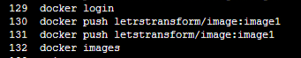

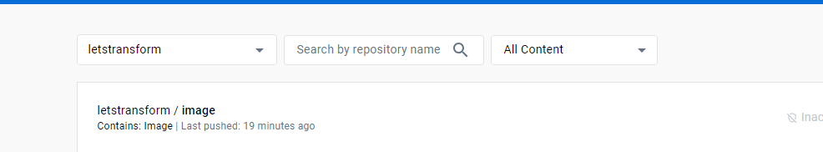

7 sudo apt update

8 sudo apt-get install docker.io

9 docker

10 docker login

11 docker image pull letstransform/image

12 docker image pull letstransform/image:image1

13 docker images

14 docker run -itd -p 80:80 --name conA letstransform/image

15 docker run -itd -p 80:80 --name conA e4c58958181a

16 docker container ls

17 docker exec -it conA bash

18 history

root@9938d42bf61c:/# history

1 apt-get update

2 apt-get install -y apache2

3 service apache2 start

