1. **Kubernetes Assignment - 1**

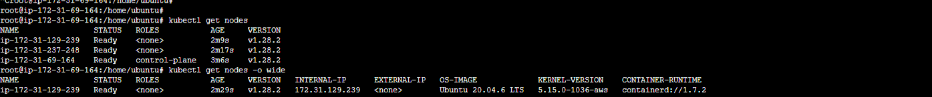

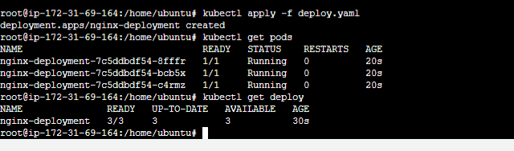

1. **Kubernetes Assignment – 2**

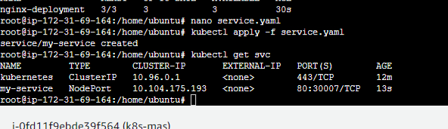

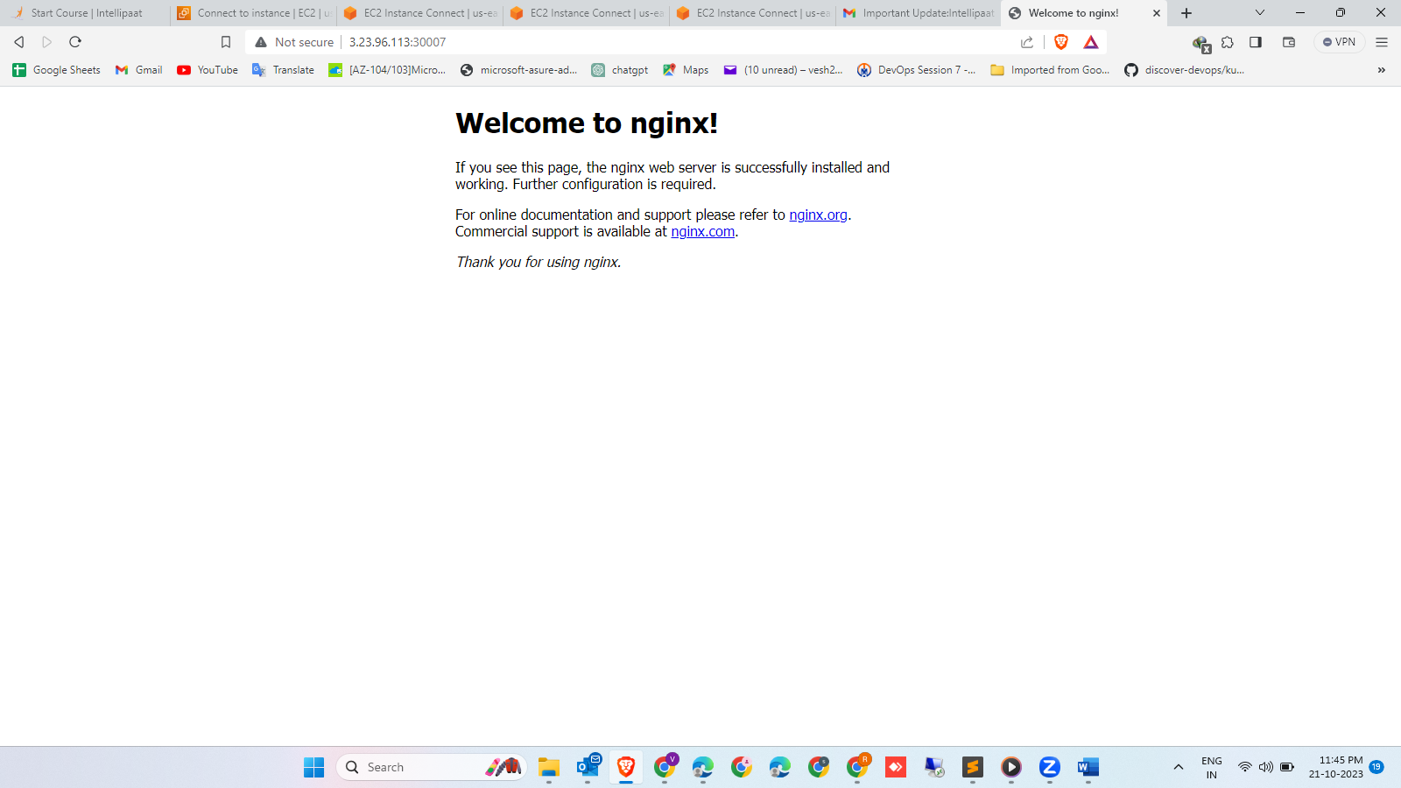

1. **Kubernetes Assignments -3**

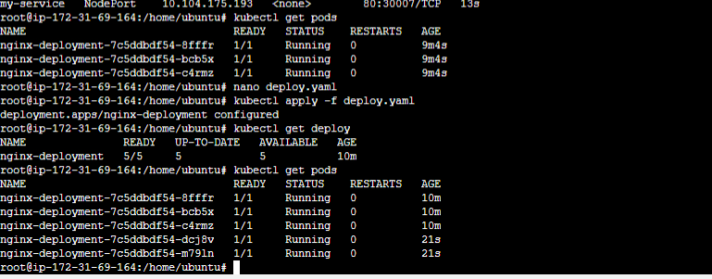

1. **Kubernetes Assignment -4**

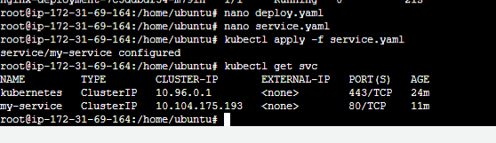

1. **Kubernetes Assignment - 5**

