**Terraform Assignment - 1**

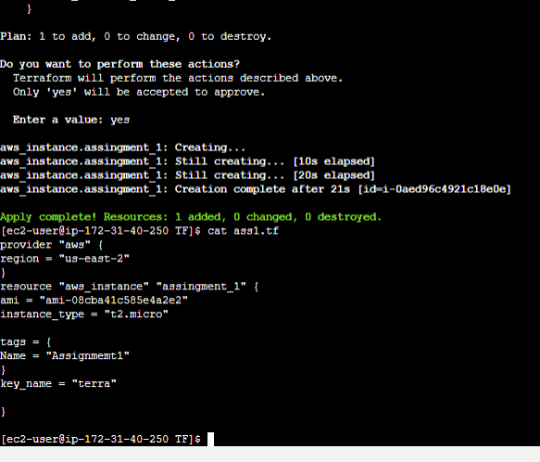

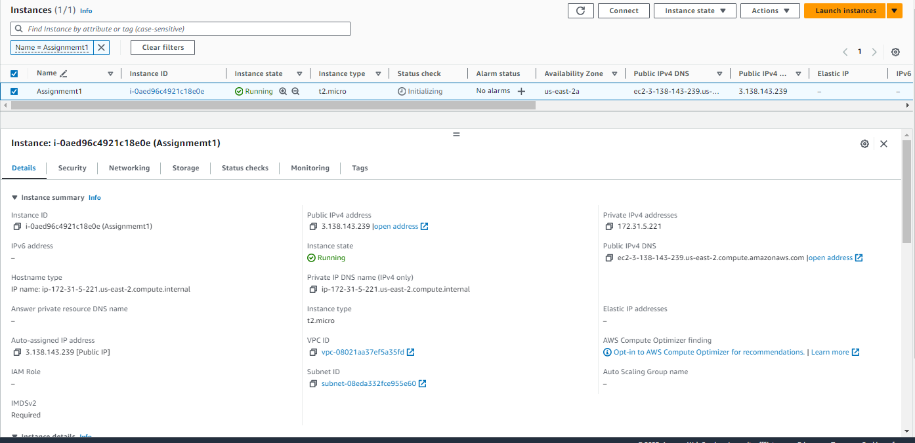

**Terraform Assignment - 2**

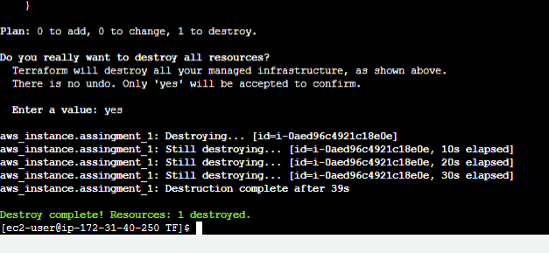

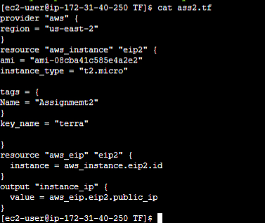

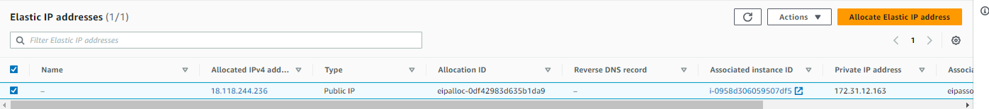

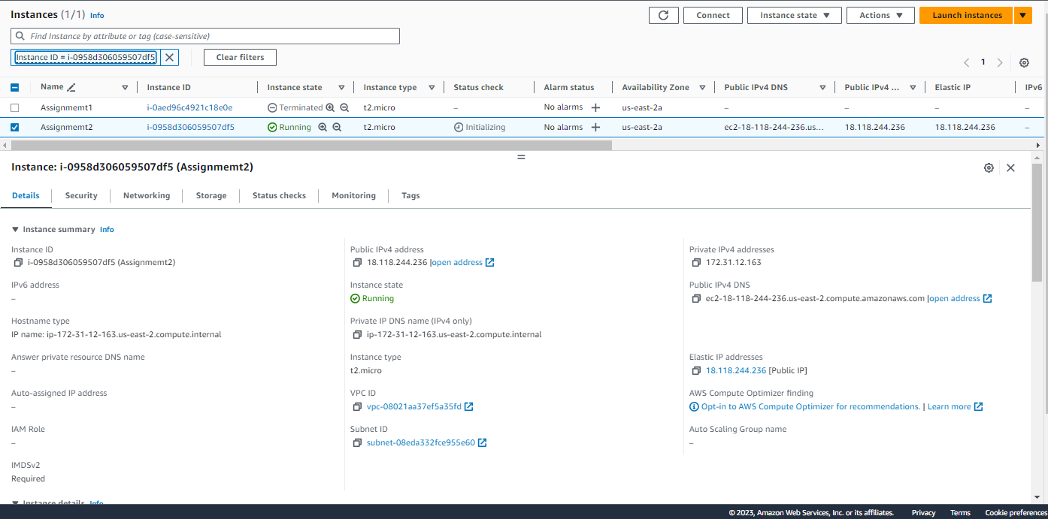

**Terraform Assignment - 3**

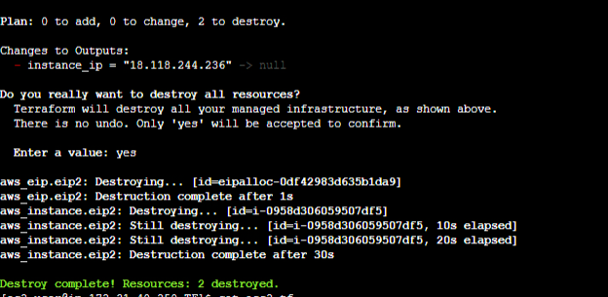

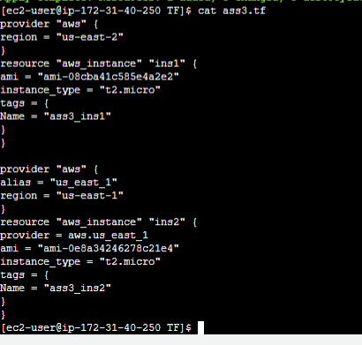

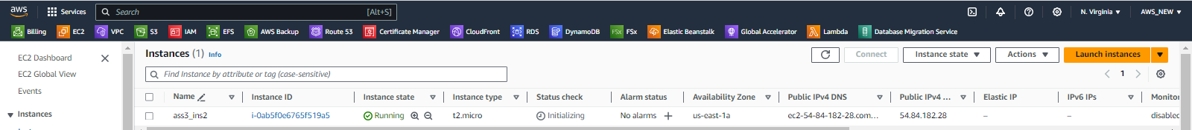

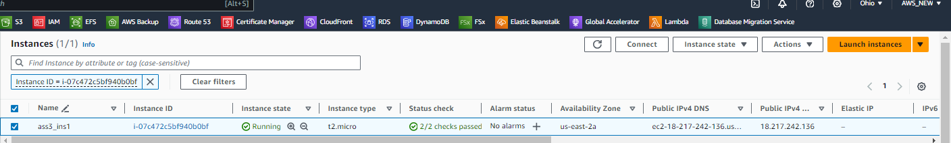

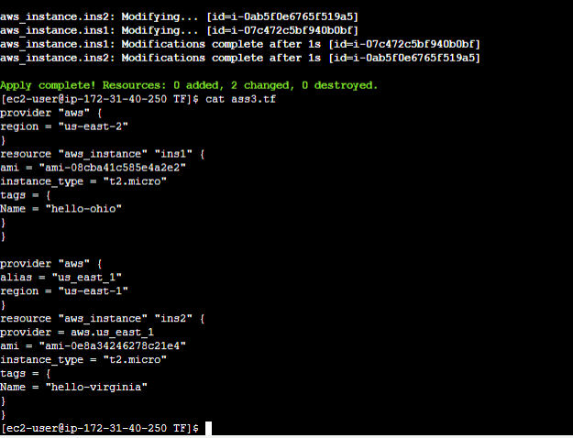

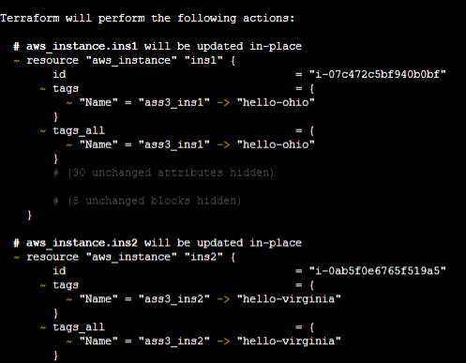

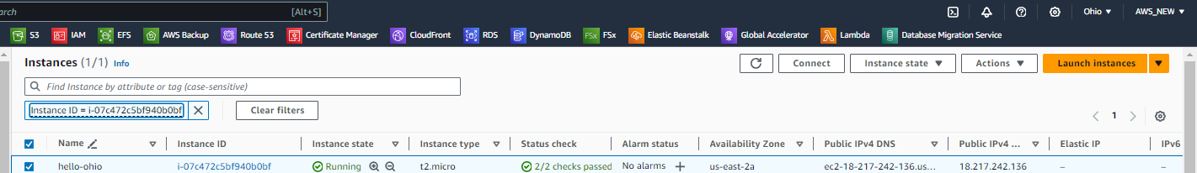 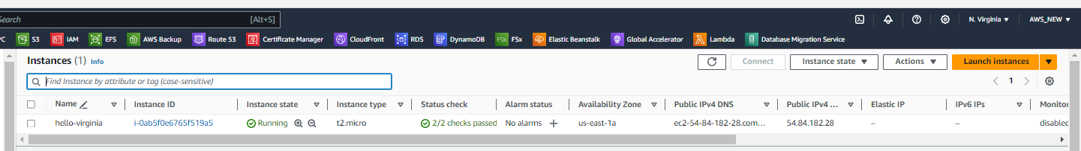

**Terraform Assignment – 4**

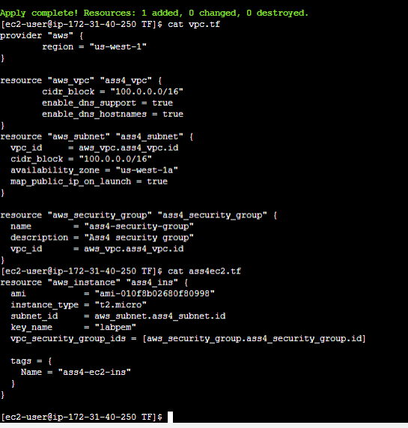

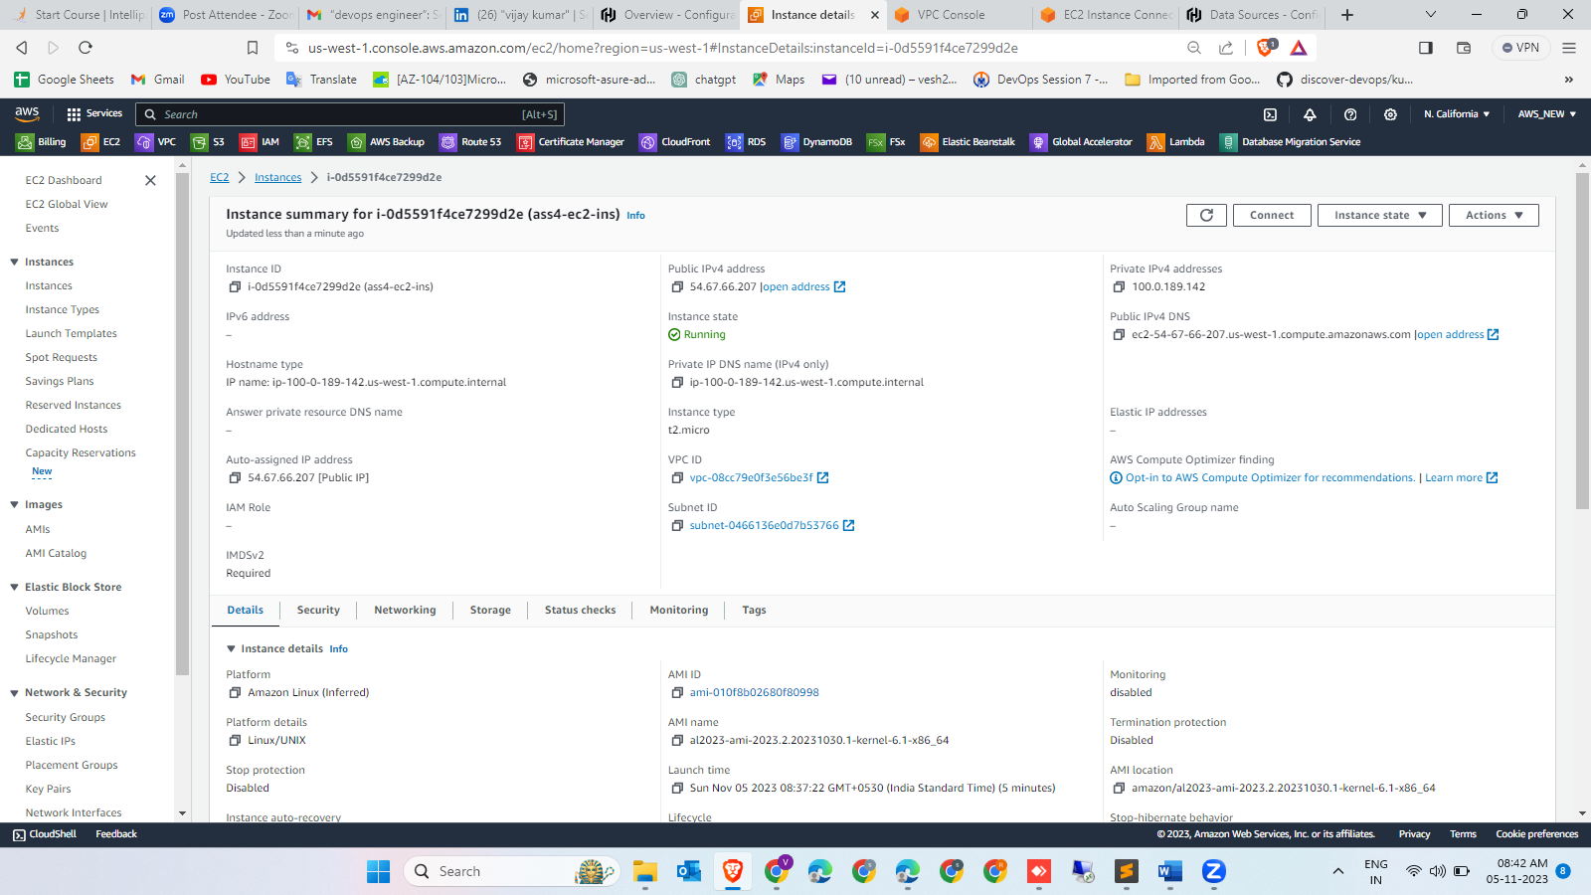

**Terraform Assignment – 5**

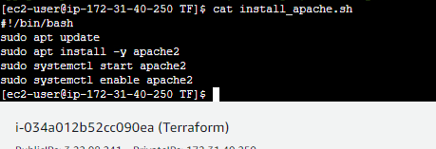

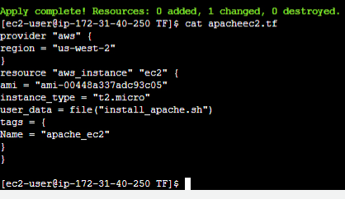

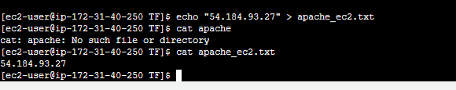

**CASE STUDY -CREATING AN ARCHITECTURE USING TERRAFORM ON AWS**

**[ec2-user@ip-172-31-40-250 TF]$ cat ass5.tf**

**provider "aws" {**

**region = "us-west-2"**

**}**

**resource "aws_vpc" "my_vpc" {**

**cidr_block = "50.0.0.0/16"**

**}**

**resource "aws_subnet" "subnet1" {**

**vpc_id = aws_vpc.my_vpc.id**

**cidr_block = "50.0.1.0/24"**

**availability_zone = "us-west-2a"**

**}**

**resource "aws_subnet" "subnet2" {**

**vpc_id = aws_vpc.my_vpc.id**

**cidr_block = "50.0.2.0/24"**

**availability_zone = "us-west-2b"**

**}**

**resource "aws_security_group" "my_sg" {**

**name = "my-sg"**

**description = "Allow incoming HTTP traffic"**

**vpc_id = aws_vpc.my_vpc.id**

**ingress {**

**from_port = 80**

**to_port = 80**

**protocol = "tcp"**

**cidr_blocks = ["0.0.0.0/0"]**

**}**

**}**

**resource "aws_internet_gateway" "my_igw" {**

**vpc_id = aws_vpc.my_vpc.id**

**}**

**resource "aws_internet_gateway_attachment" "my_igw_attachment" {**

**vpc_id = aws_vpc.my_vpc.id**

**internet_gateway_id = aws_internet_gateway.my_igw.id**

**}**

**resource "aws_instance" "my_instance1" {**

**ami = "ami-0efcece6bed30fd98"**

**instance_type = "t2.micro"**

**subnet_id = aws_subnet.subnet1.id**

**security_groups = [aws_security_group.my_sg.id]**

**}**

**resource "aws_instance" "my_instance2" {**

**ami = "ami-0efcece6bed30fd98"**

**instance_type = "t2.micro"**

**subnet_id = aws_subnet.subnet2.id**

**security_groups = [aws_security_group.my_sg.id]**

**}**

**[ec2-user@ip-172-31-40-250 TF]$**

