1.
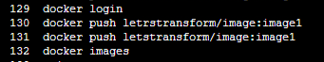

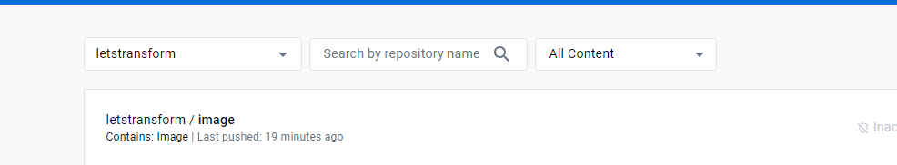
7 sudo apt update
8 sudo apt-get install docker.io
9 docker
10 docker login
11 docker image pull letstransform/image
12 docker image pull letstransform/image:image1
13 docker images
14 docker run -itd -p 80:80 --name conA letstransform/image
15 docker run -itd -p 80:80 --name conA e4c58958181a
16 docker container ls
17 docker exec -it conA bash
18 history

root@9938d42bf61c:/# history
1 apt-get update
2 apt-get install -y apache2
3 service apache2 start
