Terraform Assignment - 1

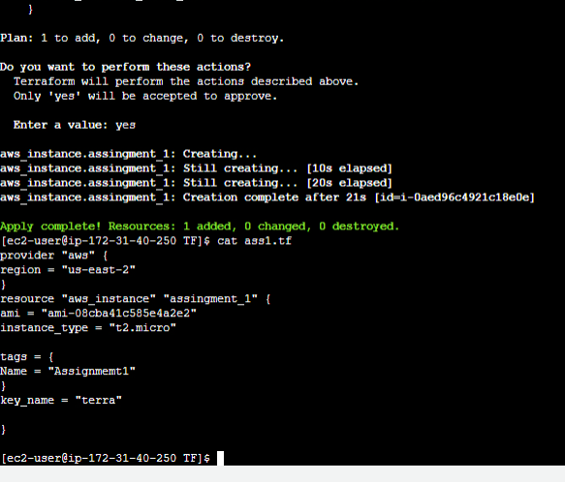
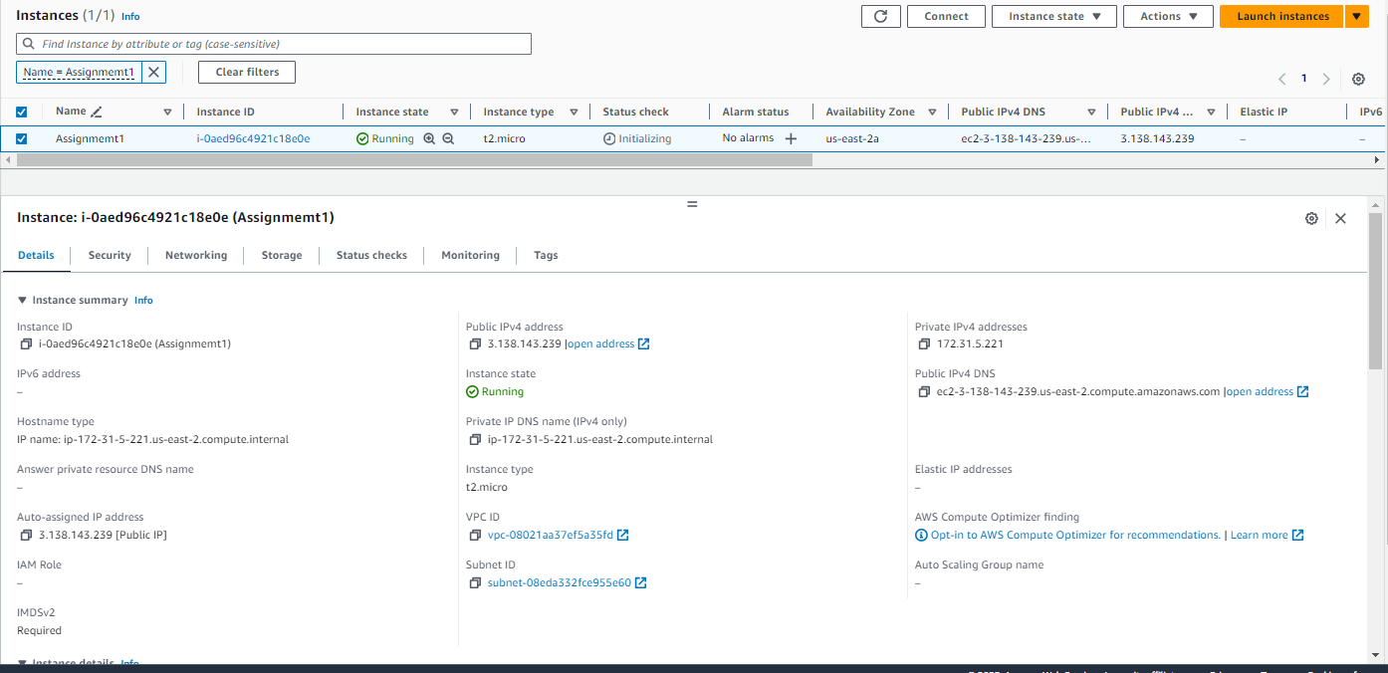

Terraform Assignment - 2

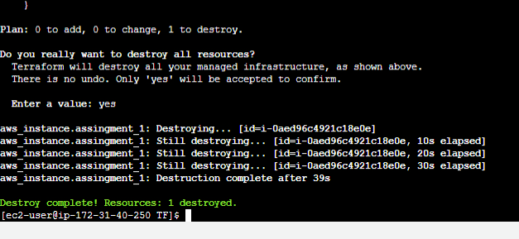
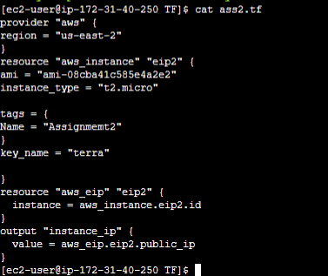
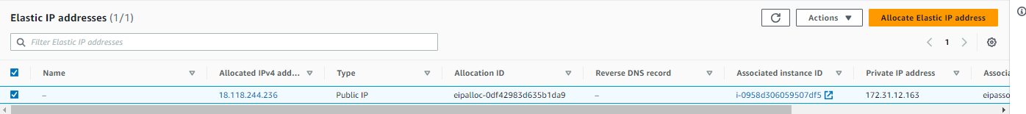
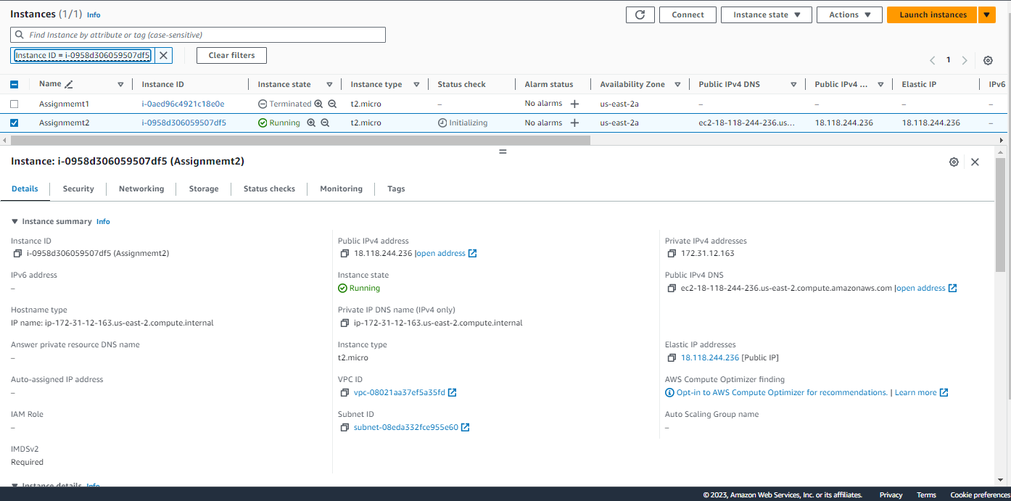

Terraform Assignment - 3
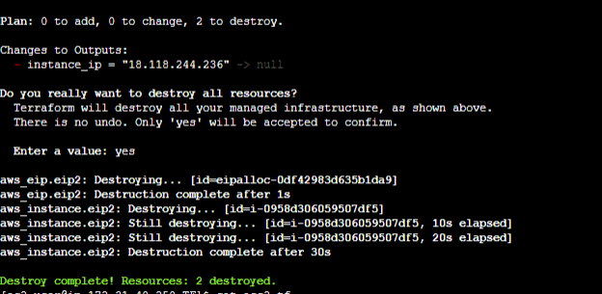
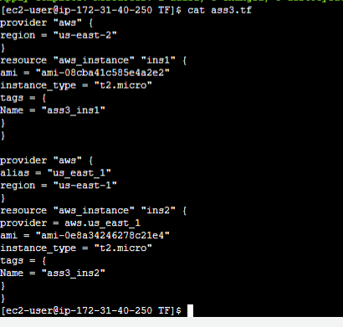
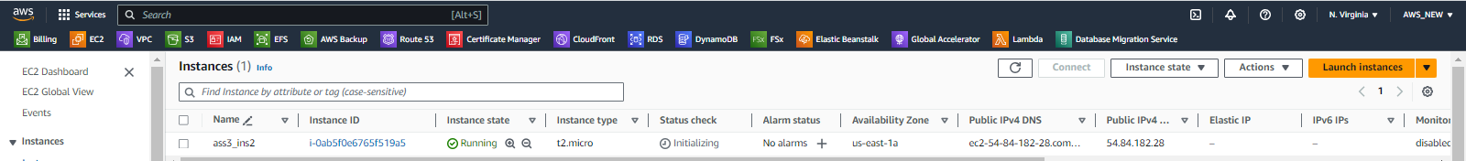
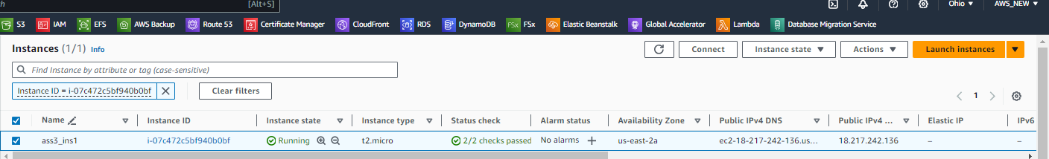
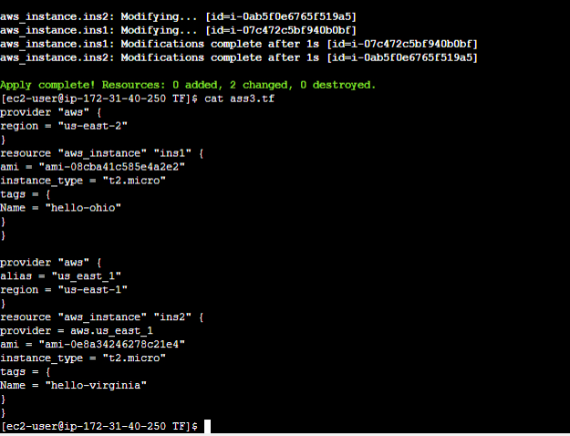
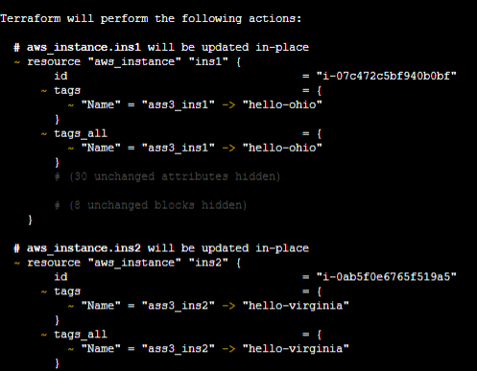
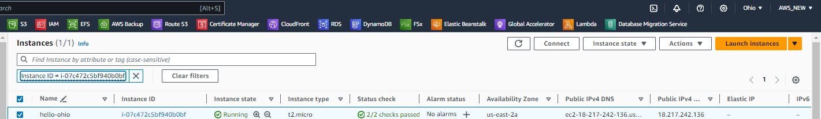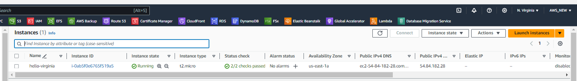

Terraform Assignment – 4

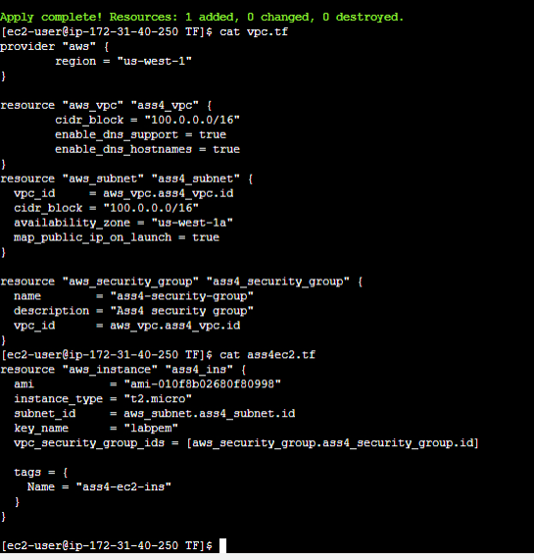
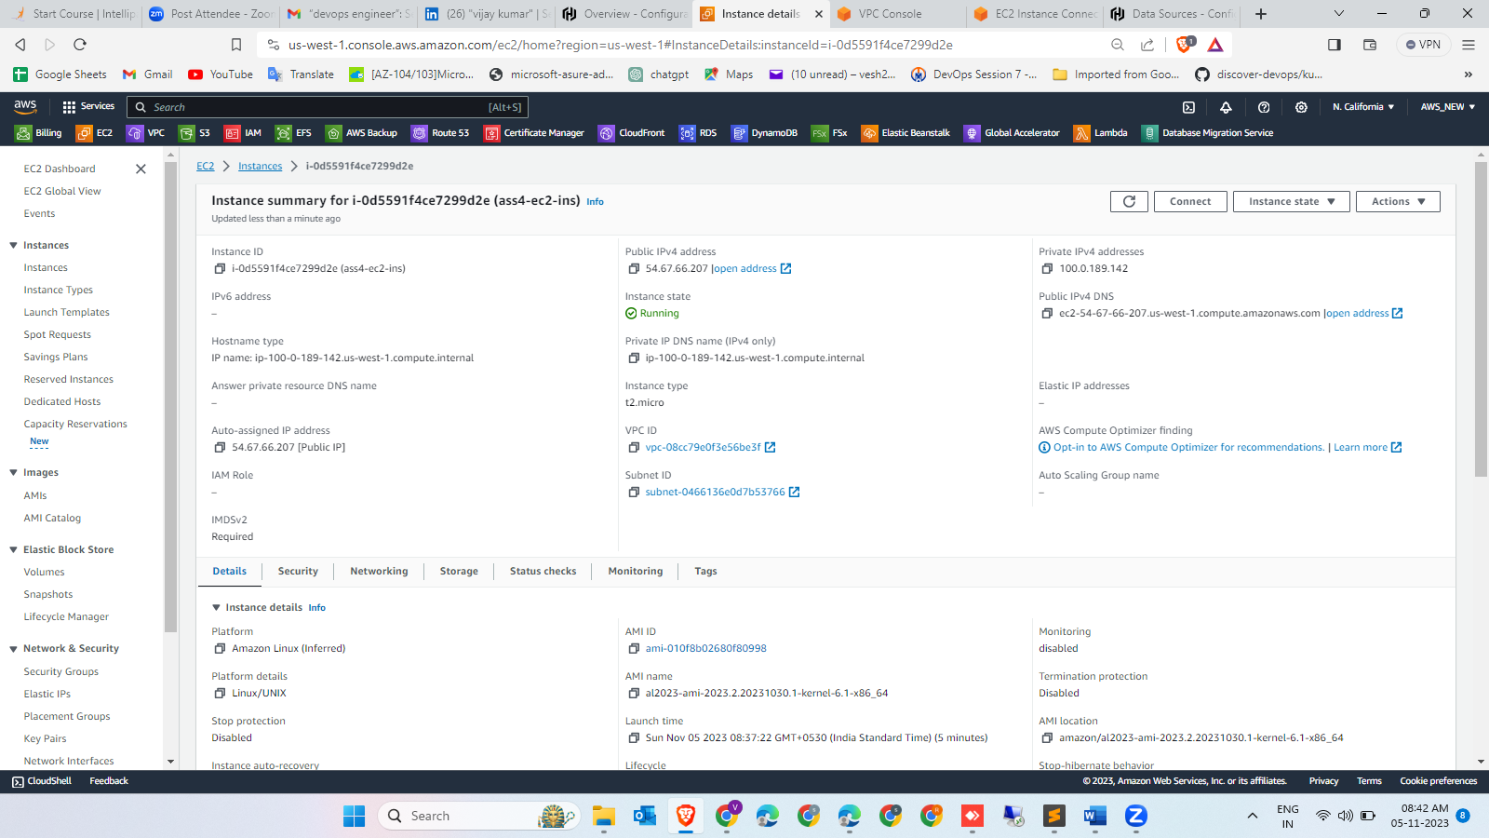

Terraform Assignment – 5
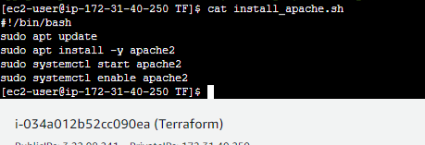
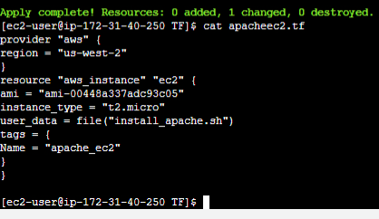
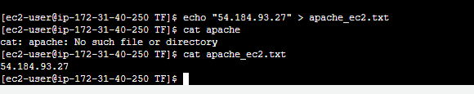

CASE STUDY -CREATING AN ARCHITECTURE USING TERRAFORM ON AWS

[ec2-user@ip-172-31-40-250 TF]$ cat ass5.tf
provider "aws" {
region = "us-west-2"
}
resource "aws_vpc" "my_vpc" {
cidr_block = "50.0.0.0/16"
}
resource "aws_subnet" "subnet1" {
vpc_id = aws_vpc.my_vpc.id
cidr_block = "50.0.1.0/24"
availability_zone = "us-west-2a"
}
resource "aws_subnet" "subnet2" {
vpc_id = aws_vpc.my_vpc.id
cidr_block = "50.0.2.0/24"
availability_zone = "us-west-2b"
}
resource "aws_security_group" "my_sg" {
name = "my-sg"
description = "Allow incoming HTTP traffic"
vpc_id = aws_vpc.my_vpc.id
ingress {
from_port = 80
to_port = 80
protocol = "tcp"
cidr_blocks = ["0.0.0.0/0"]
}
}
resource "aws_internet_gateway" "my_igw" {
vpc_id = aws_vpc.my_vpc.id
}
resource "aws_internet_gateway_attachment" "my_igw_attachment" {
vpc_id = aws_vpc.my_vpc.id
internet_gateway_id = aws_internet_gateway.my_igw.id
}
resource "aws_instance" "my_instance1" {
ami = "ami-0efcece6bed30fd98"
instance_type = "t2.micro"
subnet_id = aws_subnet.subnet1.id
security_groups = [aws_security_group.my_sg.id]
}

resource "aws_instance" "my_instance2" {
ami = "ami-0efcece6bed30fd98"
instance_type = "t2.micro"
subnet_id = aws_subnet.subnet2.id
security_groups = [aws_security_group.my_sg.id]
}
[ec2-user@ip-172-31-40-250 TF]$
