Sprint 2 UX Evidence Pack and Sprint 3 UX Refinement Handoff
IBM — Responsible Content-Safety Infrastructure
UX Design | Harneet Kaur

Deliverable | Sprint 2 UX Evidence Pack and Sprint 3 UX Refinement Handoff
Dependency | T29
Builds on | Final Raw MVP UX QA & Wellbeing/Accessibility Review (issue log UX-01 to UX-20)
Evidence captured | 27/09/2026 (latest build shared by Dev1 at the time of writing)
Prepared | 04/10/2026
Status | Prepared — verification items will be updated when the next build is provided

1. Purpose
This document consolidates the Sprint 2 UX evidence and converts the Week 3 QA findings into an implementation-ready Sprint 3 refinement handoff. Issues affecting Auditor wellbeing, accessibility, clarity of AI-assisted information, system feedback and incomplete interaction states are prioritised. Unconfirmed business parameters remain clearly marked TBC.

Part A — Sprint 2 UX Evidence Pack

2. Sprint 2 UX Deliverables and Week 2/3 Gap Reconciliation
Deliverable | Covers | Status
Sprint 2 UX Workstream Planning Input | Week 1 task plan (240 min), Weeks 2–3 outline, dependencies, requirements baseline and open-item cross-reference. | Delivered
Public User Submission UX Specification | Submission screen, required fields, synthetic/staged confirmation, upload, processing, success, failure and validation states, and feedback messages. | Delivered
Auditor/Manager Implementation UX Specification | Case Preview, Analysis & Decision, controlled media access, final decision, Decline and Manager notification, Loading and Error states, minimum Manager oversight states. | Delivered
Public User Submission UI Review | Review of the implemented submission UI against the specification, with observations and Dev1 notes. | Delivered — updated build pending
Auditor Review UI Review | Review of the implemented Auditor UI against the specification, with observations and Dev1/BA notes. | Delivered — updated build pending
Final Raw MVP UX QA & Wellbeing/Accessibility Review | Consolidated QA of the latest build with annotated evidence, implementation status and the issue log (UX-01 to UX-20). | Delivered

Week 2 review findings reconciled:
Week 2 finding | Status at Week 3 | Ref
Two versions of the submission page | Open — unchanged; current version not confirmed | UX-01
Confirmation checkbox not as specified | Open — unchanged | UX-02
Upload shown without a progress bar | Open — unchanged | UX-04
No distinct case-creation processing state | Not yet evidenced | UX-05
No validation feedback observed | Not yet evidenced | UX-09
Failure wording and Retry action | Open — unchanged | UX-07
Format and size guidance; 500 MB unconfirmed | Open — TBC | UX-08
First case observed in the Auditor queue; Public User Success / Case ID screen not captured | Observed in the Week 2 review; the user-facing screen is still to be captured | UX-06
Long system Case ID instead of a short reference | Open — BA decision | UX-11
No Severity indicator in the Auditor queue | Open — unchanged | UX-13
Case Review and Analysis tabs not shared | Open — not yet evidenced | UX-14
“---Manager Overview---” divider and “Team Overview: Done” placeholder | Open — unchanged | UX-15
Manager Dashboard is a heading only; Decline and Manager notification not implemented | Open — not yet implemented | UX-19
Missing-timestamp behaviour undefined | Open — BA decision | UX-18
“Violent content exposure” label | Open — BA decision | UX-17
Interface unstyled | Open — expected, styling in progress | UX-16
Specification has no Dashboard section | Open — UX action | UX-20

No newer build evidence has been provided since the Week 2 reviews (evidence dated 27/09/2026), so each finding is carried forward unchanged. Raised for the first time in this review: UX-03 (manual content type), UX-10 (duplicate page heading) and UX-12 (entry points and access scope).

3. Build Evidence
All build screenshots were captured on 27/09/2026 and are the latest shared by Dev1 at the time of writing. The Sprint 1 prototype (four Figma frames) remains the design reference. Numbered markers on each image correspond to the legend beside it and to the issue IDs in the QA review.
ID | Screen | Role | Captured
E1 | Landing page | All roles | 27/09/2026
E2 | User Dashboard | Public User | 27/09/2026
E3 | Submission form (Version A), default state | Public User | 27/09/2026
E4 | Upload state (Version A) | Public User | 27/09/2026
E5 | Failure state (Version A) | Public User | 27/09/2026
E6 | Submission page (Version B, “User Console”) | Public User | 27/09/2026
E7 | Auditor Dashboard | Auditor | 27/09/2026
E8 | Manager Dashboard | Manager | 27/09/2026

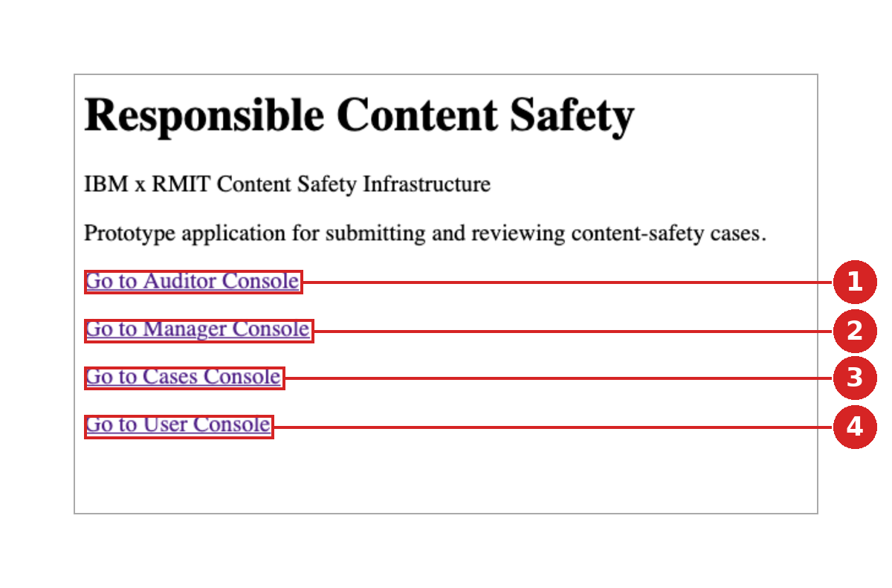 | E1 — Landing page (“Responsible Content Safety”)  1 Auditor Console link — available from the shared landing page.  2 Manager Console link — available from the shared landing page.  3 Cases Console link — purpose not evidenced.  4 User Console link — leads to the User Dashboard and submission form.  No sign-in step was evidenced between the landing page and any console (UX-12).

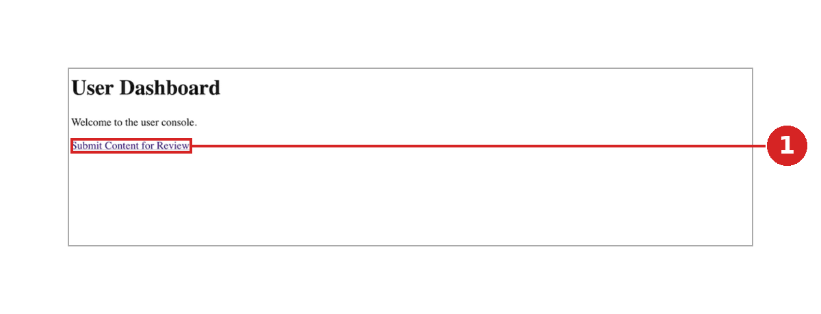 | E2 — User Dashboard  1 Single link to “Submit Content for Review”; intermediate page before the form.

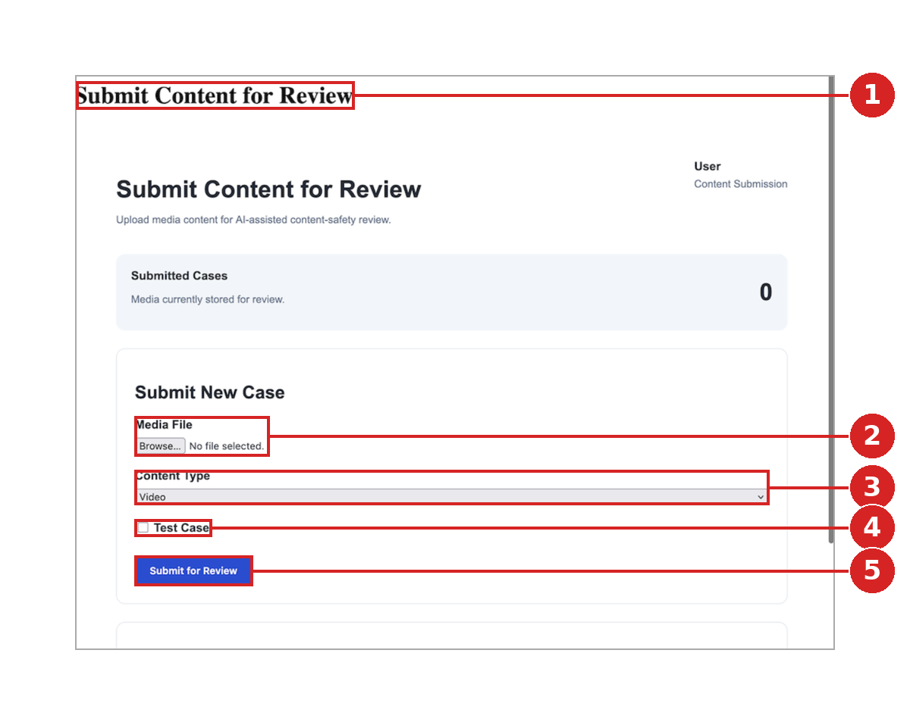 | E3 — Submission form (Version A), default state  1 Page title appears twice with different styling (UX-10).  2 Media File: no supported-format or maximum-size guidance (UX-08).  3 Content Type: manual dropdown, defaulting to Video; the approved specification calls for auto-detection (UX-03).  4 “Test Case” checkbox: label does not state the approved synthetic/staged confirmation (UX-02).  5 Submit for Review: no indication of required fields or validation feedback (UX-09).

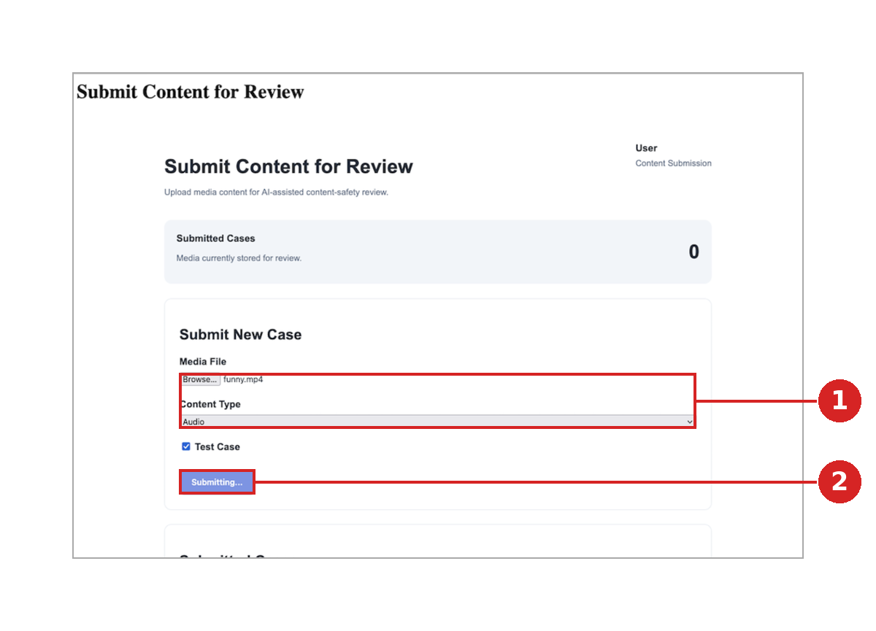 | E4 — Upload state (Version A)  1 .mp4 file with Content Type “Audio” selected (UX-03).  2 Upload shown as a button label change only (“Submitting…”); no progress bar, file name or percentage (UX-04).

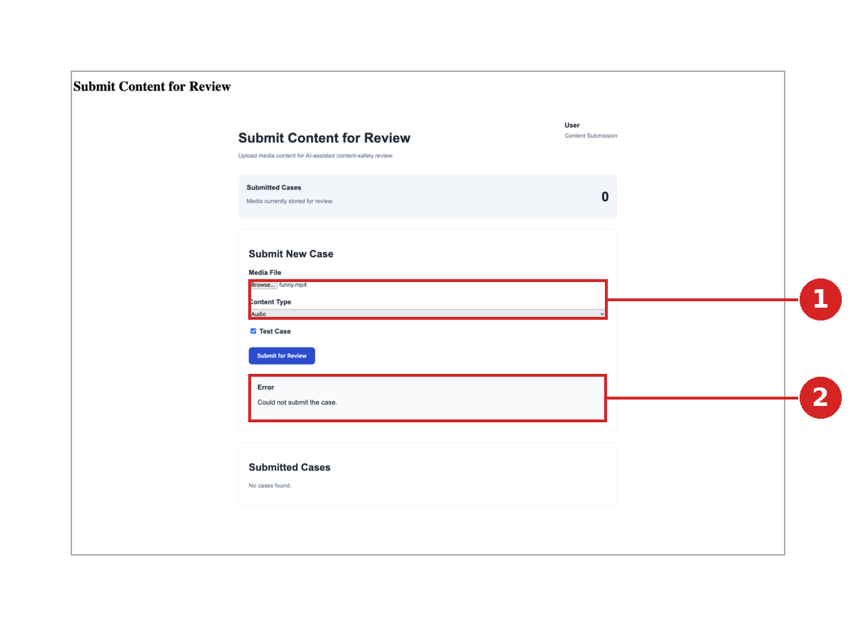 | E5 — Failure state (Version A)  1 Same .mp4 / “Audio” combination as E4 (UX-03).  2 “Could not submit the case.” is plain-language and free of technical detail, but differs from the approved wording and no Retry action is shown (UX-07).

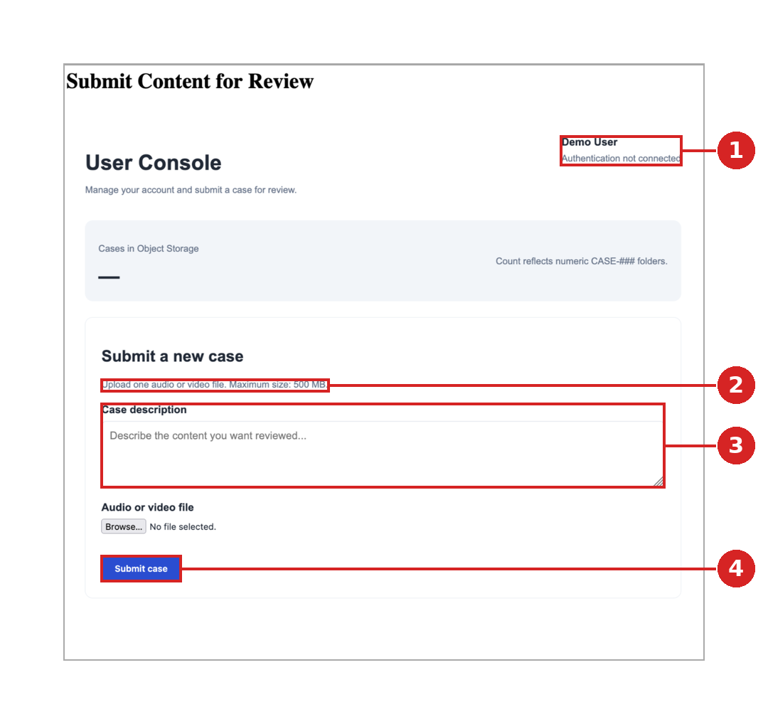 | E6 — Submission page (Version B, “User Console”)  1 “Authentication not connected” is displayed (UX-12).  2 “Maximum size: 500 MB” — limit not yet confirmed as a backend constraint (UX-08).  3 “Case description” field is not in the approved specification (UX-01).  4 Submit case: no synthetic/staged confirmation control (UX-02).

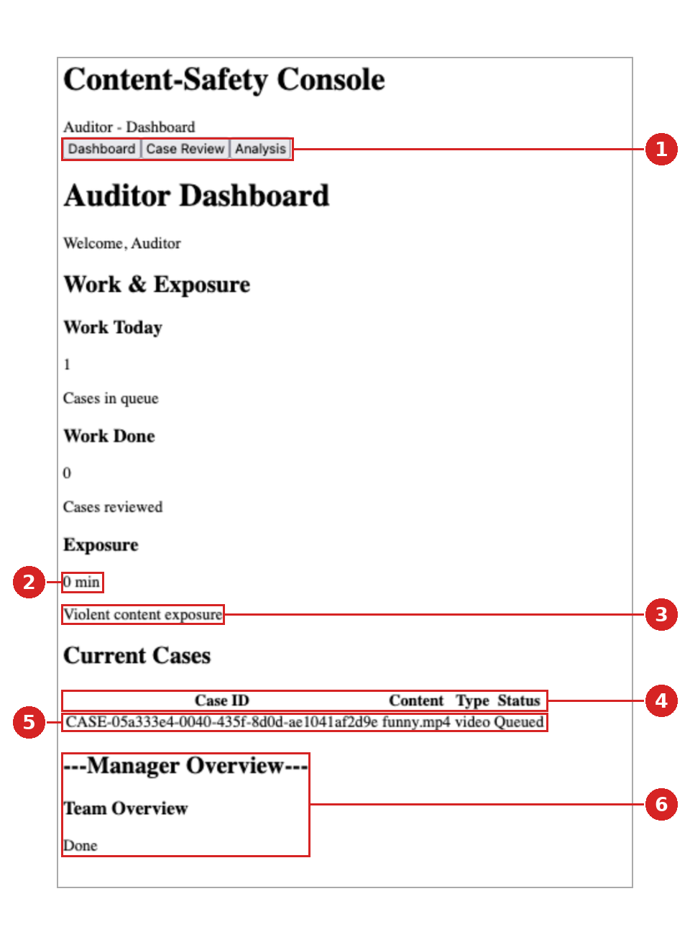 | E7 — Auditor Dashboard (first case in queue)  1 Case Review and Analysis tabs are present; their content has not been shared (UX-14).  2 Exposure is shown with its unit (min), in line with BA feedback; update behaviour not evidenced.  3 “Violent content exposure” — specific category not in the approved requirements (UX-17).  4 Queue columns are Case ID, Content, Type and Status — no Severity indicator (UX-13).  5 First case observed in the queue; the Case ID is a long system identifier (UX-11).  6 Manager Overview placeholder on the Auditor page: text-dash heading and “Done” (UX-15).

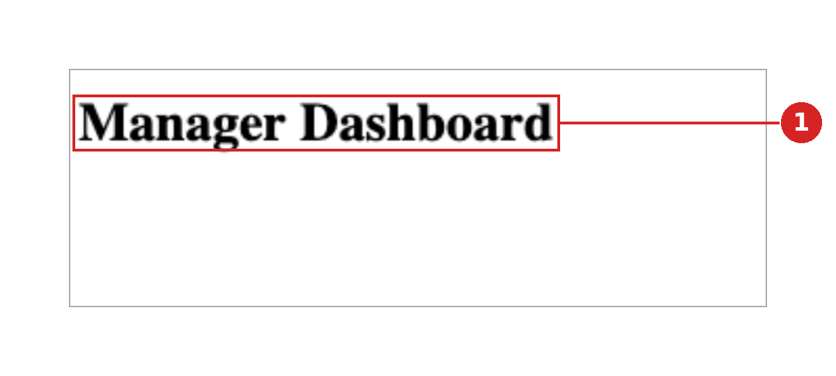 | E8 — Manager Dashboard  1 Page heading only; no content implemented (UX-19).

Part B — Sprint 3 UX Refinement Handoff

4. Prioritisation
Priority 1 | Address first. A confirmed Raw MVP requirement is not met, wellbeing or core-flow behaviour is affected, or verification of a core step is pending.
Priority 2 | Address once Priority 1 is complete. Usability, accessibility, feedback and specification-alignment items.
Priority 3 | Minor or cosmetic.

Items carry the theme they address: Auditor wellbeing, accessibility, clarity of AI-assisted information, system feedback or incomplete interaction states. Issue IDs refer to the QA review.

5. Prioritised Refinement Backlog
ID | Theme | Recommended Sprint 3 change | Owner | Depends on / TBC
Priority 1 — address first
UX-14 | AI-result clarity | Provide the build or screenshots; re-run QA on these items first. | Dev1 / UX | Updated build; OD-01, OD-03, OD-05
UX-19 | Wellbeing | Implement the minimum Manager oversight states and the Decline-to-Manager notification state; thresholds and workflow remain TBC. | Dev1 | OD-06, OD-07, OD-10, OD-11
UX-13 | AI-result clarity | Add a severity label (text and colour) to each queue row. | Dev1 | OD-01; TBC-08
UX-02 | Interaction states | Replace with the approved required checkbox wording and prevent submission until it is confirmed. | Dev1 | —
UX-06 | System feedback | Provide a screenshot of the success screen and confirm the Case ID is shown with the “Case created” confirmation. | Dev1 | TBC-01
UX-01 | Interaction states | Confirm the current version, retire the other and align it with the approved specification. | Dev1 | Dev1 confirmation; TBC-02
Priority 2 — address once Priority 1 is complete
UX-17 | Wellbeing | Use a generic “Exposure” label unless BA approves the category. | BA / Dev1 | TBC-04
UX-18 | AI-result clarity | BA to decide; a proposed approach is included in the Sprint 3 handoff. | BA / UX | TBC-03
UX-03 | Interaction states | Detect the type from the file and display it read-only. | Dev1 | —
UX-04 | System feedback | Add the progress bar with file name and percentage; keep Submit disabled during upload. | Dev1 | —
UX-05 | System feedback | Add the processing message defined in the specification and provide evidence. | Dev1 | —
UX-07 | System feedback | Update the message and add a Retry action. | Dev1 | TBC-07
UX-08 | System feedback | Show the confirmed formats and size limit once agreed. | Dev1 / BA | TBC-05
UX-09 | System feedback | Add inline field-level messages and provide evidence. | Dev1 | TBC-05
UX-11 | System feedback | BA to confirm the format; show users a short reference and keep the long identifier internal if required. | BA / Dev1 | TBC-01
UX-12 | Specification | BA to confirm the Raw MVP scope for role-based access; add role-specific entry points once agreed. | BA / Dev1 | TBC-09
UX-15 | Accessibility | Remove the placeholder or move it to the Manager view; use proper headings. | Dev1 | TBC-09
UX-16 | Accessibility | Apply the design styling, then re-test contrast, focus order and keyboard operation. | Dev1 / UX | TBC-10
UX-20 | Specification | UX to add a Dashboard section to the specification. | UX | TBC-08
Priority 3 — minor
UX-10 | Accessibility | Remove the duplicate and use a single page heading. | Dev1 | —

6. Refinements by Theme
6.1 Auditor wellbeing
- Implement Decline as an opt-out that hands the case to the Manager’s escalation queue, with an on-screen confirmation and a matching entry in the Manager view, as specified. The reassignment workflow and notification content remain TBC (OD-06, OD-10). [UX-19, Priority 1]
- Verify that the content warning appears before any raw media, that media stays hidden until a segment is selected, and that the “segments revealed” count feeds exposure tracking. [UX-14, Priority 1]
- Confirm the exposure counter (shown in minutes) updates as media is viewed. Limits and trigger rules remain TBC (OD-07). [UX-14]
- Replace the “Violent content exposure” label with a generic label unless BA approves the category. [UX-17, Priority 2]
- Show cooldown, SOS and Manager exposure visibility as confirmed capabilities with thresholds marked TBC (OD-07, OD-08, OD-09, OD-11); no values are to be hard-coded. [UX-19]
- Use the wellbeing message shown in the Sprint 1 prototype on the Analysis screen, without stating cooldown or SOS thresholds.
  - Accessibility
- Apply the design styling with sufficient text and interface contrast. WCAG 2.1 AA is proposed as the working reference, subject to BA confirmation (TBC-10). [UX-16]
- Convey severity with a text label as well as colour. [UX-13]
- Provide visible focus states and a logical keyboard order for the upload control, form fields, queue rows, timestamp chips and decision buttons.
- Associate every label with its control and give the confirmation checkbox a clear, specific label. [UX-02]
- Use proper headings, with one page heading per page, and replace text-dash dividers. [UX-10, UX-15]
- Announce errors and status changes to assistive technology and place error messages beside the relevant field.
6.3 Clarity of AI-assisted information
- Show severity in each queue row and as a pill on the Analysis screen, followed by the summary and clickable timestamp chips, as specified. [UX-13, UX-14]
- Keep AI output visually separate from the human decision bar; the final decision always rests with the Auditor.
- Display the severity scale as Low/Medium/High until confirmed (OD-01) and show no accuracy or confidence figures (OD-02).
- Treat the transcript as a placeholder until its inclusion is confirmed (OD-05).
- Define the behaviour when no incident timestamps are returned (see Section 8.1). [UX-18]
6.4 System feedback and interaction states
- Public User: progress bar with file name and percentage [UX-04]; “Creating your case…” state [UX-05]; success screen with Case ID [UX-06]; failure message with a Retry action [UX-07]; inline validation messages [UX-09].
- Auditor: Loading and Error states as defined in the Auditor/Manager implementation specification. No automatic escalation and no retry limits are specified (TBC-07).

7. TBC Business Rules
The following parameters are not confirmed. None has been introduced in the UX documents or the issue log; each remains marked TBC until BA confirms it. TBC-01 to TBC-10 were identified during Sprint 2 and have not yet been numbered by BA.
Ref | Item | Decision owner
OD-01 | Severity scale (Low/Medium/High is a placeholder) | BA / client
OD-02 | Minimum AI accuracy threshold | BA / client
OD-03 | Exact final-decision options (Approve/Reject/Decline shown as draft) | BA / client
OD-04 | Case assignment and availability rules | BA / client
OD-05 | Mandatory AI outputs beyond severity, summary and timestamps | BA / client
OD-06 | Decline and reassignment workflow | BA / client
OD-07 | Exposure-limit values and trigger rules | BA / client
OD-08 | Cooldown threshold and duration | BA / client
OD-09 | SOS trigger and action | BA / client
OD-10 | Manager notification trigger and content | BA / client
OD-11 | Manager permissions and exposure-control actions | BA / client
TBC-01 | Case ID format: long system identifier or short human-readable reference | BA
TBC-02 | “Case description” field on the submission form | BA
TBC-03 | Behaviour when no incident timestamps are returned | BA
TBC-04 | Exposure category labelling (e.g. “Violent content exposure”) | BA
TBC-05 | Supported file formats and maximum file size (500 MB shown in one version) | BA / Dev1
TBC-06 | Tracking of “Skip to raw media” as a distinct action | BA
TBC-07 | Retry limits and escalation after repeated analysis failure | BA
TBC-08 | Dashboard requirements (queue columns and counters) | BA / UX
TBC-09 | Scope of role-based access and authentication for the Raw MVP | BA
TBC-10 | Accessibility target (WCAG 2.1 AA proposed as the working reference) | BA / PM

8. Proposed Approaches Pending BA Confirmation
8.1 Behaviour when no incident timestamps are returned (TBC-03)
Proposed: when the AI returns a severity and summary but no incident timestamps, the Analysis panel shows “No incident timestamps were identified for this case.” in place of the timestamp chips. The media viewer stays locked. An explicit “Open full media” action, placed behind the existing content warning, is available and is recorded as exposure. Media never plays automatically. This follows the confirmed principles of controlled access and exposure tracking and introduces no threshold.
8.2 Dashboard section (TBC-08, UX-20)
Proposed: the Auditor/Manager specification gains a Dashboard section covering the counters for cases in queue, cases reviewed and exposure in minutes (present in the current build), and queue rows showing a short Case ID, type, severity label and status. This reflects Sprint 1 prototype Frame 1 and the current build, and depends on the Case ID decision (TBC-01).

9. UX Actions and Verification Plan
UX actions for Sprint 3:
- Add the Dashboard section to the Auditor/Manager implementation specification. [UX-20]
- Re-run the QA on the updated build, starting with the UX-14 items, and update the issue log with the new evidence.
- Record BA decisions on the TBC list and update the specifications accordingly.
- Re-test accessibility on the styled build (keyboard, focus and contrast).
Dev1 acknowledged the Sprint 2 review findings on 27/09/2026 and indicated that further evidence will be provided. The following is required to close the items marked Not yet evidenced:
- Public User: Success and Case ID screen; case-creation processing state; validation messages for a missing file and an unsupported format; failure state with a Retry action.
- Auditor: Case Review screen; Analysis screen (summary, severity, timestamps); media viewer with content warning; Approve, Reject and Decline controls (labels draft, OD-03).
- Manager: Dashboard content and the Decline notification state.

