**ASSIGNMENT-5**

**QUESTION-1**

Install Docker on Windows desktop and Pull Hello-world image from Docker HUB

Write about following concepts in Docker

1. Docker Image 2. Docker Container 3. Docker File

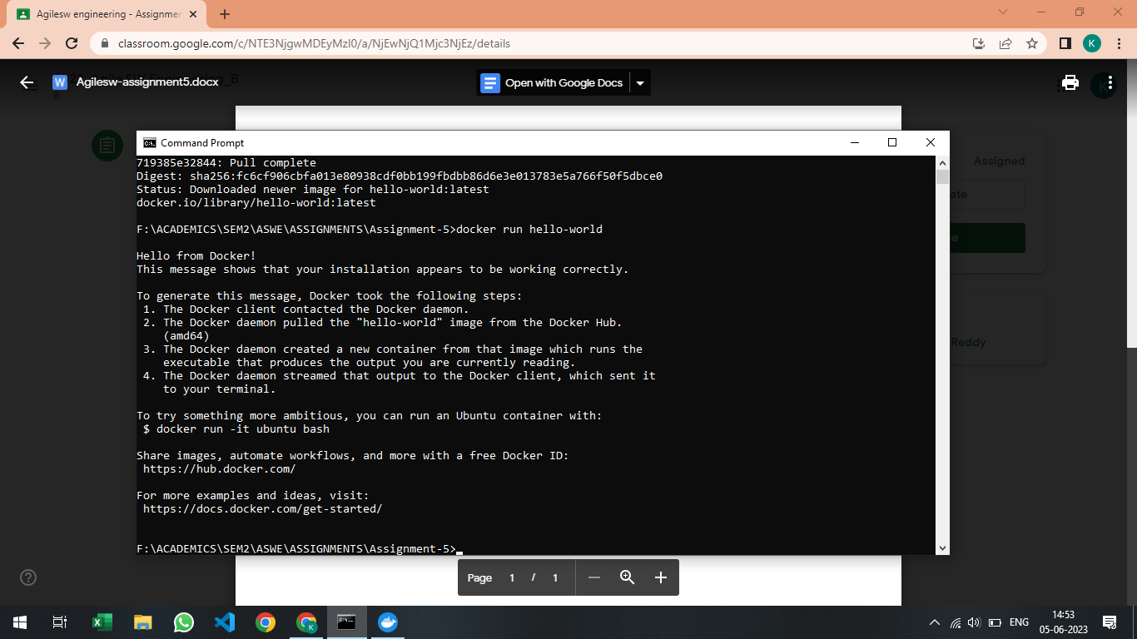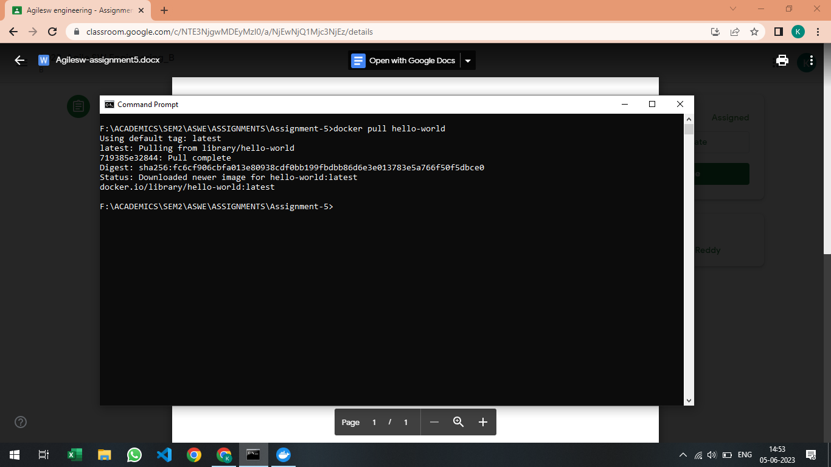**ANSWER**

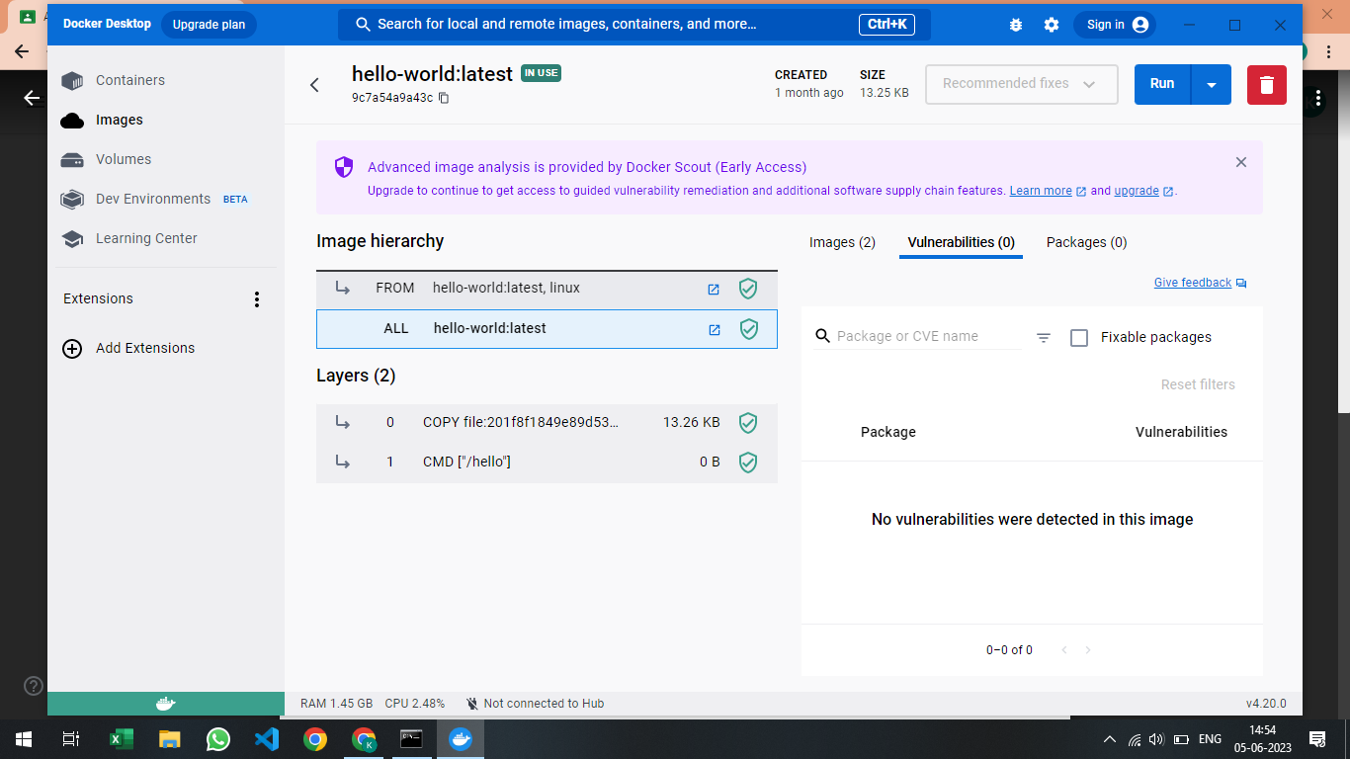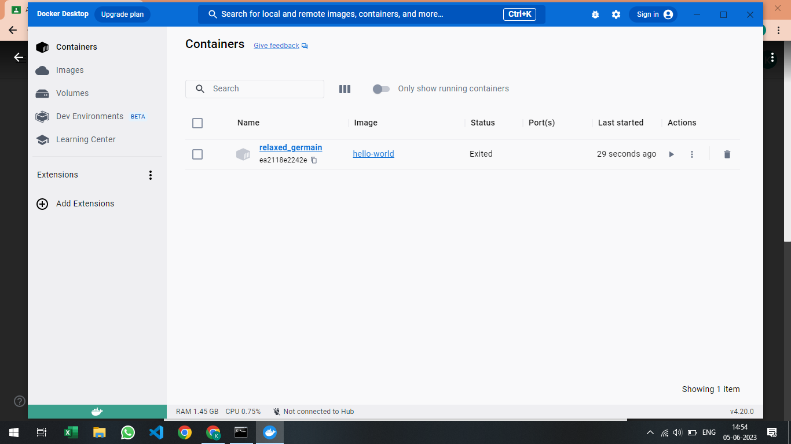

Docker Image – Docker Images act like a template to build the container. Docker Image is a file used to execute code in a Docker Container.

Docker Container – Container contains all the packages and dependencies required for the proper functioning of the product/code/program.

Docker File – A Docker File is a text document that consists of the instructions required to build a docker image.

**QUESTION-2**

Write Simple Python Program and do unit testing with PYUNIT

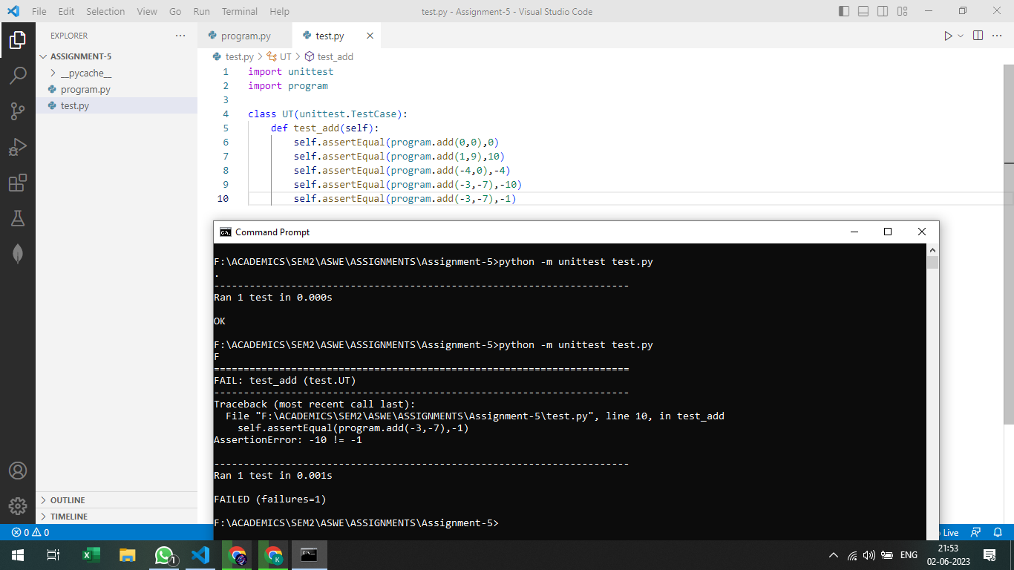**ANSWER**

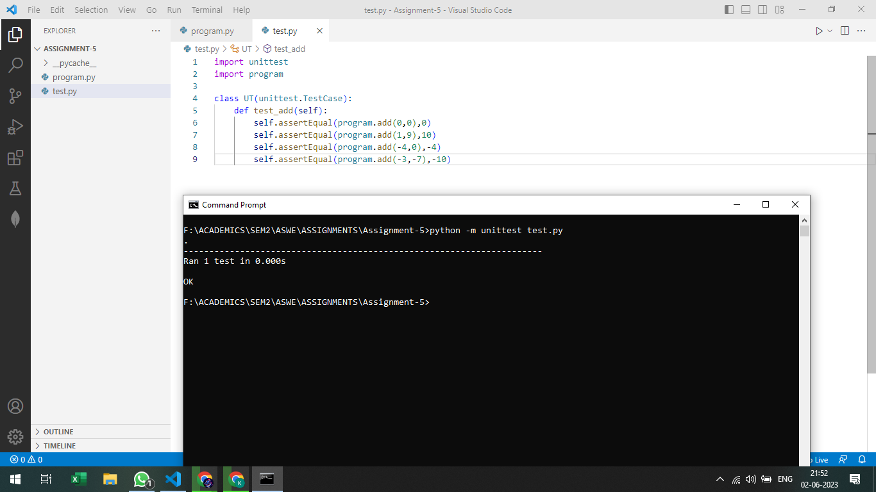

**QUESTION-3**

Write Python Program and store in GIT/GITHUB

**ANSWER**

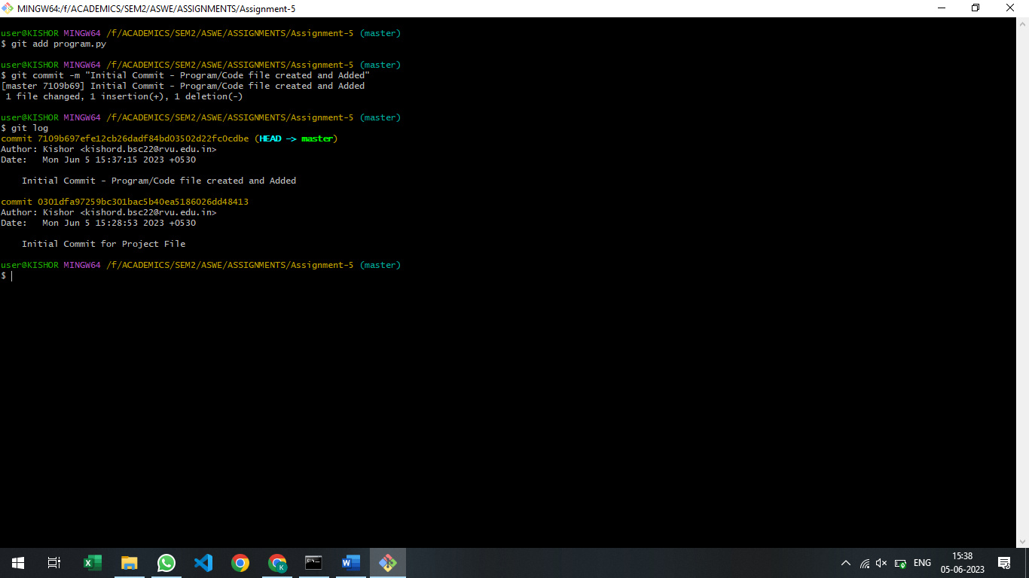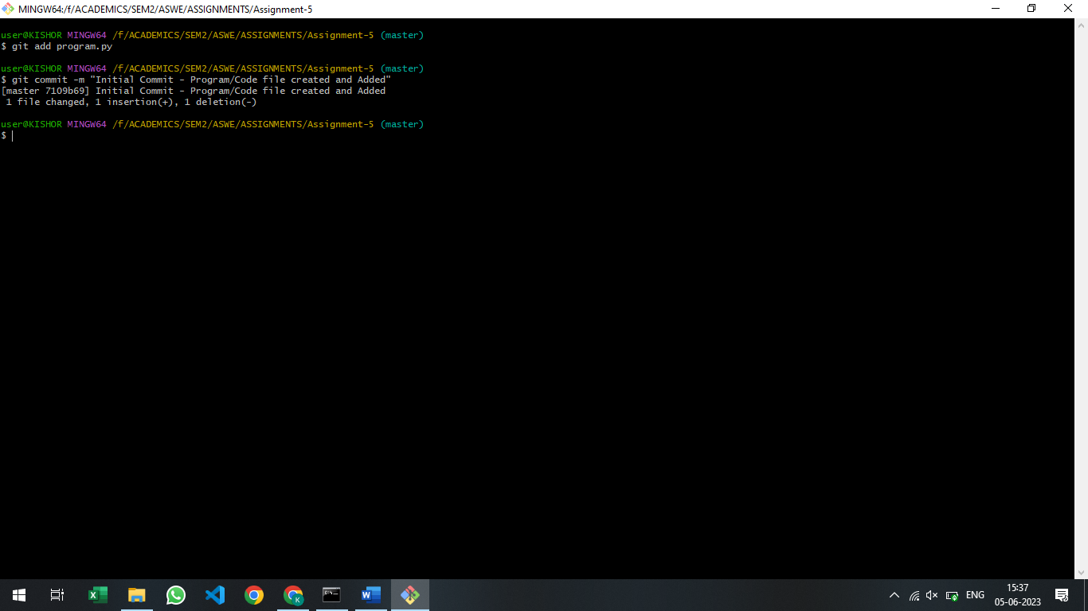

**QUESTION-4**

Write about Maven.

**ANSWER**

Maven is a DevOps which is used to build code. Building the code refers to writing the code, compiling it, fixing the code if any error occurs, then compiling the code again till there are no errors.

**QUESTION-5**

Write about JENKINS

**ANSWER**

Jenkins is a DevOps tool which is used to manage/orchestrate all the other DevOps tools used in the SDLC Processes. All other DevOps tools sit on top of Jenkins. Jenkins is called DevOps Orchestrator.