

RV University

Diabetes Prediction System

Software Requirements Specification

Version 1.0

08-06-2023

By Kishor Desai

RV Restricted

©RV University. This document is not to be copied or distributed without the express written consent of RV University. No part of this document may be used for purposes other than those intended by RV University.

Based on template Version: Diabetes_Prediction_Software_SRS_V_1.0

Document Identification

Project Name | Diabetes Prediction Software
Document Home | <>
Version No | 1.0
Status | Revised
Audience | Public

Document Revision History

Version | Date | Description | Document owner / Modified by
1.0 | 07-06-2023 | Document created | Kishor Desai

Software Requirement Specification

TABLE OF CONTENTS

13. Table Of Figures 4

1. OBJECTIVES AND SCOPE 5

2. INTENDED AUDIENCE 5

3. DEFINITIONS, ACRONYMS AND ABBREVIATIONS 5

4. REFERENCES 6

5. REQUIREMENTS OVERVIEW 6
5.1 Project Perspective 6
5.2 Project functions 7
5.3 Operating Environment 9
5.4 Customer enforced technology choices 9
5.5 User Documentation 9
5.6 Assumptions ,dependencies and external risks 9

6. EXTERNAL INTERFACE REQUIREMENTS 10
6.1 User Interfaces 10
6.2 Hardware interfaces 10
6.3 Software interfaces 11
6.4 Communication interfaces 11

7. FUNCTIONAL REQUIREMENTS 11
7.1 Graphical User Interface 11
7.2 Encoder/Decoder……………………………………………………………….14
7.3 Communication module 19

8. PERFORMANCE REQUIREMENTS 23

9. ACCEPTANCE REQUIREMENTS 23

10. MAINTAINABILITY REQUIREMENTS 23

11. OTHER REQUIREMENTS 23
11.1 Portability Requirements 23
11.2 Reliability requirements 24
11.3 Scalability requirements 24

12. OPEN ISSUES 24

13. Table Of Figures

Figure 1 CLI for User Input for Blood Glucose Level 6
Figure 2 CLI for User Input for Blood Pressure Value 6
Figure 3 CLI for Output of Result…………………………………………………………………7

- OBJECTIVES AND SCOPE
Using ML algorithms and data sets related to glucose levels and blood pressure, we have created a system to predict the presence of diabetes in a patient

- INTENDED AUDIENCE

This document is intended to be reviewed by customer, test plan developers and the code developers.

- DEFINITIONS, ACRONYMS AND ABBREVIATIONS
ML | Machine Learning
AI | Artificial Intelligence
DL | Deep learning
NB | Naïve Bayes
DT | Decision Trees

- REFERENCES
Code provided
- REQUIREMENTS OVERVIEW

Project Perspective
This project is to be used to accurately predict whether a person is likely to have diabetes or not based on their glucose and blood pressure level. This is bulit to be a platform independent program that can be used easily and efficiently by providing the data set that is to be analysed.

Project functions

The main functionality of the project involves diagnosing a patient for Diabetes based on the User Input values of Blood Glucose Level and Blood Pressure.

.

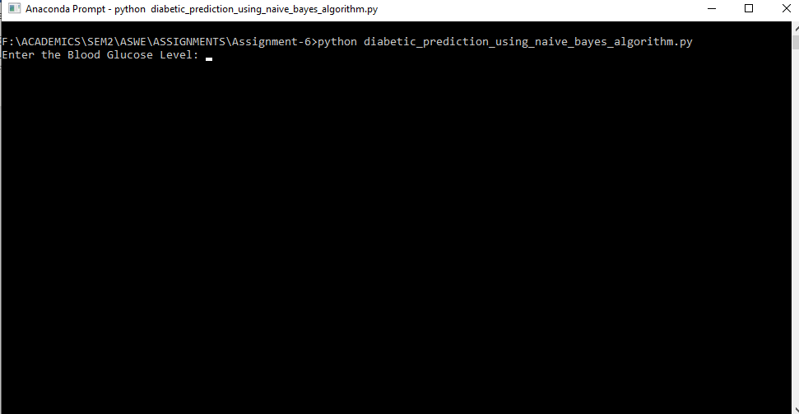
Figure 1: User Input for Blood Glucose Level

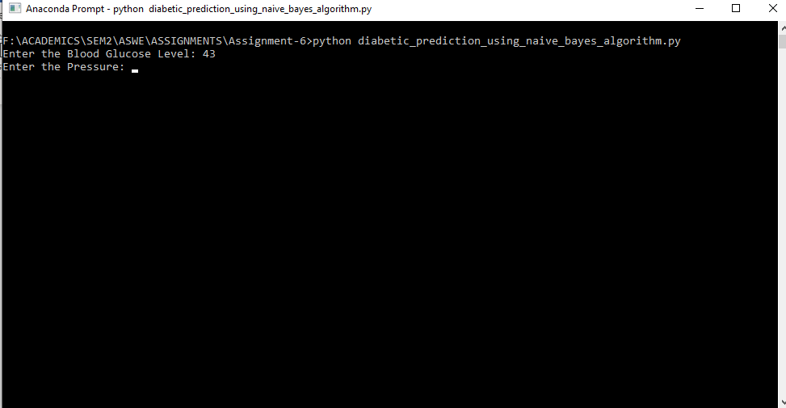

Figure 2: User Input for Blood Pressure

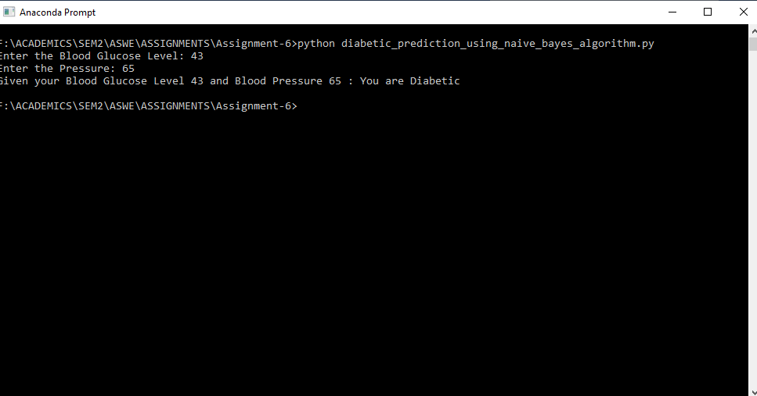

Figure 3: Program Output with Result

Operating Environment
- Hardware platform Pentium III, 166 MHz Pentium II or higher.
- Operating system Linux or HP-UX
- Software components C, GTK, Minimum of 64 MB of RAM

Customer enforced technology choices
- Operating system to be used should be Linux or Windows.
- Python should be used as a langauge for the implementation of the described product

User Documentation

Users will be provided with a user manual that will include instructions on how to use the product

Assumptions ,dependencies and external risks
- The data set has been provided and is accurate
- The pattern developed can be used to predict the presence of diabetes

- EXTERNAL INTERFACE REQUIREMENTS

User Interfaces
- A Command Prompt window to accept user data from the user
- The user should enter accurate glucose and blood pressure levels

Hardware interfaces
CPU above i5
RAM of atleast 8GB to 16GB
Storage to store the data set

Software interfaces
Data set collection
Warning page

Communication interfaces
Data collection interface
Data processing interface
Prediction interface

- FUNCTIONAL REQUIREMENTS

Command Line Interface

RFP Id-F1

Description
F1.1 window for Prediction results

This Command Line Interface will accept the
- Glucose
- Blood pressure

- Code
#Using the Naive Bayes Algorithm
import numpy as np
import pandas as pd
from sklearn.model_selection import train_test_split
from sklearn.naive_bayes import GaussianNB
from sklearn.metrics import accuracy_score
import matplotlib.pyplot as plt
import seaborn as sns
df = pd.read_csv("./Data/diabetes.csv")
df.head()
x=df.drop('diabetes',axis=1)
y=df['diabetes']
x_train,x_test,y_train,y_test = train_test_split(x,y,test_size=0.25,random_state=42)
model=GaussianNB()
model.fit(x_train,y_train)
unplucks=int(input("Enter the Blood Glucose Level: "))
uinp_bloodpressure=int(input("Enter the Pressure: "))
dict={'glucose':0, 'bloodpressure':0}
dict['glucose']=(uinp_glucose)
dict['bloodpressure']=(uinp_bloodpressure)
x_test=pd.DataFrame(data=dict,index=[0])
y_pred = model.predict(x_test)
print(f"Given your Blood Glucose Level {uinp_glucose} and Blood Pressure {uinp_bloodpressure}",end=' ')
if(y_pred):
print(": You are Diabetic")
else:
print(": You are not Diabetic")
- MAINTAINABILITY REQUIREMENTS
Maintaing the data model

