WEB TECHNOLOGY LAB

ASSIGNMENT-2

Name: Kriti Mehrotra

Roll No.: 22IT3022

5.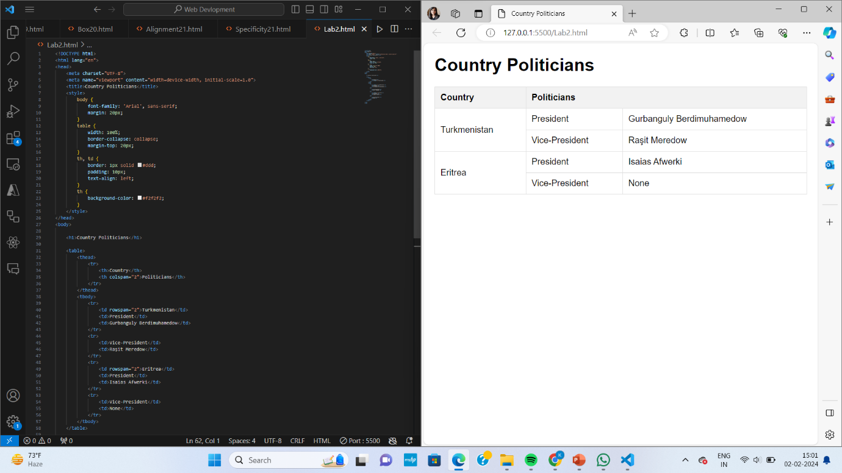

10.

