WEB TECHNOLOGY

ASSIGNMENT 1

Name: Kriti Mehrotra

Roll No.: 22IT3022

T1. Design a web page that has the following content: Title: Simple Web Page Heading: Welcome to Web Technology

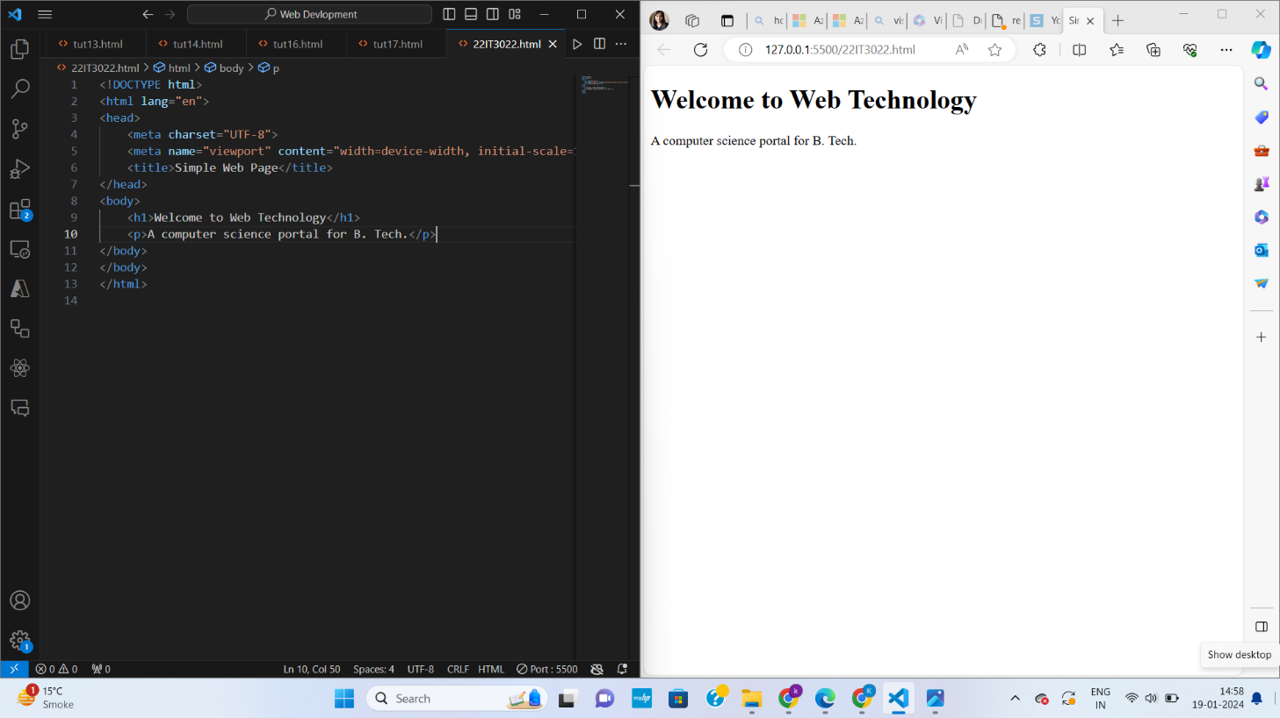

T2. For task T1, try with 7 different levels of heading.

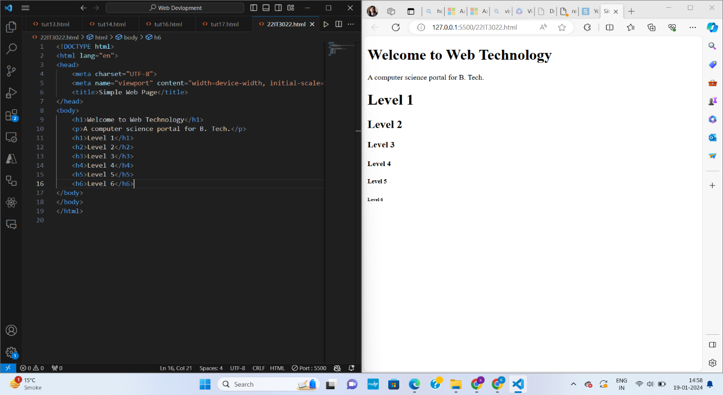

T3. Create a html document with multiple paragraphs within the body. The content should be multiline for at least one of the paragraphs. Nested HTML elements:

T4. Nest one paragraph within another.

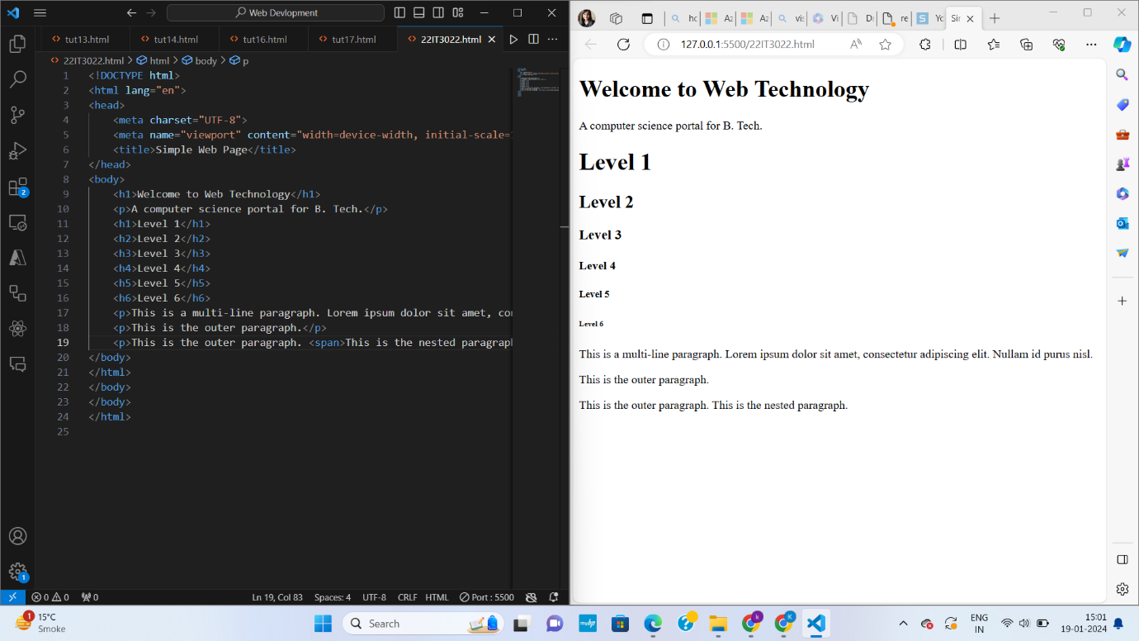

T5. Nest a heading within a paragraph.

T6. Nest a paragraph within a heading.

T7. Nest a heading within another heading.

T8. Add an image to your web page.

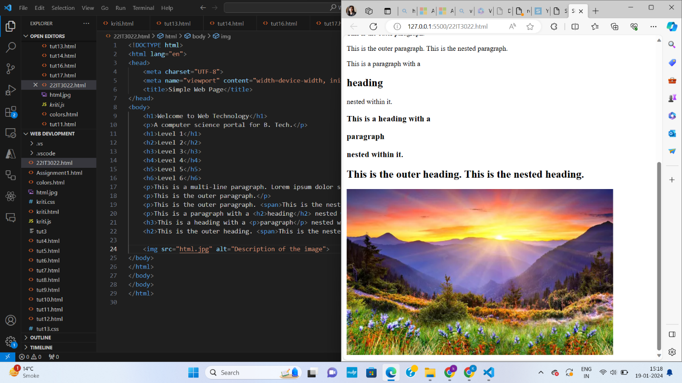

T9. Change the height and width of the image. provide the code for the following

