Electronic Module of Laser Altimeter

Marek Böhm

České vysoké učení technické v Praze, Břehová 7, 115 19 Praha 1, Czech Republic

Abstract

This paper deals with the electronics of a laser altimeter implemented in a Complex Programmable Logic Device, a Time-to-Digital Converter and a PIC microcontroller. The introduction describes the principles of function of a single photon laser altimeter. It contains the description of types of programmable logic devices and a description of the CPLD Lattice ispLSI0132E. A short description of the 8-bit microcontroller PIC18F4620, Time-to-Digital Converters in general and the ACAM TDC GP1 is given. The paper describes the module CTU ET, which serves as the hardware for this laser altimeter. The practical part contains a program for the implementation of a range gate of a laser altimeter in a Complex Programmable Logic Device and a program for the PIC microcontroller, which serves for data acquisition and communication with the TDC. This paper helps to understand the issue of designing digital logic circuits and gives an idea what it takes to use the selected hardware components.

Keywords:laser altimeter, HDL, CPLD, microcontroller, TDC

Introduction

The goal of this paper is to describe the function of a program for the module CTU ET which will work as a single photon laser altimeter. The desired functions are: generation of a gate signal to control a photon counting detector, generation of a start signal for the laser, recording of the laser pulse epoch, time interval measurement between sent and received optical pulse and data collecting. The result of the measurement is a histogram of pulse detections. Two main approaches are used in echo signal detection and processing: multiphoton detection and photon counting approach. The multiphoton approach principle is as follows: The optical signal is received by a photodetector and this optical signal with a certain amplitude temporal profile is transferred to an electrical signal with a corresponding temporal profile. It is possible to gather a complete temporal profile of the echo from each measurement. This approach calls for high power lasers and large optical telescopes. The photon counting approach solves this problem by utilizing a different point of view. Trying to analyse echo LIDAR signals from distant targets, the echo signal splits to the contributions of individual photons. Repetitive measurements and statistical treatment of the data set must be applied [1].

Design of the module CTU ET

The module CTU ET which is used for the demonstrator of the laser altimeter, was designed and constructed at CTU FNSPE. Most elements of the board are SMD. The small and compact SMD components reduce parasitic capacitances and thus enable faster signal transmission and reduce power consumption. The serial and parallel interface and the programmers are accessible via a pin field. Our version of the module has a 10 MHz internal clock oscillator IQXO - 350. It is however possible to connect an external clock through a SMA connector. The board has signal LEDs, providing information whether the power is on or the measurements of various states. The main parts of the board include [2]:

* Microcontroller Microchip PIC18F4620
* Complex Programmable Logic Device Lattice ispLSI 1032E [3]
* Time-to-digital converter Acam TDC-GP1
* Internal oscillator IQXO - 350 with a 10 MHz frequency

Software development

The PLD Lattice ispLSI 1032E is programmed using the Hardware Description Language ABEL HDL [4]. The microcontroller Microchip PIC18F4620 is programmed in the IDE MPLAB X using the C language.

Communication between the components of the laser altimeter demonstrator

We can see the basic idea of data flow between the module CTU ET, detector and laser on one side and the user on the other in **Figure 1**. The user enters commands and data (value of preset time interval, number of measurements) through a suitable terminal program to the PIC microcontroller. The PIC microcontroller processes these data and sends them to the CPLD Lattice and initiates the TDC. The CPLD serves as a coarse counter with 100 ns resolution. The CPLD measures the number of clock cycles based on the data from the PIC microcontroller and the signals from laser (emitted photon) and detector (recorded photon) and these data are sent to the PIC. The LASER signal indicates the moment when the laser fires. Counting of the preset time interval starts based on this signal. After counting down the preset time interval, the detector gate is opened. The detector is waiting for the first returned photon and the detector gate is closed after receiving it. It then sends the DETECTOR signal to the CPLD. The TDC is used as a fine counter with a 125 ps resolution. It measures the time intervals between LASER signal and first rising edge of the clock signal and the time interval between DETECTOR signal and first rising edge of the clock and send them back to the PIC.

The complete time interval using the TDC and CPLD together is then computed as:

$$t_{total}=TDC1+n*CLOCK+(CLOCK-TDC2)$$

This computation is illustrated in **Figure 2**.Measurements of time intervals were performed separately with the CPLD and TDC in the laboratory. The data from the CPLD and TDC are collected by the PIC after each measurement and processed. The result of each measurement batch is then sent to the user.

Principle of function of the time gate realized in the CPLD Lattice

The principle of function of the time gate realized in CPLD Lattice is shown in **Figure 3**. Whenever the laser emits a photon, it will send the information about this event to the CPLD. The time of arrival of the echoed photon is expected approximately in the time interval given by the preset time interval. The preset time interval counts down and when it reaches zero, the detector opens. The detector remains open until the first echoed photon arrives. It is possible to eliminate most of the background noise by setting the appropriate value of the preset time interval. The width of the time window is typically a few μs*.*

PIC microcontroller programming

The PIC microcontroller can be considered the “brain” of the laser altimeter electronic module, because it guarantees the communication between the chips of the CTU ET module and the PC. The microcontroller is programmed using C language. The IDE from Microchip MPLAB X was used to develop and debug the source code. The C18 compiler from Microchip Company is specially designed for PIC18 family microcontrollers [5].

The PIC microcontroller must execute these tasks, before the actual measurement can begin:

* Send the user input to the CPLD and TDC chip
* Save the user inputs in the data memory of the PIC
* Initialize the TDC

There are two write and two read function implemented in the program (TDCRead, CPLDRead and TDCWrite, CPLDWrite). The communication is ensured by a standard parallel interface with 8 bit of data signal, 4 bit of address signal and 4 control signals. The control signals are read (RD), write (WR) and chip select for Lattice and TDC (CS\_Lattice and CS\_TDC). The main difference is in the chip select signal, the TDC and Lattice use separate chip select signals.

Testing

The photon counting detector of the PDM series by MPD (Micro Photon Devices) was used. The PDM is a solid state instrument equipped with a SPAD (Single Photon Avalanche Diodes). The detector generates a TTL level output pulse per detected photon. The detector offers a fast gating option which is triggered by an external TTL signal. The gating function is used for viewing a signal that occurs in a small time window and therefore enabling to detect weak signals with high background noise [6].

The laser used is from JDS Uniphase, model NG-10120-110. It is a pulsed diode pumped, passively Q-switched microchip laser. The primarily wavelength is 532 nm. The power output per pulse is 1 μJ and the typical pulse width is 0.6 ns [7].

Experimental setup

The experimental setup is shown in **Figure 4**. The laser fires into a group of four filters with a transmission coefficient of $0.22$, so the laser pulse is attenuated by an factor of:

$$T_{total}= {0.22}^{4} ≅2.34.{10}^{-3}$$

The laser beam then reflects from a mirror and hits a beam blocker. The beam is scattered and the reflected photons are detected by the SPAD. The result of an experimental measurement with the peak of backscattered signal is shown in **Figure 5**. The width of one channel is 250 ps. This data is further fitted with a Poisson distribution using a data processing program. The output of the fitting program is shown in **Figure 6**. In the next step, only noise was measured. **Figure 7** shows the histogram of noise.

Discussion

The paper deals with the development of the software for the complex programmable logic device Lattice and the PIC microcontroller. The principle of function of a time gate realized in CPLD Lattice is given. The program for the PIC microcontroller, which serves for data acquisition and communication with the user is described.

The paper also examines the measurement limits and the parameters of the device. This part is important, because it gives an idea what the theoretical limits of the device are. Basic distance measurements and noise measurements that were carried out in laboratory environment are described in the Experimental setup section. These experiments proved, that the module CTU ET is capable of working as a single photon laser altimeter. All the project goals were met successfully:

* Get in touch with single photon-counting laser altimeters
* Familiarize yourself with the module CTU ET
* Create a program for the complex programmable logic device and for the

microcontroller, so that the module will work as a laser altimeter. The required

functions are: generation of a time gate to control the detector, triggering off the

laser, registration of the epoch of the laser pulse, time interval measurement

between sent and received laser pulse, data collection, communication with a

personal computer.

Conclusion

The experiments conducted confirmed the expected behaviour of the CTU ET module as an electronic module of a laser altimeter. In the future, the photon-counting laser altimeter technology demonstrator could be tested in more situations than presented in this paper. Better results could be obtained by using better circuit technology (shorter data delay, faster CPLD). A better user interface could be developed instead of the current simple interface.

Acknowledgement

I would like to express my thanks to the following people who have contributed to the creation of this paper:

* Jan Kodet, my supervisor
* Vojtěch Michálek, my consultant
* Ivan Procházka, head of advanced space research laboratory

Nomenclature

CPLD – Complex Programmable Logic Device

HDL – Hardware Description Language

TDC – Time-to-Digital Converter

SMD – Surface mounted device

SMA – SubMiniature Version A

IDE – Integrated Development Environmet

TTL – Transistor-transistor Logic

SPAD – Single Photon Avalanche Detector

References

[1] PROCHÁZKA, Ivan. *Optical Methods for Atmospheric Monitoring and Enviromental Sensing*. 1st edition. CTU Publishing House, 1999. ISBN 80-01-01986-1.

[2] KODET, Jan. *Time measurement control box with 100 ps resolution.* Master`s Thesis. CTU FNSPE. Department of Physical Electronics, Prague, 2008.

[3] LATTICE, *ispLSI 1032EA In-System Programmable High Density PLD*. Available from: http://www.latticesemi.com/ , 2004.

[4] PELLERIN, David, HOLLEY, Michael. *Digital Design Using Abel.* 1st edition. Prentice Hall, 1994, ISBN 0136058744.

[5] MICROCHIP, *PIC18F2525/2620/4525/4620,* Data Sheet*,* Enhanced Flash Microcontrollers. Available from: http://microchip.com, 2004.

[6] *PMD series Overview Version 4.0.* [online] Micro Photon Devices. [cited 14.4.2014]. Available from: [www.micro-photon-devices.com](http://www.micro-photon-devices.com)

[7] *Pulsed Diode Pumped Solid State MicroChip NanoLasers.* User‟s manual. JDS Uniphase. July 2003.

Figures

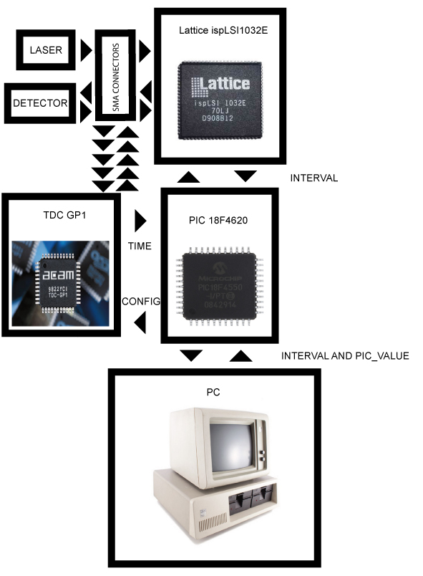

Figure 1: Data flow in CTU ET module.

C:\Škola FJFI Zima 2013\Diplomová práce zimní semestr\Psaní diplomová práce\Obrázky_diplomova_prace\Kapitola 3\Principle_master_thesis.tifFigure 2: Computation of the total time between LASER and DETECTOR signal.

C:\Škola FJFI Zima 2013\Diplomová práce zimní semestr\Psaní diplomová práce\Obrázky_diplomova_prace\Measure_waves.tif

Figure 3: The principle of function of time gate realized in the CPLD, where P – period of laser, PI – preset time interval, W – time window, T – measured time interval.

C:\Škola FJFI Zima 2013\Diplomová práce zimní semestr\Psaní diplomová práce\Obrázky_diplomova_prace\Experiment_12_3.emf

Figure 4: Diagram of experimental setup.



Figure5:Result of experimental measurement showing peak of backscattered signal. The width of one channel is 250 ps.



Figure 6: Output of PHISTF fitting program showing fitted data set.