百度贴吧单吧SDK文档

1. 百度贴吧单吧SDK简介
   1. 目的

让第三方移动应用能便捷地嵌入百度贴吧单吧服务

* 1. 支持平台

Android 2.1及以上

1.3. 集成方式

以library工程方式

1. 单吧SDK功能

访问贴吧frs（贴子列表）页，pb（贴子详情）页；

发表主题贴与吧友进行讨论，回复吧友的贴子；

查看吧友互动消息；

以瀑布流的方式方便地查看吧友发表的图贴；

1. SDK组成

单吧SDK是以lib库的方式对外提供服务的，它的主要组成包括一些libs库和资源文件：

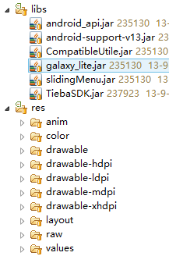

其中android-support-v13.jar的版本是r13，如有重合，应保证保留r13以上版本。

1. SDK使用方式

使用单吧SDK，需要添加对SDK工程的引用，如下图：

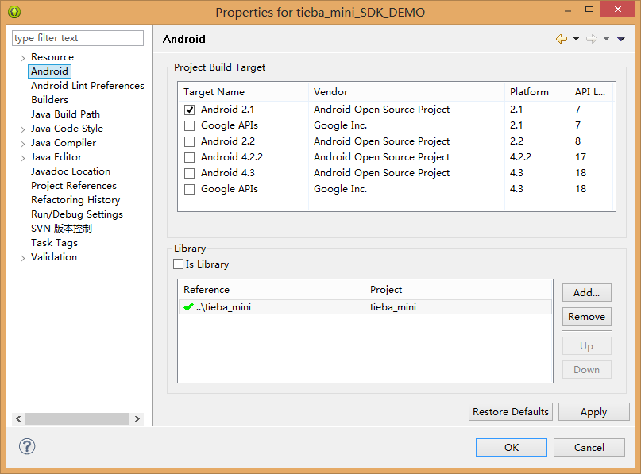

添加完引用后，需要将SDK工程的AndroidManifest.xml文件中的部分代码添加到自身APP的AndroidManifest.xml文件中，包括如下：（其中android:process=*":remote"*可以自行配置。）

**注册Activity**

<activity

android:name=*"com.baidu.tiebasdk.account.LoginActivity"*

android:configChanges=*"orientation|keyboardHidden|navigation"*

android:process=*":remote"*

android:screenOrientation=*"portrait"* >

<intent-filter>

</intent-filter>

</activity>

<activity

android:name=*"com.baidu.tiebasdk.account.Register2Activity"*

android:configChanges=*"orientation|keyboardHidden|navigation"*

android:process=*":remote"*

android:screenOrientation=*"portrait"* >

<intent-filter>

</intent-filter>

</activity>

<activity

android:name=*"com.baidu.tiebasdk.account.ActivationActivity"*

android:configChanges=*"orientation|keyboardHidden|navigation"*

android:process=*":remote"*

android:screenOrientation=*"portrait"* >

<intent-filter>

</intent-filter>

</activity>

<activity

android:name=*"com.baidu.tiebasdk.account.ProtocolActivity"*

android:configChanges=*"orientation|keyboardHidden|navigation"*

android:process=*":remote"*

android:screenOrientation=*"portrait"* >

<intent-filter>

</intent-filter>

</activity>

<activity

android:name=*"com.baidu.tiebasdk.person.AllPostActivity"*

android:configChanges=*"orientation|keyboardHidden|navigation"*

android:process=*":remote"*

android:screenOrientation=*"portrait"* >

<intent-filter>

</intent-filter>

</activity>

<activity

android:name=*"com.baidu.tiebasdk.person.MyPostActivity"*

android:configChanges=*"orientation|keyboardHidden|navigation"*

android:process=*":remote"*

android:screenOrientation=*"portrait"* >

<intent-filter>

</intent-filter>

</activity>

<activity

android:name=*"com.baidu.tiebasdk.frs.FrsActivity"*

android:configChanges=*"orientation|keyboardHidden|navigation"*

android:process=*":remote"*

android:screenOrientation=*"portrait"* >

</activity>

<activity

android:name=*"com.baidu.tiebasdk.frs.FrsImageActivity"*

android:configChanges=*"orientation|keyboardHidden|navigation"*

android:process=*":remote"*

android:screenOrientation=*"portrait"* >

</activity>

<activity

android:name=*"com.baidu.tiebasdk.mention.MentionActivity"*

android:configChanges=*"orientation|keyboardHidden|navigation"*

android:process=*":remote"*

android:screenOrientation=*"portrait"* >

<intent-filter>

</intent-filter>

</activity>

<activity

android:name=*"com.baidu.tiebasdk.mention.ReplyMeActivity"*

android:configChanges=*"orientation|keyboardHidden|navigation"*

android:process=*":remote"*

android:screenOrientation=*"portrait"* >

<intent-filter>

</intent-filter>

</activity>

<activity

android:name=*"com.baidu.tiebasdk.mention.AtMeActivity"*

android:configChanges=*"orientation|keyboardHidden|navigation"*

android:process=*":remote"*

android:screenOrientation=*"portrait"* >

<intent-filter>

</intent-filter>

</activity>

<activity

android:name=*"com.baidu.tiebasdk.mention.PostActivity"*

android:configChanges=*"orientation|keyboardHidden|navigation"*

android:process=*":remote"*

android:screenOrientation=*"portrait"* >

<intent-filter>

</intent-filter>

</activity>

<activity

android:name=*"com.baidu.tiebasdk.person.PersonChangeActivity"*

android:configChanges=*"orientation|keyboardHidden|navigation"*

android:process=*":remote"*

android:screenOrientation=*"portrait"* >

<intent-filter>

</intent-filter>

</activity>

<activity

android:name=*"com.baidu.tiebasdk.pb.NewPbActivity"*

android:configChanges=*"orientation|keyboardHidden|navigation"*

android:process=*":remote"*

android:screenOrientation=*"portrait"*

android:windowSoftInputMode=*"adjustResize|stateHidden"* >

<intent-filter>

</intent-filter>

</activity>

<activity

android:name=*"com.baidu.tiebasdk.pb.ImagePbActivity"*

android:configChanges=*"orientation|keyboardHidden|navigation"*

android:process=*":remote"*

android:screenOrientation=*"portrait"*

android:windowSoftInputMode=*"adjustResize"* >

<intent-filter>

</intent-filter>

</activity>

<activity

android:name=*"com.baidu.tiebasdk.write.WriteActivity"*

android:configChanges=*"orientation|keyboardHidden|navigation"*

android:process=*":remote"*

android:screenOrientation=*"portrait"*

android:windowSoftInputMode=*"stateVisible|adjustResize"* >

<intent-filter>

</intent-filter>

</activity>

<activity

android:name=*"com.baidu.tiebasdk.write.VcodeActivity"*

android:configChanges=*"orientation|keyboardHidden|navigation"*

android:process=*":remote"*

android:screenOrientation=*"portrait"*

android:windowSoftInputMode=*"stateVisible|adjustResize"* >

<intent-filter>

</intent-filter>

</activity>

<activity

android:name=*"com.baidu.tiebasdk.write.NewVcodeActivity"*

android:configChanges=*"orientation|keyboardHidden|navigation"*

android:process=*":remote"*

android:screenOrientation=*"portrait"*

android:windowSoftInputMode=*"stateHidden"* >

<intent-filter>

</intent-filter>

</activity>

<activity

android:name=*"com.baidu.tiebasdk.write.AtListActivity"*

android:configChanges=*"orientation|keyboardHidden|navigation"*

android:process=*":remote"*

android:screenOrientation=*"portrait"* >

<intent-filter>

</intent-filter>

</activity>

<activity

android:name=*"com.baidu.tiebasdk.write.WriteImageActivity"*

android:configChanges=*"orientation|keyboardHidden|navigation"*

android:process=*":remote"*

android:screenOrientation=*"portrait"* >

<intent-filter>

</intent-filter>

</activity>

<activity

android:name=*"com.baidu.tiebasdk.pb.ImageActivity"*

android:configChanges=*"orientation|keyboardHidden|navigation"*

android:process=*":remote"* >

<intent-filter>

</intent-filter>

</activity>

<activity

android:name=*"com.baidu.tiebasdk.pb.WebActivity"*

android:configChanges=*"orientation|keyboardHidden|navigation"*

android:process=*":remote"* >

<intent-filter>

</intent-filter>

</activity>

<activity

android:name=*"com.baidu.tiebasdk.UpdateDialog"*

android:process=*":remote"*

android:screenOrientation=*"portrait"*

android:theme=*"@style/UpdateStyle"* >

<intent-filter>

</intent-filter>

</activity>

<activity

android:name=*"com.baidu.tiebasdk.more.AccountActivity"*

android:process=*":remote"*

android:screenOrientation=*"portrait"* >

<intent-filter>

</intent-filter>

</activity>

**注册service**

<service

android:name=*"com.baidu.tiebasdk.service.TiebaUpdateService"*

android:enabled=*"true"*

android:process=*":remote"* >

<intent-filter>

<category android:name=*"android.intent.category.DEFAULT"* />

</intent-filter>

</service>

<service

android:name=*"com.baidu.tiebasdk.service.TiebaFullUpdateService"*

android:enabled=*"true"*

android:process=*":remote"* >

<intent-filter>

<category android:name=*"android.intent.category.DEFAULT"* />

</intent-filter>

</service>

<service

android:name=*"com.baidu.tiebasdk.service.ClearTempService"*

android:enabled=*"true"*

android:process=*":remote"* >

<intent-filter>

<category

android:name=*"android.intent.category.DEFAULT"*

android:process=*":remote"* />

</intent-filter>

</service>

<service

android:name=*"com.baidu.tiebasdk.service.FatalErrorService"*

android:enabled=*"true"*

android:process=*":remote"* >

<intent-filter>

<category android:name=*"android.intent.category.DEFAULT"* />

</intent-filter>

</service>

<service

android:name=*"com.baidu.tiebasdk.service.TiebaSyncService"*

android:enabled=*"true"*

android:process=*":remote"* >

<intent-filter>

<category android:name=*"android.intent.category.DEFAULT"* />

</intent-filter>

</service>

<service

android:name=*"com.baidu.tiebasdk.service.TiebaMessageService"*

android:enabled=*"true"*

android:process=*":remote"* >

<intent-filter>

<action android:name=*"com.baidu.tiebasdk.service.Message"* />

<category android:name=*"android.intent.category.DEFAULT"* />

</intent-filter>

</service>

<service

android:name=*"com.baidu.tiebasdk.service.TiebaPrepareImageService"*

android:enabled=*"true"*

android:process=*":remote"* >

<intent-filter>

<category android:name=*"android.intent.category.DEFAULT"* />

</intent-filter>

</service>

**注册receiver**

<receiver

android:name=*"com.baidu.tiebasdk.service.TiebaReceiver"*

android:process=*":remote"* >

<intent-filter>

<action android:name=*"com.baidu.tiebasdk.broadcast.service"* />

<action android:name=*"com.baidu.tiebasdk.broadcast.sync"* />

</intent-filter>

</receiver>

<receiver

android:name=*"com.baidu.tiebasdk.service.InstallReceiver"*

android:process=*":remote"* >

<intent-filter>

<action android:name=*"android.intent.action.PACKAGE_ADDED"* />

<action android:name=*"android.intent.action.PACKAGE_REMOVED"* />

<data android:scheme=*"package"* />

</intent-filter>

</receiver>

权限需求：

<uses-permission android:name=*"android.permission.RESTART_PACKAGES"* />

<uses-permission android:name=*"android.permission.ACCESS_NETWORK_STATE"* >

</uses-permission>

<uses-permission android:name=*"android.permission.INTERNET"* >

</uses-permission>

<uses-permission android:name=*"android.permission.WRITE_EXTERNAL_STORAGE"* >

</uses-permission>

<uses-permission android:name=*"android.permission.CAMERA"* >

</uses-permission>

<uses-permission android:name=*"android.permission.VIBRATE"* >

</uses-permission>

<uses-permission android:name=*"android.permission.READ_PHONE_STATE"* >

</uses-permission>

<uses-permission android:name=*"android.permission.GET_ACCOUNTS"* />

<uses-permission android:name=*"android.permission.USE_CREDENTIALS"* />

<uses-permission android:name=*"android.permission.MANAGE_ACCOUNTS"* />

<uses-permission android:name=*"android.permission.BROADCAST_STICKY"* />

<uses-permission android:name=*"android.permission.AUTHENTICATE_ACCOUNTS"* />

<uses-permission android:name=*"android.permission.GET_TASKS"* />

<uses-permission android:name=*"com.android.launcher.permission.READ_SETTINGS"* />

<uses-permission android:name=*"android.permission.WRITE_SETTINGS"* />

<uses-permission android:name=*"android.permission.ACCESS_WIFI_STATE"* >

</uses-permission>

<uses-permission android:name=*"android.permission.CHANGE_WIFI_STATE"* >

</uses-permission>

<uses-permission android:name=*"android.permission.MOUNT_UNMOUNT_FILESYSTEMS"* >

</uses-permission>

<uses-permission android:name=*"android.permission.READ_LOGS"* >

</uses-permission>

<uses-permission android:name=*"android.permission.PROCESS_OUTGOING_CALLS"* >

</uses-permission>

5、接口说明：

接口统一封装到com.baidu.tiebasdk.TiebaSDK类中。

TiebaSDK.init(Application app);

初始化方法，需要在贴吧SDK所运行进程调用，完成初始化操作。

TiebaSDK.setFrom(String from)

设置渠道名称

TiebaSDK.openBar(Context context ,String bar)

打开某个吧，需要在init函数之后调用

String TiebaSDK.*getBarData*(String barName)

获取吧名为barName的吧的JSON格式数据，需要在init之后调用。该方法会发起网络IO读取服务器的数据，同步函数。失败则返回空字符串。

因为此方法无需调起贴吧UI，无需做if (isTiebaProcess() == true)判断，直接调用TiebaSDK.init(Application app)即可（见demo MainApplication类的oncreate方法）

6、注意事项：

1. crash统计：

贴吧SDK内置crash统计模块，需要调用Thread.setDefaultUncaughtExceptionHandler 方法。此方法不会冲掉原来设置的UncaughtExceptionHandler，内部在处理过异常之后把异常传给默认UncaughtExceptionHandler处理。建议不要在调用TiebaSDK.init之后再调用Thread.setDefaultUncaughtExceptionHandler 覆盖贴吧SDK 的crash搜集。

1. 运行进程：

为保证贴吧SDK的crash不影响主app运行，建议将SDK放到非主进程运行。只需要在SDK运行进程中调用TiebaSDK.init(Application app);即可（见DEMO）。

1. 对原app影响

集成贴吧SDK之后，原APP的APK文件会增大1M。