|  |  |
| --- | --- |
| **Project Case** | Description: LogoBINUS-University |
| CProject |
| **Periode Berlaku** Semester Genap 2020/2021  ***Valid on*** *Even Year 2020/2021* | **Software Laboratory Center**  **Assistant Recruitment 21-2** |

## Materi

*Material*

* Shortest Path

## Soal

*Case*

**Live by Nightlight**

**Live by Nightlight** is a new game which is inspired by an old game. It has quite a similar goal which is **not** to get **caught** by the enemy.As a programmer of **LbN Game Company**, you are asked to create a demo of the game using C programming language.

The demo is quite simple, you are asked to **create** a **map** which **contains** the **player** and the **enemy**. The **player** needs to **collect** **coins** in order to **win** the **game**. Then the **enemy** will **chase** the **player** as the **player** runs while **collecting** **coins**. However, there are some **additional** **tweaks** in order to make the game more interesting. Below contains the detailed explanation of how you should create the demo,

1. **Map**

The **map** **size** will be about **50 (Horizontal)** x **25 (Vertical) cells**. The map will have **walls** on **each** **side**. For **every** **space** of the map (excluding the walls on each side), there is a **20% chance** for an **obstacle** to appear. But the **generated** **map** should **not** **have** any **dead** **spot** (space which can’t be visited by both player and enemy).

After the map is generated, you will have to **generate** the **position** of the **player**, **enemy** and **coins**. The **position** of the **player** will be on the **middle top** of the **map** while the **enemy** will be on the **middle bottom** of the **map**. The **positions** of **coin** are **random**, you need to **generate** **25** **coins** on the map.

These are the **symbols** and **explanations** of each object you need to generate,

* **Wall and obstacle ( # )**, **not passable by** both **player** and **enemy**
* **Player ( O )**,this is you, trying to survive
* **Enemy ( ^, <, v, > )**, this is the enemy, it chases you
* **Coin ( * )**, **passable by** both **player** and **enemy** butonly **player** can **take** the **coin**

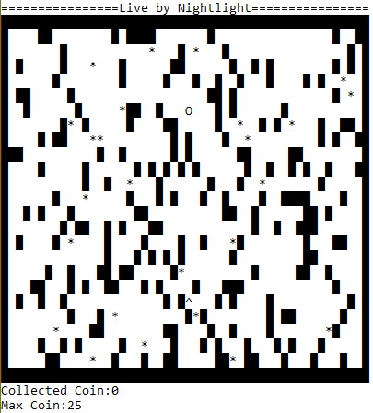

**Figure 1. Map Preview**

1. **Player**

The **player** can be **controlled** using keyboard by **pressing** **W (up), A (left), S (down)** and **D (right)**. As a **player** you can **only** **move** and **collect** **coins**.

1. **Enemy**

The **enemy** moves automatically, it **chases** the **player** by using **shortest path**. But the **enemy** doesn’t always know the **player’s location**, so it usually goes to the **last** **location** where the **player** was. There are several ways for the **enemy** to **locate** the **player** which is,

* The **enemy** has a **vision** of **10 meters** (space) towards the **direction** it is **facing** (the direction which the enemy is facing updates according to the enemy’s movement). Whenever the **player** **enters** the **enemy’s vision**, the **enemy** will **know** the **player’s location**. (For more information on how the vision works, open “Vision.gif” in CH4BP folder)
* The **enemy** also **set** up a **trap** on all **coins**. It will **alert** the enemy on **player’s location** if the **coin** is **collected** by the **player**.
* If the **enemy** **doesn’t find** the player at **player’s last seen location**, the **enemy** will **check** out a **random** **location** in search for the player (this might also apply on the start of the game).

1. **Win & Lose**

If all the **coins** on the map are **collected**, then the **player** **wins** the game. If the **player** gets **captured** by the **enemy** first, then the **player** **loses** the game. Simply print out the message “Live by Nightlive” if the player wins, otherwise print out the message “Dead by Daylight”.

**Komponen**

*Component*

|  |  |  |
| --- | --- | --- |
| **No.** | **Criteria** | **Score** |
| 1. | Generate Map | 10 |
| 2. | Generate Coin | 5 |
| 3. | Enemy’s Movement | 10 |
| 4. | Enemy’s Vision | 25 |
| 5. | Shortest Path | 50 |