**Exercise: work part 2**

**Name: Oskari Helenius**

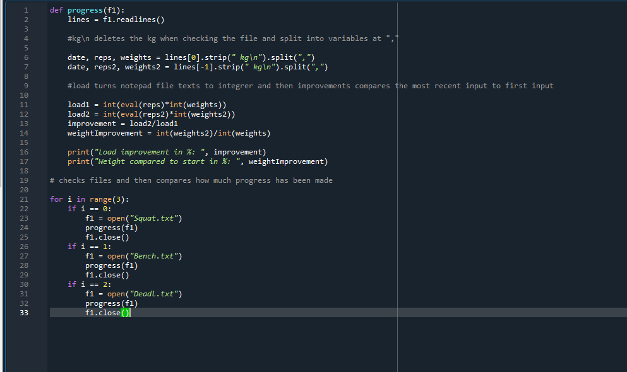

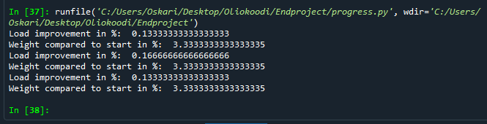

Self-assessment:

This exercise was easy/difficult/ok/etc. for me because… I did a progress comparison module which compares progression overtime

Doing this exercise, I learned… … How to compare values in a textfile, and how to strip strings in a textfile. And also how to use eval in python.

I am still wondering…

I understood/did not understand that… ; I did/did not know that… ;

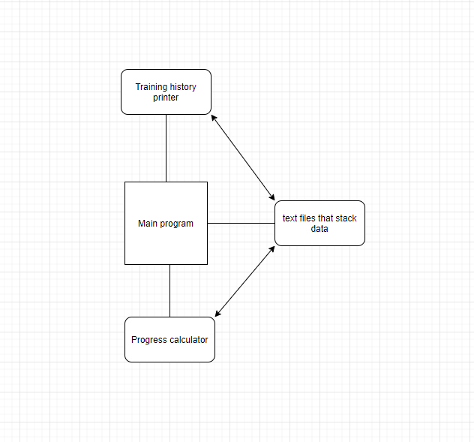

Flowchart would’ve looked stupid because there is not yet enough code.