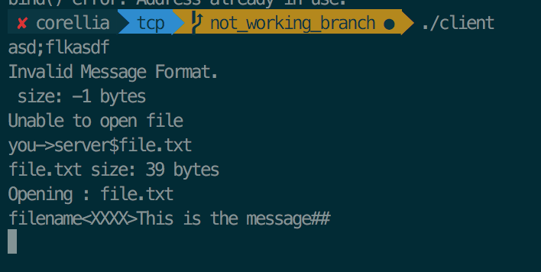

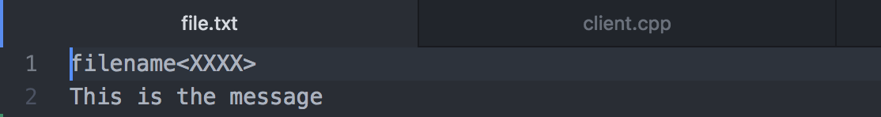

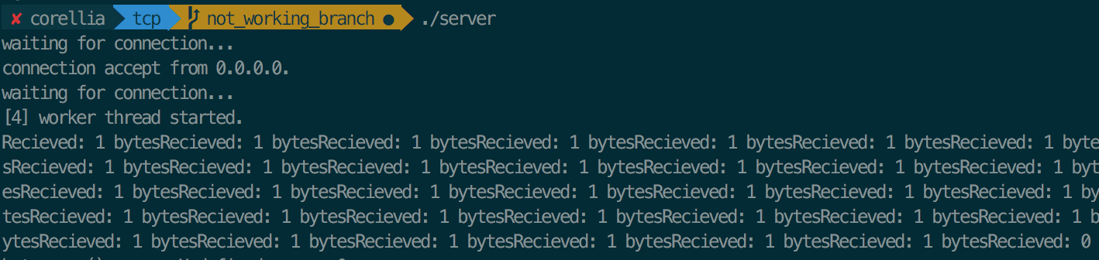

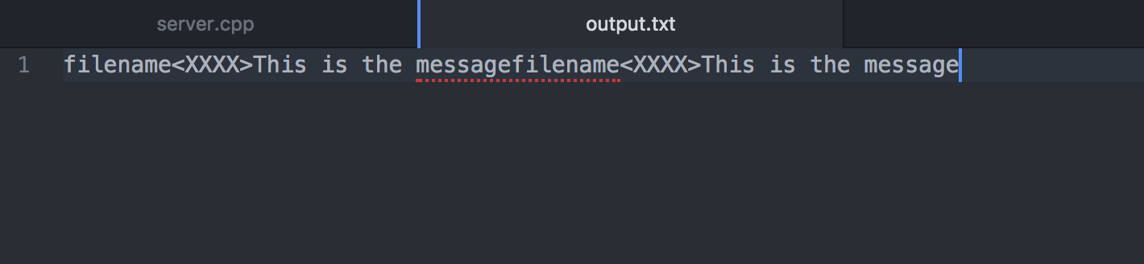

The client will attempt to send a message to the server. However, the first message was not in the correct format therefore it declined to send. When the correct format was met the server accepts the input. The client then reads the file contents and begins to transmit character by character. The server then begins to append each character into the output.txt file. When the client is done sending the file the server will see a hash then stop writing into the output file. The server will send an acknowledgement to the client that the file was sent. I ran two clients and the server saved both the transmissions into the output.txt file.