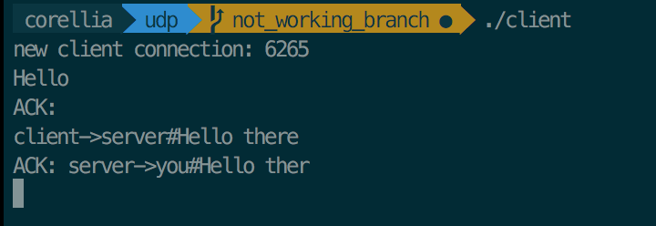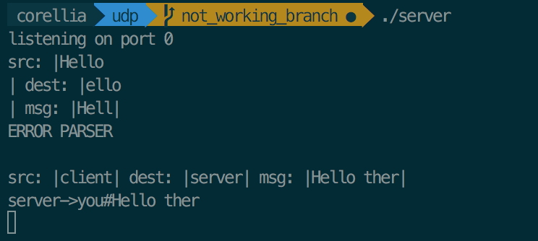

Here I show the first transmission of Hello since it is not the correct format the server does not send back an acknowledgement. But when I send client->server#Hello there the server sends back the ACK of server->you#Hello ther