Creator: Didier Stevens

Title: polyglot.doc

Description:

This document was found on VirusTotal, and our researchers couldn’t figure out what kind of document this is. We hope you are more successful.

Flag: CSC{AHGFEOFQRTCHIN}

Solution: This is a simple challenge, when the document is opened with Word, the following text can be seen:

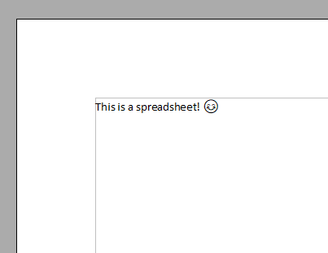

When the extension is changed from .doc to .xls, and then opened with Excel, the following text can be seen:

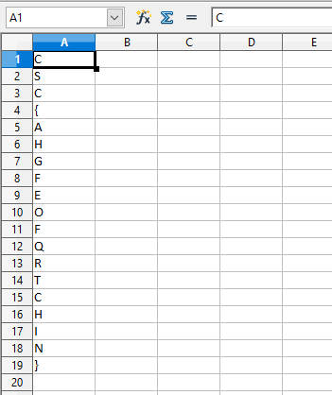

This file can also be opened with OpenOffice to obtain the same result (in fact, the screenshots were taken from OpenOffice).

I would guess this challenge would only take a couple of minutes to someone familiar with the internals of these file formats.

And if one is not familiar with the file format, just opening the document and understanding the clue, will also quickly lead to the solution.

Tools like oledump.py can also be used to find the solution, but opening with an Office application will be much quicker.

It actually requires much more work and skills to create this kind of polyglot document, than to solve this challenge

Hint: if the participants really need a hint, I would say: “This is a polyglot document, not only Word can open this document”.