Validate Signup Form
- Create the following form in Template driven & Reactive approaches for displaying the following….and perform the validations to on the same for each control.
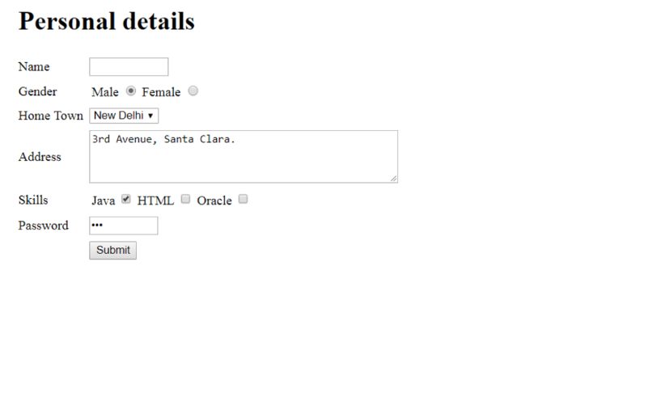
After successful submission display the details in console.

- Develop an application to read a movie details like: movie id, movie title, movie genre, movie release date, movie rating. Create a Reactive form for accepting the above mentioned details. Perform the following:
- On user submission, store the data into a movies.json file.
- Create a search box to search for a movie based on title
- display the movies details on movie rating basic (high to low).

