React Lab-2

Problem Statement-1

Creating a webpage to work with react

Create a web page in React & display the results shown below.
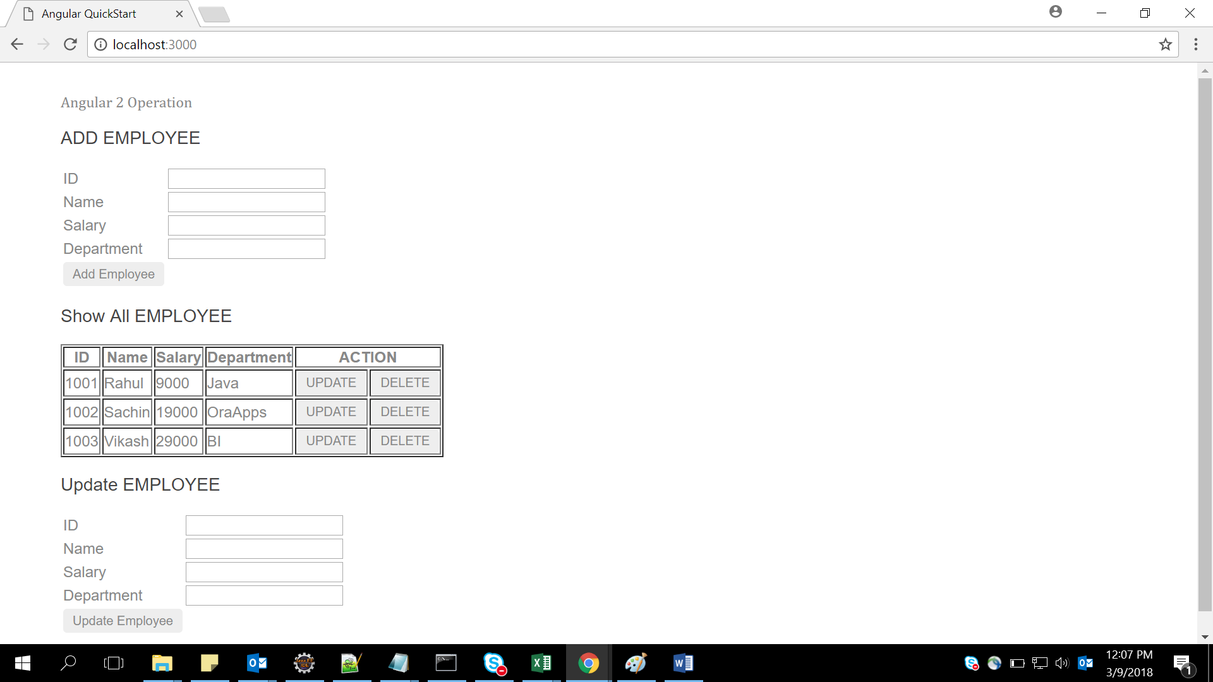

Show all data comes from array as below :
[
{empId:1001,empName:"Rahul",empSal:9000,empDep:"Java"},
{empId:1002,empName:"Sachin",empSal:19000,empDep:"OraApps"},
{empId:1003,empName:"Vikash",empSal:29000,empDep:"BI"},
];
When the user enter Id,name,salary &department in Add Employee & click button Add Employee data will come in Show All Employee & message will display as shown in figure below–example inserted id 1004,name rashi,salary 87000,department BI
When weclick button “Delete” that particular row will be deleted from Show All Employee & message will come ”DATA Deleted” as shown in below figure –Example delete rows 1003 by pressing delete button

Problem Statement-2

Creating awebpage to work with react
Create a web page and display the results shown below :
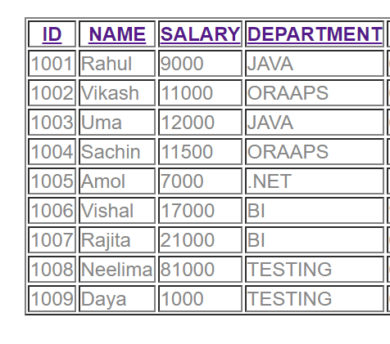
Click on any header --Id, name, salary, department it will display the list in sorted order of that header .
Suppose Clicking on Name header so we will get desired output
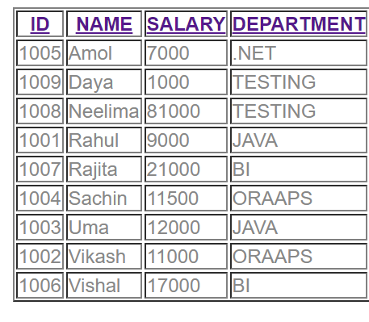
So by clicking any header data will come in sorted order.
Internal Array:[
{empId:1001,empName:'Rahul',empSal:9000,empDep:'JAVA',empjoiningdate:'6/12/2014'},
{empId:1002,empName:'Vikash',empSal:11000,empDep:'ORAAPS',empjoiningdate:'6/12/2017'},
{empId:1003,empName:'Uma',empSal:12000,empDep:'JAVA',empjoiningdate:'6/12/2010'},
{empId:1004,empName:'Sachin',empSal:11500,empDep:'ORAAPS',empjoiningdate:'11/12/2017'},
{empId:1005,empName:'Amol',empSal:7000,empDep:'.NET',empjoiningdate:'1/1/2018'},
{empId:1006,empName:'Vishal',empSal:17000,empDep:'BI',empjoiningdate:'9/12/2012'},
{empId:1007,empName:'Rajita',empSal:21000,empDep:'BI',empjoiningdate:'6/7/2014'},
{empId:1008,empName:'Neelima',empSal:81000,empDep:'TESTING',empjoiningdate:'6/17/2015'},
{empId:1009,empName:'Daya',empSal:1000,empDep:'TESTING',empjoiningdate:'6/17/2016'} ];

Problem Statement-3
Create a registration form and perform validations on the data entered in the fields.

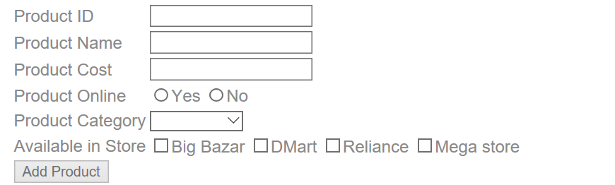

Note:
- Make use of React form
- All fields are mandatory
- Product category will be –Grocery, Mobile, Electronics & Cloths
- When click on Add Product if all fields are validated the output will come on console
- We can select multiple store in Available list

Problem Statement-4

Read the booklist.json file with the help of react & display the images shown below;

Use booklist.json

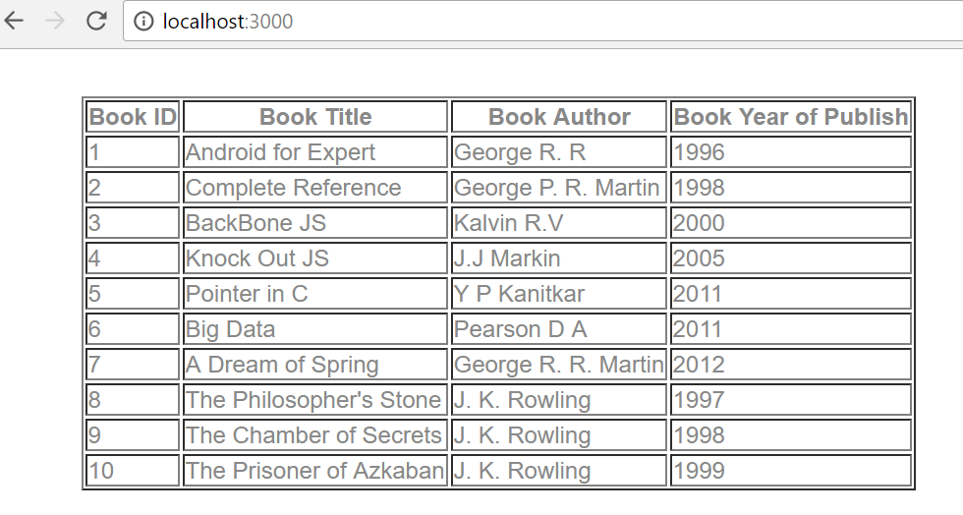
Extended assignment 4.1 read booklist.json & apply search filter on id, title, year & author ,as shown in diagram

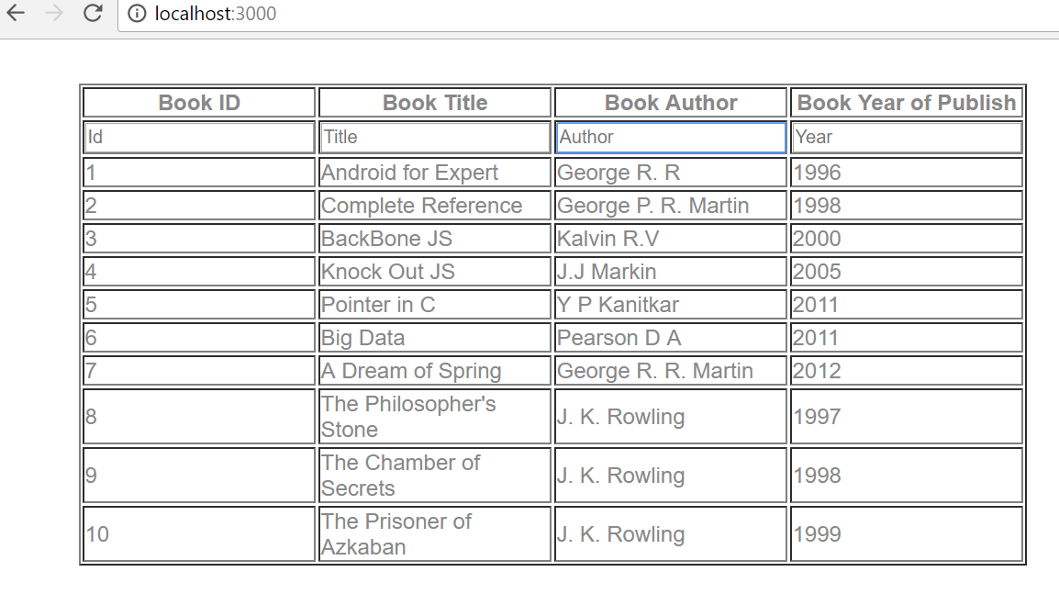
If we Search author, id, title, year only searched value will display in output …..searching K in author

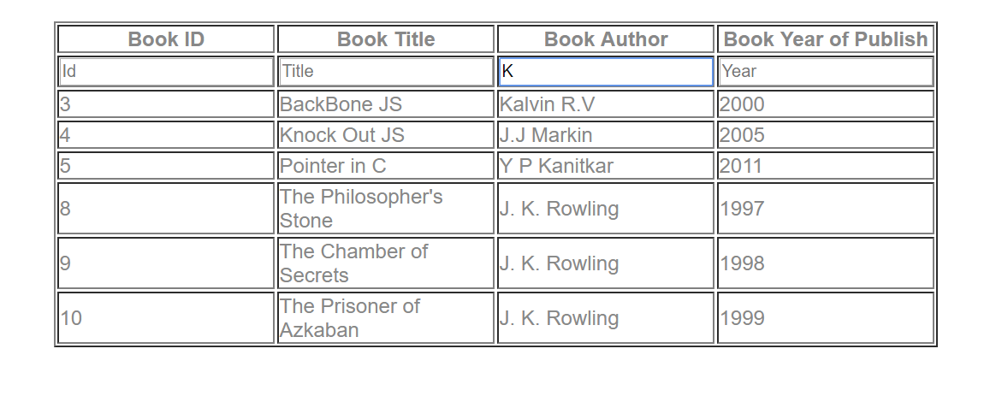
Searching Book Title …..A
