HTML, CSS problem statements

Problem 1)
Create a Web Page for a AI Division to display information about the AI under the
following heads:
a) What are AI Tools
b) Benefits of AI
c) Best AI tools of 2023
d) AI Video Generators & Editors
e) AI Writing tools and Text generators
Implement the above in a Card Layout with brief shadows for every Card with appropriate
images using FLEX and its properties like flex-wrap.
The Sample Output is as shown Below:

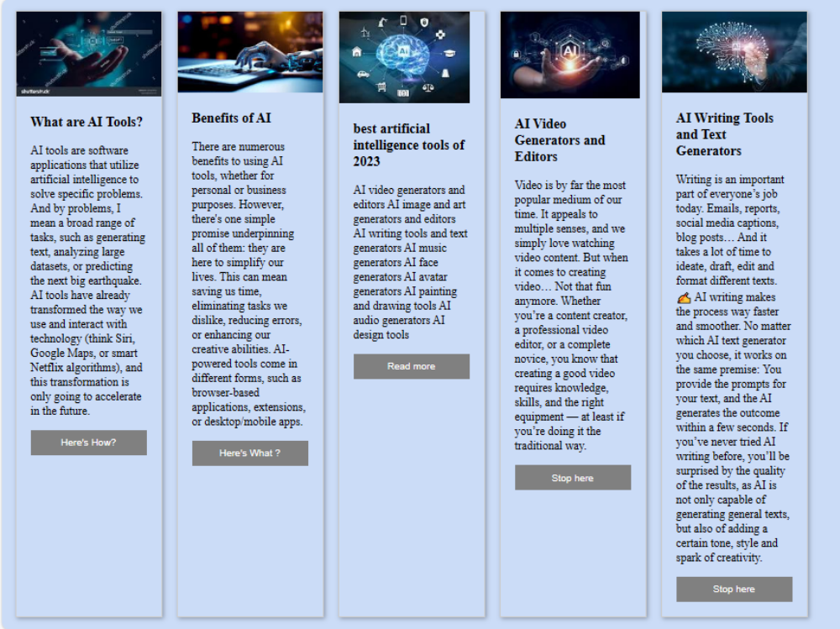

Problem 2)
Create a Web Page for a News Publisher for their online issue,
Page should show The Images & Corresponding news in the following format using FLEX and
its Properties like FLEX Wrap, flex-direction etc.
The Sample Output is as shown below:

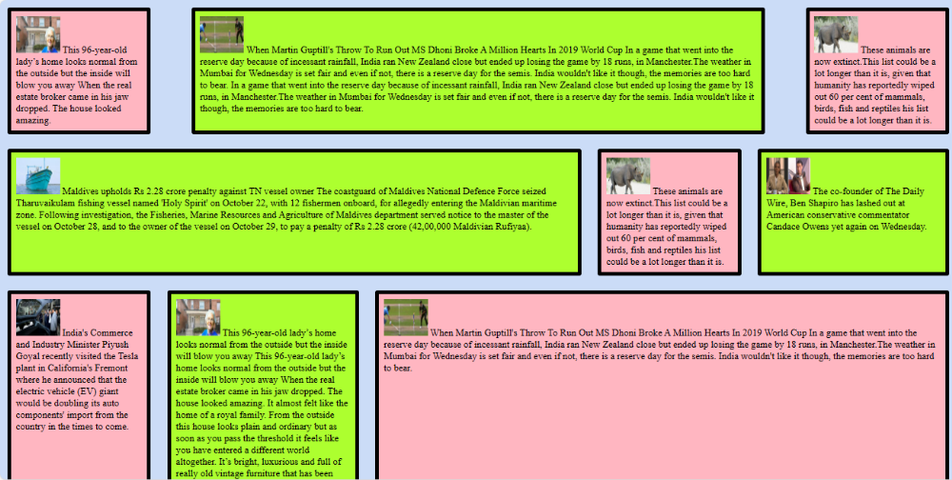

Problem 3:
Implement the Content of Problem 1 using GRID since the AI division wants it
to be in the GRID format using grid-template-columns: also try changing it to
grid-template-rows and check the output.

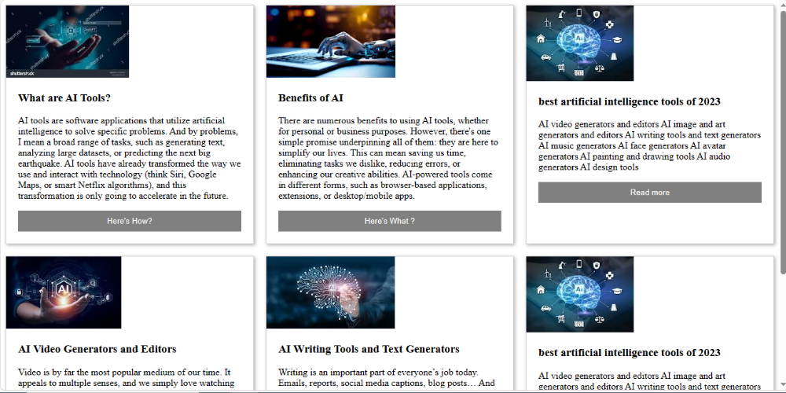
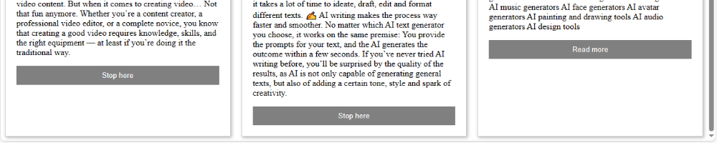

Problem statement-4
Imagine you are a front-end developer in “Spread The Message” News organization. Your
Organization provides Digital and Physical paper also. You are given a task to create a
News Web Page with various functionalities like, logIn Page, signUp Page, Support Page
(complaint form) and an Advertisement Form.
See the requirements below for every page and design and develop the application accordingly.
Home Page:
● Make sure that you will be able to access all the other pages from the Home Page.
● Create a Header Section and below that a horizontal navigation bar with news
categories and at the right end display Login and Sign Up options.
● Make the horizontal bar stick at top of the page when scrolling the page.
● On the header’s right end, display Support and Advertisement links.
● Divide your Page into various blocks for World News, Indian News, Regional News
and Business News.
● Horizontally align every news of each category.
● On Hovering to every news item, make sure the news title is visible, else hidden.
● At the end of the page provide at least 8 advertisements with videos/Images.
● Also create a Footer with Copyright information.

News Details:
● When clicked on a specific news item a new Page has to open with that news details.
● Create an aside bar with latest news and related news article links.
Login Page:
● Create username and password fields.
● Create a button to log in where you are redirected to the home page.
● With the help of the sign up link from the login page or from the sign up link from the
home page open sign up page.
Sign Up Page:
● In the SignUp Page take user data of First Name, Last Name, Email, Username,
Password, Re-enter Password.
● Create a button, when clicked redirect to the login page.
Support:
● This is the form where users can raise complaints for any issues which are related to
offline or online.
● The forms collect data of Name, Phone Number, Email Address, Home Address,
Digital Subscribers or not? and complaint description.
● Perform form validations.
● Create Reset and Submit buttons where data has to be accepted or reset accordingly.
Advertise Your Business:
● Create a page which collects details of the advertisee such as company name,
Person name, phone number, company address, type of advertisement, area of
advertisement on digital platform, Duration of the advertisement with start date and
end date, total cost, advertisement description and upload documents.
● Perform form validations.
● Include submit and reset buttons where data has to be accepted or reset accordingly.
Learning Objectives:
1. Develop a close to real life frontend application.
2. Strategize & Understand the development process.
3. Follow Clean Coding Practices.
4. Keep Experimenting.
Sample Outputs:

