Goal: Make use of Data bindings of Angular.
- Develop an application to perform the following activities.

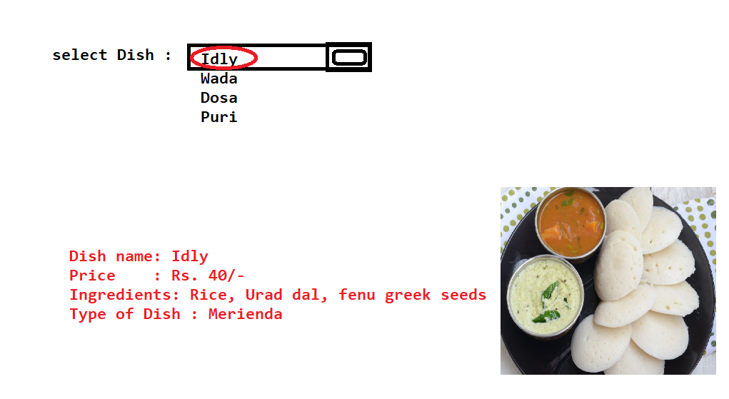

Goal : Make use of Data binding of Angular

- Develop an application to calculate loan-emi for the selected amount, rate and tenure.

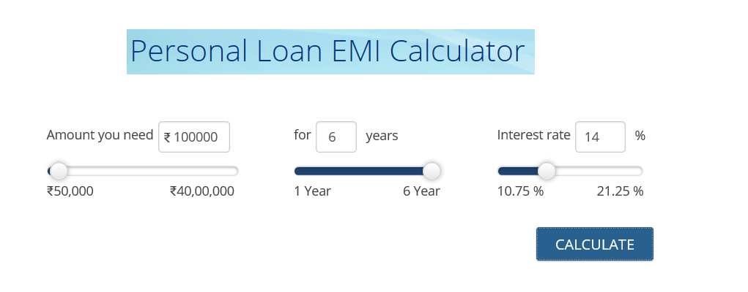

After clicking the button , you have to display the result as shown below.

