- Develop an application to perform following activities.

Create a web page and display the results shown below :
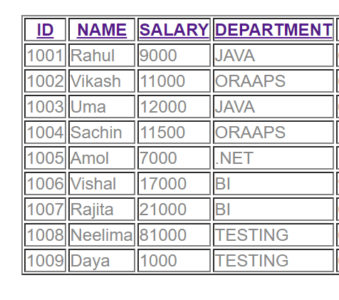
Click on any header --Id, name, salary, department it will display the list in sorted order of that header .
Suppose Clicking on Name header so we will get desired output
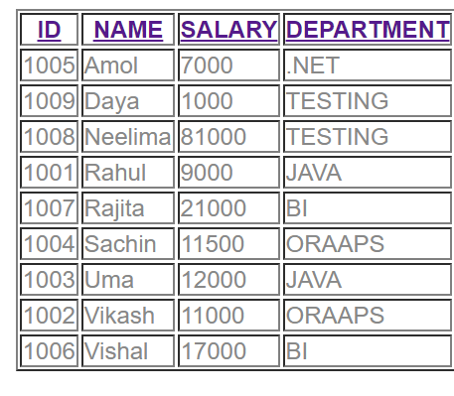
So by clicking any header data will come in sorted order.
Internal Array:[
{empId:1001,empName:'Rahul',empSal:9000,empDep:'JAVA',empjoiningdate:'6/12/2014'},
{empId:1002,empName:'Vikash',empSal:11000,empDep:'ORAAPS',empjoiningdate:'6/12/2017'},
{empId:1003,empName:'Uma',empSal:12000,empDep:'JAVA',empjoiningdate:'6/12/2010'},
{empId:1004,empName:'Sachin',empSal:11500,empDep:'ORAAPS',empjoiningdate:'11/12/2017'},
{empId:1005,empName:'Amol',empSal:7000,empDep:'.NET',empjoiningdate:'1/1/2018'},
{empId:1006,empName:'Vishal',empSal:17000,empDep:'BI',empjoiningdate:'9/12/2012'},
{empId:1007,empName:'Rajita',empSal:21000,empDep:'BI',empjoiningdate:'6/7/2014'},
{empId:1008,empName:'Neelima',empSal:81000,empDep:'TESTING',empjoiningdate:'6/17/2015'},
{empId:1009,empName:'Daya',empSal:1000,empDep:'TESTING',empjoiningdate:'6/17/2016'} ];

2. Display a mobile store with various mobile phone items with model,name, price, description and mobile image. Implement (click) event with the help of custom directive to add into a user cart where the mobiles that the user selected should be added into.

