Goals | - Understand the Angular forms

1. Create a registration form and perform validations on the data entered in the fields. [Can make use of Angular Template Driven Forms or Model driven Forms]

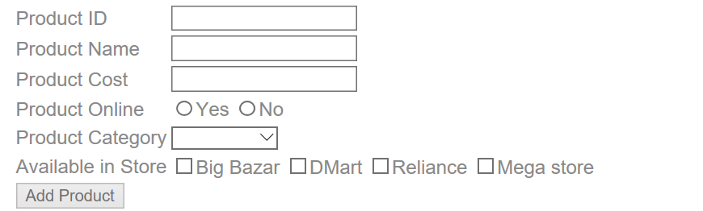

Note:
- Make use of Angular 2 Forms-Model Driven or template driven.
- All fields are mandatory
- Product category will be –Grocery, Mobile, Electronics & Cloths
- When click on Add Product if all fields are validated the output will come on console
- We can select multiple store in Available list

2.1 Read the booklist.json file with the help of Angular service & display the images shown below;
Use booklist.json

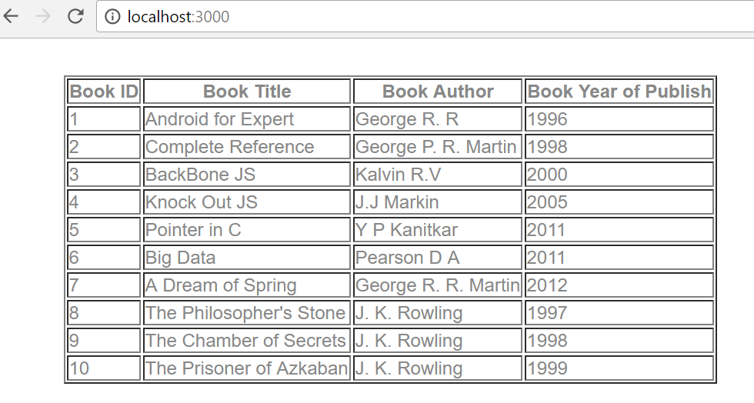
2.2: Extended assignment 2.1 read booklist.json & apply search filter on id, title, year & author ,as shown in diagram

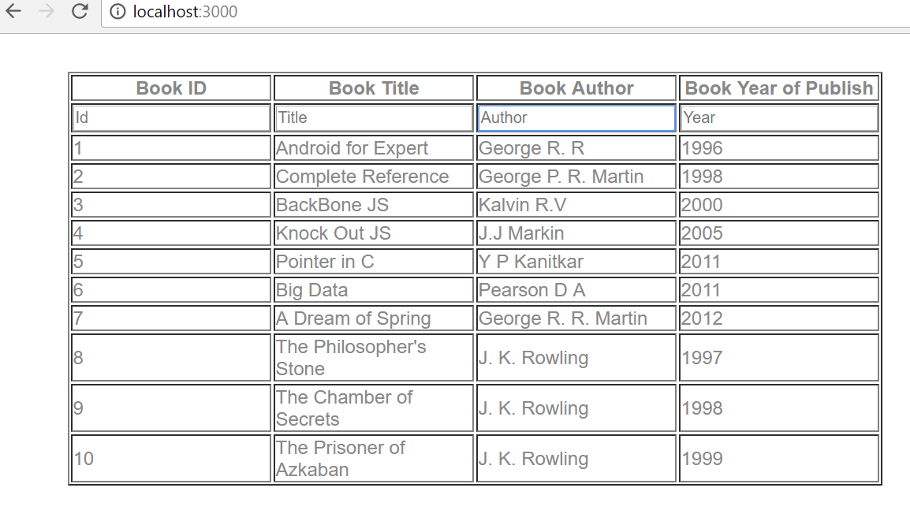
If we Search author, id, title, year only searched value will display in output …..searching K in author

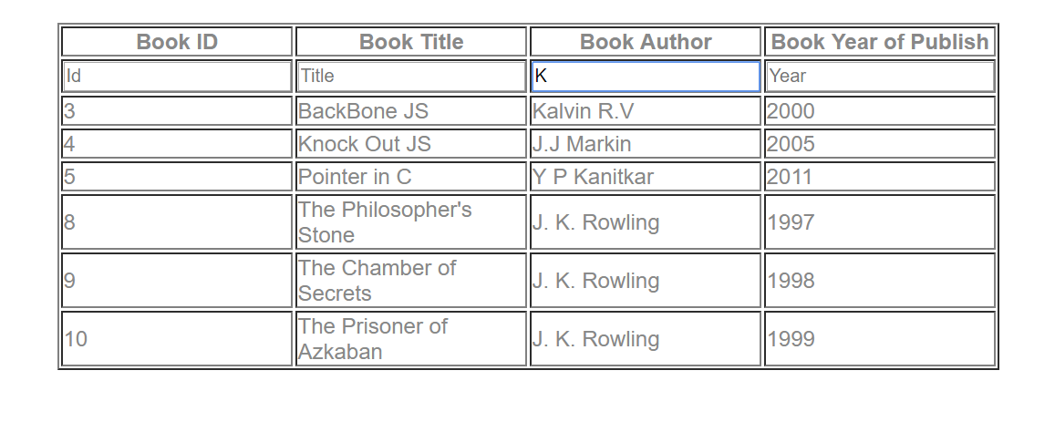
Searching Book Title …..A
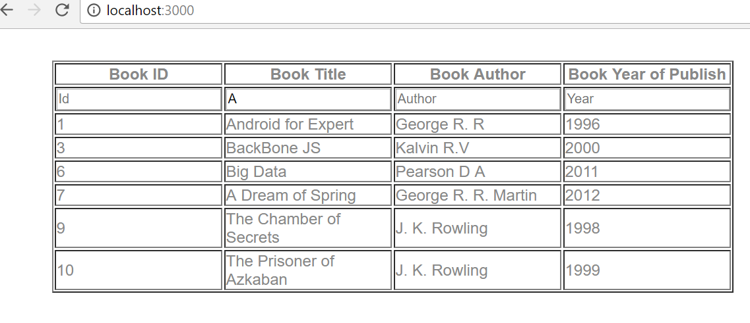

3. develop an application to read 10 books details from an array by using *ngFor directive.
Print the books whose name starts with ‘J’ or ‘H’ or ‘C’ …….use a custom directive to check the book name…..instead of using *ngIf directive.

