- Typescript: classes , interfaces, methods
Goals | - Understand the typescript classes, interfaces and methods
Time | 60 minutes

  - Create Typescript class ,as per below mentioned diagram

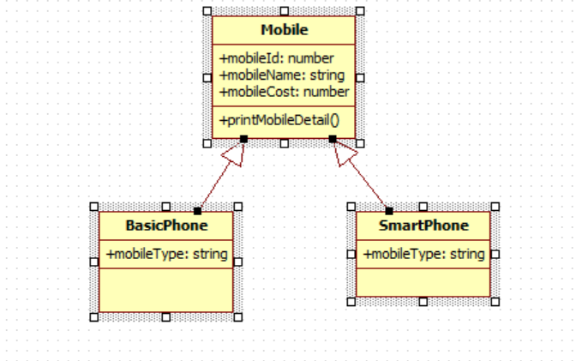
All 3 classes are in separate file. We have to add mobile details such as id, name, cost & type from different typescript file & print data in console
- Get Data from array

- Typescript classes, interfaces and methods
Goals | - Understand the typescript classes , interfaces and methods
Time | 60 minutes

  - Develop application to accept dish name, dish ingredients and price.
Specifications: i) auto generate dish code.
ii) display the dishes on a search of ingredient.
iii) display the dishes on price basis in ascending order.

