Hello There!

I'm a Word doc with some content. I have bold bits, italic bits, and bits of both. There are maybe two or three fonts and even an extra colour or two. Some docs, like this one even have emojis ☺️. Remember that links are a thing too. And tables

A | Table | as well
with | bold | italic
colour | ⁉️ | fonts

There is even an image.
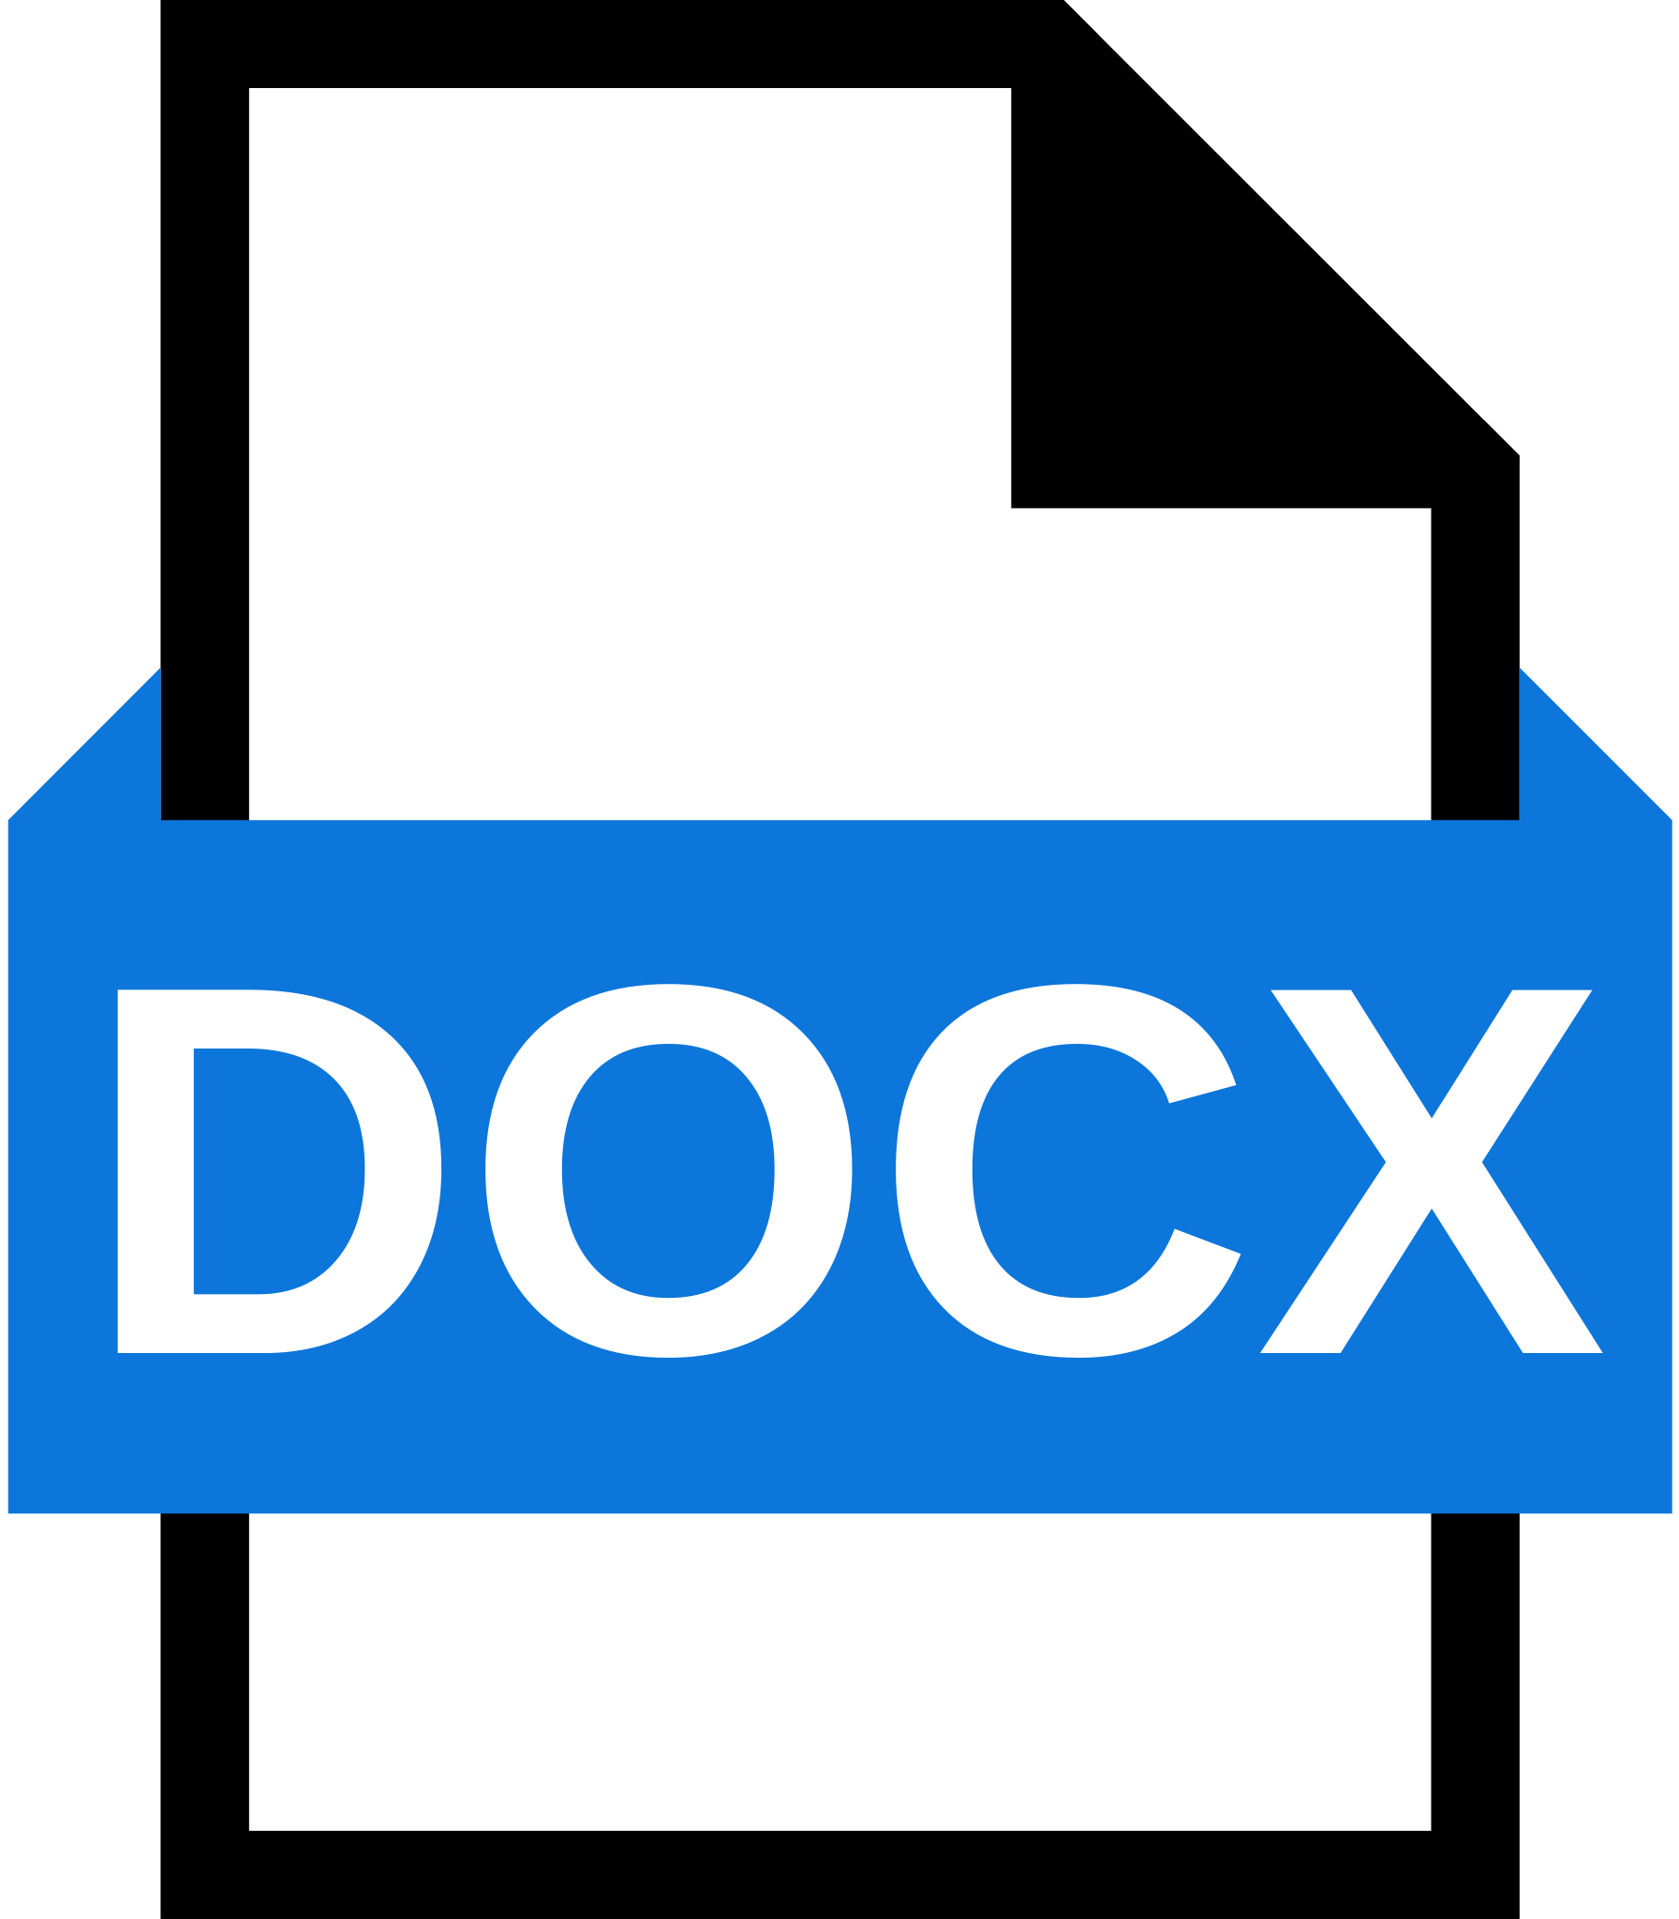

This is the second page. Its the only thing on this page. The third page is empty.

