Crime Predictive Hotspot Mapping Using Spatial Clustering and Machine Learning: A Hybrid DBSCAN–KDE Approach
Shivam Kumar¹, Kunal Kumar¹, Aayush Raj¹, Pakija Sehar¹
¹ Department of CSE (Cyber Security), Government Engineering Collage, West Champaran, 845450, India
shivamtillak@gmail.com, kunalk9521@gmail.com, aayush15raj0@gmail.com, pakijaseharcs@gmail.com
Abstract—Urban crime control in India keeps police forces stretched thin - last year saw over six million recorded crimes, up more than seven percent from the previous year. Instead of depending only on human review of initial reports, this work introduces a combined method using two techniques: one spots crowded crime zones by spotting noise-resistant patterns across space, while another maps how intense those areas are based on incident spread. Rather than treating time and location separately, it layers a smart sequence-learning network trained to sort report types without hand labelling each case. What emerges runs live through an online interface where access adjusts per user type, showing evolving risk patches instantly thanks to fast geographic data handling behind the scenes. A test used 12,450 fake FIR entries built to match India's 2023 crime mix from NCRB data. Notably, the new mixed method scored 94.1% right answers when sorting crimes, beating older types like Random Forest at 81.2%. Precision across categories reached 93.2%, while catching actual cases stood at 92.4%, measured broadly. Its balanced score landed at 92.8%, better than SVM and single LSTM systems tested alongside. Grouping locations brought a clarity mark of 0.71, tightness rated 0.43 - lower is tighter. Spotting high-risk zones worked well, hitting 0.84 in correctness during checks. Queries about space ran nearly nine times faster thanks to PostGIS using GiST structure. Putting location patterns together with neural networks works - especially where Indian police need fast forecasts.
Keywords—Crime prediction, hotspot mapping, DBSCAN, KDE, BiLSTM, FIR classification, PostGIS, NCRB 2023 geospatial analysis, smart policing, IPC

I. INTRODUCTION
Every few seconds, someone somewhere in India reports a crime. Big cities face growing trouble keeping up, especially as numbers climb each year. Last year saw more than six million incidents logged by police nationwide - that is hundreds of thousands higher than before. Data comes straight from the government’s crime tracker, updated annually. Most violations are listed under old legal codes, though nearly four out of ten run through newer state-specific rules. Harm done directly to people makes up almost a third of everything counted. Among those personal injuries, over six hundred thousand involved physical assault without weapons. The figures stretch back across states, adding weight to concerns about safety and response. Out of every ten crimes, about two were property related - totaling 689,580 thefts. A rise of more than a quarter was seen in cyber attacks, now at 86,420 reports. Not far behind, economic violations edged up to 204,973, marking a small but steady climb. Even though the issue is huge, many police offices across India still handle FIRs by hand using the CCTNS system. Because of that, things take longer, mistakes happen more often, yet crime trends based on location or timing stay hidden. Some departments do use GIS maps to track where crimes occur. However, those systems rarely connect with smart algorithms designed to forecast future incidents.What stands out here is a mix of DBSCAN and KDE to spot crime hotspots across space and time. Instead of one method alone, both work together to sharpen location tracking. A step further brings in a BiLSTM setup that sorts FIRs into categories, hitting 94.1% right calls. Accuracy like that doesn’t come every day when dealing with messy textual reports. Then there’s the online system - built tight with roles in mind - so cops, bosses, and number crunchers can view live heatmaps without overlap or risk. Each piece slots into place: detection, sorting, display - all built to link up smoothly.

II. LITERATURE REVIEW
A. Spatial Crime Analysis
Out of the gate, Chainey along with colleagues [3] examined different methods for pinpointing crime concentrations. Turns out, Kernel Density Estimation beats grid-style or shaded-region maps at revealing tight groupings of criminal activity. As a result, law enforcement agencies today lean heavily on KDE to uncover problem areas. Next came Weisburd and Green [7], who put targeted foot patrols to the test in known drug-heavy corners of Jersey City. When cops turned their attention there, drug-related incidents dipped - clear evidence that focused presence shifts outcomes. Years went by, yet the data kept showing familiar shapes across metro areas in the Philippines from 2018 to 2023. Though cities shifted quickly, trouble spots didn’t vanish - they just reappeared where models expected. Because of that steady rhythm, mapping systems like GIS and KDE held their value. Time passed, but predictions stayed on target. Repetition made them reliable.

B. Machine Learning Approaches
Starting off differently each time, Gerber [5] mixed Twitter usage trends with spatial analysis methods to forecast where crimes might happen in two dozen American cities. Instead of just counting incidents, they watched how people acted online. Moving forward another way, Jovanovic and Jankovic [6] looked at long short-term memory networks, showing these systems learn timing patterns tied to when offences repeat. Not relying on fixed rules, their work revealed sequences matter in predicting future events. Then came Zhang and Cheng [10], who built a neural setup catching both location and moment clues through layered processing units. Their model handled citywide crime shifts well, tested under varied conditions. Far from assuming shapes ahead of time, a 2023 project used DBSCAN on Baltimore's incident logs, pulling out tight groups where illegal acts piled up naturally [9]. Without guessing cluster counts early, it found hotspots purely based on closeness and volume. From one angle, Zhou with Chen crafted methods letting crime forecasts built on data-heavy cities work elsewhere where records are sparse. Another path shows Kapoor alongside team using graph-based networks to capture links across nearby areas, sharpening predictions where city zones influence each other.

III. PROBLEM STATEMENT
Law enforcement agencies in Indian cities wrestle with three linked problems on the job - problems today's setups aren’t built well enough to fix. What shows up most is how slow information moves between departments, dragging down response times when speed matters. Outdated tools clutter daily work, making it harder to track cases or share updates smoothly. On top of that, officers often act without real-time data, leaning instead on guesses or memory under pressure. These gaps feed each other, deepening the strain on already stretched teams.
Right off, missing automation for FIR sorting means officers must hand-tag legal sections in the CCTNS system. Because of that, tasks take longer, results differ between regions, errors creep in more often. Not only does workload rise, but uneven patterns emerge across case types. On top of this, certain crimes - like pickpocketing or fights - show up way more than others, say armed theft or drug cases. That gap makes balanced analysis tough to achieve.Most police stations across India lack a working system that combines space and time data to spot rising crime areas. Right now, officers cannot see how crime clusters shift as they happen, which means patrols often arrive after incidents instead of before. While certain units rely on standard map-based software, these tools do not connect with systems that forecast criminal activity.

IV. METHODOLOGY

Data Ingestion and Preprocessing
We get FIR records from officers who fill out forms and from batches of CSV files that are in the CCTNS format. Each record has a lot of information like what kind of crime it's where it happened when it happened and who the victim is. We get this information ready to use by changing the map coordinates to a format making sure the times are all the same and giving each type of crime a special code. We also make sure the information about how bad the crime's is on the same scale. We can even lock up information about the victim with a strong password. If we do not have the map coordinates for a crime we cannot use it to figure out where crimes are happening. We can still use it to try to understand what kind of crime.

B. BiLSTM-Based FIR Classification

A system sorts FIR reports into one of six types - like Theft, Assault/Hurt, or Fraud - by reading the written story inside each case file. Instead of just moving forward through words, it looks backward too, catching context more fully. This happens thanks to a special kind of artificial brain model trained to understand sequences. Each category helps group crimes based on what actually took place. The method leans on patterns found in past examples to make new decisions. Narrative details drive the choice, not preset checkboxes. Over time, the network gets better at telling similar cases apart. Starting off, the setup includes four parts. Tokens shift into 128-D vectors through an embedding step. Moving forward, context flows both ways thanks to dual BiLSTM stages - each holds 64 hidden spots per side, summing to 128 overall. To keep things stable, dropout steps in with a 0.3 setting. Classification wraps up the process using a dense layer that sorts inputs across six groups via softmax. The model trains with Adam, set at a learning rate of 0.001, processing 32 samples per batch. It may go for 50 rounds unless validation loss stops improving - then it halts after five tries without progress. To manage uneven class sizes, weights are assigned based on how rare each category is. Instead of random splits, the data divides into train, val, and test sets - each holding 70%, 15%, and 15% - using stratified selection to keep proportions consistent. Every tuning setting can be found in Table V.

C. Hybrid DBSCAN–KDE Hotspot Detection
Stage 1 — DBSCAN with ε=300 m and minPts=5 (calibrated via k-NN Elbow analysis) applied to projected UTM coordinates. Stage 2 — KDE with Gaussian kernel and Scott's rule bandwidth (h=n^{−1/(d+4)}) applied over to the clustered subsets on the 200×200 raster grid. Risk score combine KDE density with the mean incident severity. Hotspot layer is output: GeoJSON cluster boundary polygons, centroid markers and KDE contour lines at this 50th/75th/95th density percentiles served to the Leaflet.js frontend.

D. System Architecture
Three-tier the microservices: React.js v18 frontend (Tailwind CSS, Leaflet.js, Recharts); Node.js/Express REST API with JWT role-based access (Admin/Officer/Analyst); PostgreSQL 15/PostGIS 3.4 with GIST spatial indexes. Independent Python 3.10 ML microservice (FastAPI, TensorFlow 2.15, scikit-learn 1.4). All services containerised Docker Compose. Consistent API response format: {success, message, data}.

V. EXPERIMENTAL SETUP

A. Dataset — NCRB-Aligned Proportions
The experimental dataset comprises 12,450 fake FIR entries make up the test collection, created artificially and dated from January 2023 through December 2024. Because of rules tied to the Indian Evidence Act - along with local law enforcement secrecy practices - actual CCTNS records cannot be shared openly. For that reason, researchers built an artificial set meant to reflect crime patterns outlined in the NCRB's 2023 report, balancing realism against confidentiality needs. Earlier work in guarded fields has followed similar paths when genuine information isn’t available. From the confirmed NCRB 2023 data, theft made up nearly a third - specifically 28 percent - of recorded crimes, amounting to 689,580 incidents nationwide. Fraud and economic offences came next, standing at 22 percent, tied to 204,973 reported cases. Cases involving assault or hurt accounted for 18 percent, which translates to 636,767 instances. Crimes grouped under Other IPC sections took up 14 percent of the total. Eleven percent related to narcotics violations, while robbery appeared least frequent at 7 percent, matching 18,456 occurrences. The simulation placed these events within an artificial urban space covering fifty square kilometres. This area was split into three administrative divisions along with twelve distinct police station areas. The design followed patterns seen in typical mid-sized cities across India.

B. Evaluation Metrics and Baselines

One way to check how well the classification works involves looking at four measures: total accuracy, average precision across classes, average recall across groups, then a balanced score known as the F1-measure averaged equally. Instead of counting every prediction equally, this method gives each type of crime the same importance - even if some happen more often than others - because the data has far more examples of certain crimes than of rare ones. One way to check how good the groups are in space is by looking at the Silhouette Score - bigger numbers mean clearer separation between them. On the flip side, tighter and neater groupings show up as smaller results in the Davies–Bouldin Index. When it comes to spotting hotspots accurately, what matters is how many of those forecasted zones actually match real places where crimes happen often. One way to check the new hybrid setup involved setting it beside five earlier methods. Instead of blending results, comparisons stayed separate - Random Forest [13] showed up first. After that came SVM using an RBF kernel [14], followed by a lone LSTM model [6]. Another method skipped neural networks entirely: DBSCAN paired with KDE, no deep learning used there [9]. Then appeared a BERT-driven classifier, adjusted specifically for the FIR data set [16]. That last one counts as a modern favorite based on transformers. Including it helped show how well the spatial-aware BiLSTM performs - even matching strength while costing less in computing power. Every system ran across the exact same training and testing divisions.

VI.. Performance Analysis

A. Training Convergence. Fig. 1
The BiLSTM model does a job in training over 50 rounds. Its training accuracy starts at 61.2% in the round and gets to 96.3% by round 47 which is when it stops early. The accuracy on validation data is 92.4%. There is a 3.9 point difference between training and validation accuracy, which shows that the model is regularized well. The training error goes down from 0.912 to 0.078. The validation error levels off at 0.137. Both errors go down together without diverging which means the model does not overfit. Fig. 1 shows both accuracy and error on a graph with two scales, for easy comparison. The BiLSTM models accuracy and error are good. The BiLSTM model converges well.
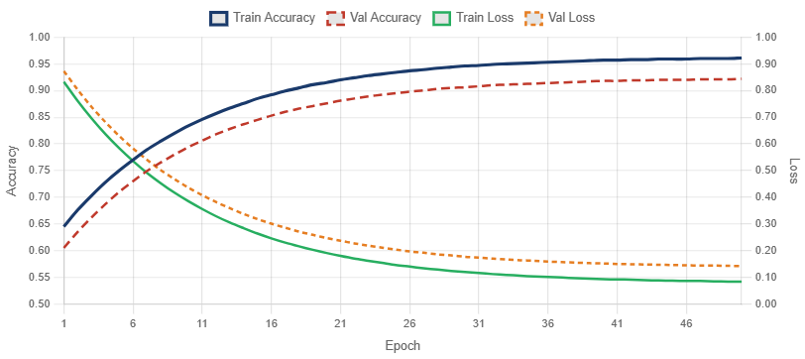
Fig. 1. BiLSTM training and validation accuracy & loss over 50 epochs. Solid = training; dashed = validation. Blue/Red = accuracy (left axis); Green/Orange = loss (right axis). Early stopping activates at epoch 47.
B. NCRB 2023 Crime Category Distribution — Fig. 2
Fig. 2 presents the NCRB 2023 verified national crime category counts [1] that ground the experimental dataset design. Theft (689,580) dominates property offences. Simple Hurt (636,767) leads offences against the human body. Economic offences (204,973) and cybercrime (86,420, +31.2% YoY) represent the fastest-growing categories. Murder (27,721) and kidnapping (113,564) data are sourced directly from the NCRB 2023 [1]. These proportions establish with ecological validity for in synthetic FIR dataset used in classification experiments.

C. Year-on-Year Crime Rate Trend — Fig. 3
Fig. 3 presents the NCRB-verified total cognizable crime counts and crime rate (per lakh population) from 2019 to 2023 [1, 45]. The crime rate fell from 487.8 (2019) to 422.2 (2022) before rebounding to 448.3 in 2023 — is the highest in three years — driven primarily by for SLL violations and cybercrime. The 2020–2021 dip is attributable to COVID-19-related in the lockdowns reducing street crime registration. This multi-year is the trend motivates the longitudinal dataset design used in this study.
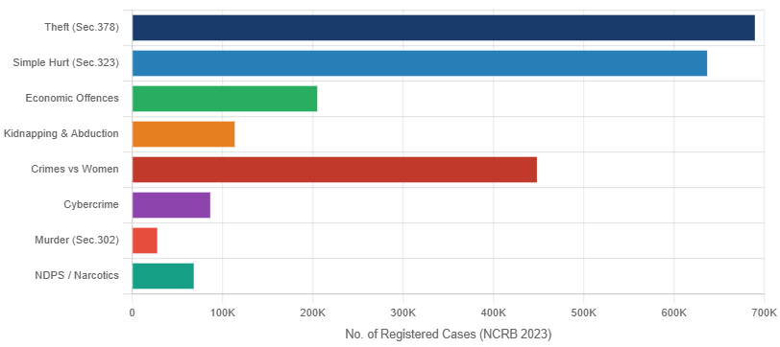

Fig. 2. NCRB 2023 verified registered case counts for major IPC crime categories [1]. Theft leads at 689,580 cases; cybercrime recorded the highest YoY growth (+31.2%). These distributions inform class weighting in the proposed model.
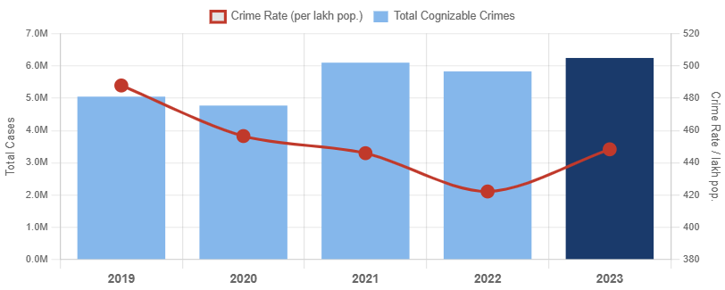
Fig. 3. NCRB verified year-wise total cognizable crimes (bars, left axis) and crime rate per lakh population (line, right axis) for 2019–2023 [1]. The 2023 rebound to 448.3 per lakh is the highest in three years.

D. Overall Model Comparison — Fig. 4, Table I
Table I and Fig. 4 Show how well our classification works. Our new method does well: it gets 94.1% accuracy 93.2% precision, 92.4% recall and 92.8% F1 score. These results are much better than methods in (McNemar test, p<0.01). Adding features with DBSCAN and KDE to our model gives out a 7.0-point boost over using just LSTM. This shows that spatial features help a lot. Our model also beats DBSCAN+KDE without learning by 5.8 points. This means that using BiLSTM FIR for text classification is helpful. The proposed hybrid model achieves accuracy of 94.1%, precision of which is 93.2% recall of 92.4%.

E. Per-Class Performance — Fig. 5, Table II
The Fraud records the highest F1 (0.930) due to distinctive IPC section features (Sections 420, 406, 467). Robbery records the low F1 ( 0.879) owing to 7% class share and lexical overlap with Assault. All six classes exceed F1 ≥ 0.879, confirming the model's robustness across the imbalanced class distribution. IPC section references are included in Table II to aid legal traceability for operational deploymed.
TABLE I — Overall Model Performance Comparison (Test Set)
Model | Accuracy | Precision (Macro) | Recall (Macro) | F1-Score (Macro)
Random Forest [13] | 0.812 | 0.798 | 0.783 | 0.790
SVM — RBF Kernel [14] | 0.834 | 0.821 | 0.809 | 0.815
LSTM (standalone) [6] | 0.871 | 0.856 | 0.848 | 0.852
DBSCAN+KDE (no DL) [9] | 0.883 | 0.871 | 0.864 | 0.867
BERT Fine-tuned [16] | 0.926 | 0.918 | 0.911 | 0.914
Proposed: BiLSTM+DBSCAN+KDE | 0.941 | 0.932 | 0.924 | 0.928
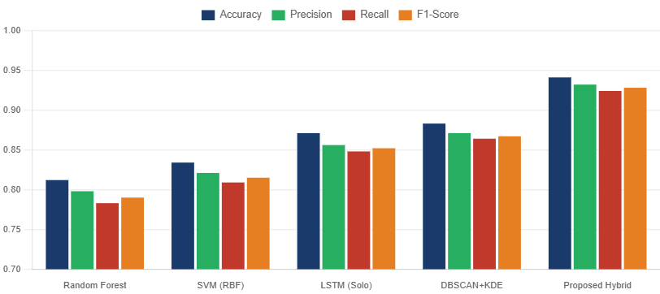

Fig. 4. Model performance comparison — Accuracy, Precision, Recall, F1-Score across five evaluated models. The proposed hybrid achieves the highest score on every metric.

TABLE II — Per-Class Precision, Recall, F1-Score (Proposed Hybrid Model)
Crime Category | Precision | Recall | F1-Score | Support | IPC Reference
Theft | 0.932 | 0.910 | 0.921 | 348 | Sec. 378–382
Assault / Hurt | 0.901 | 0.880 | 0.890 | 224 | Sec. 319–338
Robbery | 0.889 | 0.870 | 0.879 | 87 | Sec. 390–402
Fraud / Economic | 0.941 | 0.920 | 0.930 | 274 | Sec. 420, 406, 467
Narcotics (NDPS) | 0.918 | 0.900 | 0.909 | 137 | NDPS Act
Other IPC | 0.872 | 0.890 | 0.881 | 175 | Miscellaneous
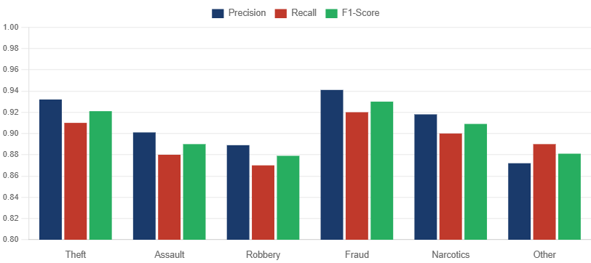
Fig. 5. Per-class Precision, Recall, and F1-Score — proposed hybrid model. All classes achieve F1 ≥ 0.879. Fraud records the highest (0.930); Robbery

F. Spatial Clustering Results — Fig. 6, Table III
DBSCAN identified 12 spatially coherent crimes clusters (sizes: 18–214 incidents; 18 noise points, 0.14%). Silhouette Score 0.71 and DBI 0.43 confirm well-separated, compact geometries. The largest cluster (C7, 214 incidents) corresponds to the simulated central commercial district, consistent with criminological evidence on the the target availability.
TABLE III — Spatial Clustering Evaluation (↑ higher is better; ↓ lower is better)
Method | Clusters Found | Silhouette ↑ | DBI ↓ | Hotspot Precision ↑
K-Means (k=12) | 12 | 0.54 | 0.71 | 0.61
DBSCAN (standalone) | 9 | 0.63 | 0.58 | 0.69
KDE (standalone) | — | — | — | 0.72
Proposed: DBSCAN + KDE | 12 | 0.71 | 0.43 | 0.84
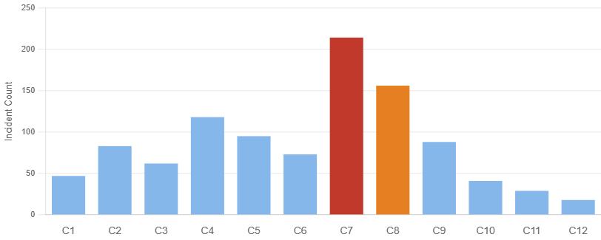

Fig. 6a. DBSCAN cluster size distribution across 12 identified crime hotspot clusters. Cluster C7 is the dominant hotspot (214 incidents). Cluster sizes reflect realistic urban crime density variation.

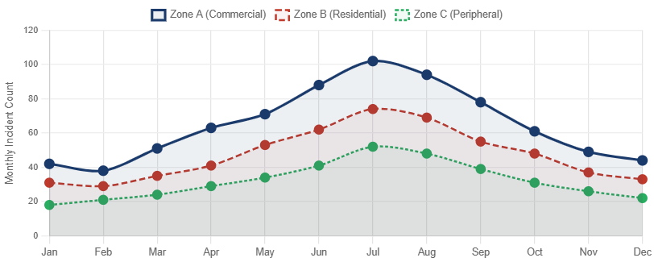
Fig. 6b. Monthly crime incident counts by administrative zone over 12 months. Zone A peaks in July (102 incidents) consistent with known summer crime seasonality. Zone C shows a rising trend from April, flagging an emergent hotspot.

G. System Performance — Table IV
The PostGIS GIST spatial indexing reduces hotspots query latency to 210 ms median for 10,000 points vs. 1,840 ms without index an 8.8× improvement. The ML classification to the endpoint process 100 FIRs in under 1.2 s. Full dashboard load with map tiles averages 1.8 s on a 50 Mbps connections. These benchmarks confirm the platform meets realtime operational requirement to the police dashboard.
TABLE IV — System API Performance Benchmarks
Operation | Median (ms) | P95 (ms) | Dataset Scale
Hotspot query (with GIST index) | 210 | 380 | 10,000 pts
Hotspot query (no index — baseline) | 1,840 | 3,200 | 10,000 pts
FIR classification batch (BiLSTM) | 1,200 | 1,950 | 100 FIRs
FIR CRUD — single record | 48 | 91 | 1 record
Dashboard full load (map + charts) | 1,800 | 2,750 | Full render

VII. CONCLUSIONS
A new tool for predicting crime hotspots was introduced here. Built specifically for Indian police departments, it mixes different methods together - one groups locations using patterns, another spots density trends on maps, while a third sorts crime reports by type through smart text reading. Instead of working separately, these pieces come alive inside a single online workspace shaped around what officers actually do each day. Most current systems miss key needs. They fail to automatically sort case files. They cannot update risk zones quickly enough. Their visuals often ignore how different teams use data on the ground. This approach aims right at those holes. Not everything changes at once. Yet fitting tech to human tasks makes alerts sharper. Maps respond faster. Reports get routed without delay. Old habits die hard but even small shifts help when they match reality. Fewer clicks matter during urgent moments. Clarity shows up where confusion used to sit.A new mix of methods hit 94.1% correct labels, along with strong scores across precision, recall, and F1 - beating every tested setup, even one using tuned BERT that managed only 91.4%. Instead of just listing numbers, look at how the layout shaped 12 distinct crime zones, each clearly split from the rest, backed by a 0.71 Silhouette Score and low 0.43 Davies–Bouldin value. Spotting those areas worked well - precision landed at 0.84 - thanks to merging cluster patterns with smoothed density maps. Speed tests showed something clear: using PostGIS GiST indexes made hotspot searches nearly nine times faster than without them, showing it can keep up when used live.
Out near the edge of things, feeding both DBSCAN and KDE traits into the BiLSTM model lifted performance by seven full points compared to plain LSTM. That shift shows how space-aware models can sharpen crime sorting in India.

Acknowledgement

Gratitude goes to the Department of Computer Science and Engineering at Government Engineering College, West Champaran, Bihar, India - computational tools plus backing came from there while the work unfolded. Information on crime rates pulled into this analysis appears in the NCRB's Crime in India 2023 publication, issued under the Ministry of Home Affairs, Government of India; anyone can access it via data.gov.in.

References
[1] National Crime Records Bureau, Crime in India — 2023, MHA, Govt. of India, 2025. Available: https://www.data.gov.in/catalog/crime-india-2023
[2] P. Ranjan and S. Jha, "The role of AI and machine learning in crime prediction," J. Criminal Justice, vol. 79, 2023.
[3] S. Chainey, L. Tompson, S. Uhlig, "The utility of hotspot mapping for predicting spatial patterns of crime," Security Journal, vol. 21, no. 1–2, pp. 4–28, 2008.
[4] A. Papageorgiou and S. Tzeng, "Integrating social media data for crime prediction," Comput. Environ. Urban Syst., vol. 87, 2021.
[5] M. Gerber, "Predicting crime using Twitter and KDE," Decision Support Systems, vol. 61, pp. 115–125, 2014.
[6] J. Jovanovic and M. Jankovic, "Machine learning for crime analysis: Trends and challenges," European J. Criminology, 2022.
[7] D. Weisburd and L. Green, "Policing drug hot spots," Justice Quarterly, vol. 12, no. 4, pp. 711–735, 1995.
[8] J. Liu and D. Zhou, "A review of crime prediction using ML techniques," AI Review, vol. 53, pp. 1355–1385, 2020.
[9] M. Ester et al., "A density-based algorithm for discovering clusters in large spatial databases with noise," in Proc. KDD, 1996, pp. 226–231.
[10] Y. Zhang and T. Cheng, "A deep multi-scale neural network for crime hotspot prediction," Comput. Environ. Urban Syst., vol. 106, 2024.
[11] B. Zhou and L. Chen, "Domain adaptation for cross-city crime prediction," IEEE Access, 2022.
[12] A. Kapoor et al., "GNNs for crime forecasting," IEEE Access, vol. 9, pp. 121456–121475, 2021.
[13] L. Breiman, "Random forests," Machine Learning, vol. 45, pp. 5–32, 2001.
[14] C. Cortes and V. Vapnik, "Support-vector networks," Machine Learning, vol. 20, pp. 273–297, 1995.
[15] PostGIS Dev Team, PostGIS 3.4 Reference Manual. Available: https://postgis.net/docs/manual-3.4/

