**Research Background**

Intelligent Rehabilitation Equipment and Technology

**Project Description**

1. Model

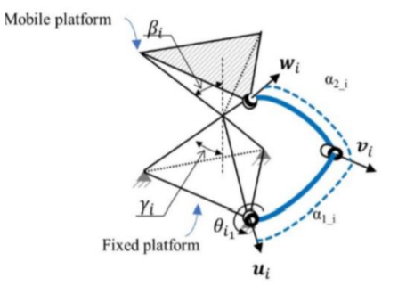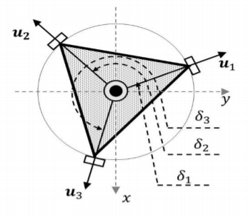

Parametric model and the top view

By analyzing the mathematical model of a three-degree-of-freedom spherical parallel mechanism, and determining 11 design parameters.

1. Optimization goal

Three optimization goals: working space, dexterity and maximum torque

3. Algorithm

The genetic algorithm is planned to adopt.

**Implement**

MATLAB Global Optimization Toolbox