**Chapter 1**

**P36** How long does it take to send a file of 640,000 bits from host A to host B over a circuit-switched network? All links are 1.536 Mbps，Each link uses TDM with 24 slots，500 msec to establish end-to-end circuit.

Solution: 1536000/24=64000bps 640000/64000 = 10s 10+0.5 = 10.5s

**P58** Assuming that the link length d between two hosts is 60m, the link bandwidth R is 10Mbps, and the signal propagation rate s is 2x108 m / s. Now host A sends 1-bit packet to host B.

1) How long does it take for host B to receive this packet? If host A starts transmitting the packet at time t = 0, how far does the front end of the signal of the packet spread at time t = dtrans?

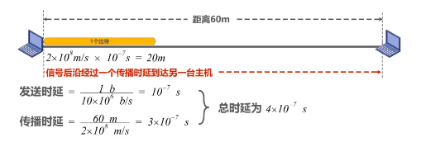

t = dtrans 时，信号前端在20m处

2) What if the link length d is 20 meters?

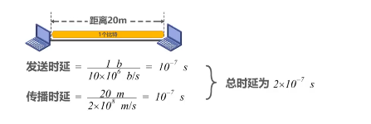

3) If the link length d is 10 meters, what is the specific transmission situation?

每个bit没发送完之前就会到达B，总延时：1.5x10-7s

4) If host A sends n-bit packet to host B, how long does it take for host B to receive the packet?

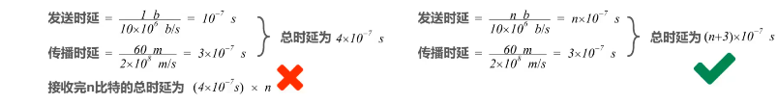

第一种计算方法是错误的。比特信号是一个跟着一个向前同时传播的，因此，无论有多少比特，在总时延中只包含一个传播时延。增加比特数量，只是增大了发送时延，而传播时延数量不变。

**结论：**若主机在一段链路上连续发送分组，则总时延为所有分组的发送时延加上信号在这一段链路上的传播时延。

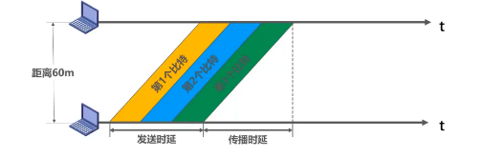

假设：分组等长，各链路长度相同、带宽也相同，忽略路由器的处理时延。

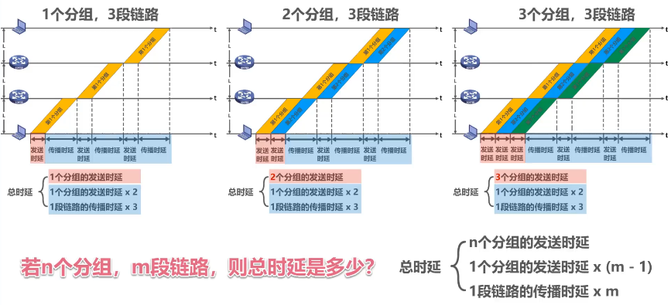

**P60**



L = 7.5 Mbits

R = 1.5 Mbps

tprop : propagation delay of each link

Divide the message into 5000 small packets: l=1.5 kbits

Calculate the end-to-end delay of message switching and packet switching

message switching 报文交换，数据不分组，按单个7.5M数据发送

总延时：每次发送时间X3+每段传播延时x3 L/R*3+ 3*tprop

packet switching 分组交换，数据分组，按每个分组大小进行数据发送

总延时：分组数量 n=7.5M/1.5K = 5k l/R*(n+2)+ 3*tprop

**P61**

The message to be sent is **x** (bits) in total. There are **k** links from the source to the destination. The propagation delay of each link is **d**(s) and the bandwidth is **R**(bps). In circuit switching, the circuit establishment time is **s**(s). In packet switching, the message can be divided into several packets with **p**(bits) length. It is assumed that the processing time and queuing time of the message/packets at each node are ignored.

Q: under what conditions is the end-to-end delay of circuit switching greater than that of packet switching?

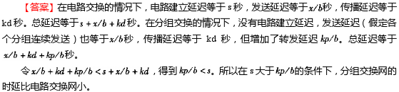

**P78-79**

**1. In the OSI model, the first bottom-up level to provide end-to-end services is ( B )**

1. data link layer B. transport layer C. session layer D. application layer

**2. Among the following options, which is not described in the network architecture is ( C )**

A. layers in the network B. protocols used by each layer

C. internal implementation details of the protocols

D. functions that must be completed by each layer

**3. In the TCP / IP reference model, what directly provides services for the application layer is ( B )**

A. presentation layer B. transmission layer C. network layer D. network interface layer

**4. Assuming that the application layer in the ISO/OSI reference model wants to send 400B data (without splitting), except the physical layer and application layer, all other layers introduce 20B additional overhead when packaging PDU, the transmission efficiency of the application layer is about ( A )**

A.80% B.83% C.87% D.91%

解析：OSI参考模型共7层（应用层、表示层、会话层、传输层、网络层、数据链路层、物理层），除去物理层和应用层，剩5层。它们会向PDU引入20Bx5=100B的额外开销。应用层是最顶层，因此数据传输效率为400B/500B=0.8

**Chapter 2**

**P62-65**

1. In the physical layer interface characteristics, the time sequence used to describe the completion of each function is ( **D** )

A. Mechanical Characteristics

B. Electrical Characteristics

C. Functional Characteristics

D. Procedural Characteristics

2. Among the following options, that do not belong to the definition scope of physical layer interface specification is ( **C** )

A. interface shape B. pin function

C. physical address D. signal level

3. Under the condition of no noise, if the frequency bandwidth of a communication link is 3kHz and QAM modulation technology with four phases and four amplitudes in each phase is adopted, the maximum data transmission rate of the communication link is ( **B** )

A. 12kbps B. 24kbps C. 48kbps D. 96kbps

波特率 6K，每个波特表示4bit。C=2Wlog2N=2 * 3K * log2（4*4）=24Kbps

4. If the data transmission rate of a communication link is 2400bps and 4-phase modulation is adopted, the baud rate of the link is （ **B** ）

A. 600 baud B. 1200 baud

C. 4800 baud D. 9600 baud

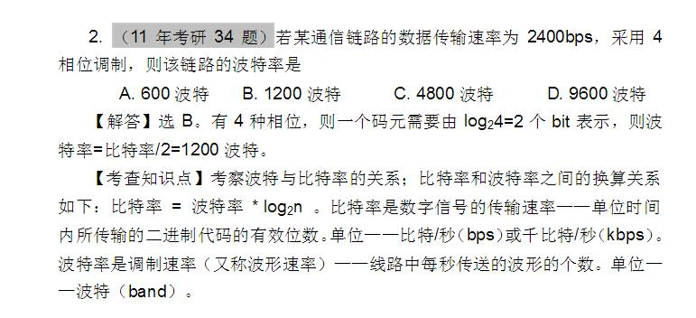

5. If the frequency bandwidth connecting R2 and R3 link is 8kHz and the signal-to-noise ratio is 30dB, and the actual data transmission rate of the link is about 50% of the maximum data transmission rate, the actual data transmission rate of the link is about ( **C** )

A. 8kbps B. 20kbps C. 40kbps D. 80kbps

根据香农定理：

理论最大：8klog2（1+1000）=8k10=80kbps

实际最大：0.5*理论最大=40kbps

6. Among the following factors, which will not affect the channel data transmission rate is ( **D** )

A. signal to noise ratio B. frequency bandwidth

C. symbol speed D. signal propagation speed （2-3X108）

7. If the following figure shows the signal waveform received by the 10Base-T network interface card, the bit string received by the network interface card is （ **A** ）

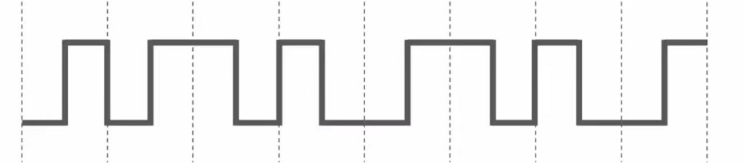

A. 00110110 B. 10101101 C. 01010010 D. 11000101

从波形看出是曼彻斯特编码，所以是00110110或11001001

**Chapter 3**

**P18**

1. HDLC protocol sets the bit stream 01111100 01111110 after framing as ( **A** )

A. 01111100 00111110 10

B. 01111100 01111101 01111110

C. 01111100 01111101 0

D. 01111100 01111110 01111101

**P24**

1. If the information received by an Ethernet adapter is 101101001 and the generator is G(x) = x3+x2+1, judge whether the transmission has bit error?

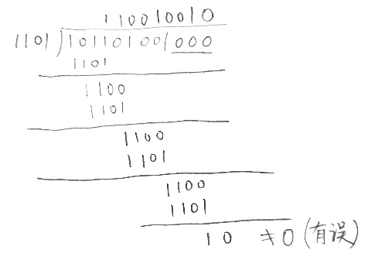

**P43-44**

The data link layer uses the GBN protocol, and the sender has sent frames numbered 0 ~ 7. When the timer expires, if the sender only receives the acknowledgement of frames 0, 2 and 3, the number of frames to be retransmitted by the sender is ( C )

A. 2 B. 3 C. 4 D.5

解析：已经收到3号帧的确认，表示0—3号帧都已经正确接收，超时发生就重发4—7帧。

GBN不只是超时重传的特点，它还有累计确认的功能，即：发一个确认N，表示前N帧都已正确收到。超时重传一旦发生，就重发最后确认帧之后的所有帧。不要和选择重传（SR）弄混，选择重传可以乱序接收，只发送单个帧的确认。如果是选择重传，还要再多传1号帧。

Considering GBN protocol and SR protocol, assuming that the length of sequence number space is n, what is the maximum allowed sender window?

**n/2**

解析：如果发送方发送一整组数据，接收方接受数据并发出ACK消息，发送方此时没有接受到ACK消息；对于发送方而言，窗口为[m-w,m-1]；对于接收方而言，窗口为[m, m+w-1]；其中m表示send_base，w表示window大小；

问题：为了区分是第一个分组的重传还是下一组的初次传送

QUESTION：0 1 2 3 0 1 2 3 ；序号k为4；若此时窗口大小为3

0 1 2 **3 0 1** 2 3 ；[0, 1, 2]表示发送方窗口；[3, 0, 1]表示接收方窗口；若此时接收方接受到0分组，它为第一个分组的0的重传？还是下一个分组的**0**的初次传送？

QUESTION：0 1 2 3 0 1 2 3；序号k为4；若此时窗口大小为2

0 1 **2 3** 0 1 2 3 ；[0, 1]表示发送方窗口；[2, 3]表示接收方窗口；此时无论如何都不会出现相同序号的分组的情况。

即分组序号k ≥ 2w（窗口）.

**P68**

A LAN adopts CSMA/CD protocol to realize the media access control. The data transmission rate is 10Mbps, the distance between host A and host B is 2km, and the signal propagation speed is 200000km/s. If there is a conflict when two hosts send data, how long will it take from the time when they start sending data to the time when both hosts detect the conflict? (What is the minimum and maximum duration?)

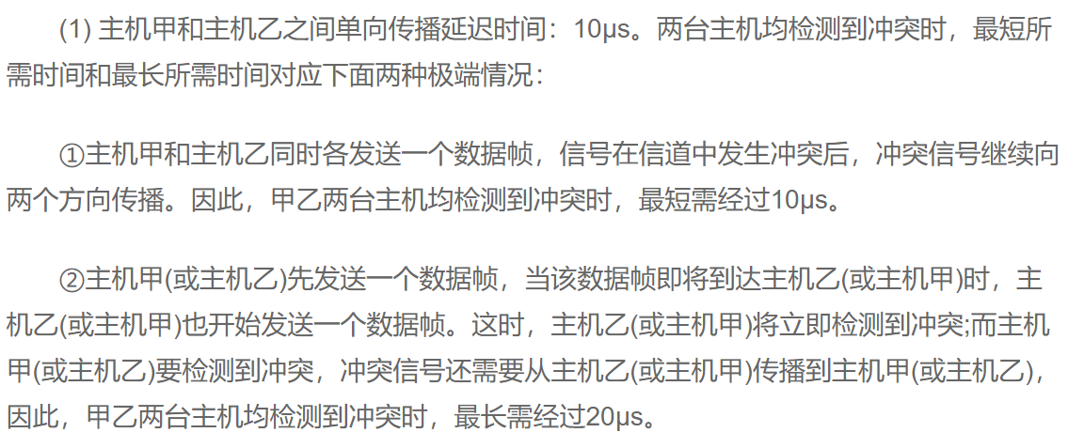

**Chapter 4**

**P20**

In a LAN using CSMA / CD protocol, the transmission medium is a complete cable, the transmission rate is 1Gbps, and the signal propagation rate in the cable is 200000 km / s. if the minimum data frame length is reduced by 800 bits, the distance between the farthest two stations needs to be at least（ **D** ）

A increased by 160m B increased by 80m

C reduced by 160m D reduced by 80m

解析：

1.传输时延>2*最远两个站点间的传播时延

2.传输时延=数据包的大小/数据包的发送率

3.传播时延=站点间距离/信号传播速率

1式为最远站点发出的数据产生冲突后，能被远端站点感知的最短时间，保证了在远端站点发送完数据之前能够检测到冲突

由2式，数据帧减小800bit，即传输时延减小 800bit/1Gbps=8*10^(-7) s

由1式，因此传播时延至少减小1/2 * 8*10^(-7) =4*10^(-7) s

由3式，因此站点间距离最少减少 4*10^(-7) * 200000 = 0.08km = 80m

