Chapter 2 OSI Model

Overview

During the past two decades there has been a tremendous increase in the numbers and sizes of networks. Many of the networks, however, were built using different implementations of hardware and software. As a result, many of the networks were incompatible and it became difficult for networks using different specifications to communicate with each other. To address this problem, the International Organization for Standardization (ISO) researched many network schemes. The ISO recognized that there was a need to create a network model that would help network builders implement networks that could communicate and work together (interoperability) and therefore, released the OSI reference model in 1984.

This chapter explains how standards ensure greater compatibility and interoperability between various types of network technologies. In this chapter, you will learn how the OSI reference model networking scheme supports networking standards. In addition, you will see how information or data makes its way from application programs (such as spreadsheets) through a network medium (such as wires) to other application programs located on other computers on a network. As you work through this chapter, you will learn about the basic functions that occur at each layer of the OSI model, which will serve as a foundation as you begin to design, build and troubleshoot networks.

|  |  |
| --- | --- |
| |  | | --- | | The concept of *layers* will help you understand the action that occurs during communication from one computer to another. Shown in the Figure D:\SEMESTER1\images\1.gifare questions that involve the movement of physical objects such as highway traffic, or electronic data. This motion of objects, whether it is physical or logical, is referred to as flow. There are many layers that help describe the details of the flow process. Other examples of systems that flow, are the public water system, the highway system, the postal system, and the telephone system.  Now examine the Figure D:\SEMESTER1\images\2.gif"Comparing Networks" chart. What network are you examining? What is flowing? What are the different forms of the object that is flowing? What are the rules for flow? Where does the flow occur? The networks listed in this chart give you more analogies to help you understand computer networks.  Another example of how you might use the concept of layers to analyze an everyday subject is to examine human conversation. When you create an idea that you wish to communicate to another person, the first thing you do is choose how you want to express that idea, then you decide how to properly communicate it, and finally, you actually deliver the idea.  Imagine a young boy seated at one end of a very long dinner table. On the other end of the table, quite a distance away, sits the young boy's grandmother. The youngster speaks English. The grandmother prefers to speak Spanish. The table has been set with a wonderful meal that the grandmother has prepared. Suddenly the young boy shouts at the top of his lungs, "Hey, you! Give me the rice!" and reaches across the table to grab it. In most places, this action is considered quite rude. What should the young boy have done to communicate his wishes in an acceptable manner?  To help you find the solution to this question, analyze the communication process by using layers. First there is the idea – the young boy wants rice; then there is the representation of the idea– spoken English (instead of Spanish); next is the method of delivery – "Hey, you"; and finally, the medium – shouting (sound) and grabbing (physical action) across the table for the rice.  From this group of four layers*,* you can see that three of them prevent the young boy from communicating his idea in an appropriate/acceptable manner. The first layer (the idea) is acceptable. The second layer (representation), using spoken English instead of Spanish, and the third layer (delivery), demanding instead of a politely requesting, most definitely do not follow acceptable social protocol. The fourth layer (medium), shouting and grabbing from the table rather than politely requesting assistance from another person seated nearby, is unacceptable behavior in most any social situation.  By analyzing this interaction in terms of layers you can understand more clearly some of the problems of communication in both humans or computers, and how you might solve them. | |

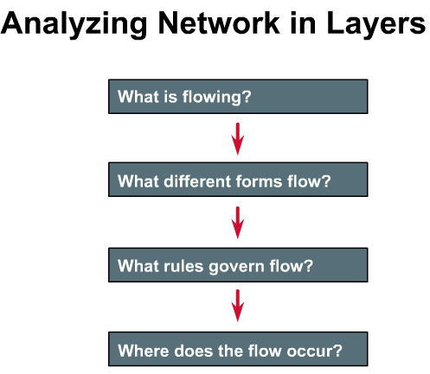

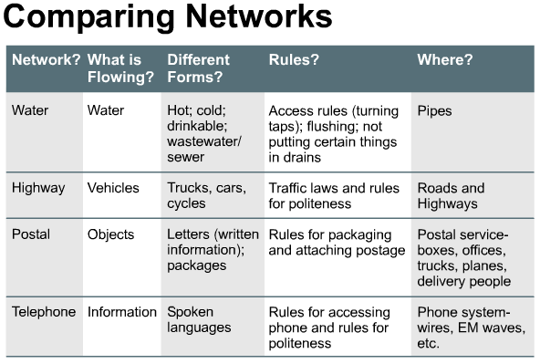

|  |  |  |
| --- | --- | --- |
|  | **2.1.2** | **Source, destination, and data packets** |
| |  | | --- | | As you learned in chapter 1, the most basic level of computer information consists of *binary digits*, or bits (0s and 1s). Computers that send one or two bits of information, however, would not be very useful, so other groupings - *bytes*, *kilobytes*, *megabytes*, and *gigabytes* - are necessary.  In order for computers to send information through a network, all communications on a network originate at a source, then travel to a destination.  As illustrated in the Figure, the information that travels on a network is referred to as *data*, *packet*, or *data packet*. A data packet is a logically grouped unit of information that moves between computer systems. It includes the source information along with other elements that are necessary in order to make communication possible and reliable with the destination device. The source address in a packet specifies the identity of the computer that sends the packet. The destination address specifies the identity of the computer that finally receives the packet. | | | |

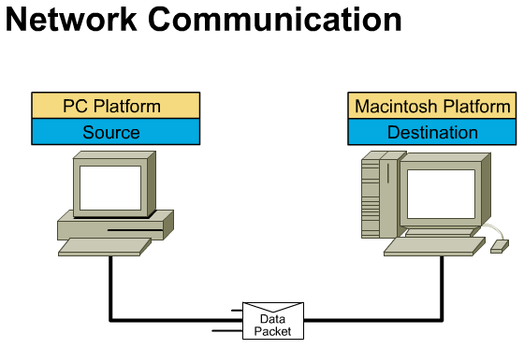

|  |  |
| --- | --- |
| **2.1.3** | **Media** |
| |  | | --- | | During your study of networking, you will hear references to the word "*medium*". (Note: The plural form of medium is *media*.) In networking, a medium is a material through which data packets travel. It could be any of the following materials: D:\SEMESTER1\images\1.gifD:\SEMESTER1\images\2.gifD:\SEMESTER1\images\3.gif   * telephone wires * Category 5 UTP (used for 10BASE-T Ethernet) * coaxial cables (used for cable TV) * optical fibers (thin glass fibers that carry light)   There are two more types of media that are less obvious, but should nonetheless be taken into account in network communications. First, is the atmosphere (mostly oxygen, nitrogen, and water) that carries radio waves, microwaves, and light.  Communication without some type of wires or cables is called wireless or free-space communication. This is possible using electromagnetic (EM) waves. EM waves, which in a vacuum all travel at the speed of light, include power waves, radio waves, microwaves, infrared light, visible light, ultraviolet light, x-rays, and gamma rays. EM waves travel through the atmosphere (mostly oxygen, nitrogen, and water), but they also travel through the vacuum of outer space (where there is virtually no matter, no molecules, no atoms). | | |

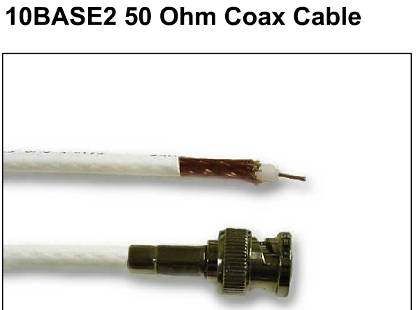

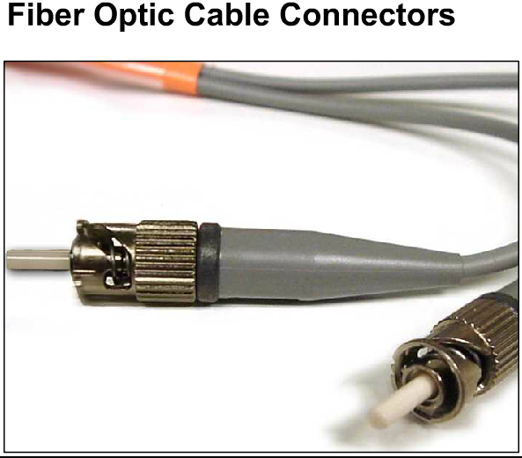

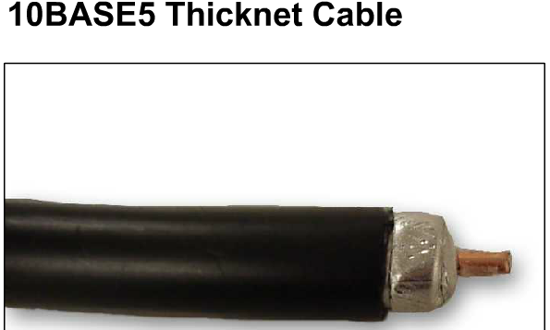

|  |  |  |  |  |  |  |
| --- | --- | --- | --- | --- | --- | --- |
|  | **2.1.4** | | | | | **Protocol** |
| |  | | --- | | In order for data packets to travel from a source to a destination on a network, it is important that all the devices on the network speak the same language or *protocol*.  A *Protocol*is a set of rules that make communication on a network more efficient. Some common examples are as follows:   * In congress, a form of Roberts Rules of Order makes it possible for hundreds of representatives, who all like to talk, to take turns, and to communicate their ideas in an orderly manner. * While driving a car, other cars (should!) signal when they wish to make a turn; if they did not, then the roads would be chaos. * While flying an airplane, pilots obey very specific rules for communication with other airplanes and with air traffic control. * When answering the telephone, someone says, "Hello," then the person calling says, "Hello. This is.... "; and so it goes back and forth.   One technical definition of a data communications protocol is: a set of rules, or an agreement, that determines the format and transmission of data. Layer non one computer communicates with layer n on another computer. The rules and conventions used in this communication are collectively known as the *Layer n protocol*. | | | | | | | |
| **2.1.5** | | | **The evolution of ISO networking standards** | | | |
| |  | | --- | | The early development of LANs, MANs, and WANs was chaotic in many ways. The early 1980's saw tremendous increases in the numbers and sizes of networks. As companies realized the money they could save and the productivity they could gain by using networking technology, they added networks and expanded existing networks almost as rapidly as new network technologies and products could be introduced.  By the mid-1980's, these companies began to experience growing pains from all the expansions they had made. It became harder for networks that used different specifications and implementations to communicate with each other. They realized that they needed to move away from *proprietary* networking systems.  Proprietary systems are privately developed, owned, and controlled. In the computer industry, proprietary is the opposite of open, meaning that one or a small group of companies controls all usage of the technology. Open means that free usage of the technology is available to the public.  To address the problem of networks being incompatible  and unable to communicate with each other, the *International Organization for Standardization* (***ISO***) researched network schemes like DECNET, SNA, and TCP/IP in order to find a set of rules. As a result of this research, the ISO created a network model that would help vendors create networks that would be compatible with, and operate with, other networks.  The process of breaking down complex communications into smaller discrete tasks could be compared to the process of building an automobile.  When taken as a whole, the design, manufacture, and assembly of an automobile is a highly complex process.  It’s unlikely that one single person would know how to perform all the required tasks to build a car from scratch.  This is why mechanical engineers design the car, manufacturing engineers design the molds to make the parts, and assembly technicians each assemble a part of the car.  The ***OSI*** *reference model* (Note: Do not confuse with ISO*.*), released in 1984, was the descriptive scheme they created. It provided vendors with a set of standardsthat ensured greater compatibility and interoperability between the various types of network technologies that were produced by the many companies around the world. | | | | | | | |
|  | **2.2.1** | | | | **The purpose of the OSI reference model** | |
| |  | | --- | | The OSI reference modelis the primary model for network communications. Although there are other models in existence, most network vendors, today, relate their products to the OSI reference model, especially when they want to educate users on the use of their products. They consider it the best tool available for teaching people about sending and receiving data on a network.  The OSI reference model allows you to view the network functions that occur at each layer. More importantly, the OSI reference model is a framework that you can use to understand how information travels throughout a network. In addition, you can use the OSI reference model to visualize how information, or data packets, travels from application programs (e.g. spreadsheets, documents, etc.), through a network medium (e.g. wires, etc.), to another application program that is located in another computer on a network, even if the sender and receiver have different types of networks.  In the OSI reference model, there are seven numbered layers, each of which illustrates a particular network function. This separation of networking functions is called *layering*. Dividing the network into these seven layers provides the following advantages:   * It breaks network communication into smaller simpler parts. * It standardizes network components to allow multiple-vendor development and support. * It allows different types of network hardware and software to communicate with each other. * It prevents changes in one layer from affecting the other layers, so that they can develop more quickly. * It breaks network communication into smaller parts to make learning it easier to understand. | | | | | | | |
|  | **2.2.2** | | | **The seven layers of the OSI reference model** | | |
| |  | | --- | | The problem of moving information between computers is divided into seven smaller and more manageable problems in the OSIreference model. Each of the seven smaller problems is represented by its own layer in the model. The seven layers of the OSIreference model are:  Layer 7: The application layer Layer 6: The presentation layer Layer 5: The session layer Layer 4: The transport layer Layer 3: The network layer Layer 2: The data link layer Layer 1: The physical layer  During the course of this semester, you will start your studies with Layer 1 and work your way through the OSImodel, layer by layer. By working through the layers of the OSI reference model, you will understand how data packets travel through a network and what devices operate at each layer as data packets travel through them. As result, you will understand how to troubleshoot network problems as they may occur during data packet flow. For more information about the OSI model, visit the following site: | | | | | | | |
| **2.2.3** | | **The functions of each layer** | | | | |
| |  | | --- | | Each individual OSI layer has a set of functions that it must perform in order for data packets to travel from a source to a destination on a network. Below is a brief description of each layer in the OSI reference model as shown in the Figure.  **Layer 7: The Application Layer D:\SEMESTER1\images\7.gif** The application layer is the OSI layer that is closest to the user; it provides network services to the user’s applications. It differs from the other layers in that it does not provide services to any other OSI layer, but rather, only to applications outside the OSI model. Examples of such applications are spreadsheet programs, word processing programs, and bank terminal programs. The application layer establishes the availability of intended communication partners, synchronizes and establishes agreement on procedures for error recovery and control of data integrity. If you want to remember Layer 7 in as few words as possible, think of browsers.  **Layer 6: The Presentation Layer D:\SEMESTER1\images\6.gif** The presentation layer ensures that the information that the application layer of one system sends out is readable by the application layer of another system. If necessary, the presentation layer translates between multiple data formats by using a common format. If you want to think of Layer 6 in as few words as possible, think of a common data format.  **Layer 5: The Session Layer D:\SEMESTER1\images\5.gif** As its name implies, the session layer establishes, manages, and terminates sessions between two communicating hosts. The session layer provides its services to the presentation layer. It also synchronizes dialogue between the two hosts' presentation layers and manages their data exchange. In addition to session regulation, the session layer offers provisions for efficient data transfer, class of service, and exception reporting of session layer, presentation layer, and application layer problems. If you want to remember Layer 5 in as few words as possible, think of dialogues and conversations.  **Layer 4: The Transport Layer D:\SEMESTER1\images\4.gif** The transport layer segments data from the sending host's system and reassembles the data into a data stream on the receiving host's system. The boundary between the session layer and the transport layer can be thought of as the boundary between media-layer protocols and host-layer protocols. Whereas the application, presentation, and session layers are concerned with application issues, the lower three layers are concerned with data transport issues.  The transport layer attempts to provide a data transport service that shields the upper layers from transport implementation details. Specifically, issues such as how reliable transport between two hosts is accomplished is the concern of the transport layer. In providing communication service, the transport layer establishes, maintains, and properly terminates virtual circuits. In providing reliable service, transport error detection-and-recovery and information flow control are used. If you want to remember Layer 4 in as few words as possible, think of quality of service, and reliability.  **Layer 3: The Network Layer D:\SEMESTER1\images\3.gif** The network layer is a complex layer that provides connectivity and path selection between two host systems that may be located on geographically separated networks. If you want to remember Layer 3 in as few words as possible, think of path selection, routing, and addressing.  **Layer 2: The Data Link Layer D:\SEMESTER1\images\2.gif** The data link layer provides reliable transit of data across a physical link. In so doing, the data link layer is concerned with physical (as opposed to logical) addressing, network topology, network access, error notification, ordered delivery of frames, and flow control. If you want to remember Layer 2 in as few words as possible, think of frames and media access control.  **Layer 1: The Physical Layer D:\SEMESTER1\images\1.gif** The physical layer defines the electrical, mechanical, procedural, and functional specifications for activating, maintaining, and deactivating the physical link between end systems. Such characteristics as voltage levels, timing of voltage changes, physical data rates, maximum transmission distances, physical connectors, and other, similar, attributes are defined by physical layer specifications. If you want to remember Layer 1 in as few words as possible, think of signals and media. | | | | | | | |
| **2.2.4** | | **Encapsulation** | | | | |
| |  | | --- | | You know that all communications on a network originate at a source, and are sent to a destination, and that the information that is sent on a network is referred to as data or data packets. If one computer (host A) wants to send data to another computer (host B), the data must first be packaged by a process called encapsulation.  Encapsulation wraps data with the necessary protocol information before network transit. Therefore, as the data packet moves down through the layers of the OSI model, it receives headers, trailers, and other information. (Note: The word "header" means that address information has been added.)  To see how encapsulation occurs, lets examine the manner in which data travels through the layers as illustrated in the Figure. Once the data is sent from the source, as depicted in the Figure, it travels through the application layer down through the other layers.  As you can see, the packaging and flow of the data that is exchanged goes through changes as the networks perform their services for end-users. As illustrated in the Figures, networks must perform the following five conversion steps in order to encapsulate data:  Figure D:\SEMESTER1\images\1.gif:   1. **Build the data.**  As a user sends an e-mail message, its alphanumeric characters are converted to data that can travel across the internetwork. 2. **Package the data for end-to-end transport.**  The data is packaged for internetwork transport. By using segments, the transport function ensures that the message hosts at both ends of the e-mail system can reliably communicate. 3. **Append (add) the network address to the header.**  The data is put into a packet or datagram that contains a network header with source and destination logical addresses. These addresses help network devices send the packets across the network along a chosen path.   Figure D:\SEMESTER1\images\2.gif:   1. **Append (add) the local address to the data link header.**  Each network device must put the packet into a frame. The frame allows connection to the next directly-connected network device on the link. Each device in the chosen network path requires framing in order for it to connect to the next device. 2. **Convert to bits for transmission.** The frame must be converted into a pattern of 1s and 0s (bits) for transmission on the medium (usually a wire). A clocking function enables the devices to distinguish these bits as they travel across the medium. The medium on the physical internetwork can vary along the path used. For example, the e-mail message can originate on a LAN, cross a campus backbone, and go out a WAN link until it reaches its destination on another remote LAN. Headers and trailers are added as data moves down through the layers of the OSI model. | | | | | | | |

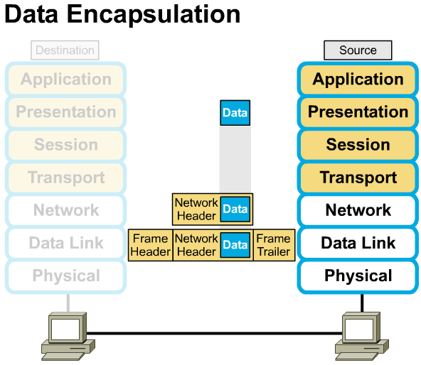

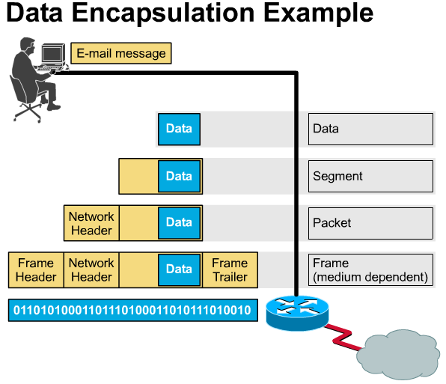

|  |  |  |
| --- | --- | --- |
|  | **2.2.5** | **Names for data at each layer of the OSI model** |
| |  | | --- | | In order for data packets to travel from the source to the destination, each layer of the OSI model at the source must communicate with its peer layer at the destination. This form of communication is referred to as *Peer-to-Peer Communications*.  During this process, each layer's protocol exchanges information, called  *protocol data units* (*PDUs),* between peer layers . Each layer of communication, on the source computer, communicates with a layer-specific PDU, and with its peer layer on the destination computer as illustrated in the Figure. D:\SEMESTER1\images\1.gif | | | |

Data packets on a network originate at a source and then travel to a destination. Each layer depends on the service function of the OSI layer below it. To provide this service, the lower layer uses encapsulation to put the PDU from the upper layer into its data field; then it adds whatever headers and trailers the layer needs to perform its function. Next, as the data moves down through the layers of the OSI model, additional headers and trailers are added.  After Layers 7, 6, and 5 have added their information, Layer 4 adds more information. This grouping of data, the Layer 4 PDU, is called a *segment*. D:\SEMESTER1\images\2.gif

The network layer, for example, provides a service to the transport layer, and the transport layer presents data to the internetwork subsystem. The network layer has the task of moving the data through the internetwork. It accomplishes this task by encapsulating the data and attaching a header creating a packet (the Layer 3 PDU). The header contains information required to complete the transfer, such as source and destination logical addresses.

The data link layer provides a service to the network layer. It encapsulates the network layer information in a *frame* (the Layer 2 PDU); the frame header contains information (e.g. physical addresses) required to complete the data link functions. The data link layer provides a service to the network layer by encapsulating the network layer information in a frame.

The physical layer also provides a service to the data link layer. The physical layer encodes the data link frame into a pattern of 1s and 0s (bits) for transmission on the medium (usually a wire) at Layer 1.

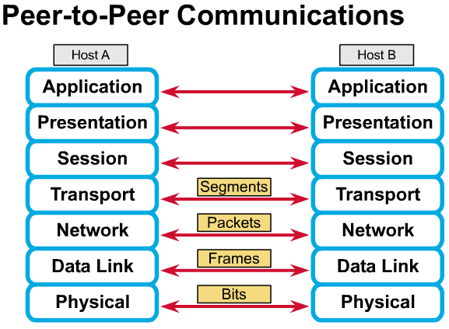

|  |  |
| --- | --- |
| **2.3.1** | **The TCP/IP reference model** |
| |  | | --- | | Although the OSI reference model is universally recognized, the historical and technical open standard of the Internet is *Transmission Control Protocol/Internet Protocol (TCP/IP).* The *TCP/IP reference model* and the *TCP/IP protocol stack* make data communication possible between any two computers, anywhere in the world, at nearly the speed of light. The TCP/IP model has historical importance, just like the standards that allowed the telephone, electrical power, railroad, television, and videotape industries to flourish. To get up-to-date information on networking models and standards, visit the following websites: | | |

[The Internet Engineering Task Force](http://www.ietf.org/)  
[Introduction to the Internet Protocols](http://oac3.hsc.uth.tmc.edu/staff/snewton/tcp-tutorial/)