Q7) Calculate Mean, Median, Mode, Variance, Standard Deviation, Range & comment about the values / draw inferences, for the given dataset

* For Points,Score,Weigh>

Find Mean, Median, Mode, Variance, Standard Deviation, and Range and also Comment about the values/ Draw some inferences.

Ans:

PROGRAM

df=read.csv("C:/Users/india/Desktop/data science/assignments/Q7.csv")

df

mean(df$Points)

median(df$Points)

mode(df$Points)

var(df$Points)

sd(df$Points)

range(df$Points)

mean(df$Score)

median(df$Score)

mode(df$Score)

var(df$Score)

sd(df$Score)

range(df$Score)

mean(df$Weigh)

median(df$Weigh)

mode(df$Weigh)

var(df$Weigh)

sd(df$Weigh)

range(df$Weigh)

Output:

mean(df$Points)[1] 3.596563

median(df$Points)[1] 3.695

mode(df$Points)[1] "numeric"

var(df$Points)[1] 0.2858814

sd(df$Points)[1] 0.5346787

range(df$Points)[1] 2.76 4.93

mean(df$Score)[1] 3.21725

mean(df$Score)[1] 3.21725

median(df$Score)[1] 3.325

mode(df$Score)[1] "numeric"

var(df$Score)[1] 0.957379

sd(df$Score)[1] 0.9784574

range(df$Score)[1] 1.513 5.424

mean(df$Weigh)[1] 17.84875

median(df$Weigh)[1] 17.71

mode(df$Weigh)[1] "numeric"

var(df$Weigh)[1] 3.193166

sd(df$Weigh)[1] 1.786943

range(df$Weigh)[1] 14.5 22.9

For Points:

**We can conclude that the distribution is Left skewed i.e negatively skewed and Platykurtic i.e negative**

For Score:

**We can conclude that the distribution is Left skewed i.e negatively skewed and Platykurtic i.e negative**

For Weigh:

**We can conclude that the distribution is Right skewed i.e positively skewed and Mesokurtic i.e positive**

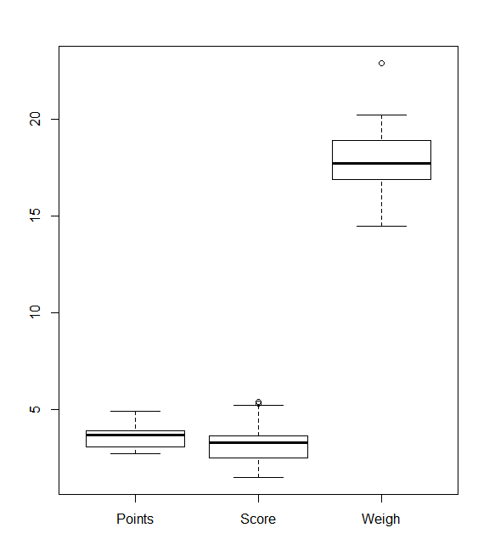

**Q9) Calculate Skewness, Kurtosis & draw inferences on the following data**

**Cars speed and distance**

**Use Q9_a.csv**

**SP and Weight(WT)**

**Use Q9_b.csv**

Ans:

Cars speed and distance

Program

df1=read.csv("C:/Users/india/Desktop/data science/assignments/Q9_a.csv")

df1

skew(df1, na.rm = TRUE,type=3)

kurtosi(df1, na.rm = TRUE,type=3)

Output:

skew(df1, na.rm = TRUE,type=3)[1] 0.0000000 -0.1105533 0.7591268

kurtosi(df1, na.rm = TRUE,type=3)

Index speed dist

-1.2722024 -0.6730924 0.1193971

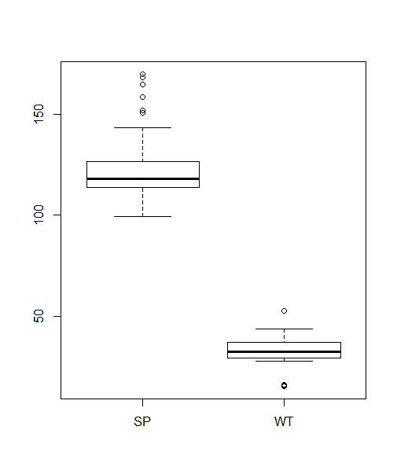

SP and Weight

Program

df2=read.csv("C:/Users/india/Desktop/data science/assignments/Q9_b.csv")

df2

describe(df2)

skew(df2, na.rm = TRUE,type=3)

kurtosi(df2, na.rm = TRUE,type=3)

Output:

skew(df2, na.rm = TRUE,type=3) 0.0000000 1.5522581 -0.5921721

kurtosi(df2, na.rm = TRUE,type=3)

X SP WT

-1.2445270 2.5830723 0.7257402

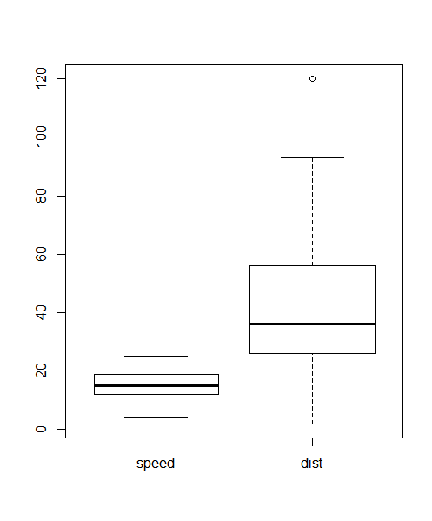

Q 20) Calculate probability from the given dataset for the below cases

Data _set: Cars.csv

Calculate the probability of MPG of Cars for the below cases.

MPG <- Cars$MPG

* 1. P(MPG>38)
  2. P(MPG<40)
  3. P (20<MPG<50)

Ans:

Program

MPG <-c(df3$MPG)

MPG

sample(MPG)

a=subset(MPG,MPG>38)

a1=length(a)/length(MPG)

a1

b=subset(MPG,MPG<40)

b1=length(b)/length(MPG)

b1

d=subset(MPG,MPG>20 & MPG <50)

d1=length(d)/length(MPG)

d1

Output:

a=subset(MPG,MPG>38)

a1=length(a)/length(MPG)

a1[1] 0.4074074

b=subset(MPG,MPG<40)

b1=length(b)/length(MPG)

b1[1] 0.7530864

d=subset(MPG,MPG>20 & MPG <50)

d1=length(d)/length(MPG)

d1[1] 0.8518519

Q 21) Check whether the data follows normal distribution

1. Check whether the MPG of Cars follows Normal Distribution

Dataset:Cars.csv

Ans: It follows normal distribution

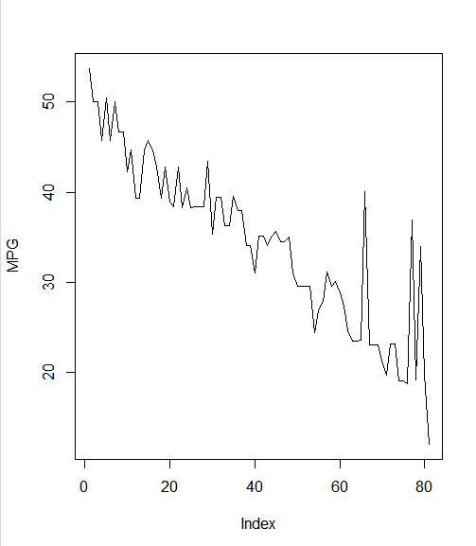

1. Check Whether the Adipose Tissue (AT) and Waist Circumference(Waist) from

wc-at data set follows Normal Distribution

Dataset: wc-at.csv

Ans: They follows normal distribution

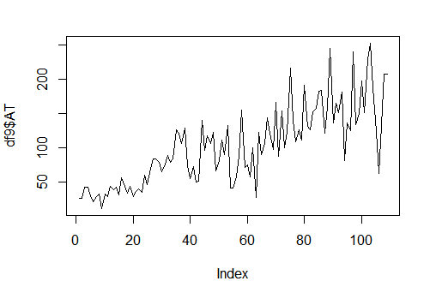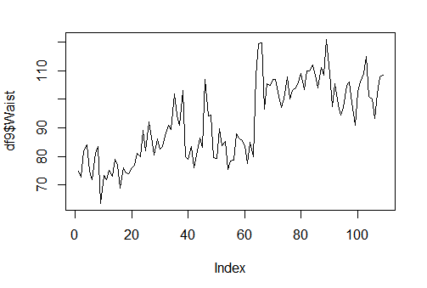

Q 24**)** A Government company claims that an average light bulb lasts 270 days. A researcher randomly selects 18 bulbs for testing. The sampled bulbs last an average of 260 days, with a standard deviation of 90 days. If the CEO's claim were true, what is the probability that 18 randomly selected bulbs would have an average life of no more than 260 days

Ans:

Program

p <- pt((260-270)/(90/sqrt(18)), 18)

p

Output:

p[1] 0.3215076