Assignment 2

Introduction to Artificial Intelligence

Gitansh Mittal

301200517

Solution:

Exercise 2

**Results of Greedy search vs UCS and A\***

UCS

UCS is an uninformed search algorithm as the goal is not defined. So, it searches every node and then creates a path. In this Function is f(n) = g(n) where g(n) is a path cost

A star

A star is an informed search algorithm as the goal is already defined. In this, it doesn’t search every node. In this Function is f(n) = g(n) +h(n) where g(n) is a path cost and h(n) is heuristic function.

The major difference I noticed in output is that in the tree as in UCS the tree is complete whereas the tree is not complete.

Exercise 3

1. 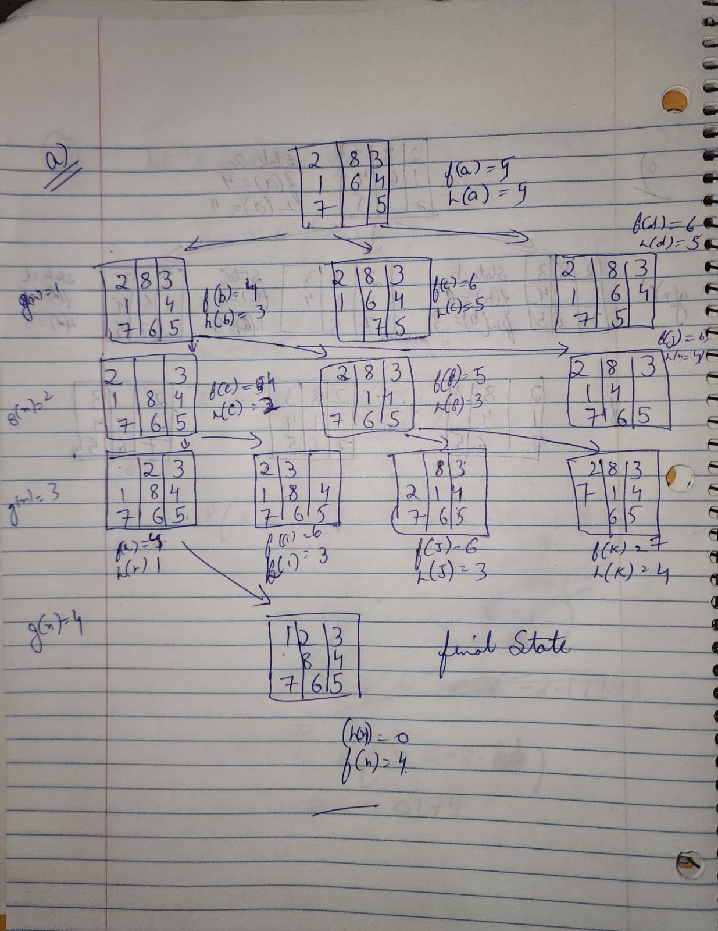
2. The heuristic used in the problem (h(n)= “the number of misplaced tiles.”). is able to complete the basic for A*Algorithm and provide a complete solution for the problem in just 4 steps as the g(n) comes out to be just 4. Moreover, this is non-negative as well. That makes it a good heuristic function.
3. The heuristic function I suggest is can be (h(n)= “The numbers that are not in order of (1,2,3,4,5,6,7,8 ”.). This can be an admissible heuristic as it’s not much different from the proposed one and has all the same features that a good heuristic needs.