

Submitted to: Lekhraj Vilhekar

Introduction

Our Project is Based on POP (Process Oriented Programming) C Programming Language. Online shopping has become an integral part of our daily lives, offering convenience and accessibility to a wide range of products. In this project, we aim to create an online shopping retail store using the C programming language. This project will allow users to browse products, add items to their cart, and make purchases securely.

Theory

Units That Are Used:

* Switch Case.
* Functions.
* Nesting of If - Else .
* Structures and Array.
* Basic Input / Output Usage.
* Different Operator.
* Recursion.
* Use of different data types.

1. If – else:

if (condition) {

// block of code to be executed if the condition is true

} else {

// block of code to be executed if the condition is false

}

**if-else** is a control structure used for decision-making. It allows you to execute certain code blocks based on whether a condition is true or false.

1. Switch Case :

switch (expression) {

case constant1:

// block of code to be executed if expression matches constant1

break;

case constant2:

// block of code to be executed if expression matches constant2

break;

// more cases as needed

default:

// block of code to be executed if expression does not match any case

}

**switch** statement is another control structure used for decision-making, particularly when you have multiple conditions to check against a single variable.

1. **Structure :**

**Struct structure_name**

**{**

**// Member variables or fields**

**data_type1 member1;**

**data_type2 member2;**

**// ...**

**};**

structure is a composite data type that allows you to group together variables of different types under a single name. This enables you to create more complex data structures that represent entities with multiple attribute

1. **Use of different data types in C**

* **int**: Used to store integers (whole numbers) such as -10, 0, 42, etc.
* **char**: Used to store single characters, such as 'A', 'x', '5', etc. Internally, char is stored as integers.
* **short**: Used to store small integers, typically smaller than **int**.
* **long**: Used to store large integers, typically larger than **int**.
* **long long**: Used to store very large integers, introduced in C99.
* **float**: Used to store single-precision floating-point numbers, which can represent decimal numbers with less precision.
* **double**: Used to store double-precision floating-point numbers, which provide higher precision compared to **float**.

#include <stdio.h>

int main() {

int integerVariable = 42;

char characterVariable = 'A';

float floatVariable = 3.14;

double doubleVariable = 3.141592653589793;

printf("Integer Variable: %d\n", integerVariable);

printf("Character Variable: %c\n", characterVariable);

printf("Float Variable: %f\n", floatVariable);

printf("Double Variable: %lf\n", doubleVariable);

return 0;

}

**Functionalities:**

* User Authentication: Users will be required to register and log in to access the shopping functionalities. Authentication will ensure security and personalized experiences for users.
* Product Catalog: The system will maintain a catalog of products available for purchase. Each product will have attributes such as name, description, price, and quantity.
* Browsing Products: Users can browse through the product catalog to view details about each product.
* Checkout Process: Once users are satisfied with their selection, they can proceed to the checkout process. During checkout, users will provide payment information.
* Order Confirmation: After successful checkout, users will receive confirmation of their order.

**Implementation Details:**

* **Modular Approach:** The project will be implemented using a modular approach, with separate modules for user authentication, product management, cart management, and checkout process.
* **File Handling:** Data persistence will be achieved using file handling techniques. User information, product catalog, and order details will be stored in separate files

Input Code

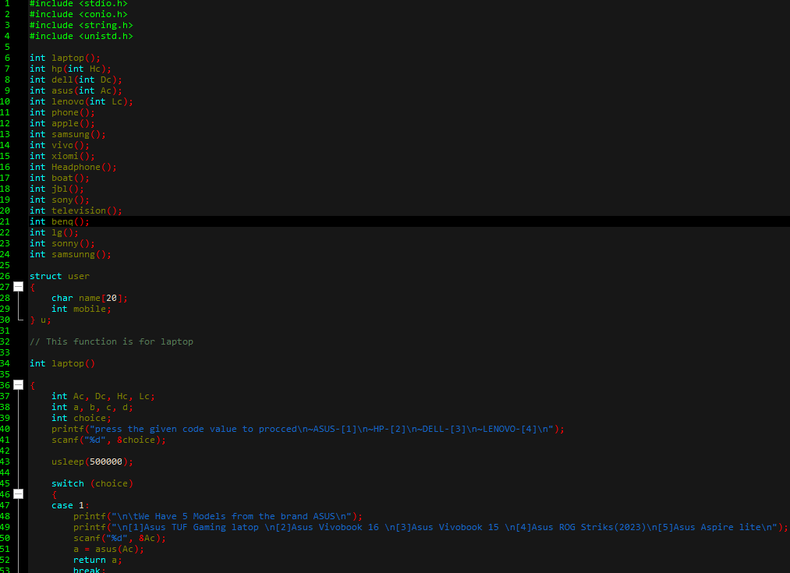

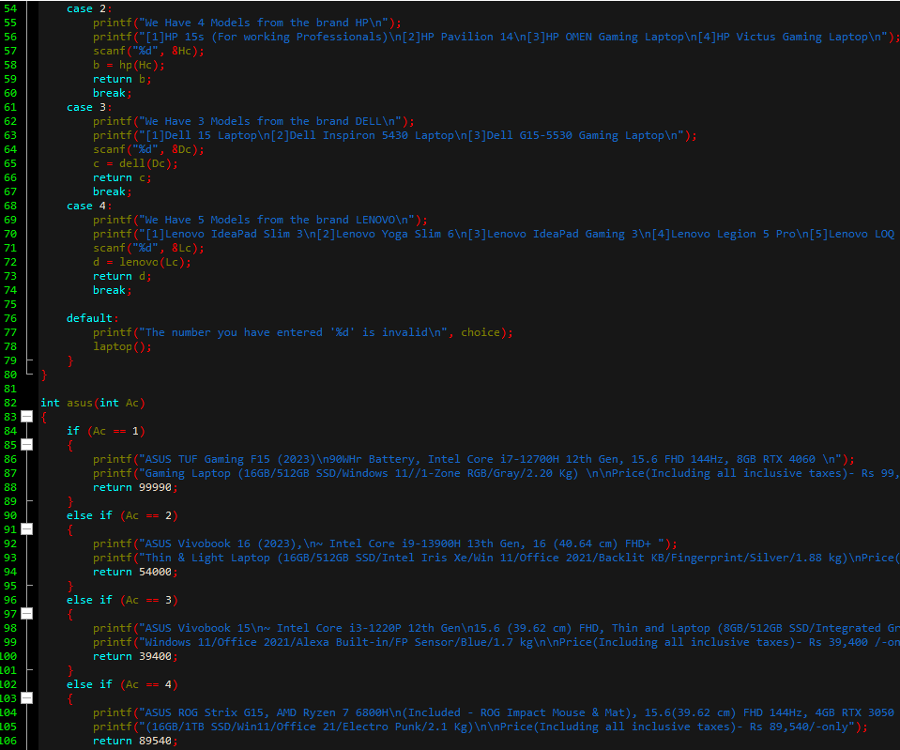

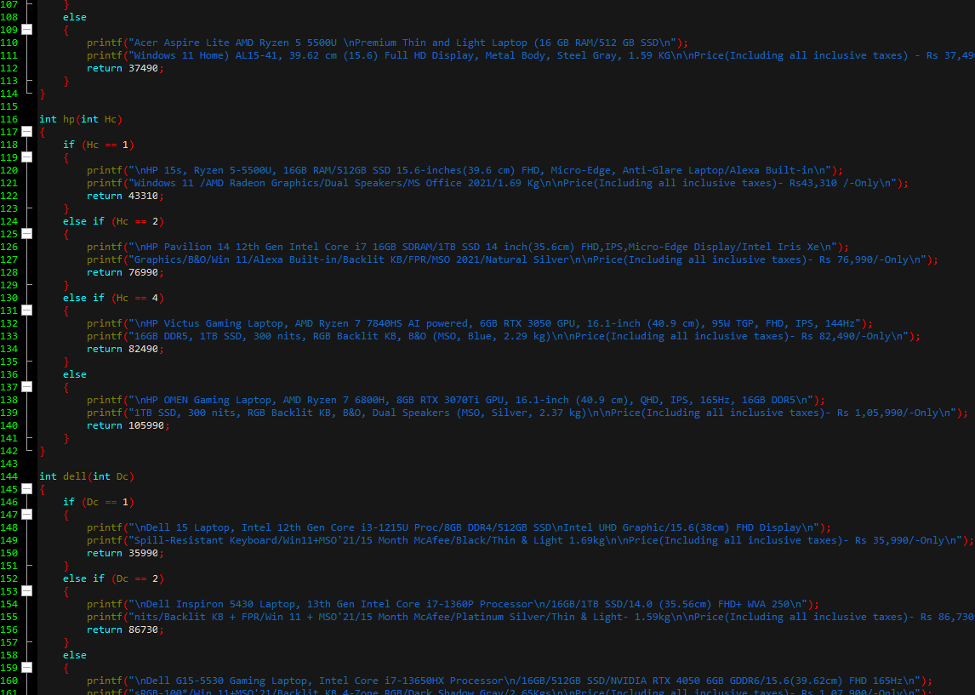

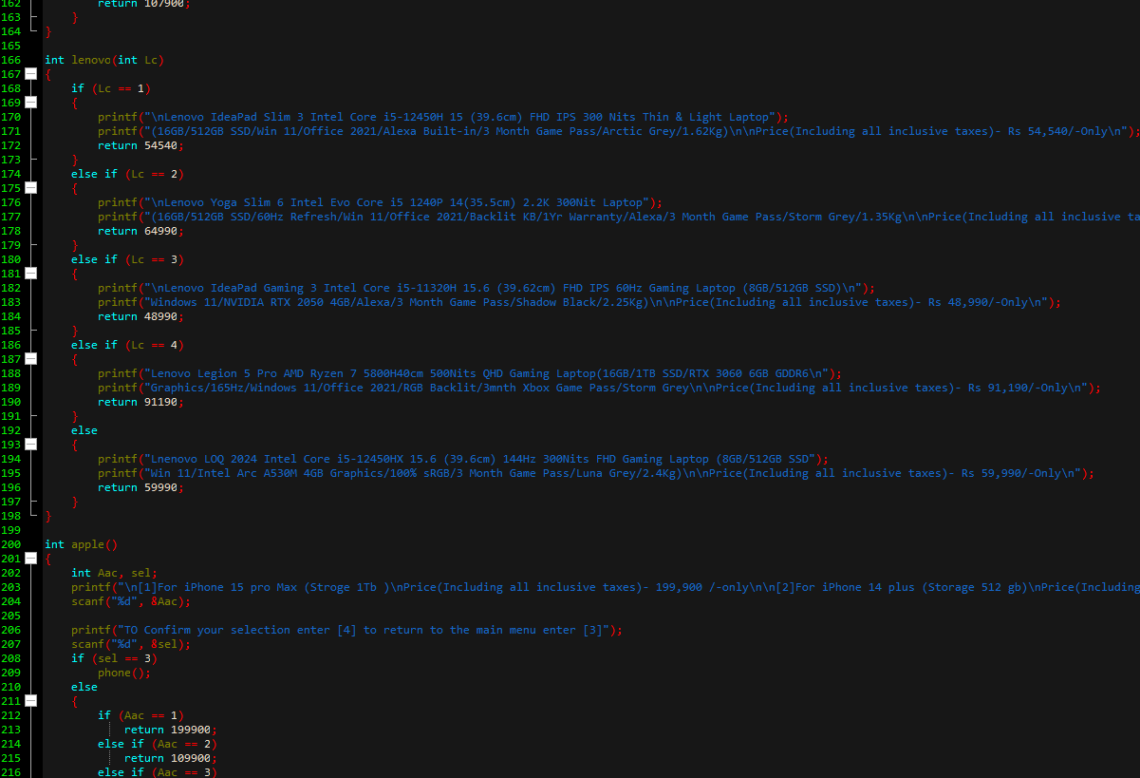

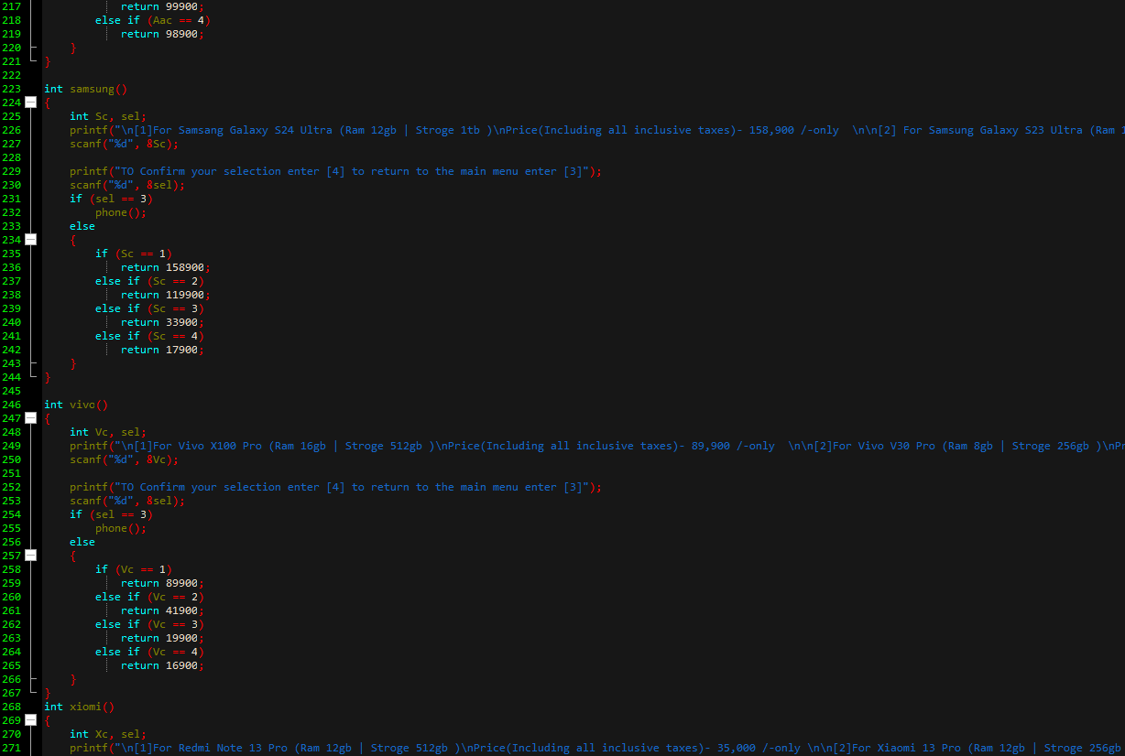

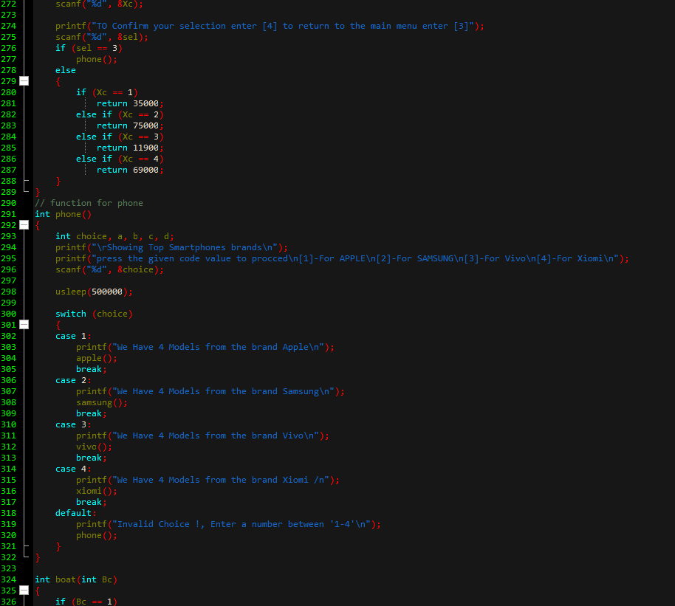

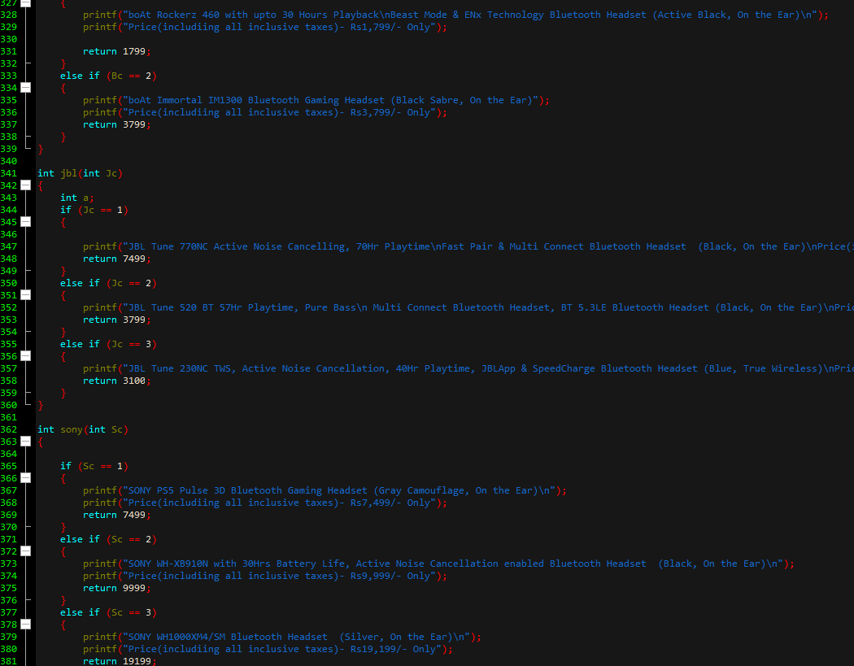

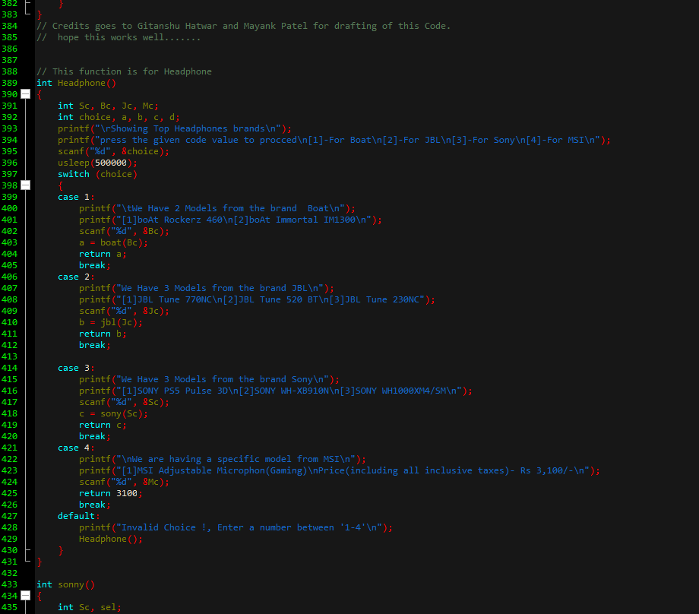

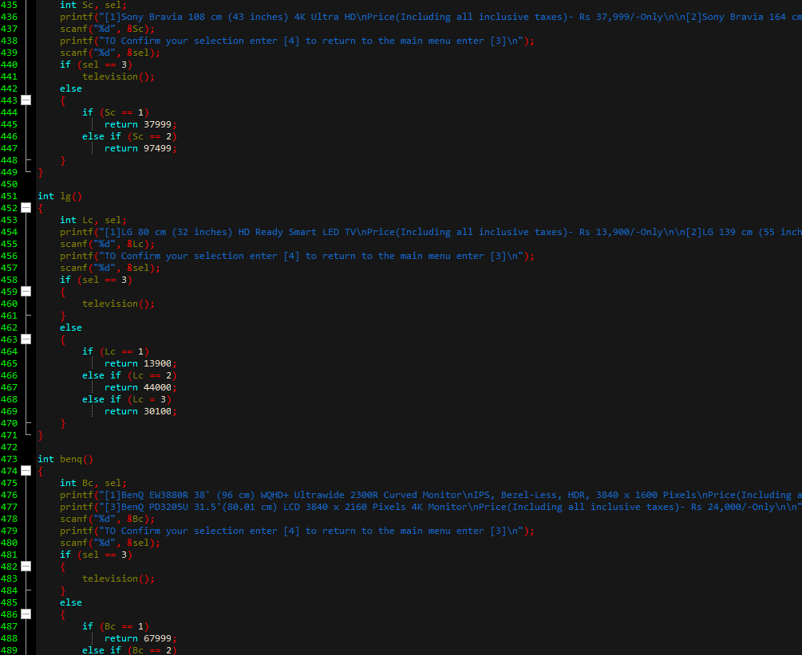

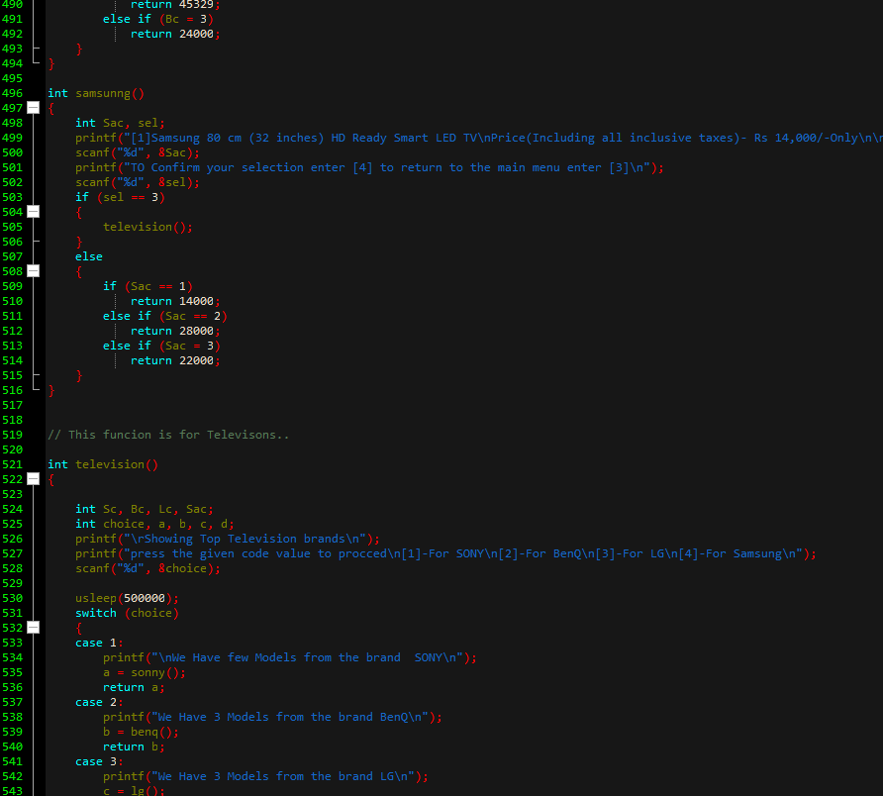

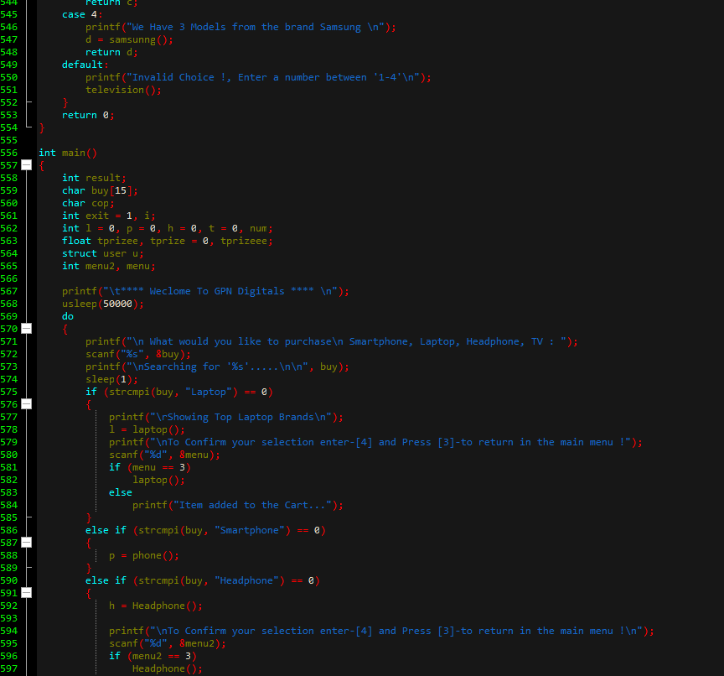

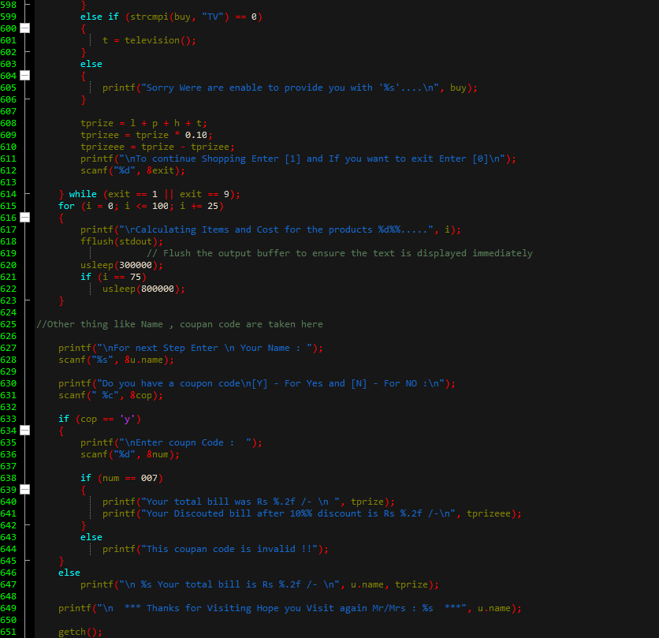

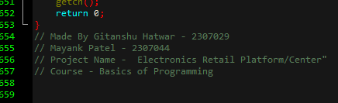

Github link for the code : <https://github.com/GitanshuHatwar/Projects-.git>

(make sure to visit our page )..

Conclusion

In This Practical We Have Successfully Designed the project which efficiently uses Function, Structure ,Switch Case , if- else nesting and Other Concepts of C Programming Language.

Thank you Note:

Thank You Vilhekar Sir for Teaching a C Programing Language …..

The knowledge which you have given us and the concepts you have thought will definitely help us a lot in the future .