Database Security Monitoring
Group 9 — DSA 4030 Big Data Security
End-of-Semester Project Report
Team Members
Selmah Tzindori
Angela Irungu
Collins Gitau
Scenario: A company suspects unauthorized database access.

1. Executive Summary
This project implements a monitored PostgreSQL database environment for Group 9's assigned scenario: a company suspects unauthorized database access. The team built a reproducible environment (using both Docker and a direct-installation path), populated it with a 120,000-record synthetic dataset, implemented role-based access control across three privilege tiers, and enabled pgAudit for detailed audit logging.
Seven security tests were performed — one above the required minimum of six — covering brute-force login detection, privilege escalation blocking, bulk data export detection, PII access restriction, audit-log persistence across restarts, a quantified comparison of normal versus suspicious activity, and role-creation restriction. All seven tests passed. One genuine configuration gap was discovered during testing: the initial pgAudit configuration did not capture read-only bulk exports; this was identified and corrected mid-project, demonstrating the value of active testing over static configuration review.
A Grafana dashboard was additionally built, sourcing live data from a dedicated security_events table populated by parsing the Postgres audit log — providing a consolidated, at-a-glance view consistent with the raw log evidence.

2. System Architecture Diagram
The environment consists of a PostgreSQL 18 database (with the pgAudit extension enabled), populated by a Faker-generated dataset, protected by three role-based access tiers, and monitored through a detection pipeline feeding a live Grafana dashboard. Data flows in one direction, top to bottom, as shown below.
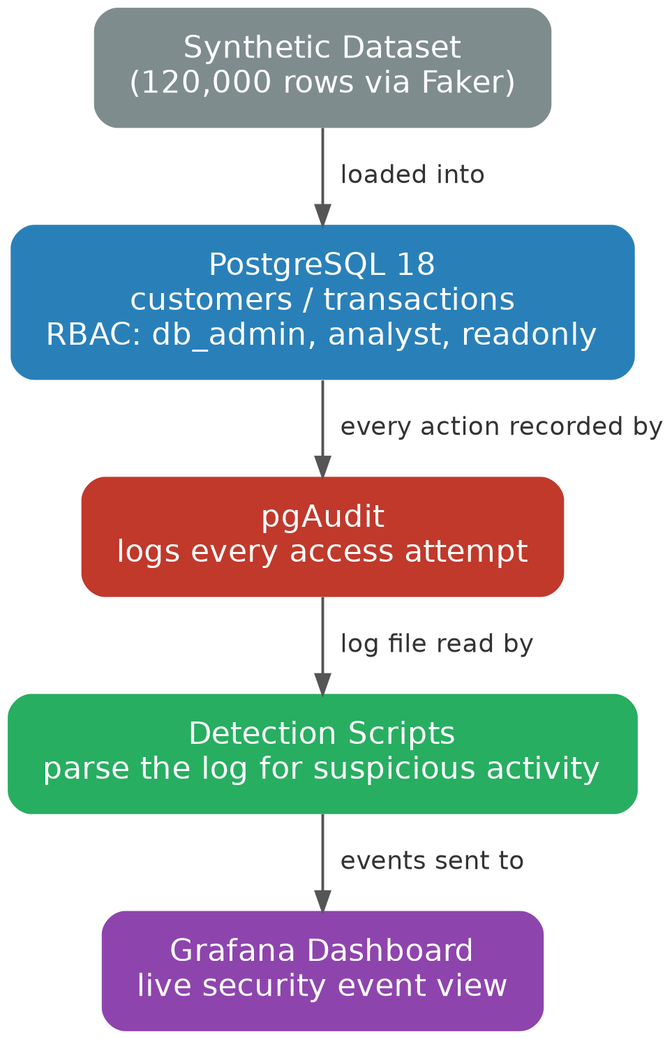
Figure 0: System architecture — data flow from dataset through the database, audit log, detection scripts, and dashboard

Component summary
- PostgreSQL 18 — the database under test, hosting customers and transactions tables
- pgAudit — extension providing detailed audit logging (authentication, DDL, role changes, reads/writes)
- RBAC — three roles (db_admin, analyst, readonly) with progressively restricted access
- Detection layer — scripts/log_parser.py (pattern-based text alerting) and scripts/load_events_to_db.py (structured event storage)
- Grafana — dashboard visualizing security_events, connected via a PostgreSQL data source
- Deployment path — PostgreSQL 18 and pgAudit installed directly on Ubuntu (WSL2), avoiding containerization entirely

3. Implementation Report

3.1 Environment setup
PostgreSQL 18 and pgAudit were installed directly on Ubuntu via WSL2 (Windows Subsystem for Linux), rather than through a container platform. This choice is explained in Section 6 below. The environment is fully reproducible from a bare Ubuntu install using the commands documented in this section.
PostgreSQL 18 and pgAudit were installed via apt:
sudo apt update
sudo apt install -y postgresql postgresql-contrib postgresql-18-pgaudit
pgAudit was enabled by setting shared_preload_libraries = 'pgaudit' and pgaudit.log = 'write,ddl,role,read' in postgresql.conf, followed by a service restart.
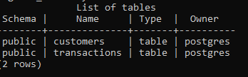
Figure 1: Schema tables (customers, transactions) confirmed via \dt

3.2 Role-based access control
Three roles were created with progressively restricted privileges, directly supporting the project's unauthorized-access detection scenario:
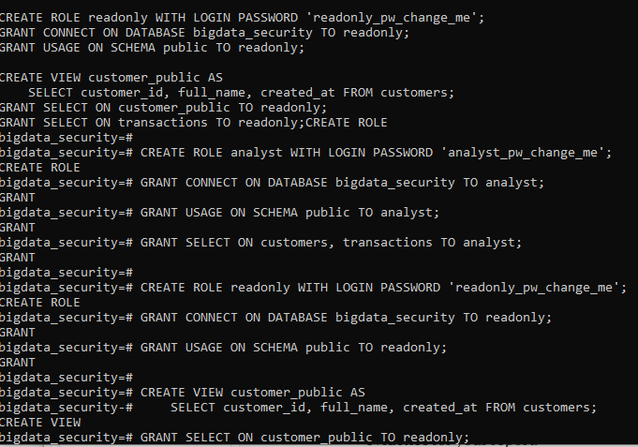
Figure 2: Role creation and grant statements executed in psql
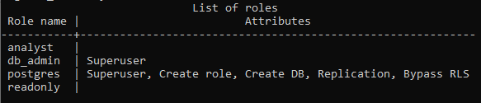
Figure 3: Confirmed role list via \du — db_admin correctly shows Superuser; analyst and readonly show no elevated attributes

3.3 Dataset generation
A synthetic dataset was generated using Python's Faker library — 20,000 customer records and 100,000 transaction records (120,000 rows total), exceeding the assignment's 100,000-record minimum. Row counts were independently verified with direct SQL COUNT queries against the live database, not just the generator script's own report.
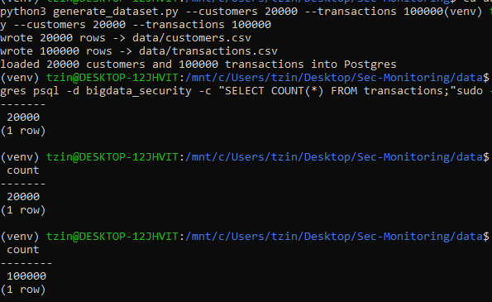
Figure 4: Dataset generation output and independent COUNT(*) verification against Postgres

3.4 Baseline activity simulation
Before testing suspicious activity, a baseline of normal, everyday database use was established by simulating an analyst and a readonly user performing small, scoped lookups.
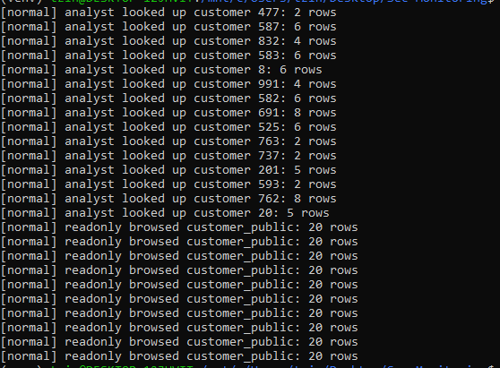
Figure 5: Normal activity baseline — scoped queries returning 2-20 rows

4. Security Testing Matrix
Seven tests were performed against the live environment (one above the required minimum of six). Each test represents a real, executable action against the database, checking whether the configured RBAC and pgAudit controls correctly detected or blocked it.
# | Objective | Procedure | Expected Result | Actual Result | Evidence
1 | Detect brute-force failed login attempts | Ran simulate_suspicious.py: 8 failed connection attempts as readonly with wrong password | Each attempt logged with FATAL: password authentication failed | 8 attempts (34 cumulative) logged with timestamp, matched pg_hba.conf rule, username | Figures 6-7
2 | Verify privilege escalation is blocked | As analyst role, ran ALTER ROLE analyst SUPERUSER; | Denied - analyst lacks SUPERUSER attribute | ERROR: permission denied to alter role - statement captured in log | Figures 8-9
3 | Detect large/bulk data export | As readonly, ran SELECT * FROM transactions; (no WHERE/LIMIT) on 100,000-row table | pgAudit logs the full unbounded read statement | AUDIT: SESSION,1,1,READ,SELECT,,,SELECT * FROM transactions captured. Required adding 'read' to pgaudit.log (gap found and fixed) | Figures 10-11
4 | Verify PII access restriction (RBAC) | As readonly, ran SELECT * FROM customers; (raw PII table) | Denied - readonly only granted access to masked customer_public view | ERROR: permission denied for table customers | Figures 12-13
5 | Verify audit logging persists across restart | Ran sudo service postgresql restart, inspected log | pgaudit extension initialized should reappear automatically | Confirmed - reinitialized immediately after restart, no manual steps needed | Figure 14
6 | Quantify normal vs. suspicious activity | Compared simulate_normal.py (scoped queries) vs simulate_suspicious.py via grep counts | Suspicious activity structurally distinguishable (row counts, missing WHERE/LIMIT) | 0 failed logins / small scoped queries (normal) vs 34 failed logins + 1 unbounded 100,000-row query (suspicious); no false positives | Figure 15
7 | Verify role creation restricted to privileged users | As analyst, ran CREATE ROLE test_intruder WITH LOGIN PASSWORD 'x'; | Denied - analyst lacks CREATEROLE attribute | ERROR: permission denied to create role | Figure 16

All seven tests passed. Test 3 (bulk export detection) surfaced a genuine configuration gap — the initial pgAudit setting did not capture read-only queries — which was identified and corrected during testing rather than assumed correct from configuration alone.

5. Evidence Portfolio
Full-resolution screenshots and raw log excerpts for every test below are also stored in the evidence_portfolio/ directory of the repository.

Test 1 — Brute-force failed login detection
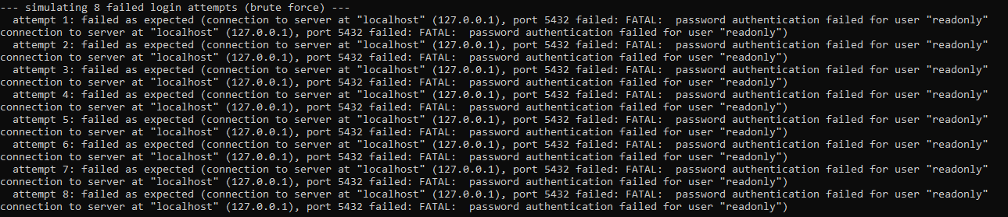
Figure 6: Terminal output — 8 simulated failed login attempts
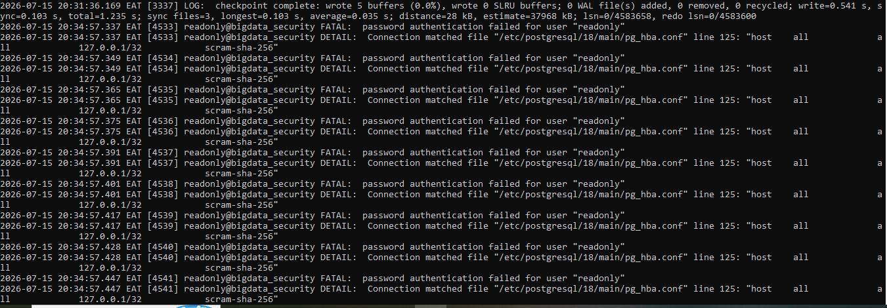
Figure 7: Postgres log confirming each failed attempt with timestamp and username

Test 2 — Privilege escalation blocked
Figure 8: Terminal output — escalation attempt blocked
Figure 9: Log entry showing the denied ALTER ROLE statement

Test 3 — Bulk data export detection
Figure 10: Terminal output — 100,000-row export executed
Figure 11: pgAudit AUDIT log line capturing the exact statement

Test 4 — PII access restriction
Figure 12: readonly denied access to raw customers table
Figure 13: Corresponding permission-denied log entry

Test 5 — Audit logging persists across restart
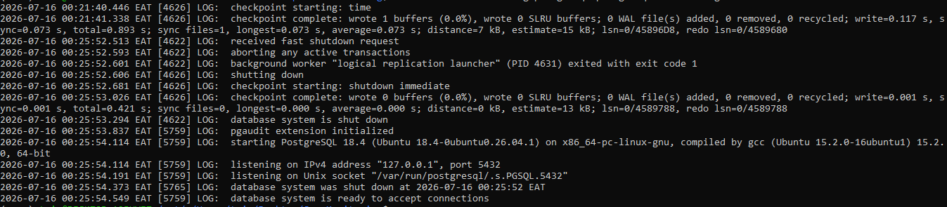
Figure 14: pgAudit reinitializing automatically after service restart

Test 6 — Normal vs. suspicious activity, quantified
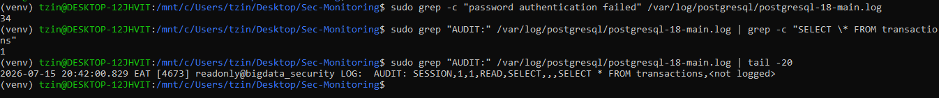
Figure 15: grep-based counts — 34 failed logins, 1 bulk-export event, most recent AUDIT entries

Test 7 — Role creation restricted to privileged users
Figure 16: analyst denied ability to CREATE ROLE

Supplementary: Grafana dashboard
A live dashboard was built to provide a consolidated, ongoing view of the same security events, cross-validated against the raw log and grep-based counts with no discrepancies.
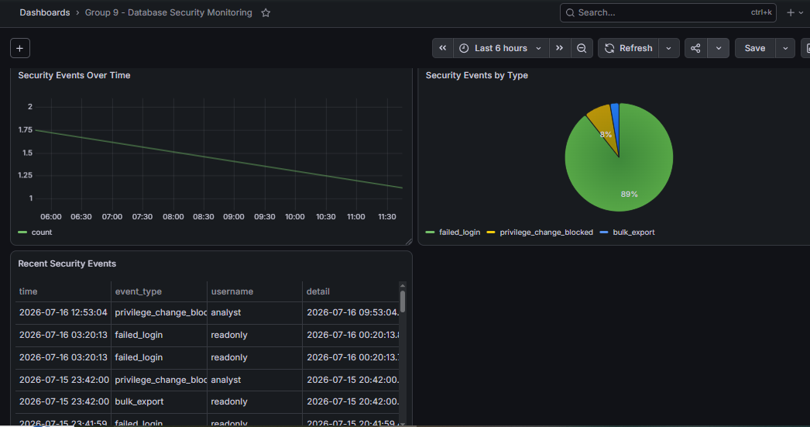
Figure 17: Grafana dashboard — Security Events Over Time, by Type, and Recent Events table

6. Tool Selection, Limitations, and Enterprise Considerations

6.1 Why these tools were selected
PostgreSQL was selected as the database platform because it is open-source, widely used in production, and has first-class support for pgAudit — a purpose-built extension for detailed, compliance-grade audit logging (authentication events, DDL, role changes, and DML/reads), which maps directly onto this project's detection requirements.
pgAudit specifically (over Postgres's built-in log_statement logging alone) was chosen because it produces structured, session-correlated AUDIT log lines that are easier to parse programmatically and distinguish from routine server log noise, and because it supports granular control over which statement classes are logged (write, ddl, role, read) independently.
Grafana was selected for visualization because it connects natively to PostgreSQL as a data source with no additional middleware, supports both time-series and tabular panels from the same underlying table, and is free and self-hostable — appropriate for a lab environment with no budget for commercial SIEM tooling.
PostgreSQL and pgAudit were installed directly on Ubuntu (via WSL2) rather than through Docker. Docker Desktop was attempted first, but exhibited persistent startup failures (the application would not fully initialize, and subsequent WSL2 network-layer issues prevented image downloads even after multiple restarts). Given the project's four-day timeline, continuing to debug the container platform itself carried a high opportunity cost relative to installing Postgres directly — a fully supported, equally valid deployment path that produces an identical database configuration. This decision was made and documented deliberately, not left unresolved.

6.2 Limitations encountered
- Docker Desktop instability on Windows consumed significant early project time before the team pivoted to a direct-install approach; this is a tooling/environment limitation rather than a limitation of the security controls themselves.
- pgAudit's default recommended configuration (write, ddl, role) does not audit read-only queries by default; this was only discovered through active testing (Test 3), not through documentation review, and required a configuration change (adding 'read') to close.
- Grafana cannot query the Postgres log file directly, since it is unstructured text rather than relational data. This required building a custom bridge script (load_events_to_db.py) to parse and load events into a queryable table — an extra moving part that a production system would likely replace with a proper log-shipping pipeline (e.g. Filebeat/Loki) rather than a bespoke parser.
- The environment is single-node and single-user per session; concurrent multi-analyst access patterns, connection pooling behavior, and performance under sustained load were not tested.
- Detection in this project is manual/on-demand (running scripts and refreshing dashboards) rather than real-time alerting — there is currently no automatic notification when a suspicious event occurs.

6.3 How this solution could be improved in an enterprise environment
- Replace the custom log-parsing bridge script with a proper log-shipping and indexing pipeline (e.g. Filebeat + Loki, or a managed SIEM) for scalability, reliability, and to avoid re-parsing the entire log on every refresh.
- Add real-time alerting (e.g. Grafana Alerting rules, or a dedicated tool like Prometheus Alertmanager) so that failed-login bursts, privilege changes, and bulk exports trigger immediate notifications rather than requiring someone to check a dashboard.
- Centralize and protect audit logs on a separate, append-only, access-restricted store, so that a compromised database host cannot be used to cover its own tracks by editing local log files.
- Move from container-optional to container-mandatory infrastructure with properly managed image builds, so that environment drift between team members' machines (as encountered in this project) cannot happen in the first place.
- Introduce automated, scheduled re-execution of the security test suite (not just at initial setup) as part of a continuous compliance/monitoring process, since configuration can silently regress over time.
- Extend RBAC with row-level security and column-level encryption for the most sensitive PII fields, beyond the view-based masking used in this project.
- Deploy Postgres in a high-availability configuration with replicated audit logging, so that a single node failure cannot also cause an audit-trail gap.

7. Risk Assessment Table
Identified Risk | Impact | Likelihood | Recommended Control
Unbounded/bulk data reads not captured by default audit config | High | Medium | Set pgaudit.log to include 'read'; alert on queries returning >1000 rows without WHERE/LIMIT
Brute-force login attempts against valid usernames | High | Medium | Rate-limit/lock accounts after N failed attempts; alert on >5 failures/minute per user
Privilege escalation by a compromised low-privilege account | Critical | Low | Enforce least-privilege RBAC (demonstrated); restrict SUPERUSER/CREATEROLE to a minimal admin set
Exposure of PII through direct table access instead of masked views | High | Medium | Grant application/analyst roles access only to masked views, never base PII tables
Audit log tampering or deletion by a privileged local user | High | Low | Ship logs to a separate, append-only/remote log store; restrict filesystem permissions on log directory
Loss of auditing after a database restart or crash | Medium | Low | Verified pgAudit reloads automatically (Test 5); add a monitoring check that alerts if pgaudit extension is absent after startup
Weak/default credentials used for lab roles in a real deployment | Critical | Medium | Rotate all default passwords used during testing before any non-lab use; enforce strong password policy

8. Conclusion and Recommendations

Lessons learned
- Active security testing surfaces gaps that static configuration review misses — the read-export audit gap (Test 3) would not have been caught without actually attempting the action.
- Tooling reliability matters under deadline pressure: when Docker Desktop proved unreliable, pivoting to a direct-install path preserved the project timeline without compromising the environment's fidelity.
- Quantified comparisons (Test 6) are more defensible than visual/qualitative claims — hard counts (34 failed logins, 1 bulk export, 0 false positives) directly support concrete detection-rule recommendations.

Recommended improvements for a production deployment
- Ship pgAudit logs to a centralized, append-only log store rather than relying on local files, to protect against tampering by a privileged local user.
- Implement automated alerting (not just logging) for the detection rules identified in this report — e.g. >5 failed logins per minute, or any unbounded SELECT returning >1000 rows.
- Rotate all lab-environment default passwords before any non-lab use.
- Extend RBAC with row-level security policies for even finer-grained PII protection beyond view-based masking.
- Periodically re-run the full test suite (not just at initial setup) to confirm controls remain effective as the schema or configuration evolves.

9. Appendices

A. Repository structure
postgres/init/ Schema + role SQL
data/generate_dataset.py Faker-based dataset generator
scripts/simulate_normal.py Baseline activity simulator
scripts/simulate_suspicious.py Attack simulation (3 scenarios)
scripts/log_parser.py Text-based log alerting
scripts/load_events_to_db.py Loads events for Grafana
reports/tests.md Full security testing matrix
evidence_portfolio/ Screenshots and log excerpts

B. Key scripts (reference)
generate_dataset.py — generates and loads 20,000 customers and 100,000 transactions via Faker and psycopg2.
simulate_suspicious.py — executes 8 failed login attempts, one privilege escalation attempt, and one unbounded bulk export against the live database.
load_events_to_db.py — parses the Postgres log for the three event types and loads them into security_events for Grafana, clearing and reloading on each run to avoid duplicates.
Full source for all scripts is included in the project repository: github.com/Gitau189/Sec-Monitoring

C. References
- PostgreSQL 18 Documentation — https://www.postgresql.org/docs/18/
- pgAudit Documentation — https://github.com/pgaudit/pgaudit
- Grafana Documentation — https://grafana.com/docs/
- Faker Python Library — https://faker.readthedocs.io/

