**How to Create a VPC with Public and Private EC2 Instances on AWS**

When launching cloud applications, it's important to organize your infrastructure securely and efficiently. In this blog, I’ll guide you through creating a custom **Virtual Private Cloud (VPC)** on AWS with:

* Public and Private Subnets
* An Internet Gateway (IGW)
* Proper Routing
* EC2 instances in both subnets

Let’s dive in!

**1️⃣ Design the Architecture**

Before jumping into AWS, let’s define the architecture:

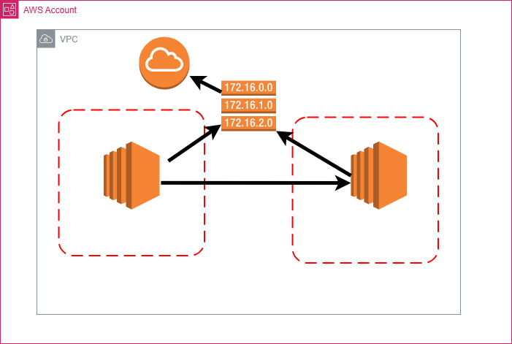

**2️⃣ Create a VPC**

1. Navigate to **VPC Dashboard > Your VPCs**
2. Click **Create VPC**
3. Choose:
   * **VPC only**
   * Name: MyCustomVPC
   * IPv4 CIDR block: 12.0.0.0/16
4. Leave everything else as default and click **Create VPC**

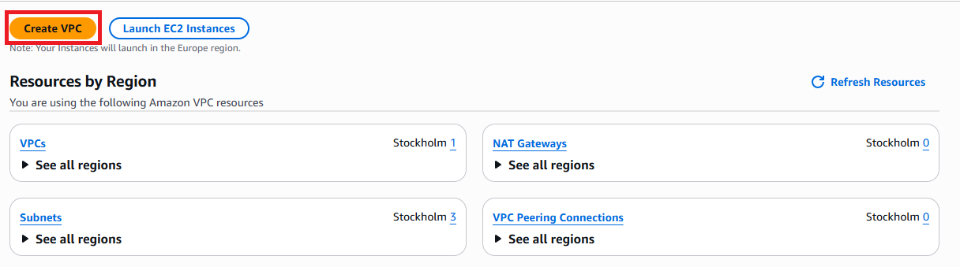

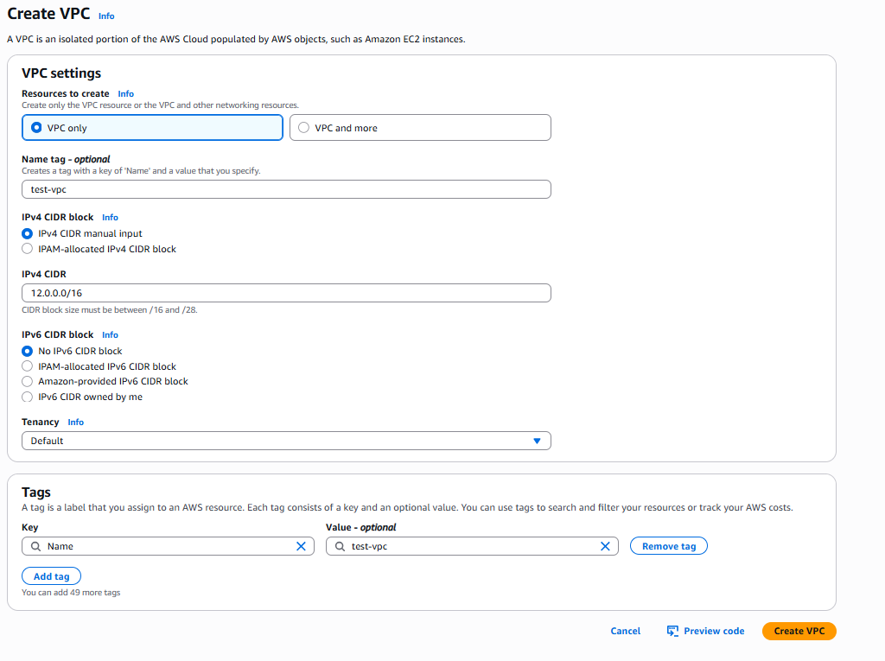

**3️⃣ Create an Internet Gateway (IGW)**

1. Go to **Internet Gateways** > **Create internet gateway**

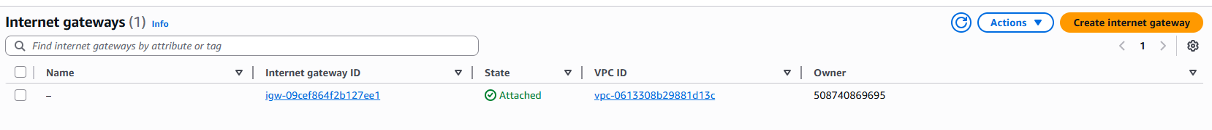

1. Name it: IGW-test
2. Click **Create internet gateway**

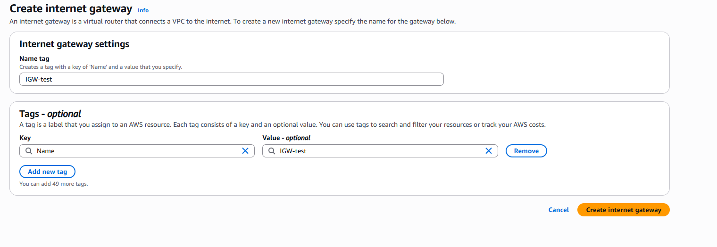

1. Select the IGW and choose **Attach to VPC**



1. Attach it to MyCustomVPC



**4️⃣ Create Public and Private Subnets**

1. Go to **Subnets > Create Subnet**
2. Choose VPC: MyCustomVPC

🔹 **Public Subnet**

* Name: PublicSubnet
* CIDR block: 12.0.0.0/16
* Availability Zone: pick one (e.g., us-north-1a)

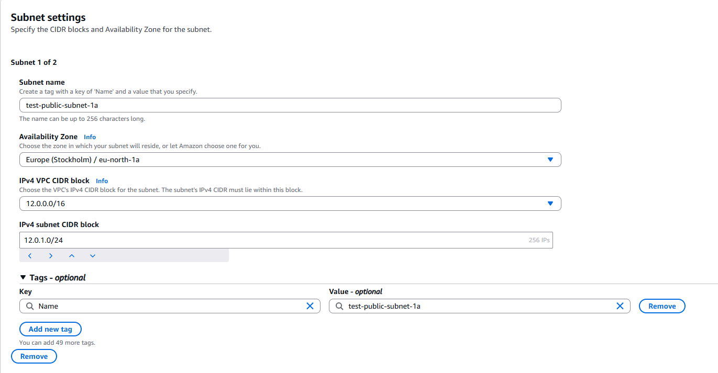

🔹 **Private Subnet**

* Name: PrivateSubnet
* CIDR block: 12.0.2.0/16
* Availability Zone: same or different

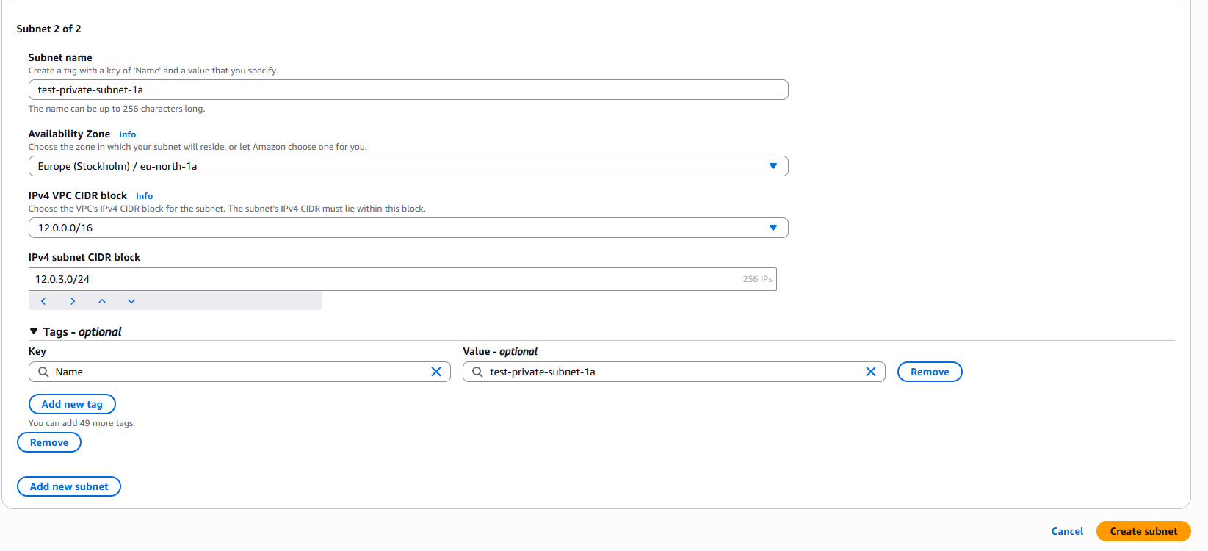

Click **Create subnet**.

**5️⃣ Create Route Tables**

1. Navigate to **Route Tables** > **Create route table**



1. Name: PublicRouteTable, associate with MyCustomVPC
2. Click **Create route table**

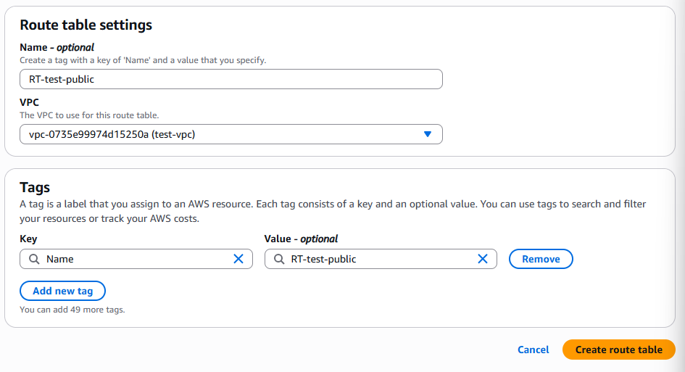

1. Repeat to create PrivateRouteTable

**6️⃣ Edit Route Table for Internet Access**

🔹 **For PublicRouteTable:**

1. Select it > **Routes** > **Edit routes**

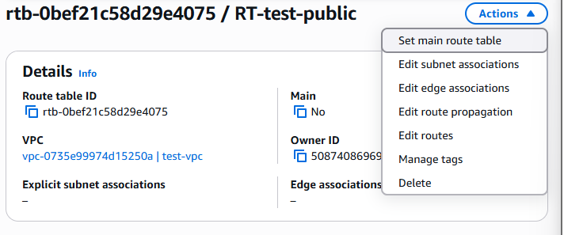

1. Add route:
   * Destination: 0.0.0.0/0
   * Target: Internet Gateway (IGW-test)

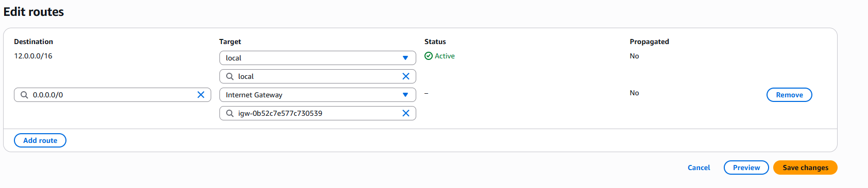

1. Save

🔹 **Associate Subnet:**

* Under **Subnet Associations** tab, click **Edit subnet associations**
* Select PublicSubnet

🔹 **For PrivateRouteTable:**

* Associate it with PrivateSubnet (no internet route added)

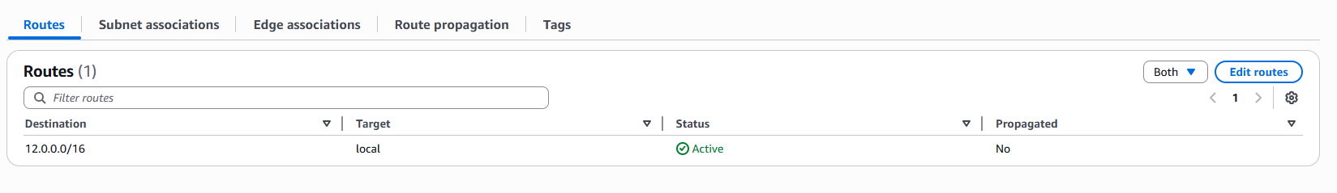

**7️⃣ Launch EC2 in Public Subnet**

1. Go to **EC2 > Launch Instance**
2. Name: PublicInstance
3. Choose ubuntu AMI (or any you prefer)
4. Select instance type: t3.micro

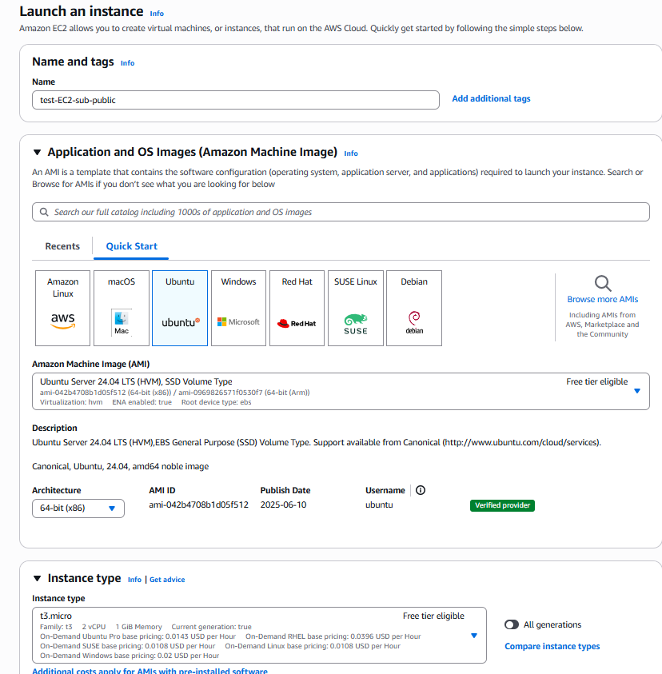

1. In **Network settings:**
   * VPC: MyCustomVPC
   * Subnet: PublicSubnet
   * Auto-assign public IP: **Enable**
2. Create or select a security group that allows **SSH (port 22)** from your IP

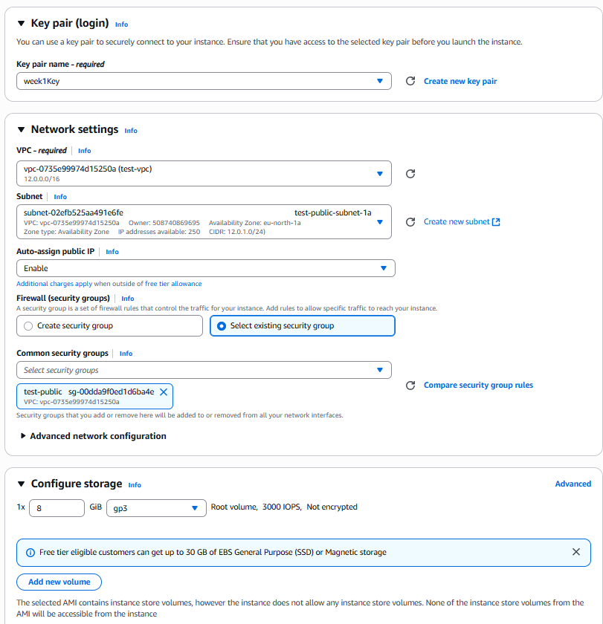

1. Launch the instance

✅ After launch, copy the **public IP** and SSH into it:

ssh -i your-key.pem ec2-user@<PUBLIC-IP>

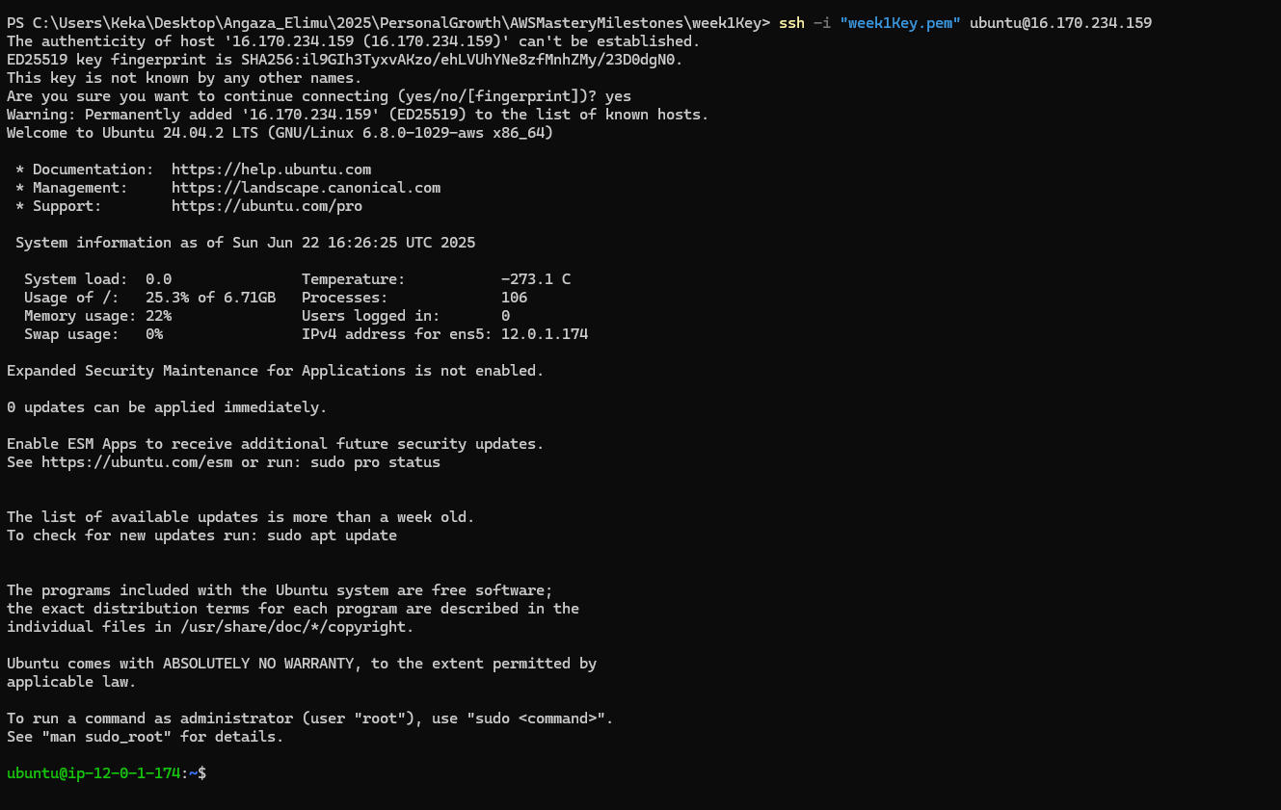

**8️⃣ Launch EC2 in Private Subnet**

Repeat the same steps, but:

* Name it: PrivateInstance
* Subnet: PrivateSubnet
* Auto-assign public IP: **Disable**

This instance won’t be reachable from the internet directly — which is exactly what we want for private infrastructure.

**✅ Summary**

By the end of this guide, you’ll have:

✔️ A custom VPC  
✔️ An Internet Gateway  
✔️ A public and a private subnet  
✔️ A route table that enables public internet access  
✔️ Two EC2 instances securely placed in the right subnets

💡 **Tip**: To allow the private instance to access the internet (for updates, etc.), you can later add a **NAT Gateway** to the public subnet.

If you found this guide helpful, follow for more AWS and cloud tutorials!

#AWS #VPC #CloudComputing #DevOps #EC2 #NetworkArchitecture #PublicPrivateSubnet #AWSBeginner

[Create VPC, IGW, Subnets, EC2](https://youtu.be/43tIX7901Gs)

Steps to create an EC2 instance.

1. Design a VPC.

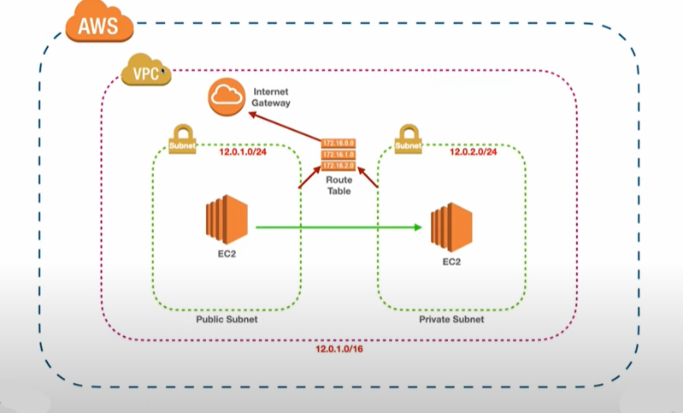

Create a VPC





1. Create Internet Gateway.





Associate IGW with VPC.





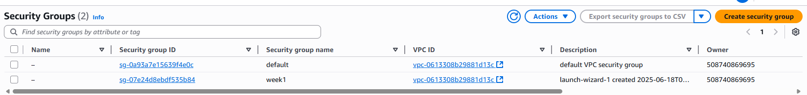

1. Create public and Private Subnet.





1. Create Route Tables.





**Create a route.**



**Edit Route to access the internet.**



**Create Private Subnet Route and Associate with Private subnet.**

**  
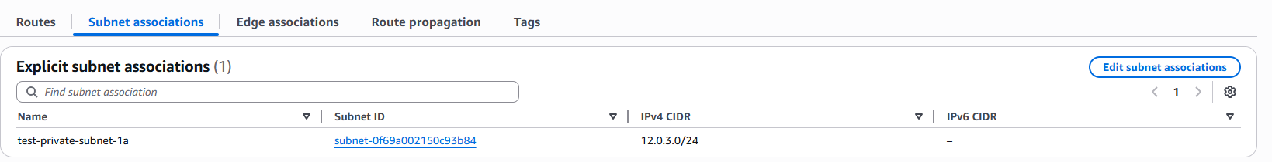**

**Create an Instance in the public subnet**

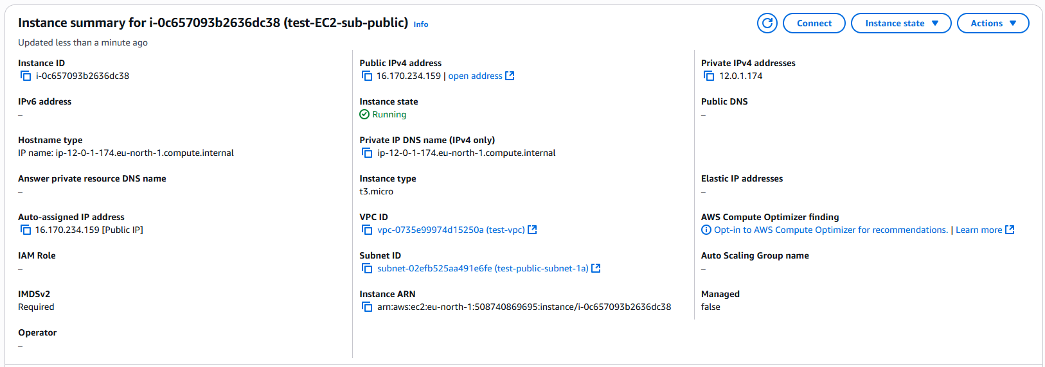

1. **Create an EC2 in the public subnet.**







**Ssh to the EC2 using the pubic ip address:**



1. **Create an EC2 in the private subnet.**