Lab4 – Gălățanu Tiberiu

-documentation-

Github link: https://github.com/Gitbuster1/FLCD/tree/main/Lab2-4

**Finite Automaton**

**Class Diagram:**

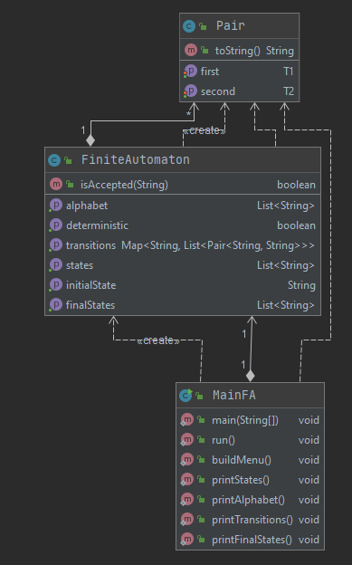

**Structure:**

FA has the following components:

- states: list of string

- alphabet: list of string

- transtions: map with source states (String) as keys and list of (symbol, destination

state) pairs as values (symbol, destinationa are both strings).

- initialState: string

- finalStates: list of string

- isDeterministic(): Checks if the given FA from FA.in is deterministic. This is done by

iterating through all the states and checking if there are any outgoing transitions with

the same symbol. If there are such transitions, the FA is not deterministic.

- isAccepted(sequence): Checks if a given sequence is accepted by the FA. The

sequence is analyzed character by character. The algorithm starts from the initial state

and uses one symbol to perform a transition to another state. The algorithm finishes

when a symbol cannot be used for a transition or the sequence is consumed. The

sequence is accepted if it is entirely consumed and the state reached is a final state.

**Format of FA.in:**

FA = STATES_LIST "\n" ALPHABET "\n" STATE "\n" STATES_LIST "\n" TRANSITIONS_LIST

STATES_LIST = STATE | STATE " " STATES_LIST

STATE = WORD

WORD = SYMBOL | SYMBOL WORD

ALPHABET = SYMBOL | SYMBOL " " ALPHABET

TRANSITIONS_LIST = TRANSITION | TRANSITION "\n" TRANSITIONS_LIST

TRANSITION = STATE " " LIST_OF_TRANSIT " " STATE

LIST_OF_TRANSIT = SYMBOL | SYMBOL " " LIST_OF_TRANSIT

SYMBOL = "a" | "b" | ... | "z" | "A" | "B" | ... | "Z" | "0" | "1" | ... | "9"